|  |
| --- |
|  |
| Spotify for Developers |
| |  |  |  | | --- | --- | --- | |  |  |  | |

Getting Started 5

Setup & Start 5

Dashboard & Settings 9

Token & Result 14

Authorisation Guide 21

Authorisation Scopes 21

Authorisation Code 25

Implicit Grant 28

Client Credentials 30

Authorisation Flows 31

Search & Browse 37

Search for an Item 37

Get All Categories 42

Get a Category 46

Get a Category's Playlists 50

Get Recommendation Genres 54

Get Recommendations 58

Get All New Releases 63

Get All Featured Playlists 67

Artists, Albums & Tracks 71

Get Multiple Artists 71

Get an Artist 75

Get an Artist's Albums 79

Get an Artist's Top Tracks 83

Get an Artist's Related Artists 87

Get Multiple Albums 91

Get an Album 95

Get an Album's Tracks 99

Get Multiple Tracks 103

Get a Track 107

Get Audio Features for Several Tracks 111

Get Audio Features for a Track 115

Get Audio Analysis for a Track 119

Episodes & Shows 123

Get an Episode 123

Get Multiple Episodes 127

Get a Show 131

Get Multiple Shows 135

Get a Show's Episodes 139

Follow 143

Follow Artists or Users 143

Follow a Playlist 147

Get Following State for Artists/Users 151

Check if Users Follow a Playlist 155

Get User's Followed Artists 159

Unfollow Artists or Users 163

Unfollow Playlist 167

Playlists 171

Get a Playlist 171

Get a Playlist’s Tracks 175

Create a Playlist 179

Get a List of Current User's Playlists 183

Get a List of a User's Playlists 187

Add Tracks to a Playlist 191

Remove Tracks from a Playlist 195

Upload a Custom Playlist Cover Image 199

Get a Playlist Cover Image 203

Change a Playlist's Details 207

Replace a Playlist's Tracks 211

Reorder a Playlist's Tracks 215

Library 219

Save Albums for Current User 219

Save Tracks for User 223

Save Shows for Current User 227

Check User's Saved Albums 231

Check User's Saved Tracks 235

Check User's Saved Shows 239

Get User's Saved Albums 243

Get User's Saved Tracks 247

Get User’s Saved Shows 251

Remove Albums for Current User 255

Remove User's Saved Tracks 259

Remove User's Saved Shows 263

Player 267

Add an Item to the User's Playback Queue 267

Start/Resume a User's Playback 271

Pause a User's Playback 275

Skip User’s Playback to Next Track 279

Skip User’s Playback to Previous Track 283

Seek to Position in Currently Playing Track 287

Set Volume for User's Playback 291

Toggle Shuffle for User’s Playback 295

Set Repeat Mode on User’s Playback 299

Get Information about the User's Current Playback 303

Get the User's Currently Playing Track 308

Get Current User's Recently Played Tracks 313

Get a User's Available Devices 317

Transfer a User's Playback 321

Personalisation & User Profile 325

Get a User's Top Artists and Tracks 325

Get a User's Profile 330

Get Current User's Profile 334

Requests & Responses 338

Request Verbs 338

Response Codes 338

# Getting Started

## Setup & Start

### Step 1

Firstly, you will need to install **Visual Studio 2019 Community**, if not done already by doing the following:

|  |  |
| --- | --- |
|  | Visit [**VisualStudio.com**](http://visualstudio.com) and then from the **Visual Studio IDE** section choose **Download Visual Studio** then **Community 2019** |
|  | Next on the **Thank you for downloading Visual Studio** page when the download prompt appears, select **Run** |
|  | Once downloaded, this should start the **Visual Studio Installer** and select **Continue** to begin the installation |
|  | Next once ready select **.NET Core cross-platform development** from the **Workloads** section |

### Step 2

Next if **Visual Studio 2019 Community** is installed, you can then start **Visual Studio 2019 Community** and **Create a new project**, by doing the following:

|  |  |
| --- | --- |
|  | In **Windows 10** choose **Start**, and then from the **Start Menu** find and select **Visual Studio 2019** |
|  | Once done, from the **Get started** screen for **Visual Studio 2019** select **Create a new project** |
|  | Then choose **ASP.NET Core Web Application** and select **Next** |

### Step 3

Next, in **Configure your new project** enter a **Project name** as **SpotifyForDevelopers** and then choose a **Location** and then select **Create**

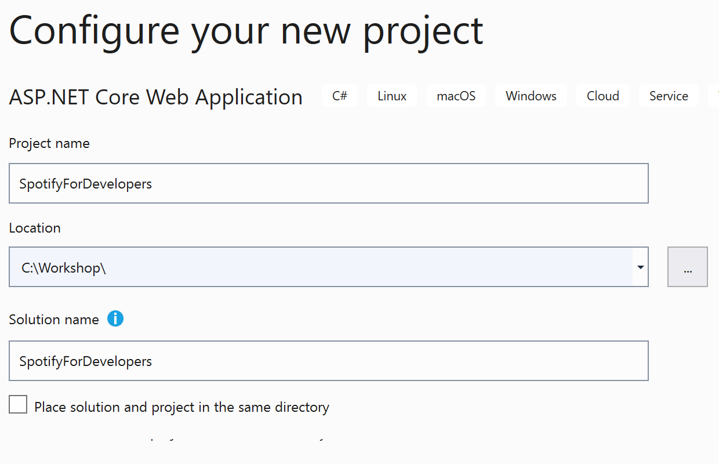

### Step 4

Then, in **Create a new ASP.NET Core web application** make sure from the two dropdowns that **.NET Core** and **ASP.NET Core 3.1** are selected, and **Web Application** is selected from the list and in **Advanced** configure for HTTPS has been selected then select **Create**

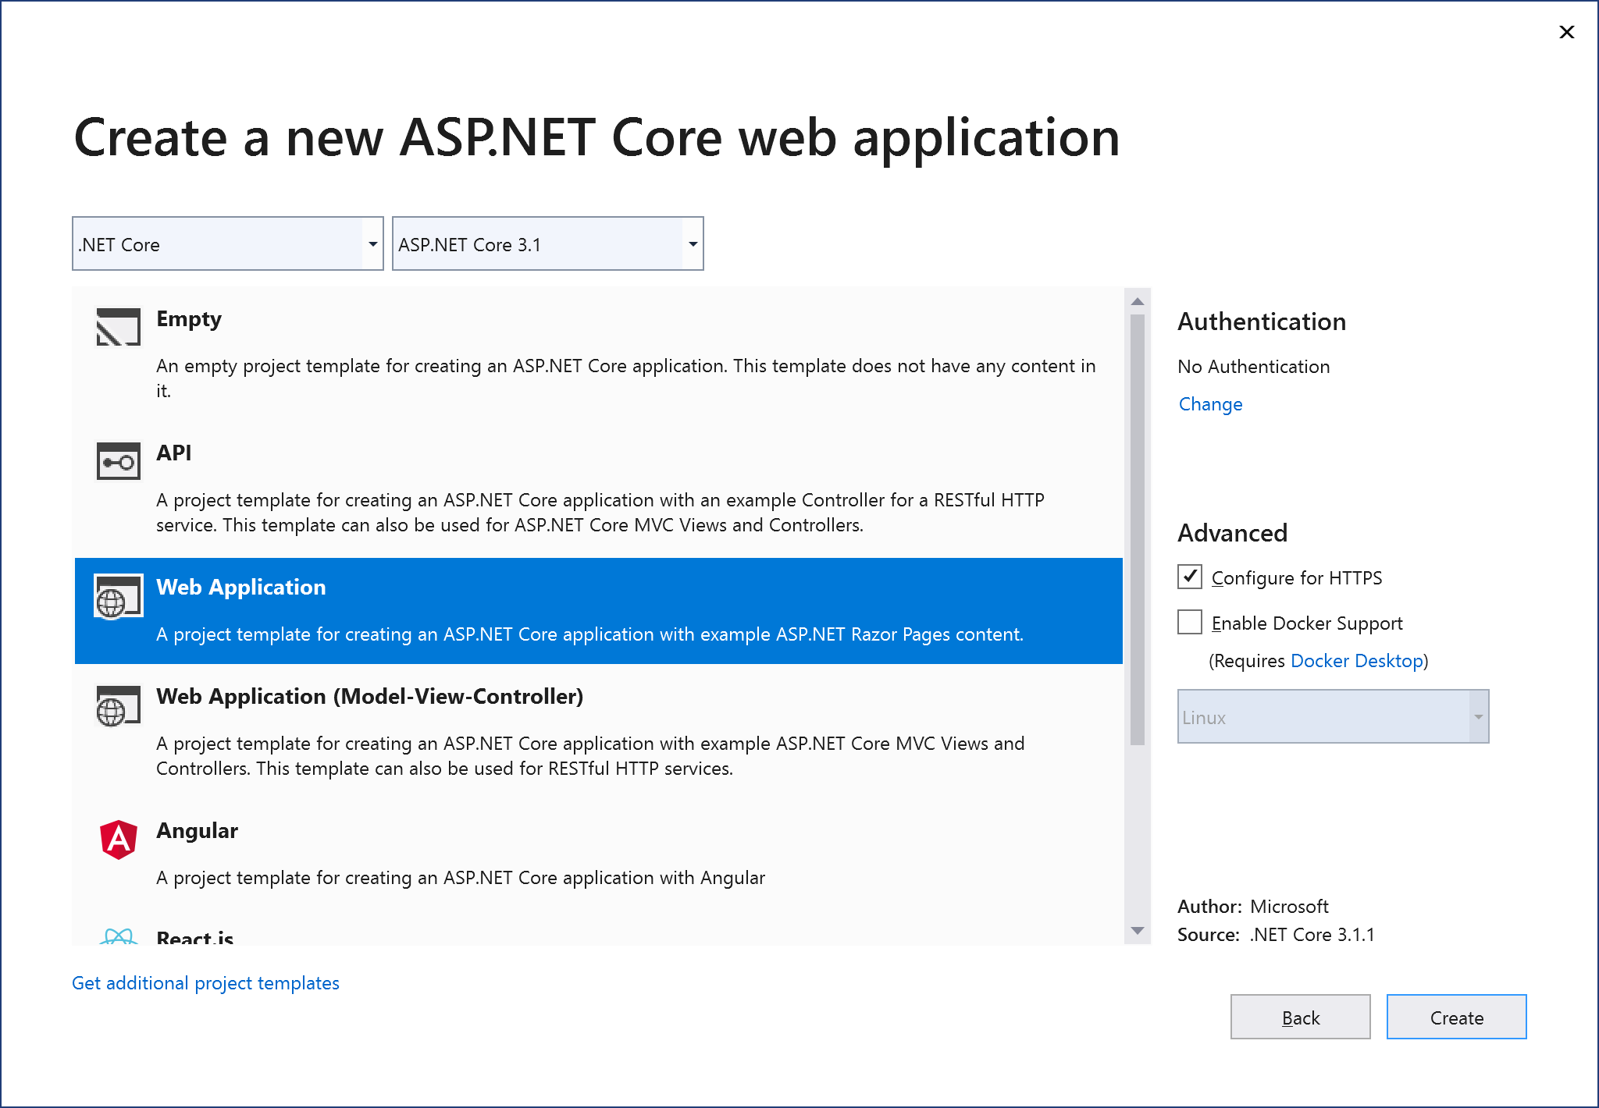

### Step 5

|  |  |
| --- | --- |
|  | In the **Solution Explorer** of **Visual Studio 2019** selectthe **Project** for **SpotifyForDevelopers** |

### Step 6

|  |  |
| --- | --- |
|  | From the **Menu** of **Visual Studio 2019** select **Project** then **SpotifyForDevelopers Properties…** |

### Step 7

|  |  |
| --- | --- |
|  | Then in **Properties** select the **Debug** section and then in the **Web Server Settings** select the **Copy** option to **Copy** the URL to the **Clipboard** e.g. <https://localhost:44395/> - please note that your URL may be different. Then **Paste** the contents into your text editor such as **Notepad** this will be used as a **Redirect URI** for use with the **Spotify API** |

### Step 8

|  |  |
| --- | --- |
|  | From the **Menu** of **Visual Studio 2019** select **Tools** then select **NuGet Package Manager** and **Manage NuGet Packages for Solution…** |

### Step 9

Then in **NuGet** select **Browse** and search for **Spotify.NetStandard by RoguePlanetoid** as indicated and select **Spotify.NetStandard** then check the box under **Project** as indicated and select **Install**.

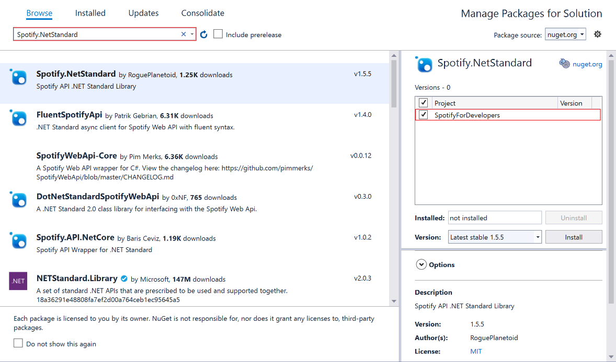

### Step 10

|  |  |
| --- | --- |
|  | Then, if **Preview Changes** is displayed, select **OK** thenor otherwisethe **NuGet** package **Spotify.NetStandard** willbe installed and then make sure to keep **Visual Studio 2019** open as you’ll come back to it later. |

## Dashboard & Settings

### Step 1

Start your favourite **Web Browser** such as **Microsoft Edge** and navigate to **developer.spotify.com** for the **Spotify for Developers** website.

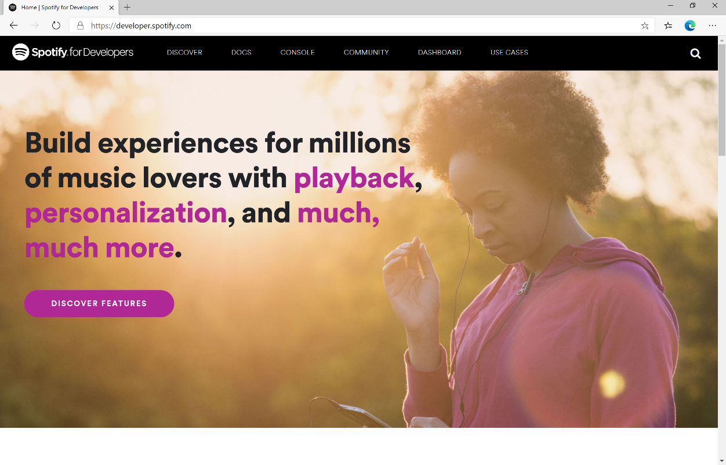

### Step 2

Then on the **Spotify for Developers** website select **Dashboard** then on the **Your Dashboard Page** choose **Log In** to sign in with a **Spotify Account**

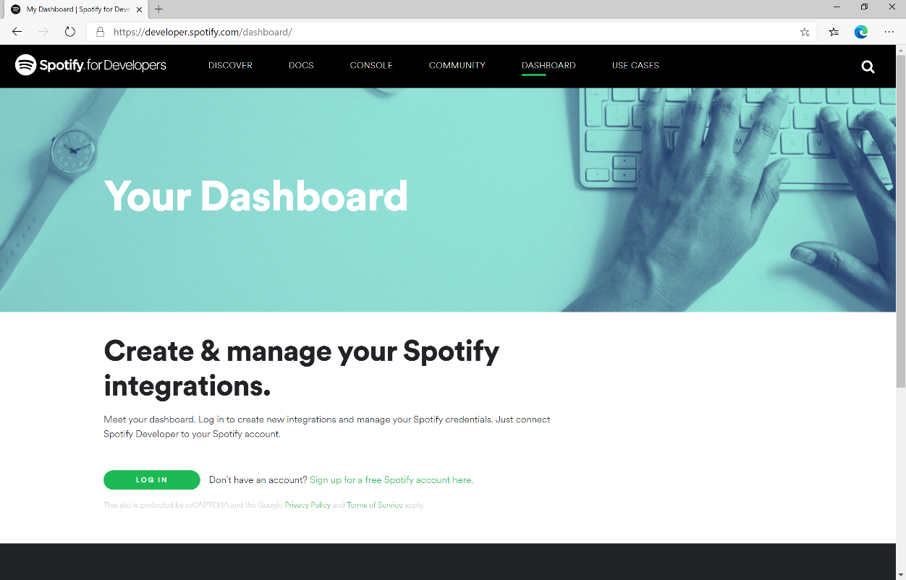

If you don’t have a **Spotify** account already you can use the **Sign up for a free Spotify account here** option to get a **Spotify** account – you will already have one if you have a **Spotify** subscription or already listen to their music service.

### Step 3

Once you’ve signed in with a **Spotify** account for the first time you will need to read through the **Spotify Developer Terms of Service** then once done select the **I accept the Spotify Developer Terms of Service** and then select **Accept the Terms** to continue.

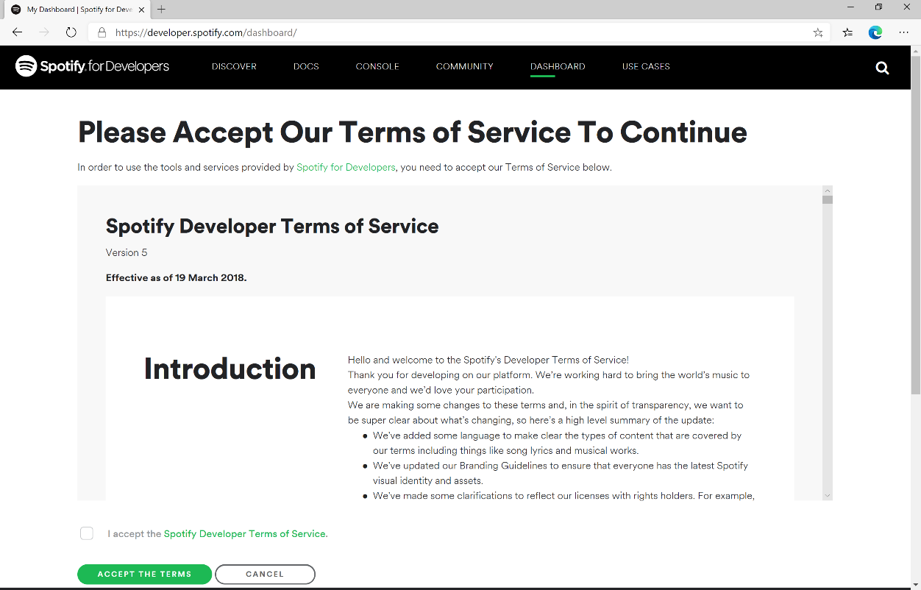

### Step 4

Once signed in with a **Spotify** Account and agreed to the **Spotify Developer Terms of Service** you’ll be taken to the **Dashboard**

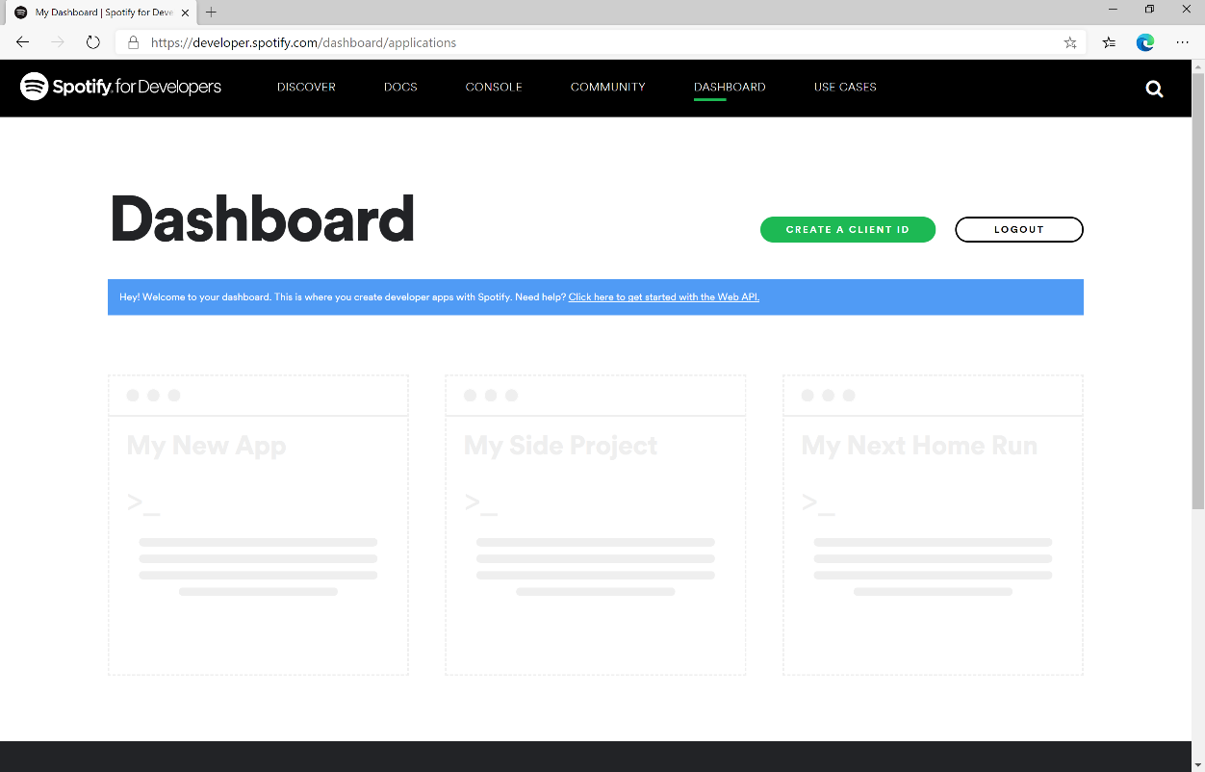

### Step 5

Then in the **Dashboard** select **Create a Client Id** then in **Step 1/3** of **Create an App or Hardware Integration** you need to enter the **App or Hardware Name** as **Spotify for Developers** and the **App or Hardware Description** as **Spotify for Developers** then under **What are you building** tick the **Website** option and select **Next**.

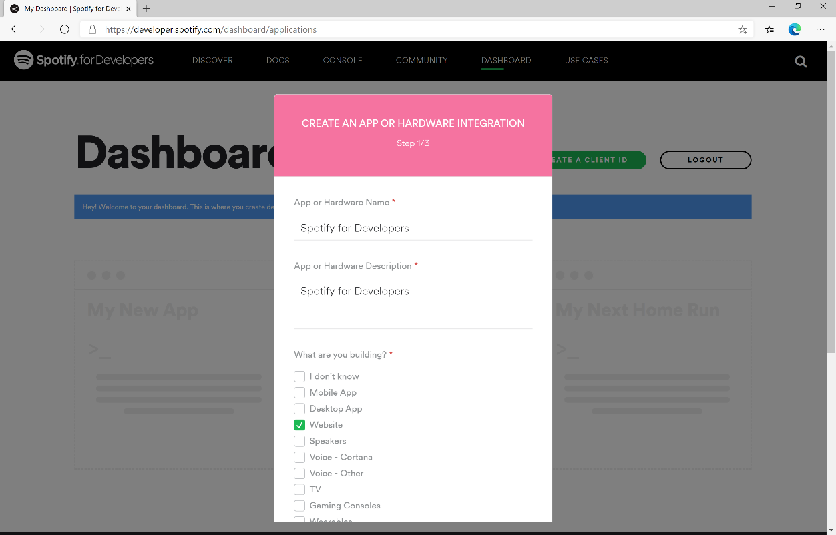

### Step 6

Then in **Step 2/3** of **Create an App or Hardware Integration** for **Are you developing a commercial integration** select **Non-Commercial**.

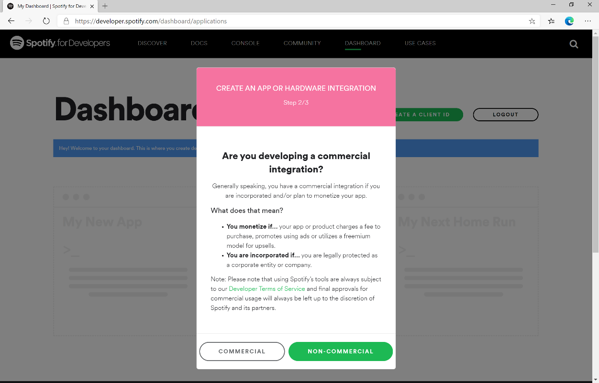

### Step 7

Then in **Step 2/3** of **Create an App or Hardware Integration** for the question **Are you developing a commercial integration** select **No**.

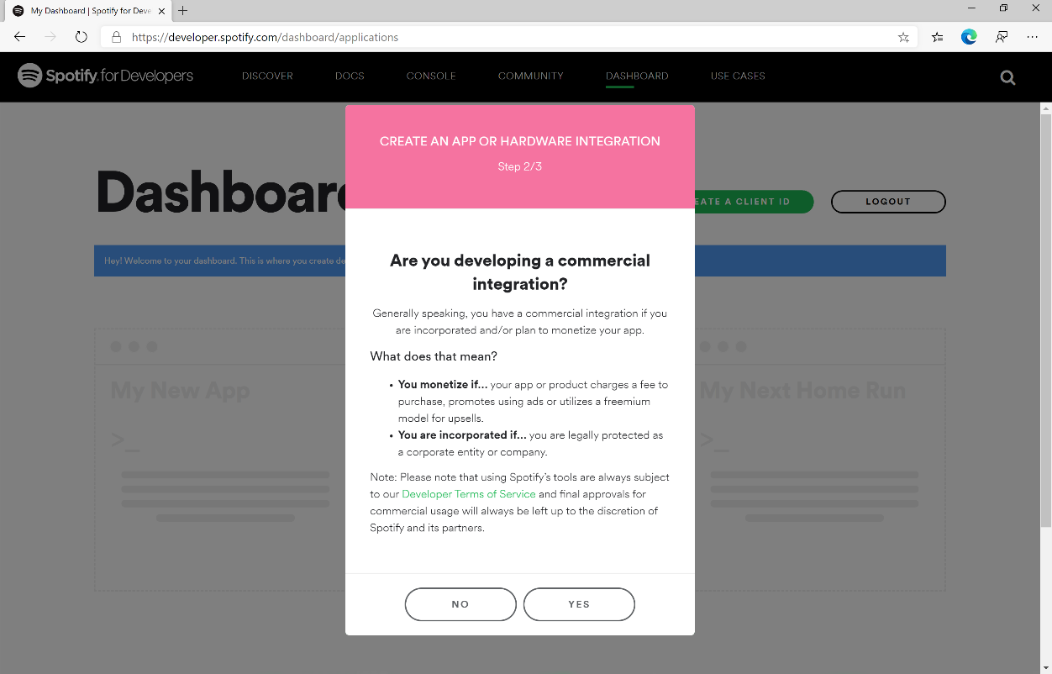

### Step 8

Then in **Step 3/3** of **Create an App or Hardware Integration** then tick the option for **I understand that this app is not for commercial use**, tick the option for **I understand that I cannot migrate my app from non-commercial to commercial without permission** andfollow and read thelinked pages then tick the option for **I understand and agree with Spotify’s Developer Terms of Service and Branding Guidelines,** then choose **Submit**

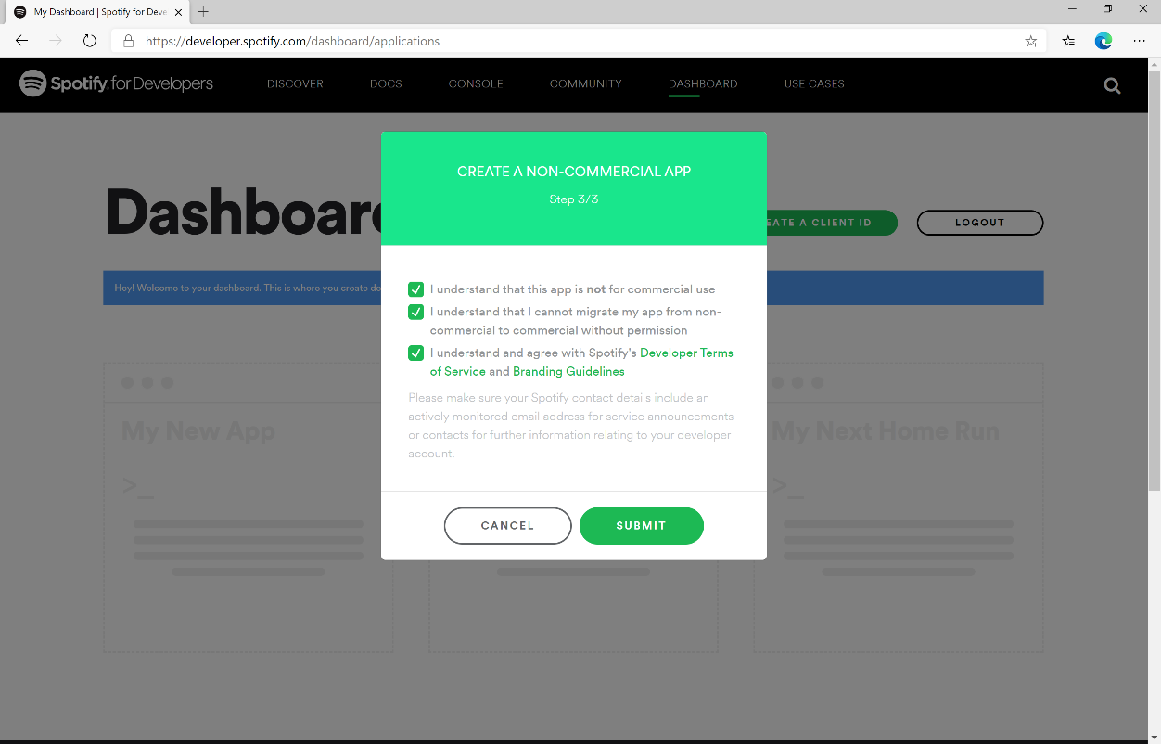

### Step 9

Once created, you will need to **Copy** the **Client ID** to the **Clipboard** e.g. 73706f74696679636c69656e746b6579 – note that your id will be different, then **Paste** the contents into a text editor such as **Notepad** where you copied the **Redirect URI** previously. Then select **Show Client Secret** and then **Copy** the **Client Secret** to the **Clipboard** e.g. 73706f74696679636c69656e74736563726574 – your secret will be different, then **Paste** this into your text editor.

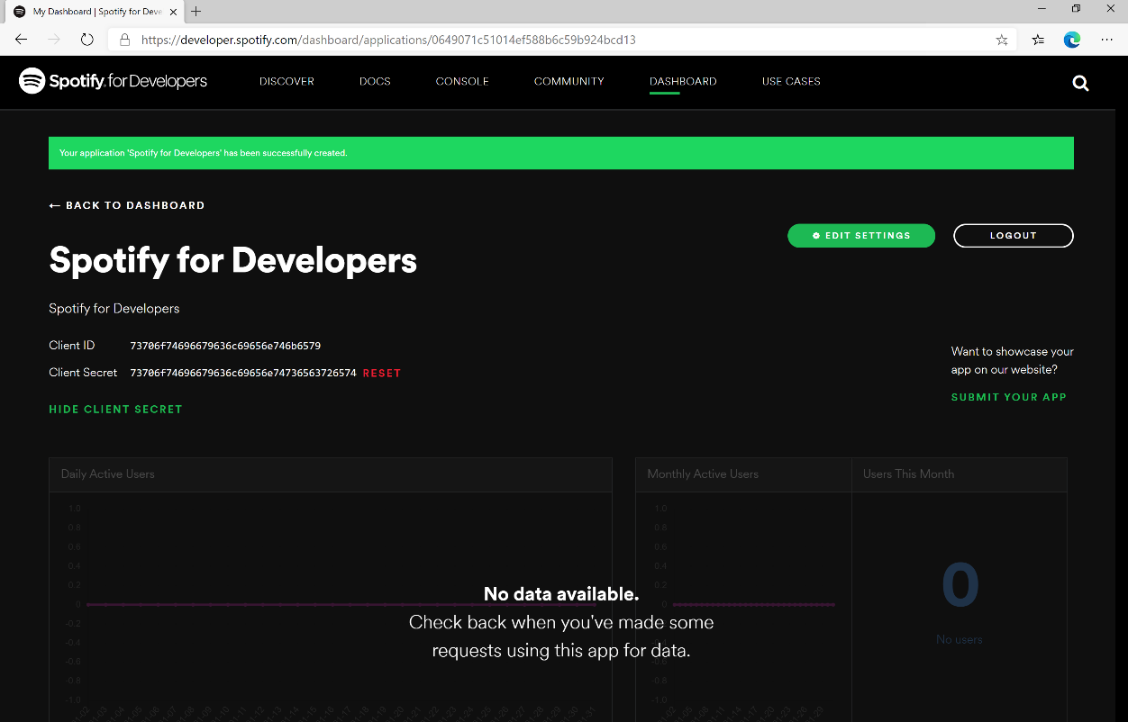

### Step 10

Finally, in your text editor such as **Notepad** you need to **Copy** the **Redirect URI** e.g. https://localhost:44395/ - please note that your **Redirect URI** may be different. Then in the **Dashboard** choose **Edit Settings** then **Paste** the contents of your **Clipboard** into the **Redirect URIs** and select **Add** then to complete the process select **Save**.

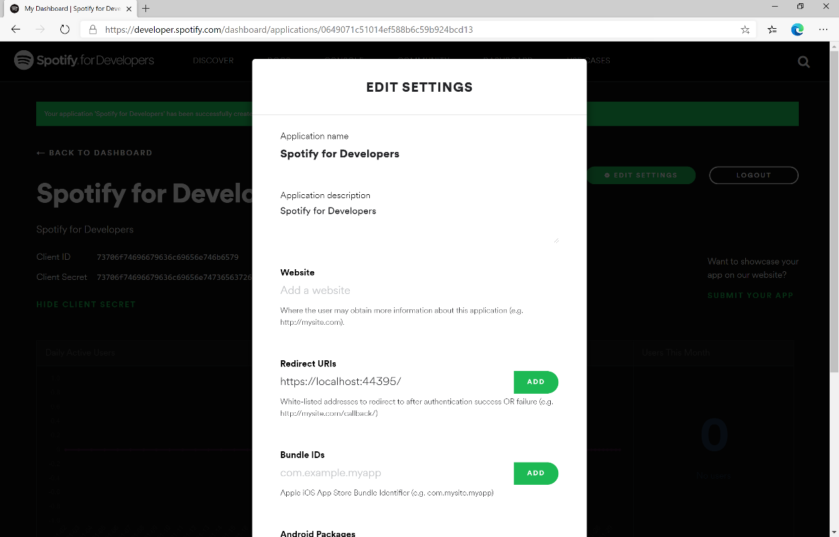

## Token & Result

### Step 1

|  |  |
| --- | --- |
|  | First return to **Visual Studio 2019** and then from the **Menu** choose **Project** then **Add New Item...** |

### Step 2

Then, from the **Add New Item** window from **Installed** select **Visual C#** then **ASP .NET Core** and select **Code File** from the list, then type in the **Name** as **Token.cs** before selecting **Add** to add the file to the **Project**

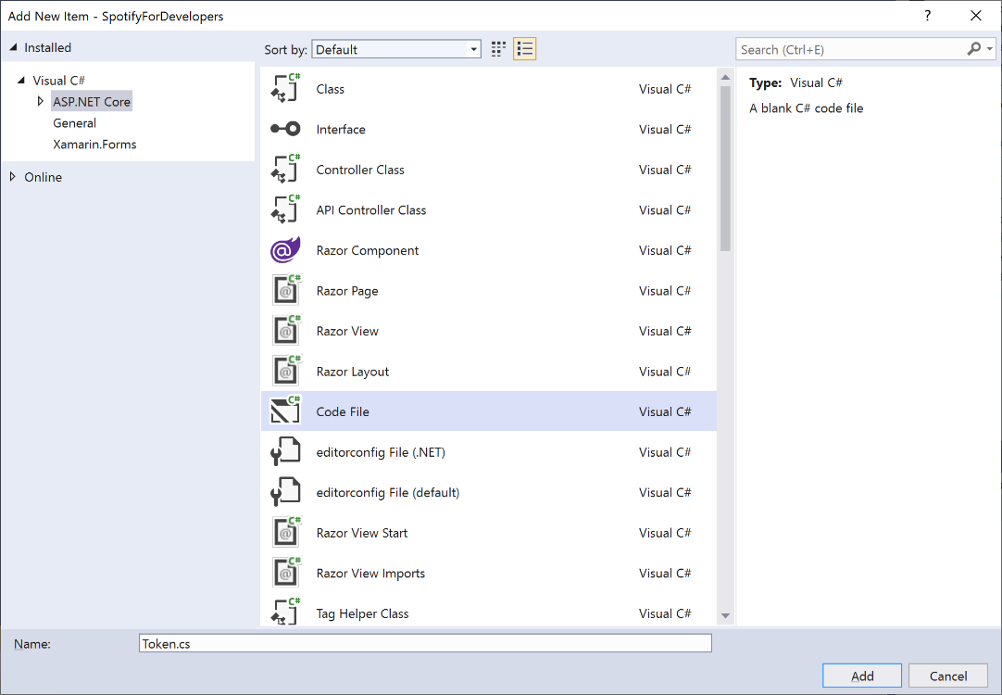

### Step 3

Once in the **Code View** for **Token.cs** the following should be entered:

|  |
| --- |
| using Spotify.NetStandard.Client.Authentication;  using Spotify.NetStandard.Client.Authentication.Enums;  using System.Text.Json;  public class Token  {  public AccessToken AccessToken { get; set; }  public bool HasUserToken => AccessToken?.TokenType == TokenType.User;  public bool HasToken => AccessToken?.TokenType == TokenType.Access || HasUserToken;  public Token(AccessToken token) => AccessToken = token;  public Token(string content) =>  AccessToken = JsonSerializer.Deserialize<AccessToken>(content);  public override string ToString() => JsonSerializer.Serialize(AccessToken);  } |

This will represent an AccessToken which is part of the **NuGet** package for **Spotify.NetStandard** and will allow the **AccessToken** to be stored and retrieved in **JSON** format using System.Text.Json.

### Step 4

|  |  |
| --- | --- |
|  | Then again from the **Menu** choose **Project** then **Add New Item...** |

### Step 5

Then, from the **Add New Item** window from **Installed** select **Visual C#** then **ASP .NET Core** and select **Code File** from the list, then type in the **Name** as **Result.cs** before selecting **Add** to add the file to the **Project**

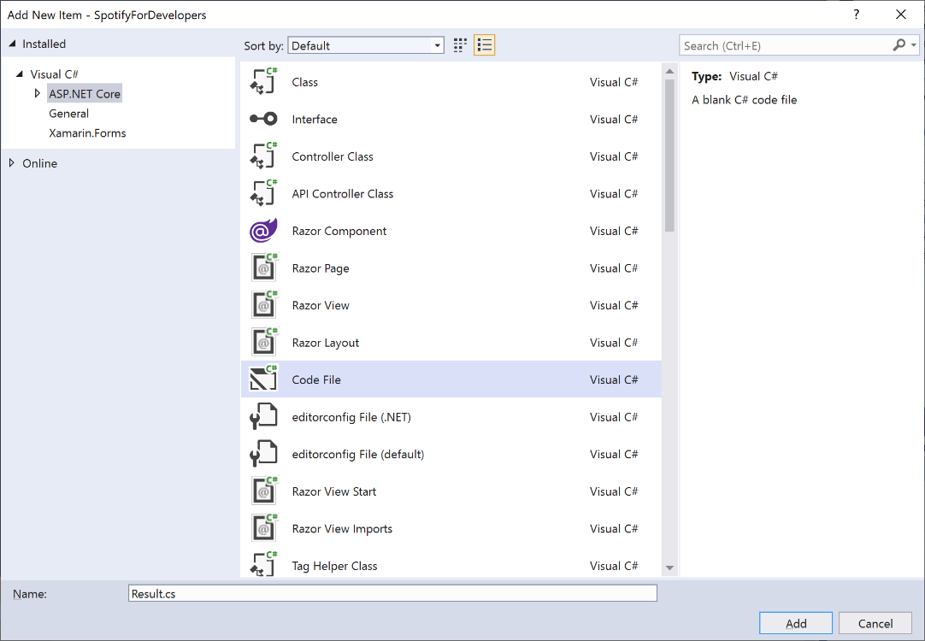

### Step 6

Once in the **Code View** for **Result.cs** the following should be entered:

|  |
| --- |
| public class Result  {  public string Id { get; set; }  public string Name { get; set; }  public string Image { get; set; }  public Result Inner { get; set; }  public Result(  string id = null,  string name = null,  string image = null,  Result inner = null)  {  Id = id;  Name = name;  Image = image;  Inner = inner;  }  } |

This will represent any response to be displayed from **NuGet** package for **Spotify.NetStandard**.

### Step 7

|  |  |
| --- | --- |
|  | In the **Solution Explorer** open the **Pages** section, then open the **Index.cshtml** section and select **Index.cshtml.cs** |

### Step 8

|  |  |
| --- | --- |
|  | Then from the **Menu** choose **View** and then **Open** |

### Step 9

Once in the **Code View** for **Index.cshtml.cs** above the namespace SpotifyForDevelopers.Pages add the following using statements:

|  |
| --- |
| using Microsoft.AspNetCore.Http;  using Spotify.NetStandard.Client;  using Spotify.NetStandard.Client.Interfaces;  using Spotify.NetStandard.Requests;  using Spotify.NetStandard.Enums; |

Then below private readonly ILogger<IndexModel> _logger; add the following const and readonly values:

|  |
| --- |
| private const string client = "clientid";  private const string secret = "clientsecret";  private const string state = "spotify.workshop";  private const string token = "token";  private const string country = "GB";  public static readonly ISpotifyApi Api = SpotifyClientFactory.CreateSpotifyClient(  client, secret).Api; |

You will need to **Copy** the **Client ID** to the **Clipboard** that you saved in your text editor e.g. **Notepad** and then **Paste** to replace clientid e.g. 73706f74696679636c69656e746b6579 - note that your id will be different. You will then need to **Copy** the **Client Secret** to the **Clipboard** from your text editor then **Paste** to replace clientsecret e.g. 73706f74696679636c69656e74736563726574 - note that your secret will be different. If done correctly those values should appear like the following:

|  |
| --- |
| private const string client = "73706f74696679636c69656e746b6579";  private const string secret = "73706f74696679636c69656e74736563726574"; |

You can also set the country to your e.g. US for United States or any supported Country such as GB for Great Britain.

### Step 10

While still in the **Code View** for **Index.cshtml.cs** above public IndexModel(ILogger<IndexModel> logger) add the following **properties**:

|  |
| --- |
| public Token Token { get; set; }  public string Value { get; set; }  public string Option { get; set; }  public bool Flag { get; set; }  public IFormFile Upload { get; set; }  public IEnumerable<Result> Results { get; set; }  public Uri RedirectUri => new Uri($"{HttpContext.Request.Scheme}://{HttpContext.Request.Host}");  public Uri CurrentUri => new Uri($"{HttpContext.Request.Scheme}://{HttpContext.Request.Host}{HttpContext.Request.Path}{HttpContext.Request.QueryString}"); |

These **properties** will represent the **Token** and **Result** plus other values that will come in useful later.

Then below the public Uri CurrentUri **property** add the following **methods**:

|  |
| --- |
| public void LoadToken()  {  if (Request.Cookies[token] != null)  Token = new Token(Request.Cookies[token]);  }  public void SaveToken()  {  if (Token != null)  Response.Cookies.Append(token, Token.ToString());  } |

The LoadToken **method** will get a Token from a **Cookie** and the SaveToken **method** will add a Token to a given **Cookie**, a **Cookie** is a way to save information for a while in a Web Browser.

### Step 11

|  |  |
| --- | --- |
|  | In the **Solution Explorer** in the **Pages** section select **Index.cshtml** |

### Step 12

|  |  |
| --- | --- |
|  | Then from the **Menu** choose **View** and then **Open** |

### Step 13

Once in the **Code View** for **Index.cshtml** remove all the existing content, which should be like the following:

|  |
| --- |
| @page  @model IndexModel  @{  ViewData["Title"] = "Home page";  }  <div class="text-center">  <h1 class="display-4">Welcome</h1>  <p>Learn about <a href="https://docs.microsoft.com/aspnet/core">building Web apps with ASP.NET Core</a>.</p> </div> |

Then, once removed you need to replace it with the following:

|  |
| --- |
| @page  @model IndexModel  @{  ViewData["Title"] = "Spotify for Developers";  }  <h1>Spotify for Developers</h1>  <div class="container">  <div class="row mb-2">  <div class="mx-auto">  <!—Authorisation Guide -->  </div>  </div>  <div class="row mb-2">  <div class="col-sm">  @if (Model?.Token?.HasToken == true)  {  <h2 class="text-center">Spotify Web API App Authorisation</h2>  <!-- Spotify Web API App Authorisation -->  }  </div>  <div class="col-sm">  @if (Model?.Token?.HasUserToken == true)  {  <h2 class="text-center">Spotify Web API User Authorisation</h2>  <!-- Spotify Web API User Authorisation -->  }  </div>  </div>  <!-- Results -->  </div> |

This represents the basic layout where you’ll place the various elements in subsequent parts, and with the **<!-- -->** statements which will help you place things correctly as you’ll always be adding anything new above those statements.

### Step 14

Then, while still in the **Code View** for **Index.cshtml** above <!-- Results --> enter the following:

|  |
| --- |
| <div class="row mb-2">  @if (Model?.Results?.Count() > 0)  {  var first = Model?.Results.First();  <h2>Results</h2>  <table class="table">  <thead>  <tr>  @if (first.Image != null)  {  <th>Image</th>  }  @if (first.Id != null)  {  <th>Id</th>  }  @if (first.Name != null)  {  <th>Name</th>  }  @if (first?.Inner?.Id != null)  {  <th>Id</th>  }  @if (first?.Inner?.Name != null)  {  <th>Name</th>  }  </tr>  </thead>  <tbody>  @foreach (var result in Model.Results)  {  <tr>  @if (result.Image != null)  {  <td><img height="64" width="64" src="@result.Image" /></td>  }  @if (result.Id != null)  {  <td>@result.Id</td>  }  @if (result.Name != null)  {  <td>@result.Name</td>  }  @if (result?.Inner?.Id != null)  {  <td>@result.Inner.Id</td>  }  @if (result?.Inner?.Name != null)  {  <td>@result.Inner.Name</td>  }  </tr>  }  </tbody>  </table>  }  </div> |

### Step 15

|  |  |
| --- | --- |
|  | Finally, in **Visual Studio 2019** select **IIS Application** to run the **Web Application** |

### Step 16

Once the **Web Application** is running it should appear something like the following:

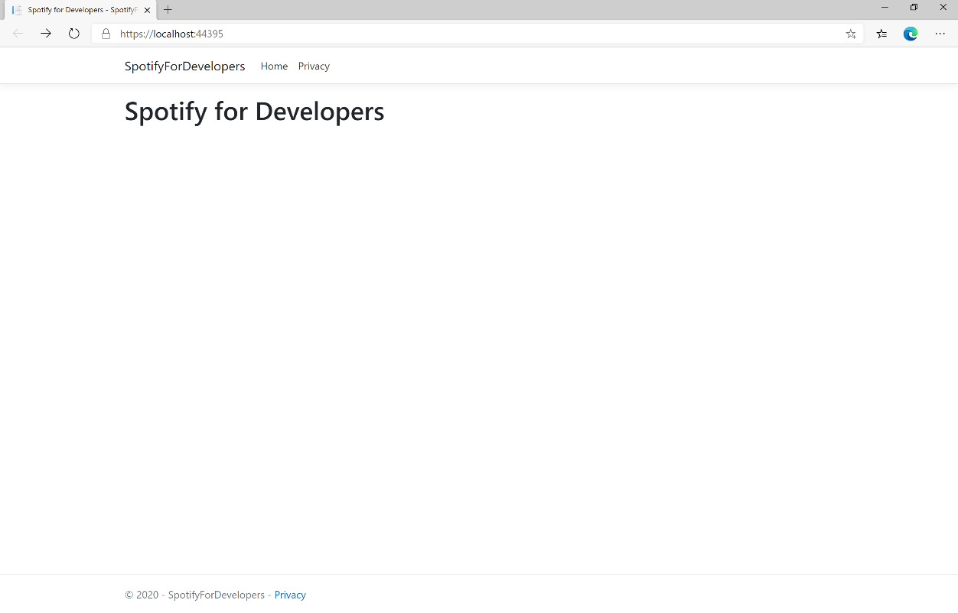

### Step 17

|  |  |
| --- | --- |
|  | You can stop the **web application** in **Visual Studio 2019** by selecting the **Stop debugging** button |

### Step 18

|  |  |
| --- | --- |
|  | You can exit **Visual Studio 2019** by selecting the **Close** button in the top right of the **application** as that completes thispart of the workshop |

# Authorisation Guide

Authorisation guide will show how to authorise your application to get data or to allow an end user to approve your application to access their Spotify data or features. Authorised requests to Spotify require permission to be granted to access data. In accordance with OAuth 2.0 the parties involved in the authorisation process are the End User, Application Client and the Spotify Server. Your application can be authorised in one of two ways. **Spotify API** **App Authorisation** where you authorise your app to access the Spotify Platform e.g. APIs, SDKs and Widgets and **Spotify API User Authorisation** where you grant your app permission to access or modify the user’s own data.

## Authorisation Scopes

Authorisation scopes allow your application to access specific API endpoints on behalf of a user. The set of scopes you can pass from your application include **Listening History**, **Library**, **Follow**, **Playlists**, **User & Images**, **Spotify Connect** and **Playback** for iOS, Android and Web Playback SDKs.

### Listening History

|  |  |
| --- | --- |
| user-top-read | |
| Endpoints | |
| Get a User's Top Artists / Get a User's Top Tracks | |
| Description | **Visible to users** |
| Read access to a user's top artists and tracks | Read your top artists and content. |

|  |  |
| --- | --- |
| user-read-playback-position | |
| Endpoints | |
| Get an Episodes, Get Multiple Episodes, Get a Show, Get Multiple Shows and Get a Show's Episodes | |
| Description | **Visible to users** |
| Read access to a user’s playback position in a content. | Read your position in content you have played. |

|  |  |
| --- | --- |
| user-read-recently-played | |
| Endpoints | |
| Get Current User's Recently Played Tracks | |
| Description | **Visible to users** |
| Read access to a user’s recently played tracks. | Access your recently played items. |

### Library

|  |  |
| --- | --- |
| user-library-modify | |
| Endpoints | |
| Remove Albums for Current User, Remove User's Saved Tracks, Remove User’s Saved Shows, Save Albums for Current User, Save Tracks for User and Save Shows for Current User | |
| Description | **Visible to users** |
| Write/delete access to a user's "Your Music" library. | Manage your saved content. |

|  |  |
| --- | --- |
| user-library-read | |
| Endpoints | |
| Check User's Saved Albums, Check User's Saved Tracks, Check User’s Saved Shows, Get Current User's Saved Albums, Get a User's Saved Tracks and Get Users Saved Shows | |
| Description | **Visible to users** |
| Read access to a user's "Your Music" library. | Access your saved content. |

### Follow

|  |  |
| --- | --- |
| user-follow-read | |
| Endpoints | |
| Get Following State for Artists/Users and Get User's Followed Artists | |
| Description | **Visible to users** |
| Read access to the list of artists and other users that the user follows. | Access your followers and who you are following. |

|  |  |
| --- | --- |
| user-follow-modify | |
| Endpoints | |
| Follow Artists or Users and Unfollow Artists or Users | |
| Description | **Visible to users** |
| Write/delete access to the list of artists and other users that the user follows. | Manage who you are following. |

### Playlists

|  |  |
| --- | --- |
| playlist-read-collaborative | |
| Endpoints | |
| Get a List of Current User's Playlists and Get a List of a User's Playlists | |
| Description | **Visible to users** |
| Include collaborative playlists when requesting a user's playlists. | Access your collaborative playlists. |

|  |  |
| --- | --- |
| playlist-modify-public | |
| Endpoints | |
| Follow a Playlist, Unfollow a Playlist, Add Tracks to a Playlist, Change a Playlist's Details, Create a Playlist, Remove Tracks from a Playlist, Reorder a Playlist's Tracks, Replace a Playlist's Tracks  and Upload a Custom Playlist Cover Image | |
| Description | **Visible to users** |
| Write access to a user's public playlists. | Manage your public playlists. |

|  |  |
| --- | --- |
| playlist-read-private | |
| Endpoints | |
| Check if Users Follow a Playlist, Get a List of Current User's Playlists and Get a List of a User's Playlists | |
| Description | **Visible to users** |
| Read access to user's private playlists. | Access your private playlists. |

|  |  |
| --- | --- |
| playlist-modify-private | |
| Endpoints | |
| Follow a Playlist, Unfollow a Playlist, Add Tracks to a Playlist, Change a Playlist's Details, Create a Playlist, Remove Tracks from a Playlist, Reorder a Playlist's Tracks, Replace a Playlist's Tracks  and Upload a Custom Playlist Cover Image | |
| Description | **Visible to users** |
| Write access to a user's private playlists. | Manage your private playlists. |

### Users & Images

|  |  |
| --- | --- |
| user-follow-read | |
| Endpoints | |
| Get Following State for Artists / Users and Get User's Followed Artists | |
| Description | **Visible to users** |
| Read access to the list of artists and other users that the user follows. | Access your followers and who you are following. |

|  |  |
| --- | --- |
| user-read-private | |
| Endpoints | |
| Search for an Item, Get Current User's Profile | |
| Description | **Visible to users** |
| Read access to user’s subscription details (type of user account). | Access your subscription details. |

|  |  |
| --- | --- |
| ugc-image-upload | |
| Endpoints | |
| Upload a Custom Playlist Cover Image | |
| Description | **Visible to users** |
| Write access to user-provided images. | Upload images to Spotify on your behalf. |

### Spotify Connect

|  |  |
| --- | --- |
| user-read-playback-state | |
| Endpoints | |
| Get a User's Available Devices, Get Information About The User's Current Playback  and Get the User's Currently Playing Track | |
| Description | **Visible to users** |
| Read access to a user’s player state. | Read your currently playing content and Spotify Connect devices information. |

|  |  |
| --- | --- |
| user-modify-playback-state | |
| Endpoints | |
| Pause a User's Playback, Seek To Position In Currently Playing Track, Set Repeat Mode On User’s Playback, Set Volume For User's Playback, Skip User’s Playback To Next Track, Skip User’s Playback To Previous Track, Start/Resume a User's Playback, Toggle Shuffle For User’s Playback, Transfer a User's Playback  and Add an Item To User's Current Playback Queue | |
| Description | **Visible to users** |
| Write access to a user’s playback state | Control playback on your Spotify clients and Spotify Connect devices. |

|  |  |
| --- | --- |
| user-read-currently-playing | |
| Endpoints | |
| Get the User's Currently Playing Track | |
| Description | **Visible to users** |
| Read access to a user’s currently playing content. | Read your currently playing content. |

### Playback

|  |  |
| --- | --- |
| streaming | |
| Endpoints | |
| Web Playback SDK | |
| Description | **Visible to users** |
| Control playback of a Spotify track. This scope is currently available to the Web Playback SDK. The user must have a Spotify Premium account. | Play content and control playback on your other devices. |

|  |  |
| --- | --- |
| app-remote-control | |
| Endpoints | |
| iOS SDK and Android SDK | |
| Description | **Visible to users** |
| Remote control playback of Spotify. This scope is currently available to Spotify iOS and Android SDKs. | Communicate with the Spotify app on your device. |

## Authorisation Code

Authorisation Code flow is designed for long-running applications where the user grants permission once and provides a Token that can be refreshed where there is an initial request from application to the accounts service, then the user can authorise access to the application followed by any requests to the API to return requested data or new access tokens.

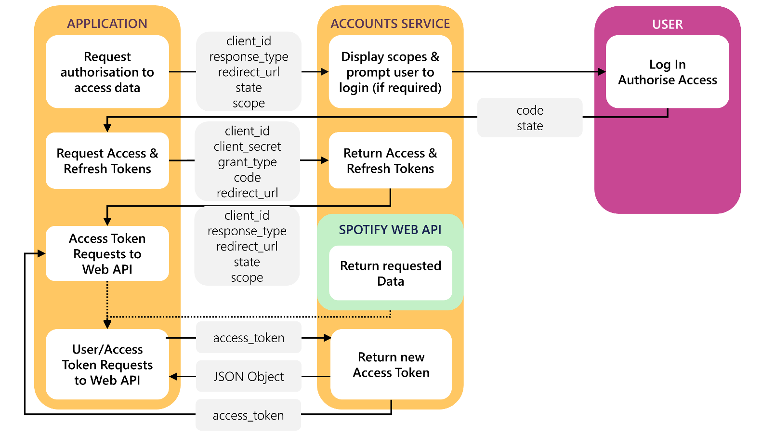

### Access Code Request

User logs in and authorises access which includes required parameters including the **Client ID** obtained from the **Spotify Dashboard**, the **Redirect URI** which is the URI to redirect to and you can also provide a **State** value.

|  |  |
| --- | --- |
| Query Parameter | |
| client_id | Client ID provided to you by Spotify when you registered your application |
| response_type | Set to “code” |
| redirect_uri | URI to redirect to after the user grants/denies permission. This URI needs to be entered in the URI whitelist that you specify when you registered your application |
| state | Strongly recommended as state can be useful for correlating requests and responses |
| scope | A space-separated list of scopes |
| show_dialog | Whether or not to force user to approve the app again if they’ve already done so |

|  |
| --- |
| Example |
| https://accounts.spotify.com/authorize?client_id=5fe01282e44241328a84e7c5cc169165&response_type=code&redirect_uri=https%3A%2F%2Fexample.com%2Fcallback&scope=user-read-private%20user-read-email&state=STATE |

### Access Code Response

If the user accepts the request, you’ll be redirected to your **Redirect URI** with the **Access Code** parameter. If the user denies the request or there’s a problem, then you’ll get an error returned – both will include the **State** value provided.

|  |  |
| --- | --- |
| https://example.com/callback?code=NApCCg..BkWtQ&state=STATE | |
| User Accepts Request | |
| code | Authorisation code that can be exchanged for Token |
| state | Value of the state parameter supplied in the request |

|  |  |
| --- | --- |
| https://example.com/callback?error=access_denied&state=STATE | |
| User Denies Request or Error Occurred | |
| code | Authorisation code that can be exchanged for Token |
| state | Reason authorisation failed, for example: “access_denied” |

### Authorisation Code Request

Your application can request a **Refresh Token** and **Access** **Token** where you provide a base-64 encoded string containing the **Client ID** and **Client Secret** and **Code** from a previous **Access Code Response** and **Redirect URI** by performing a **POST** request with the following **Header** and **Body** parameters.

|  |  |
| --- | --- |
| POST <https://accounts.spotify.com/api/token> | |
| Header | |
| Authorization | Base 64 encoded string containing Client ID and Client Secret  **Authorization: Basic <base64 encoded client_id:client_secret>** |
| Body Parameter | |
| grant_type | Set to “authorization_code” |
| code | Authorisation code returned from Access Code Request |
| redirect_uri | URI to redirect to after the user grants/denies permission. This URI needs to be entered in the URI whitelist that you specify when you registered your application |

### Authorisation Code Response

If successful you will get an **Access Token** to use in subsequent calls to the **Spotify API** and a **Refresh Token**.

|  |  |
| --- | --- |
| Result | |
| access_token | Access token that can be provided in subsequent calls e.g. Spotify Web API services |
| token_type | How the access token may be used - always “Bearer” |
| scope | Space-separated list of scopes which have been granted for this access_token |
| expires_in | Time period (in seconds) for which the access token is valid. |
| refresh_token | Token that can be sent to Spotify Accounts service in place of authorisation code |

### Refresh Token Request

You can request a refreshed **Access Token** by providing the **Refresh Token** returned from a previous **Authorisation Code Response** by performing a **POST** request with the following **Header** and **Body** parameters.

|  |  |
| --- | --- |
| POST https://accounts.spotify.com/api/token | |
| Header | |
| Authorization | Base 64 encoded string containing Client ID and Client Secret  **Authorization: Basic <base64 encoded client_id:client_secret>** |
| Body Parameter | |
| grant_type | Set to “refresh_token” |
| refresh_token | Refresh Token returned from the Authorisation Code exchange |

### Refresh Token Response

If successful you will get an **Access Token** to use in subsequent calls to the **Spotify API** and can re-use a previously obtained **Refresh Token**.

|  |  |
| --- | --- |
| Result | |
| access_token | Access token that can be provided in subsequent calls e.g. Spotify Web API services |
| token_type | How the access token may be used - always “Bearer” |
| scope | Space-separated list of scopes which have been granted for this access_token |
| expires_in | Time period (in seconds) for which the access token is valid. |

## Implicit Grant

Implicit Grant Flow is designed for clients that are implemented such as those using JavaScript and run in a web browser. There is the initial request from the application to the accounts service, then the user can log in and authorise access passing across a short-lived token followed by any requests to the API to return requested data using the token.

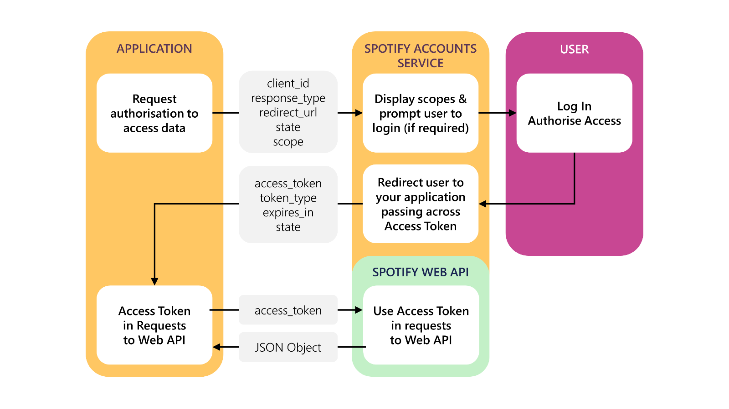

### Implicit Grant Request

User logs in and authorises access which includes required parameters including the **Client ID** obtained from the **Spotify Dashboard**, the **Redirect URI** which is the URI to redirect to and you can also provide a **State** value.

|  |  |
| --- | --- |
| Query Parameter | |
| client_id | Client ID provided to you by Spotify when you registered your application |
| response_type | Set to “token” |
| redirect_uri | URI to redirect to after the user grants/denies permission. This URI needs to be entered in the URI whitelist that you specify when you registered your application |
| state | Strongly recommended as state can be useful for correlating requests and responses |
| scope | A space-separated list of scopes |
| show_dialog | Whether or not to force user to approve the app again if they’ve already done so |

|  |
| --- |
| Example |
| https://accounts.spotify.com/authorize?client_id=5fe01282e44241328a84e7c5cc169165&response_type=code&redirect_uri=https%3A%2F%2Fexample.com%2Fcallback&scope=user-read-private%20user-read-email&state=STATE |

### Implicit Grant Response

If the user grants access the URI will contain a hash fragment with data encoded as a query string including the **Access Token**, if the user doesn’t grant access or there’s a problem an error will be returned as a normal query string – both will also include the **State** value provided.

|  |  |
| --- | --- |
| https://example.com/callback#access_token=Nw...2Tk&token_type=Bearer&expires_in=3600&state=STATE | |
| User Grants Access | |
| access_token | Token that can be provided in subsequent calls |
| token_type | Set to “Bearer” |
| expires_in | The time period (in seconds) for which the access token is valid |
| state | The value of the state parameter supplied in the request |

|  |  |
| --- | --- |
| https://example.com/callback?error=access_denied&state=STATE | |
| User Denies Access or Error Occurred | |
| error | Reason authorisation failed, for example: “access_denied” |
| state | Value of the state parameter supplied in the request |

## Client Credentials

Client Credentials Flow is designed for server-to-server authentication however only endpoints that do not access user information can be accessed, there is an initial request to obtain a token, you can optionally request the user log in to obtain a higher rate limit, followed by any requests to the API to return requested data using the token.

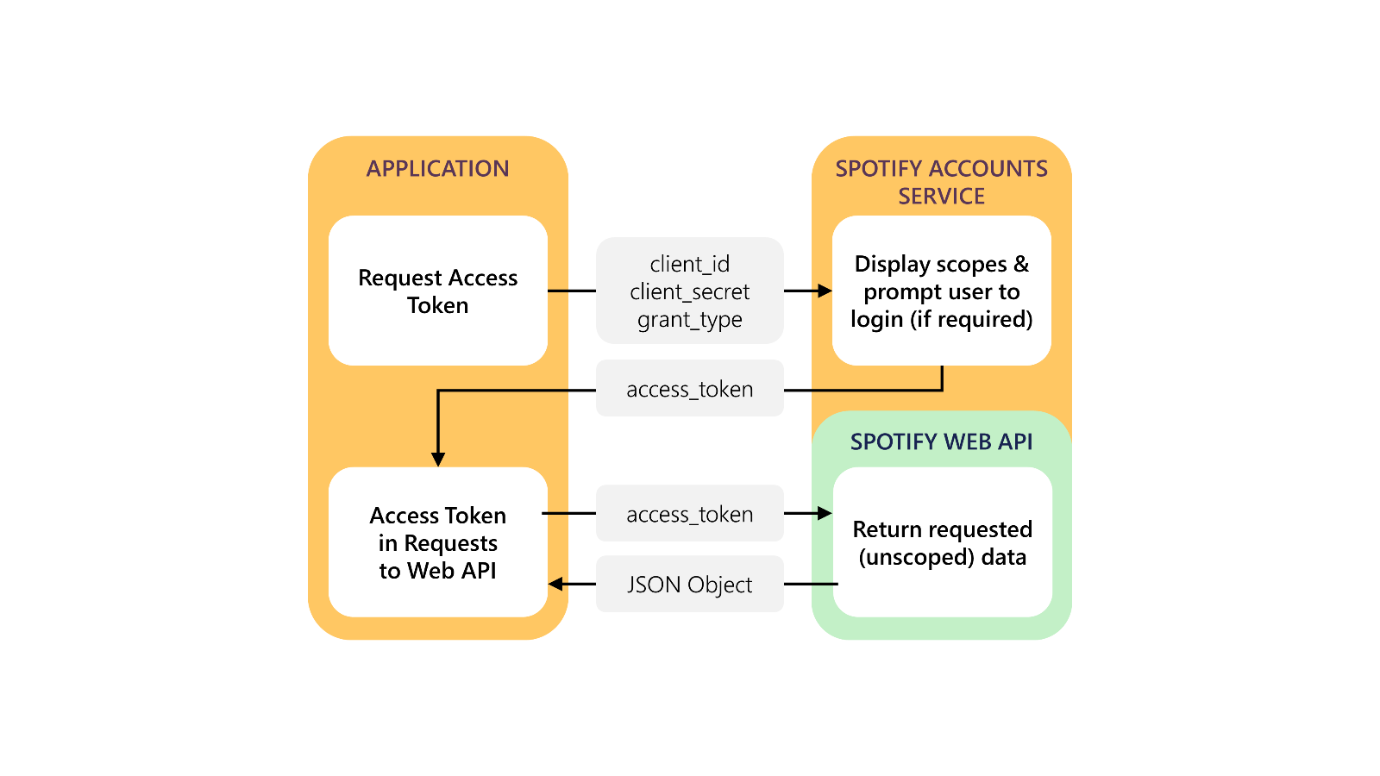

### Client Credentials Request

You can request an **Access Token** by performing a **POST** request with the following **Header** and **Body** parameters.

|  |  |
| --- | --- |
| POST https://accounts.spotify.com/api/token | |
| Header | |
| Authorization | Base 64 encoded string containing Client ID and Client Secret  **Authorization: Basic <base64 encoded client_id:client_secret>** |
| Body Parameter | |
| grant_type | Set to “client_credentials” |

### Client Credentials Response

If successful you will get an **Access Token** to use in subsequent calls to the **Spotify API**

|  |  |
| --- | --- |
| Result | |
| access_token | Access token that can be provided in subsequent calls e.g. Spotify Web API services |
| token_type | How the access token may be used - always “bearer” |
| expires_in | Time period (in seconds) for which the access token is valid. |

## Authorisation Flows

### Step 1

|  |  |
| --- | --- |
|  | In **Windows 10** choose **Start**, and then from the **Start Menu** find and select **Visual Studio 2019** |
|  | Once done, from the **Get started** screen for **Visual Studio 2019** select **Open a project or solution** |
|  | Then locate and select **SpotifyForDevelopers.sln** and select **Open** if you don’t have this file already then please follow the previous parts of the workshop including **Getting Started** |

### Step 2

|  |  |
| --- | --- |
|  | Once opened, in the **Solution Explorer** open the **Pages** section, then open the **Index.cshtml** section and select **Index.cshtml.cs** |

### Step 3

|  |  |
| --- | --- |
|  | Then from the **Menu** choose **View** and then **Open** |

### Step 4

In the **Code View** for **Index.cshtml.cs** remove the existing public void OnGet() {} **method** which will appear like the following:

|  |
| --- |
| public void OnGet()  {  } |

Then once removed, replace it with the following **method**:

|  |
| --- |
| public async Task<IActionResult> OnGetAsync(  string code = null, string access_token = null)  {  LoadToken();  if (code != null)  Token = new Token(await Api.GetAuthorisationCodeAuthTokenAsync(  CurrentUri, RedirectUri, state));  if (access_token != null)  Token = new Token(Api.GetImplicitGrantAuthToken(  CurrentUri, RedirectUri, state));  SaveToken();  return Page();  } |

This **method** will be used with the responses from the **Authorisation Code Flow** and **Implicit Grant Flow** it also will read an existing **token** with the LoadToken() **method** and write a **token** with the SaveToken() **method**.

### Step 5

While still in the **Code View** for **Index.cshtml.cs** below the public async Task<IActionResult> OnGetAsync(...) { ... } **method** add the following **methods**:

|  |
| --- |
| public IActionResult OnPostAuthorisationCode() =>  Redirect(Api.GetAuthorisationCodeAuthUri(  RedirectUri, state, Scope.AllPermissions).ToString());  public IActionResult OnPostImplicitGrant() =>  Redirect(Api.GetImplicitGrantAuthUri(  RedirectUri, state, Scope.AllPermissions).ToString()); |

These **methods** will handle the requests for the **Authorisation Code Flow**, **Implicit Grant Flow** and the whole process for the **Client Credentials Flow**.

### Step 6

|  |  |
| --- | --- |
|  | In the **Solution Explorer** in the **Pages** section select **Index.cshtml** |

### Step 7

|  |  |
| --- | --- |
|  | Then from the **Menu** choose **View** and then **Open** |

### Step 8

Once in the **Code View** for **Index.cshtml** above <!-- Authorisation Guide --> enter the following:

|  |
| --- |
| <h2 class="text-center">Authorisation</h2>  <ul class="list-group list-group-horizontal">  <li class="list-group-item">  <form **asp-page-handler**="authorisationcode" method="post">  <button class="btn btn-success m-md-1">  Authorisation Code Flow Login  </button>  </form>  </li>  <li class="list-group-item">  <form **asp-page-handler**="implicitgrant" method="post">  <button class="btn btn-success m-md-1">  Implicit Grant Flow Login  </button>  </form>  </li>  <li class="list-group-item">  <form **asp-page-handler**="clientcredentials" method="post">  <button class="btn btn-success m-md-1">  Client Credentials Flow Login  </button>  </form>  </li>  </ul> |

The button for each of these will trigger the various **Authorisation Flows** for **Authorisation Code**, **Implicit Grant** and **Client Credentials**.

### Step 9

While still in the **Code View** at the bottom of **Index.cshtml** enter the following @section and script:

|  |
| --- |
| @section Scripts  {  <script language="javascript">  $(window).ready(function () {  var href = $(location).attr("href");  if (href.indexOf('#') >= 0) {  href = href.replace('#', '?');  window.location.replace(href);  }  });  </script>  } |

The script will handle the response from the **Implicit Grant Response** which returns a **hash fragment** and turn this into a **query string** for use with the **web application**.

### Step 10

|  |  |
| --- | --- |
|  | Finally, in **Visual Studio 2019** select **IIS Application** to run the **Web Application** |

### Step 11

Once the **Web Application** is running you should see something like the following:

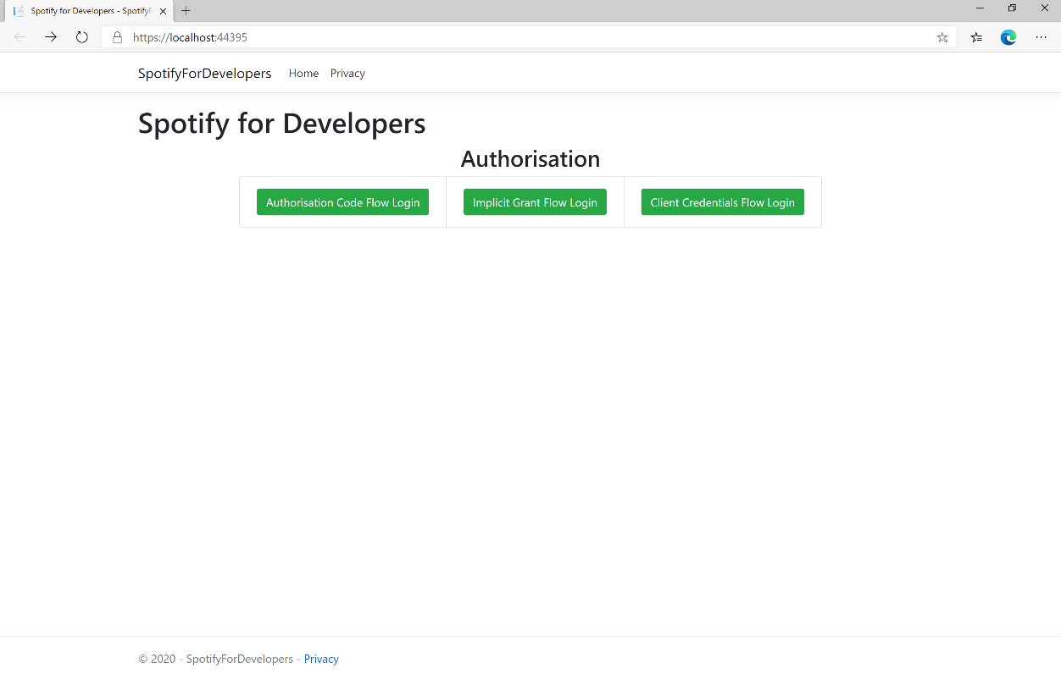

### Step 12

Then in the **Web Application** you can select the **Authorisation Code Flow Login** or the **Implicit Grant Flow Login** button then choose **Agree**:

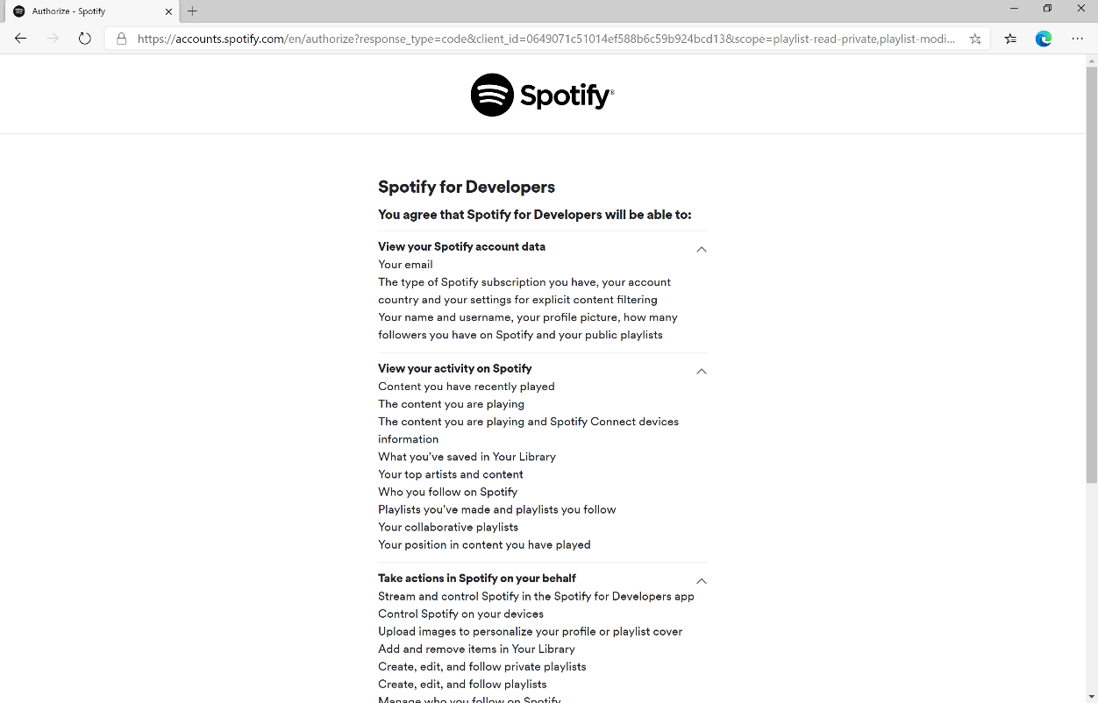

### Step 13

Once agreed the **web application** if **Authorisation Code Flow Login** or **Implicit Grant Flow Login** was selected should appear like the following:

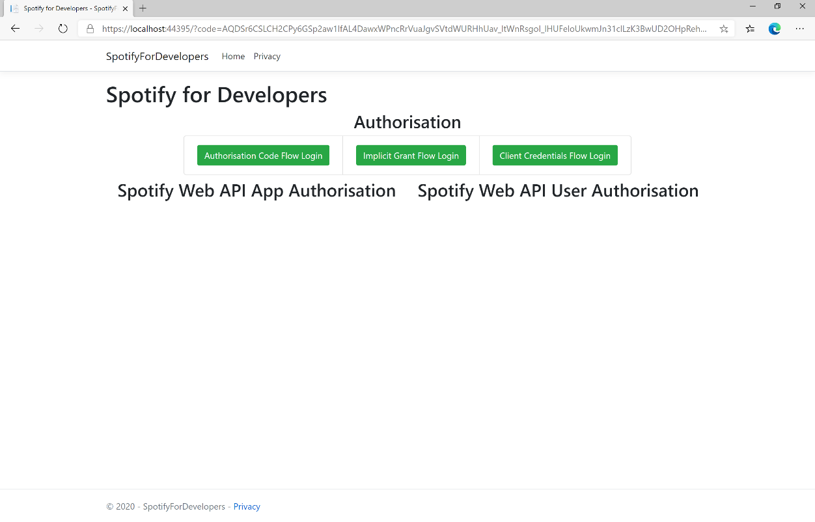

### Step 14

If the **Client Credentials Flow Login** was selected the **web application** should appear like the following:

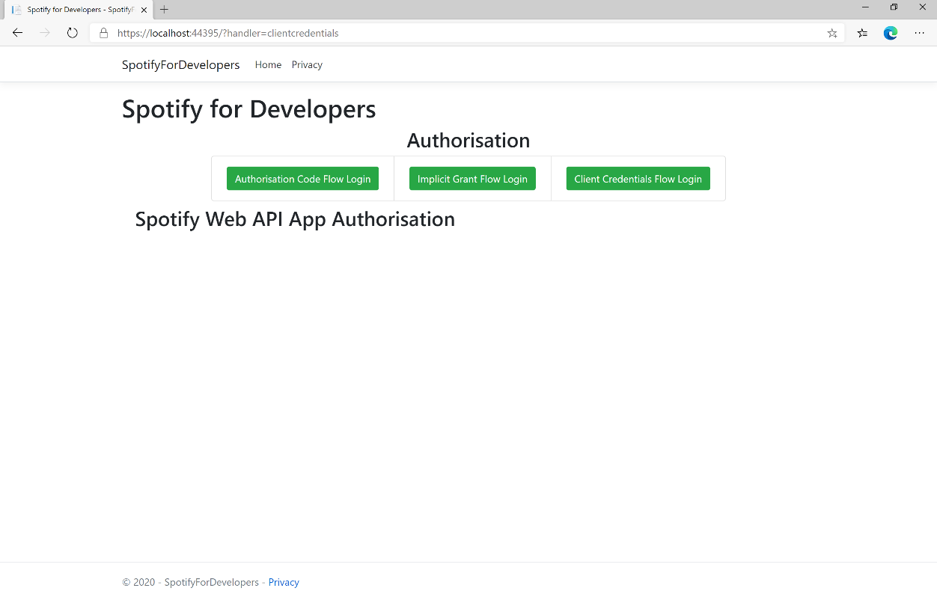

### Step 15

|  |  |
| --- | --- |
|  | You can stop the **web application** in **Visual Studio 2019** by selecting the **Stop debugging** button |

### Step 16

|  |  |
| --- | --- |
|  | You can exit **Visual Studio 2019** by selecting the **Close** button in the top right of the **application** as that completes thispart of the workshop |

# Search & Browse

## Search for an Item

Get Spotify Catalogue information about albums, artists, playlists, tracks, shows or episodes that match a query string.

|  |  |
| --- | --- |
| GET https://api.spotify.com/v1/search?q=tania%20bowra&type=artist | |
| Header | |
| Authorization | Valid Access Token from Spotify Accounts service |
| Query Parameter | |
| q | Query keywords, optional field filters and operators |
| type | A comma-separated list of item types to search across. Valid types are: album, artist, playlist, track, show and episode |
| market | ISO 3166-1 alpha-2 country code |
| limit | Maximum number of results to return |
| offset | Index of first result to return |
| include_external | “audio” includes any relevant audio content that is hosted externally |

|  |  |
| --- | --- |
| Header | Response |
| Success | |
| HTTP Status 200 OK | Array of Artist Objects / Simplified Album Objects / Track Objects / Simplified Show Object / Simplified Episode Object wrapped in a Paging Object |
| Error | |
| Error Code | Error Object |

### Step 1

|  |  |
| --- | --- |
|  | In **Windows 10** choose **Start**, and then from the **Start Menu** find and select **Visual Studio 2019** |
|  | Once done, from the **Get started** screen for **Visual Studio 2019** select **Open a project or solution** |
|  | Then locate and select **SpotifyForDevelopers.sln** and select **Open** if you don’t have this file already then please follow the previous parts of the workshop including **Getting Started** and **Authorisation Guide** |

### Step 2

|  |  |
| --- | --- |
|  | Once opened, in the **Solution Explorer** open the **Pages** section, then open the **Index.cshtml** section and select **Index.cshtml.cs** |

### Step 3

|  |  |
| --- | --- |
|  | Then from the **Menu** choose **View** and then **Open** |

### Step 4

In the **Code View** for **Index.cshtml.cs** below the **method** for public async Task<IActionResult> OnPostClientCredentialsAsync() { ... } enter the following **method**:

|  |
| --- |
| public async Task<IActionResult> OnPostSearchForAnItemAsync(string value, string option)  {  LoadToken();  var results = new List<Result>();  var search = await Api.SearchForItemAsync(value,  new SearchType()  {  Album = option.Contains("Album"),  Track = option.Contains("Track"),  Artist = option.Contains("Artist"),  Playlist = option.Contains("Playlist"),  Show = option.Contains("Show"),  Episode = option.Contains("Episode")  }, country);  if (search?.Albums?.Items != null)  {  results.AddRange(search.Albums.Items.Select(result => new Result(  result.Id, result.Name, result?.Images?.FirstOrDefault()?.Url,  new Result(result?.Artists[0]?.Id, result?.Artists[0]?.Name))));  }  if (search?.Tracks?.Items != null)  {  results.AddRange(search.Tracks.Items.Select(result => new Result(  result.Id, result.Name, result.Album?.Images?.FirstOrDefault()?.Url,  new Result(result?.Artists[0]?.Id, result?.Artists[0]?.Name))));  }  if (search?.Artists?.Items != null)  {  results.AddRange(search.Artists.Items.Select(result => new Result(  result.Id, result.Name, result?.Images?.FirstOrDefault()?.Url)));  }  if (search?.Playlists?.Items != null)  {  results.AddRange(search.Playlists.Items.Select(result => new Result(  result.Id, result.Name, result?.Images?.FirstOrDefault()?.Url)));  }  if (search?.Shows?.Items != null)  {  results.AddRange(search.Shows.Items.Select(result => new Result(  result.Id, result.Name, result?.Images?.FirstOrDefault()?.Url)));  }  if (search?.Episodes?.Items != null)  {  results.AddRange(search.Episodes.Items.Select(result => new Result(  result.Id, result.Name, result?.Images?.FirstOrDefault()?.Url)));  }  if (results.Any())  Results = results;  return Page();  } |

The **method** for OnPostSearchForAnItemAsync is used to find any **track**, **artist**, **album** or **playlist** and populates **property** for Results accordingly.

### Step 5

|  |  |
| --- | --- |
|  | In the **Solution Explorer** in the **Pages** section select **Index.cshtml** |

### Step 6

|  |  |
| --- | --- |
|  | Then from the **Menu** choose **View** and then **Open** |

### Step 7

Once in the **Code View** for **Index.cshtml** above <!-- Spotify Web API App Authorisation --> enter the following:

|  |
| --- |
| <ul class="list-group mb-2">  <li class="list-group-item list-group-item-primary">  <h5 class="list-group-item-heading">Search</h5>  </li>  <li class="list-group-item">  <form **asp-page-handler**="SearchForAnItem" method="post">  <select **asp-for**="Option" class="form-control mb-2">  <option>Album</option>  <option>Track</option>  <option>Artist</option>  <option>Playlist</option>  <option>Show</option>  <option>Episode</option>  </select>  <input **asp-for**="Value" placeholder="Query" class="form-control mb-2" />  <button class="btn btn-primary mb-2">  Search For An Item  </button>  </form>  </li>  </ul> |

This form will **post** to the **method** for SearchForAnItemAsync and has a select list to choose an option to search for and an input for the Query.

### Step 8

|  |  |
| --- | --- |
|  | Finally, in **Visual Studio 2019** select **IIS Application** to run the **Web Application** |

### Step 9

Once the **Web Application** is running and you select **Client Credentials Flow Login** you should see something like the following:

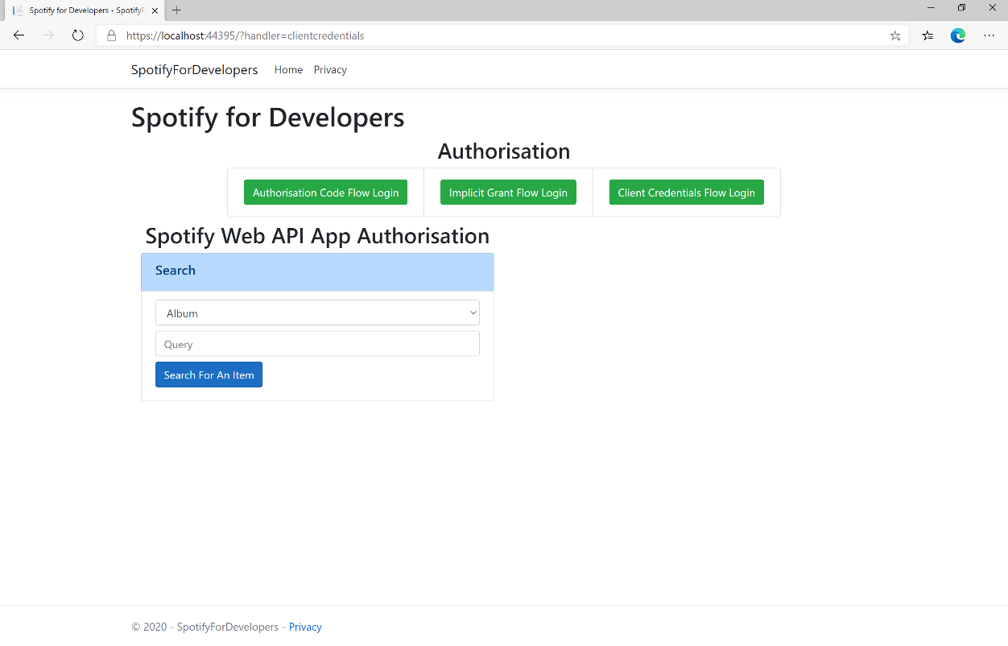

### Step 10

You can then search for something, such as an **Album** and select **Search For An Item** then scroll down to view **Results** like the following:

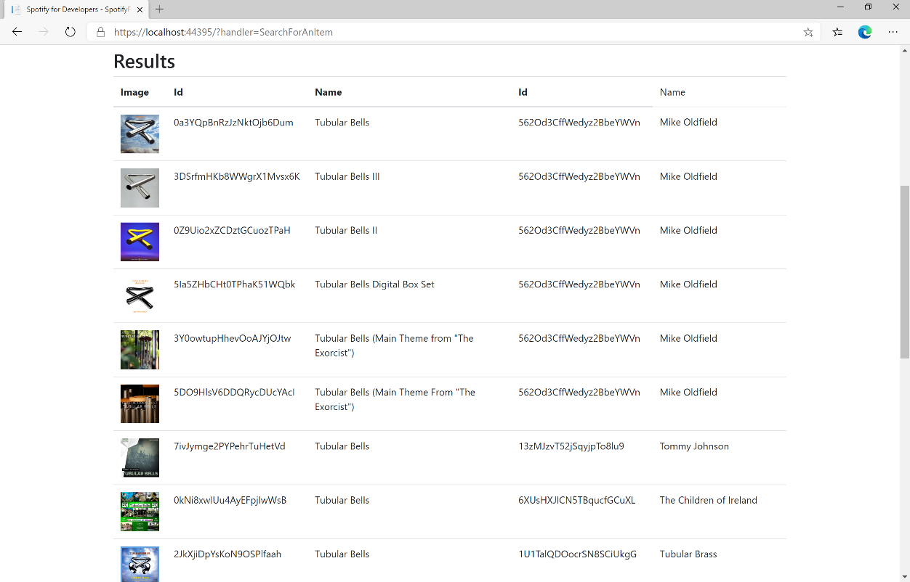

### Step 11

|  |  |
| --- | --- |
|  | You can stop the **web application** in **Visual Studio 2019** by selecting the **Stop debugging** button |

### Step 12

|  |  |
| --- | --- |
|  | You can choose to exit **Visual Studio 2019** by selecting the **Close** button in the top right of the **application** as that completes thispart of the workshop |

## Get All Categories

Get a list of categories used to tag items in Spotify, as shown in the Spotify player’s “Browse” tab.

|  |  |
| --- | --- |
| GET https://api.spotify.com/v1/browse/categories | |
| Header | |
| Authorization | Valid Access Token from Spotify Accounts service |
| Query Parameter | |
| country | ISO 3166-1 alpha-2 country code e.g. “GB”. If omitted globally relevant items returned |
| locale | Desired language, consisting of ISO 639-1 language code and ISO 3166-1 alpha-2 country code, joined by an underscore e.g. “en_GB”. If omitted results returned in American English |
| limit | Maximum number of results to return |
| offset | Index of first result to return |

|  |  |
| --- | --- |
| Header | Response |
| Success | |
| HTTP Status 200 OK | Categories field with an array of Category Objects wrapped in a Paging Object |
| Error | |
| Error Code | Error Object |

### Step 1

|  |  |
| --- | --- |
|  | If you chose to close **Visual Studio 2019** previously, in **Windows 10** choose **Start**, and then from the **Start Menu** find and select **Visual Studio 2019** |
|  | Once done, from the **Get started** screen for **Visual Studio 2019** select **Open a project or solution** |
|  | Then locate and select **SpotifyForDevelopers.sln** and select **Open** if you don’t have this file already then please follow the previous parts of the workshop including **Getting Started**, **Authorisation Guide** and **Search** **&** **Browse** |

### Step 2

|  |  |
| --- | --- |
|  | Once opened, in the **Solution Explorer** open the **Pages** section, then open the **Index.cshtml** section and select **Index.cshtml.cs** |

### Step 3

|  |  |
| --- | --- |
|  | Then from the **Menu** choose **View** and then **Open** |

### Step 4

In the **Code View** for **Index.cshtml.cs** below the **method** for public async Task<IActionResult> OnPostSearchForAnItemAsync(...) { ... } enter the following **method**:

|  |
| --- |
| public async Task<IActionResult> OnPostGetAllCategoriesAsync()  {  LoadToken();  var results = await Api.GetAllCategoriesAsync(country);  if (results?.Items != null)  {  Results = results.Items.Select(result => new Result()  {  Id = result.Id,  Name = result.Name,  Image = result.Images?.FirstOrDefault()?.Url  });  }  return Page();  } |

The **method** for OnPostGetAllCategoriesAsync is used to get all the **categories** on Spotify and populate the **property** for Results accordingly.

### Step 5

|  |  |
| --- | --- |
|  | In the **Solution Explorer** in the **Pages** section select **Index.cshtml** |

### Step 6

|  |  |
| --- | --- |
|  | Then from the **Menu** choose **View** and then **Open** |

### Step 7

Once in the **Code View** for **Index.cshtml** above <!-- Spotify Web API App Authorisation --> enter the following:

|  |
| --- |
| <ul class="list-group mb-2">  <li class="list-group-item list-group-item-primary">  <h5 class="list-group-item-heading">Browse</h5>  </li>  <li class="list-group-item">  <form **asp-page-handler**="GetAllCategories" method="post">  <button class="btn btn-primary mb-2">  Get All Categories  </button>  </form>  </li>  <!-- Browse -->  </ul> |

This form will **post** to the **method** for GetAllCategoriesAsync and will output to the **Results**.

### Step 8

|  |  |
| --- | --- |
|  | Finally, in **Visual Studio 2019** select **IIS Application** to run the **Web Application** |

### Step 9

Once the **Web Application** is running and you select **Client Credentials Flow Login** you should see something like the following:

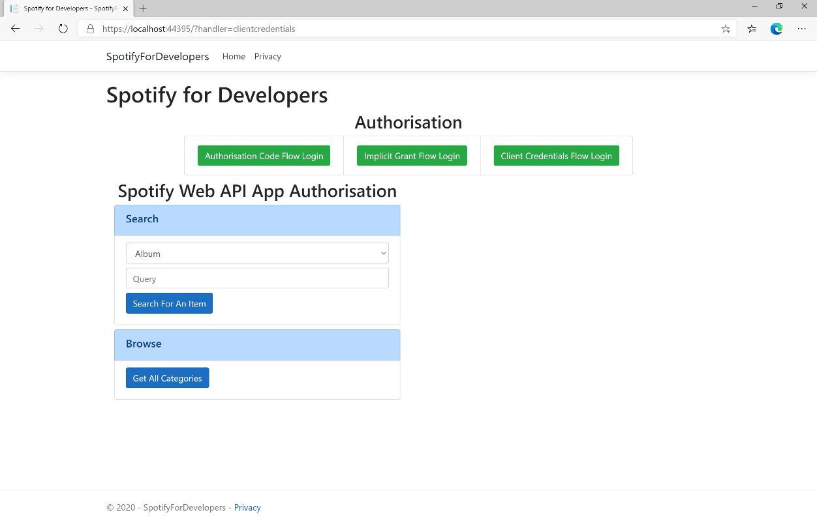

### Step 10

You can then select **Get All Categories** and scroll down to view **Results** like the following:

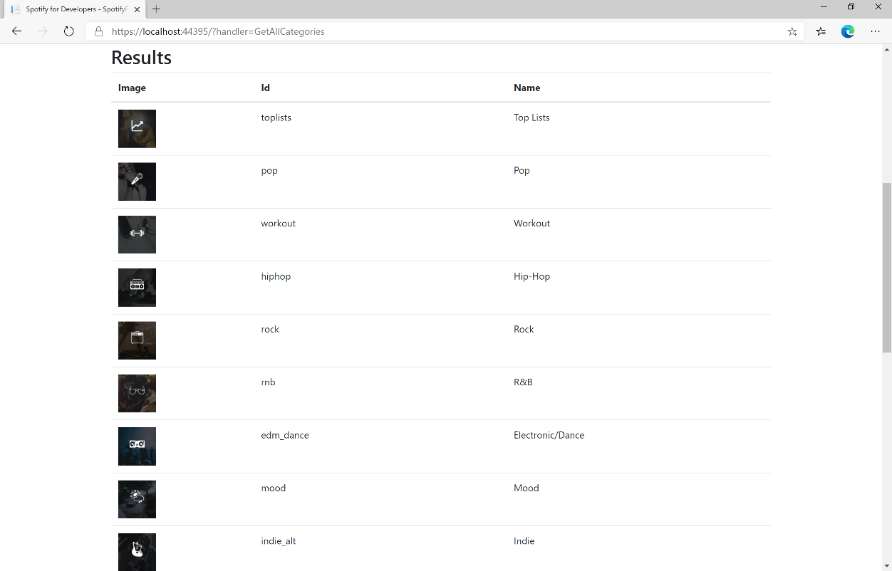

### Step 11

|  |  |
| --- | --- |
|  | You can stop the **web application** in **Visual Studio 2019** by selecting the **Stop debugging** button |

### Step 12

|  |  |
| --- | --- |
|  | You can choose to exit **Visual Studio 2019** by selecting the **Close** button in the top right of the **application** as that completes thispart of the workshop |

## Get a Category

Get a single category used to tag items in Spotify, as shown in the Spotify player’s “Browse” tab.

|  |  |
| --- | --- |
| GET https://api.spotify.com/v1/browse/categories/{category_id} | |
| Header | |
| Authorization | Valid Access Token from Spotify Accounts service |
| Path Parameter | |
| category_id | Spotify category ID for the category |
| Query Parameter | |
| country | ISO 3166-1 alpha-2 country code e.g. “GB”. If omitted globally relevant items returned |
| locale | Desired language, consisting of ISO 639-1 language code and ISO 3166-1 alpha-2 country code joined by an underscore e.g. “en_GB”. If omitted results returned in American English |

|  |  |
| --- | --- |
| Header | Response |
| Success | |
| HTTP Status 200 OK | Category Object |
| Error | |
| Error Code | Error Object |

### Step 1

|  |  |
| --- | --- |
|  | If you chose to close **Visual Studio 2019** previously, in **Windows 10** choose **Start**, and then from the **Start Menu** find and select **Visual Studio 2019** |
|  | Once done, from the **Get started** screen for **Visual Studio 2019** select **Open a project or solution** |
|  | Then locate and select **SpotifyForDevelopers.sln** and select **Open** if you don’t have this file already then please follow the previous parts of the workshop including **Getting Started**, **Authorisation Guide** and **Search** **&** **Browse** |

### Step 2

|  |  |
| --- | --- |
|  | Once opened, in the **Solution Explorer** open the **Pages** section, then open the **Index.cshtml** section and select **Index.cshtml.cs** |

### Step 3

|  |  |
| --- | --- |
|  | Then from the **Menu** choose **View** and then **Open** |

### Step 4

In the **Code View** for **Index.cshtml.cs** below the **method** for public async Task<IActionResult> OnPostGetAllCategoriesAsync() { ... } enter the following **method**:

|  |
| --- |
| public async Task<IActionResult> OnPostGetCategoryAsync(string value)  {  LoadToken();  var result = await Api.GetCategoryAsync(value);  if (result != null)  {  Results = new List<Result> { new Result()  {  Id = result.Id,  Name = result.Name,  Image = result.Images?.FirstOrDefault()?.Url  }};  }  return Page(); } |

The **method** for OnPostGetCategoryAsync is used to get a **category** by **Category Id** on Spotify with the value and populate the **property** for Results accordingly.

### Step 5

|  |  |
| --- | --- |
|  | In the **Solution Explorer** in the **Pages** section select **Index.cshtml** |

### Step 6

|  |  |
| --- | --- |
|  | Then from the **Menu** choose **View** and then **Open** |

### Step 7

Once in the **Code View** for **Index.cshtml** above <!-- Browse --> enter the following:

|  |
| --- |
| <li class="list-group-item">  <form **asp-page-handler**="GetCategory" method="post">  <input **asp-for**="Value" placeholder="Category Id" class="form-control mb-2" />  <button class="btn btn-primary mb-2">  Get Category  </button>  </form>  </li> |

This form will **post** to the **method** for OnPostGetCategoryAsync with the Value as the **Category Id** and will output to the **Results**.

### Step 8

|  |  |
| --- | --- |
|  | Finally, in **Visual Studio 2019** select **IIS Application** to run the **Web Application** |

### Step 9

Once the **Web Application** is running and you select **Client Credentials Flow Login** you should see something like the following:

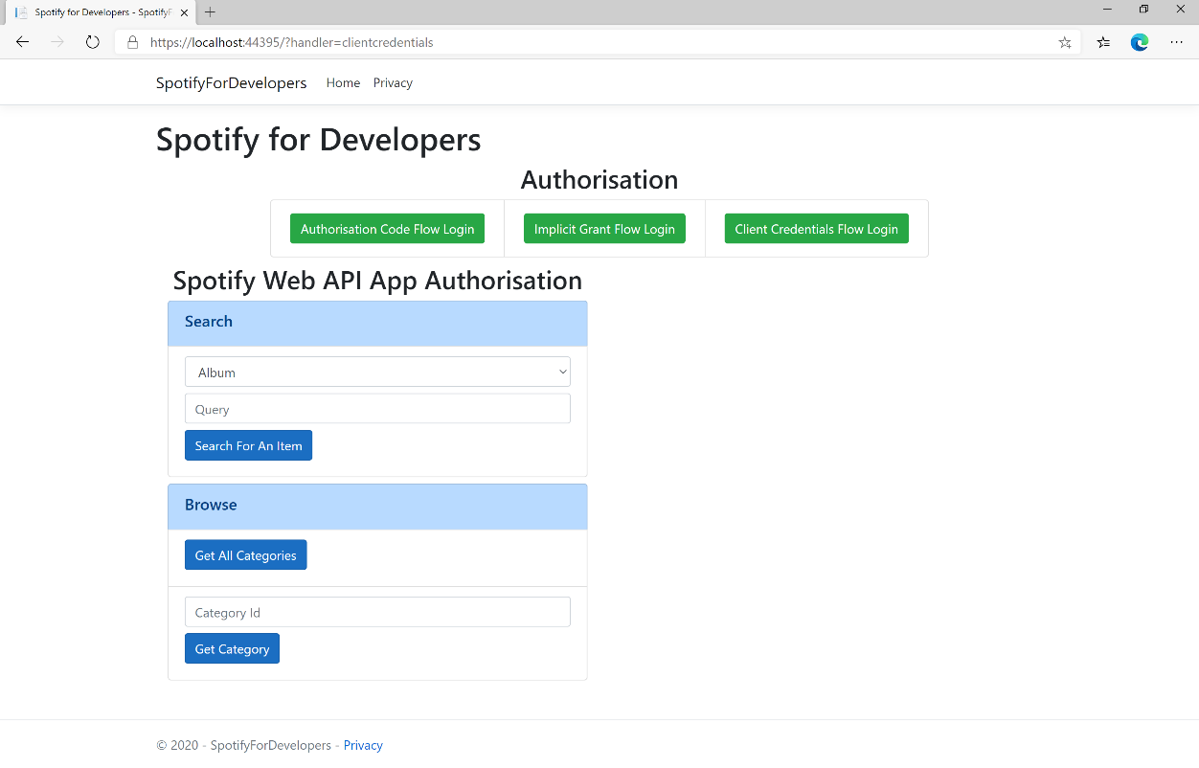

### Step 10

You can then enter a **Category Id** from **Get All Categories** and select **Get Category** and scroll down to view **Results** like the following:

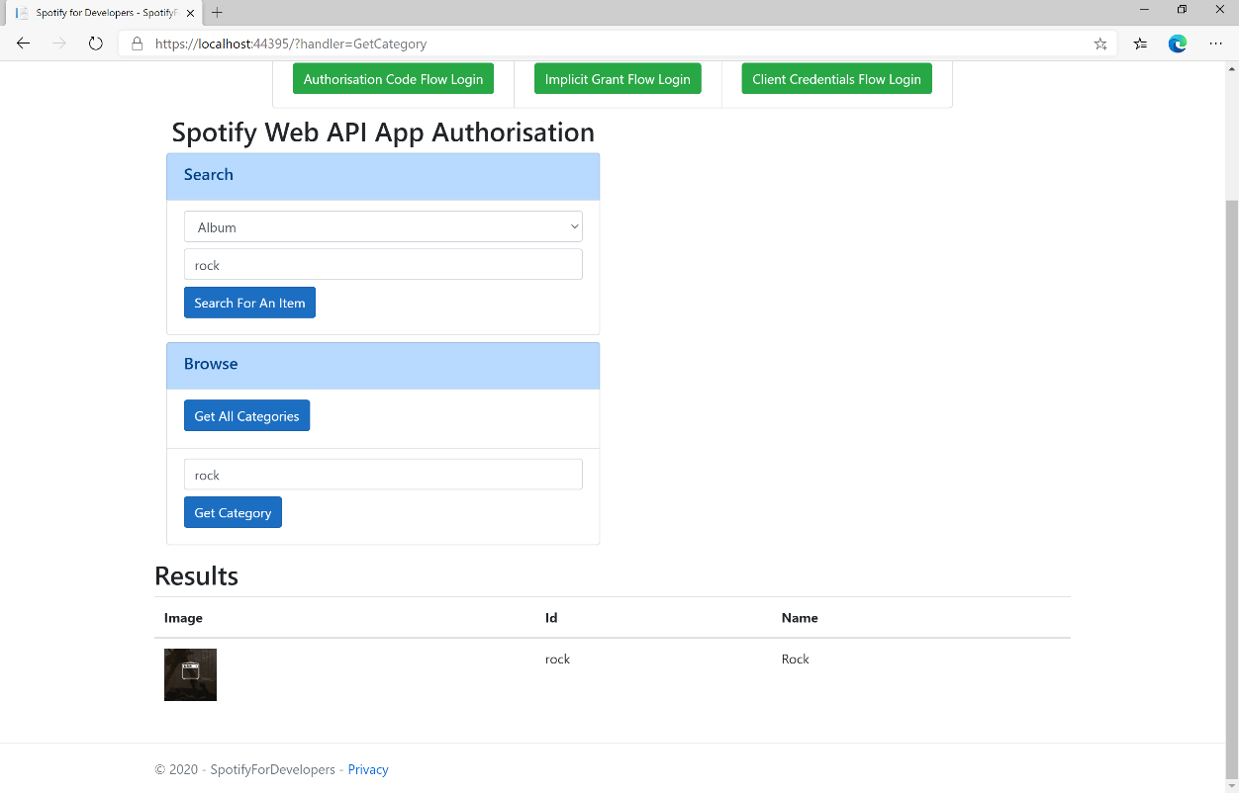

### Step 11

|  |  |
| --- | --- |
|  | You can stop the **web application** in **Visual Studio 2019** by selecting the **Stop debugging** button |

### Step 12

|  |  |
| --- | --- |
|  | You can choose to exit **Visual Studio 2019** by selecting the **Close** button in the top right of the **application** as that completes thispart of the workshop |

## Get a Category's Playlists

Get a list of Spotify playlists tagged with a category.

|  |  |
| --- | --- |
| GET https://api.spotify.com/v1/browse/categories/{category_id}/playlists | |
| Header | |
| Authorization | Valid Access Token from Spotify Accounts service |
| Path Parameter | |
| category_id | Spotify category ID for the category |
| Query Parameter | |
| country | ISO 3166-1 alpha-2 country code e.g. “GB”. If omitted globally relevant items returned |
| limit | Maximum number of results to return |
| offset | Index of first result to return |

|  |  |
| --- | --- |
| Header | Response |
| Success | |
| HTTP Status 200 OK | Array of Simplified Playlist Objects wrapped in a Paging Object |
| Error | |
| Error Code | Error Object |

### Step 1

|  |  |
| --- | --- |
|  | If you chose to close **Visual Studio 2019** previously, in **Windows 10** choose **Start**, and then from the **Start Menu** find and select **Visual Studio 2019** |
|  | Once done, from the **Get started** screen for **Visual Studio 2019** select **Open a project or solution** |
|  | Then locate and select **SpotifyForDevelopers.sln** and select **Open** if you don’t have this file already then please follow the previous parts of the workshop including **Getting Started**, **Authorisation Guide** and **Search** **&** **Browse** |

### Step 2

|  |  |
| --- | --- |
|  | Once opened, in the **Solution Explorer** open the **Pages** section, then open the **Index.cshtml** section and select **Index.cshtml.cs** |

### Step 3

|  |  |
| --- | --- |
|  | Then from the **Menu** choose **View** and then **Open** |

### Step 4

In the **Code View** for **Index.cshtml.cs** below the **method** for public async Task<IActionResult> OnPostGetCategoryAsync() { ... } enter the following **method**:

|  |
| --- |
| public async Task<IActionResult> OnPostGetCategoryPlaylistsAsync(string value)  {  LoadToken();  var results = await Api.GetCategoryPlaylistsAsync(value);  if (results?.Items != null)  {  Results = results.Items.Select(result => new Result()  {  Id = result.Id,  Name = result.Name,  Image = result?.Images?.FirstOrDefault()?.Url  });  }  return Page();  } |

The **method** for OnPostGetCategoryPlaylistsAsync is used to get the **playlists** for a **category** by **Category Id** on Spotify with the value and populate the **property** for Results accordingly.

### Step 5

|  |  |
| --- | --- |
|  | In the **Solution Explorer** in the **Pages** section select **Index.cshtml** |

### Step 6

|  |  |
| --- | --- |
|  | Then from the **Menu** choose **View** and then **Open** |

### Step 7

Once in the **Code View** for **Index.cshtml** above <!-- Browse --> enter the following:

|  |
| --- |
| <li class="list-group-item">  <form **asp-page-handler**="GetCategoryPlaylists" method="post">  <input **asp-for**="Value" placeholder="Category Id" class="form-control mb-2" />  <button class="btn btn-primary mb-2">  Get Category Playlists  </button>  </form>  </li> |

This form will **post** to the **method** for OnPostGetCategoryPlaylistsAsync with the Value as the **Category Id** and will output to the **Results**.

### Step 8

|  |  |
| --- | --- |
|  | Finally, in **Visual Studio 2019** select **IIS Application** to run the **Web Application** |

### Step 9

Once the **Web Application** is running and you select **Client Credentials Flow Login** and scroll down you should see something like the following:

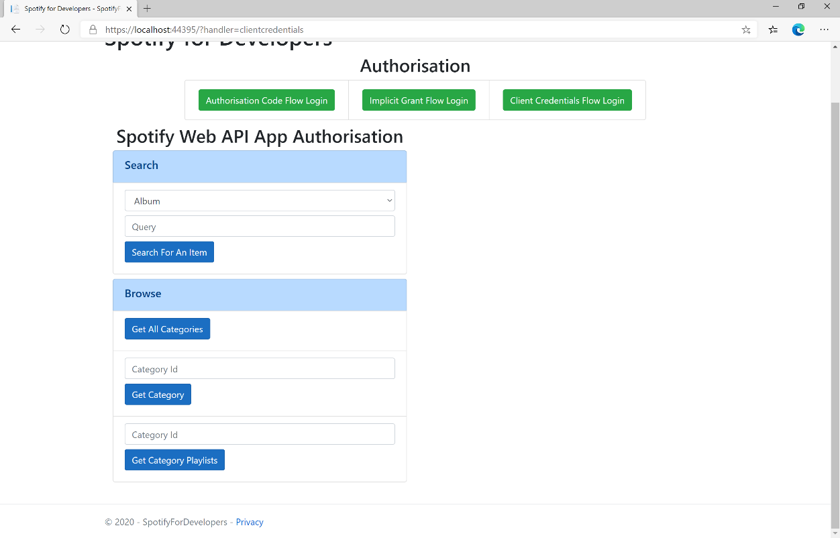

### Step 10

You can then enter a **Category Id** from **Get All Categories** and select **Get Category Playlists** and scroll down to view **Results** like the following:

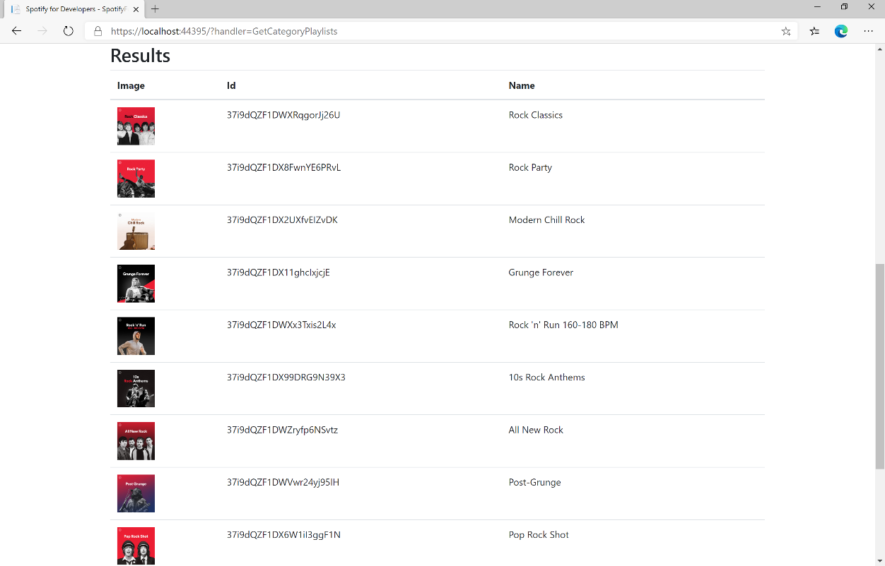

### Step 11

|  |  |
| --- | --- |
|  | You can stop the **web application** in **Visual Studio 2019** by selecting the **Stop debugging** button |

### Step 12

|  |  |
| --- | --- |
|  | You can choose to exit **Visual Studio 2019** by selecting the **Close** button in the top right of the **application** as that completes thispart of the workshop |

## Get Recommendation Genres

Retrieve a list of available genres seed parameter values for recommendations.

|  |  |
| --- | --- |
| GET https://api.spotify.com/v1/recommendations/available-genre-seeds | |
| Header | |
| Authorization | Valid Access Token from Spotify Accounts service |

|  |  |
| --- | --- |
| Header | Response |
| Success | |
| HTTP Status 200 OK | Array of Genre Seeds |
| Error | |
| Error Code | Error Object |

### Step 1

|  |  |
| --- | --- |
|  | If you chose to close **Visual Studio 2019** previously, in **Windows 10** choose **Start**, and then from the **Start Menu** find and select **Visual Studio 2019** |
|  | Once done, from the **Get started** screen for **Visual Studio 2019** select **Open a project or solution** |
|  | Then locate and select **SpotifyForDevelopers.sln** and select **Open** if you don’t have this file already then please follow the previous parts of the workshop including **Getting Started**, **Authorisation Guide** and **Search** **&** **Browse** |

### Step 2

|  |  |
| --- | --- |
|  | Once opened, in the **Solution Explorer** open the **Pages** section, then open the **Index.cshtml** section and select **Index.cshtml.cs** |

### Step 3

|  |  |
| --- | --- |
|  | Then from the **Menu** choose **View** and then **Open** |

### Step 4

In the **Code View** for **Index.cshtml.cs** below the **method** for public async Task<IActionResult> OnPostGetCategoryPlaylistsAsync() { ... } enter the following **method**:

|  |
| --- |
| public async Task<IActionResult> OnPostGetRecommendationGenresAsync()  {  LoadToken();  var results = await Api.GetRecommendationGenresAsync();  if (results?.Genres != null)  {  Results = results.Genres.Select(result => new Result()  {  Id = result  });  }  return Page(); } |

The **method** for OnPostGetRecommendationGenresAsync is used to get the **genres** for **recoomendations** on Spotify and populate the **property** for Results accordingly.

### Step 5

|  |  |
| --- | --- |
|  | In the **Solution Explorer** in the **Pages** section select **Index.cshtml** |

### Step 6

|  |  |
| --- | --- |
|  | Then from the **Menu** choose **View** and then **Open** |

### Step 7

Once in the **Code View** for **Index.cshtml** above <!-- Browse --> enter the following:

|  |
| --- |
| <li class="list-group-item">  <form **asp-page-handler**="GetRecommendationGenres" method="post">  <button class="btn btn-primary mb-2">  Get Recommendation Genres  </button>  </form> </li> |

This form will **post** to the **method** for OnPostGetRecommendationGenresAsync and will output to the **Results**.

### Step 8

|  |  |
| --- | --- |
|  | Finally, in **Visual Studio 2019** select **IIS Application** to run the **Web Application** |

### Step 9

Once the **Web Application** is running and you select **Client Credentials Flow Login** and scroll down you should see something like the following:

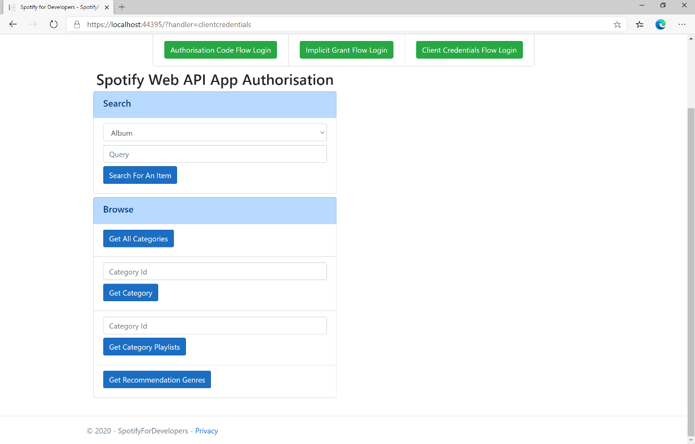

### Step 10

You can select **Get Recommendation Genres** and scroll down to view **Results** like the following:

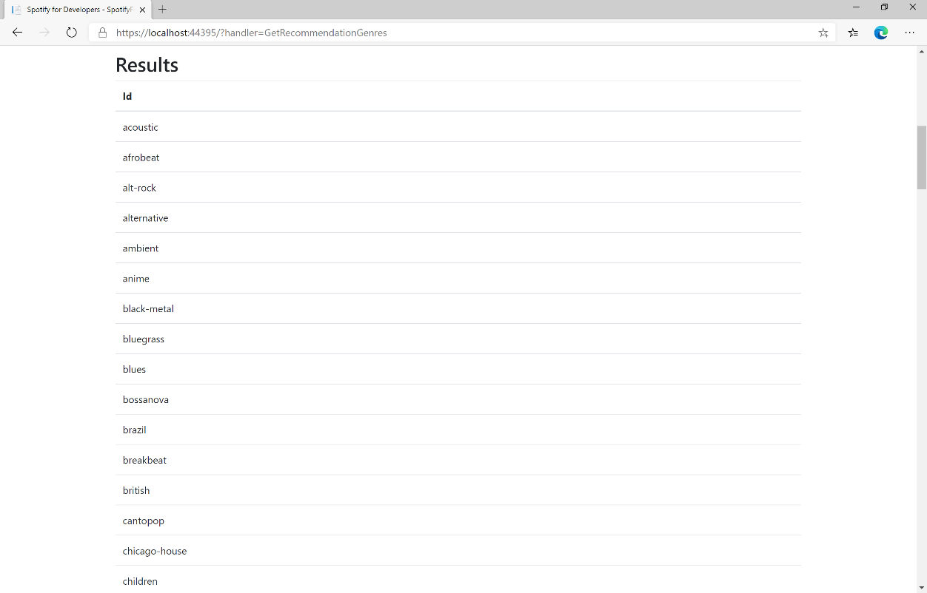

### Step 11

|  |  |
| --- | --- |
|  | You can stop the **web application** in **Visual Studio 2019** by selecting the **Stop debugging** button |

### Step 12

|  |  |
| --- | --- |
|  | You can choose to exit **Visual Studio 2019** by selecting the **Close** button in the top right of the **application** as that completes thispart of the workshop |

## Get Recommendations

Recommendations are generated based on the available information for a given seed entity and matched against similar artists and tracks. If there is enough information about the provided seeds, a list of tracks will be returned together with pool size details.

|  |  |
| --- | --- |
| GET https://api.spotify.com/v1/recommendations | |
| Header | |
| Authorization | Valid Access Token from Spotify Accounts service |
| Query Parameter | |
| seed_artists | Comma separated list of Spotify IDs for seed artists. Up to 5 seed values may be provided in any combination of seed_artists, seed_tracks and seed_genres |
| seed_genres | Comma separated list of any genres in the set of available genre seeds. Up to 5 seed values may be provided in any combination of seed_artists, seed_tracks and seed_genres |
| seed_tracks | Comma separated list of Spotify IDs for a seed track. Up to 5 seed values may be provided in any combination of seed_artists, seed_tracks and seed_genres |
| limit | Maximum number of results to return |
| market | ISO 3166-1 alpha-2 country code e.g. “GB”. Provide to enable Track Relinking |
| min_* | For each Tuneable Track attribute, a hard floor on the selected track attribute’s value can be provided |
| max_* | For each Tuneable Track attribute, a hard ceiling on the selected track attribute’s value can be provided |
| target_* | For each of the Tuneable Track attributes a target value may be provided. Tracks with the attribute values nearest to the target values will be preferred |

|  |  |
| --- | --- |
| Tuneable Track Attributes | |
| acousticness | A confidence measure from 0.0 to 1.0 of whether the track is acoustic. |
| danceability | Describes how suitable a track is for dancing based on a combination of musical elements including tempo, rhythm stability, beat strength, and overall regularity |
| duration_ms | Duration of the track in milliseconds |
| energy | Measure from 0.0 to 1.0 and represents a perceptual measure of intensity and activity |
| instrumentalness | Predicts whether a track contains no vocal |
| key | Key the track is in. Integers map to pitches using standard Pitch Class notation |
| liveness | Detects presence of an audience in the recording |
| loudness | Overall loudness of a track in decibels (dB) |
| mode | Mode indicates the modality of a track (major or minor) |
| popularity | Popularity of track, between 0 and 100, with 100 being the most popular |
| speechiness | Detects the presence of spoken words in a track |
| tempo | Estimated tempo of a track in beats per minute (BPM) |
| time_signature | Estimated overall time signature of a track |
| valence | Measure from 0.0 to 1.0 describing the musical positiveness conveyed by a track |

|  |  |
| --- | --- |
| Header | Response |
| Success | |
| HTTP Status 200 OK | Recommendations Response Object |
| Error | |
| Error Code | Error Object |

### Step 1

|  |  |
| --- | --- |
|  | If you chose to close **Visual Studio 2019** previously, in **Windows 10** choose **Start**, and then from the **Start Menu** find and select **Visual Studio 2019** |
|  | Once done, from the **Get started** screen for **Visual Studio 2019** select **Open a project or solution** |
|  | Then locate and select **SpotifyForDevelopers.sln** and select **Open** if you don’t have this file already then please follow the previous parts of the workshop including **Getting Started**, **Authorisation Guide** and **Search** **&** **Browse** |

### Step 2

|  |  |
| --- | --- |
|  | Once opened, in the **Solution Explorer** open the **Pages** section, then open the **Index.cshtml** section and select **Index.cshtml.cs** |

### Step 3

|  |  |
| --- | --- |
|  | Then from the **Menu** choose **View** and then **Open** |

### Step 4

In the **Code View** for **Index.cshtml.cs** below the **method** for public async Task<IActionResult> OnPostGetRecommendationGenresAsync() { ... } enter the following **method**:

|  |
| --- |
| public async Task<IActionResult> OnPostGetRecommendationsAsync(string value)  {  LoadToken();  var results = await Api.GetRecommendationsAsync(  seedGenres: new List<string> { value });  if (results?.Tracks != null)  {  Results = results.Tracks.Select(result => new Result()  {  Id = result.Id,  Name = result.Name,  Inner = new Result()  {  Id = result?.Artists?.FirstOrDefault()?.Id,  Name = result?.Artists?.FirstOrDefault()?.Name  }  });  }  return Page();  } |

The **method** for OnPostGetRecommendationsAsync is used to get **recommendations** by **genre** on Spotify with the value and populate the **property** for Results accordingly.

### Step 5

|  |  |
| --- | --- |
|  | In the **Solution Explorer** in the **Pages** section select **Index.cshtml** |

### Step 6

|  |  |
| --- | --- |
|  | Then from the **Menu** choose **View** and then **Open** |

### Step 7

Once in the **Code View** for **Index.cshtml** above <!-- Browse --> enter the following:

|  |
| --- |
| <li class="list-group-item">  <form **asp-page-handler**="GetRecommendations" method="post">  <input **asp-for**="Value" placeholder="Genre" class="form-control mb-2" />  <button class="btn btn-primary mb-2">  Get Recommendations  </button>  </form>  </li> |

This form will **post** to the **method** for OnPostGetRecommendationsAsync with the Value as the **Genre** and will output to the **Results**.

### Step 8

|  |  |
| --- | --- |
|  | Finally, in **Visual Studio 2019** select **IIS Application** to run the **Web Application** |

### Step 9

Once the **Web Application** is running and you select **Client Credentials Flow Login** and scroll down you should see something like the following:

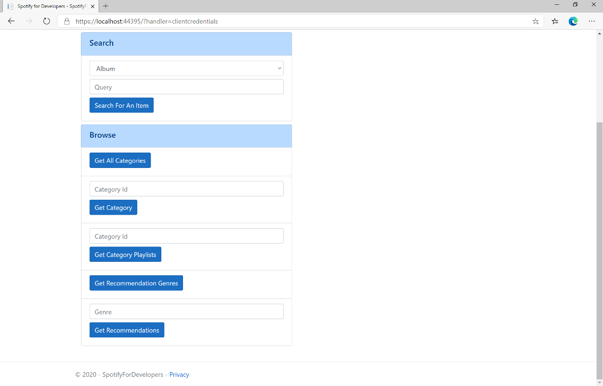

### Step 10

You can then enter a **Genre** from **Get Recommendation Genres** and select **Get Recommendations** and scroll down to view **Results** like the following:

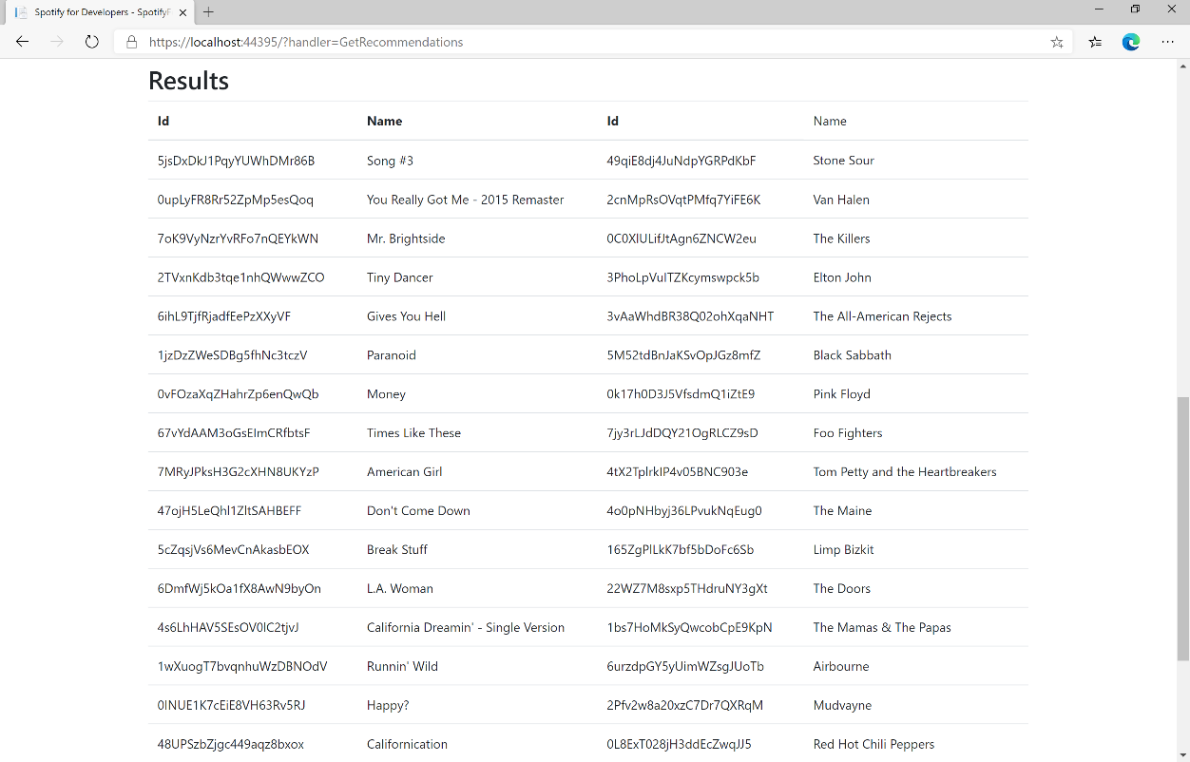

### Step 11

|  |  |
| --- | --- |
|  | You can stop the **web application** in **Visual Studio 2019** by selecting the **Stop debugging** button |

### Step 12

|  |  |
| --- | --- |
|  | You can choose to exit **Visual Studio 2019** by selecting the **Close** button in the top right of the **application** as that completes thispart of the workshop |

## Get All New Releases

Get a list of new album releases featured in Spotify as shown in the Spotify player’s “Browse” tab.

|  |  |
| --- | --- |
| GET https://api.spotify.com/v1/browse/new-releases | |
| Header | |
| Authorization | Valid Access Token from Spotify Accounts service |
| Query Parameter | |
| country | ISO 3166-1 alpha-2 country code e.g. “GB”. If omitted globally relevant items returned |
| limit | Maximum number of results to return |
| offset | Index of first result to return |

|  |  |
| --- | --- |
| Header | Response |
| Success | |
| HTTP Status 200 OK | Array of Simplified Album Objects wrapped in a Paging Object |
| Error | |
| Error Code | Error Object |

### Step 1

|  |  |
| --- | --- |
|  | If you chose to close **Visual Studio 2019** previously, in **Windows 10** choose **Start**, and then from the **Start Menu** find and select **Visual Studio 2019** |
|  | Once done, from the **Get started** screen for **Visual Studio 2019** select **Open a project or solution** |
|  | Then locate and select **SpotifyForDevelopers.sln** and select **Open** if you don’t have this file already then please follow the previous parts of the workshop including **Getting Started**, **Authorisation Guide** and **Search** **&** **Browse** |

### Step 2

|  |  |
| --- | --- |
|  | Once opened, in the **Solution Explorer** open the **Pages** section, then open the **Index.cshtml** section and select **Index.cshtml.cs** |

### Step 3

|  |  |
| --- | --- |
|  | Then from the **Menu** choose **View** and then **Open** |

### Step 4

In the **Code View** for **Index.cshtml.cs** below the **method** for public async Task<IActionResult> OnPostGetRecommendationsAsync() { ... } enter the following **method**:

|  |
| --- |
| public async Task<IActionResult> OnPostGetAllNewReleasesAsync()  {  LoadToken();  var results = await Api.GetAllNewReleasesAsync(country);  if (results?.Items != null)  {  Results = results.Items.Select(result => new Result()  {  Id = result.Id,  Name = result.Name,  Image = result.Images?.FirstOrDefault()?.Url,  Inner = new Result()  {  Id = result?.Artists?.FirstOrDefault()?.Id,  Name = result?.Artists?.FirstOrDefault()?.Name  }  });  }  return Page();  } |

The **method** for OnPostGetAllNewReleasesAsync is used to get **all new releases** by country on Spotify and populate the **property** for Results accordingly.

### Step 5

|  |  |
| --- | --- |
|  | In the **Solution Explorer** in the **Pages** section select **Index.cshtml** |

### Step 6

|  |  |
| --- | --- |
|  | Then from the **Menu** choose **View** and then **Open** |

### Step 7

Once in the **Code View** for **Index.cshtml** above <!-- Browse --> enter the following:

|  |
| --- |
| <li class="list-group-item">  <form **asp-page-handler**="GetAllNewReleases" method="post">  <button class="btn btn-primary mb-2">  Get All New Releases  </button>  </form>  </li> |

This form will **post** to the **method** for OnPostGetAllNewReleasesAsync and will output to the **Results**.

### Step 8

|  |  |
| --- | --- |
|  | Finally, in **Visual Studio 2019** select **IIS Application** to run the **Web Application** |

### Step 9

Once the **Web Application** is running and you select **Client Credentials Flow Login** and scroll down you should see something like the following:

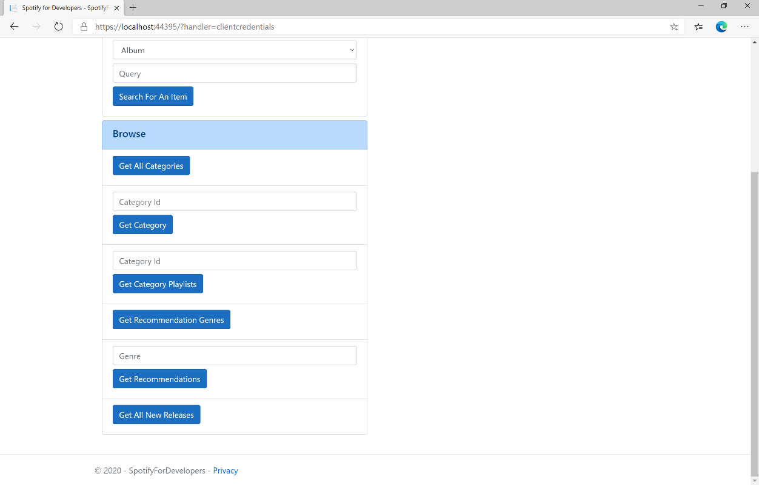

### Step 10

You can then select **Get All New Releases** and scroll down to view **Results** like the following:

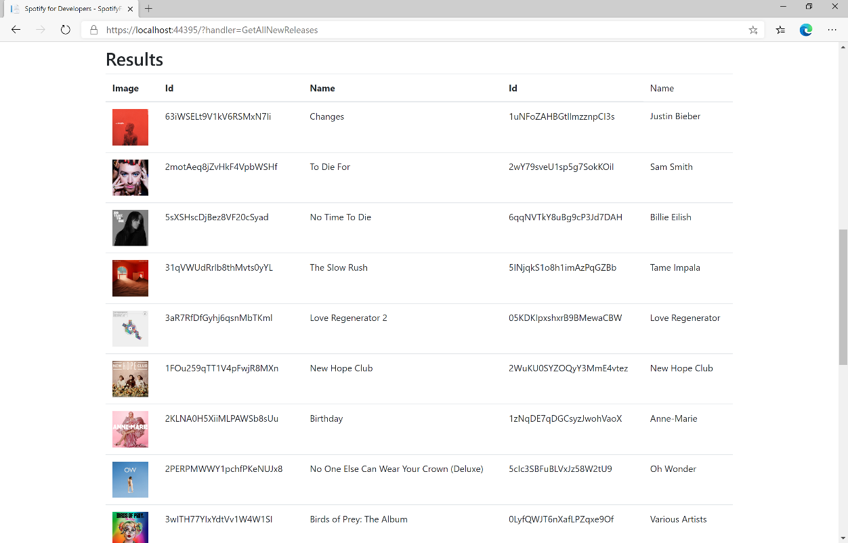

### Step 11

|  |  |
| --- | --- |
|  | You can stop the **web application** in **Visual Studio 2019** by selecting the **Stop debugging** button |

### Step 12

|  |  |
| --- | --- |
|  | You can choose to exit **Visual Studio 2019** by selecting the **Close** button in the top right of the **application** as that completes thispart of the workshop |

## Get All Featured Playlists

Get a list of Spotify featured playlists as shown in the Spotify player’s “Browse” tab.

|  |  |
| --- | --- |
| GET https://api.spotify.com/v1/browse/featured-playlists | |
| Header | |
| Authorization | Valid Access Token from Spotify Accounts service |
| Query Parameter | |
| country | ISO 3166-1 alpha-2 country code e.g. “GB”. If omitted globally relevant items returned |
| locale | Desired language, consisting of ISO 639-1 language code and ISO 3166-1 alpha-2 country code, joined by an underscore e.g. “en_GB”. If omitted results returned in American English |
| timestamp | Timestamp in ISO 8601 format: yyyy-MM-ddTHH:mm:ss. Use this parameter to specify the user’s local time to get results tailored for that specific date and time in the day |
| limit | Maximum number of results to return |
| offset | Index of first result to return |

|  |  |
| --- | --- |
| Header | Response |
| Success | |
| HTTP Status 200 OK | Playlists Object contains an Array of Simplified Playlist Objects |
| Error | |
| Error Code | Error Object |

### Step 1

|  |  |
| --- | --- |
|  | If you chose to close **Visual Studio 2019** previously, in **Windows 10** choose **Start**, and then from the **Start Menu** find and select **Visual Studio 2019** |
|  | Once done, from the **Get started** screen for **Visual Studio 2019** select **Open a project or solution** |
|  | Then locate and select **SpotifyForDevelopers.sln** and select **Open** if you don’t have this file already then please follow the previous parts of the workshop including **Getting Started**, **Authorisation Guide** and **Search** **&** **Browse** |

### Step 2

|  |  |
| --- | --- |
|  | Once opened, in the **Solution Explorer** open the **Pages** section, then open the **Index.cshtml** section and select **Index.cshtml.cs** |

### Step 3

|  |  |
| --- | --- |
|  | Then from the **Menu** choose **View** and then **Open** |

### Step 4

In the **Code View** for **Index.cshtml.cs** below the **method** for public async Task<IActionResult> OnPostGetAllNewReleasesAsync() { ... } enter the following **method**:

|  |
| --- |
| public async Task<IActionResult> OnPostGetAllFeaturedPlaylistsAsync()  {  LoadToken();  var results = await Api.GetAllFeaturedPlaylistsAsync(country);  if (results?.Items != null)  {  Results = results.Items.Select(result => new Result()  {  Id = result.Id,  Name = result.Name,  Image = result?.Images?.FirstOrDefault()?.Url  });  }  return Page();  } |

The **method** for OnPostGetAllFeaturedPlaylistsAsync is used to get **all featured playlists** by country on Spotify and populate the **property** for Results accordingly.

### Step 5

|  |  |
| --- | --- |
|  | In the **Solution Explorer** in the **Pages** section select **Index.cshtml** |

### Step 6

|  |  |
| --- | --- |
|  | Then from the **Menu** choose **View** and then **Open** |

### Step 7

Once in the **Code View** for **Index.cshtml** above <!-- Browse --> enter the following:

|  |
| --- |
| <li class="list-group-item">  <form **asp-page-handler**="GetAllFeaturedPlaylists" method="post">  <button class="btn btn-primary mb-2">  Get All Featured Playlists  </button>  </form>  </li> |

This form will **post** to the **method** for OnPostGetAllFeaturedPlaylistsAsync and will output to the **Results**.

### Step 8

|  |  |
| --- | --- |
|  | Finally, in **Visual Studio 2019** select **IIS Application** to run the **Web Application** |

### Step 9

Once the **Web Application** is running and you select **Client Credentials Flow Login** and scroll down you should see something like the following:

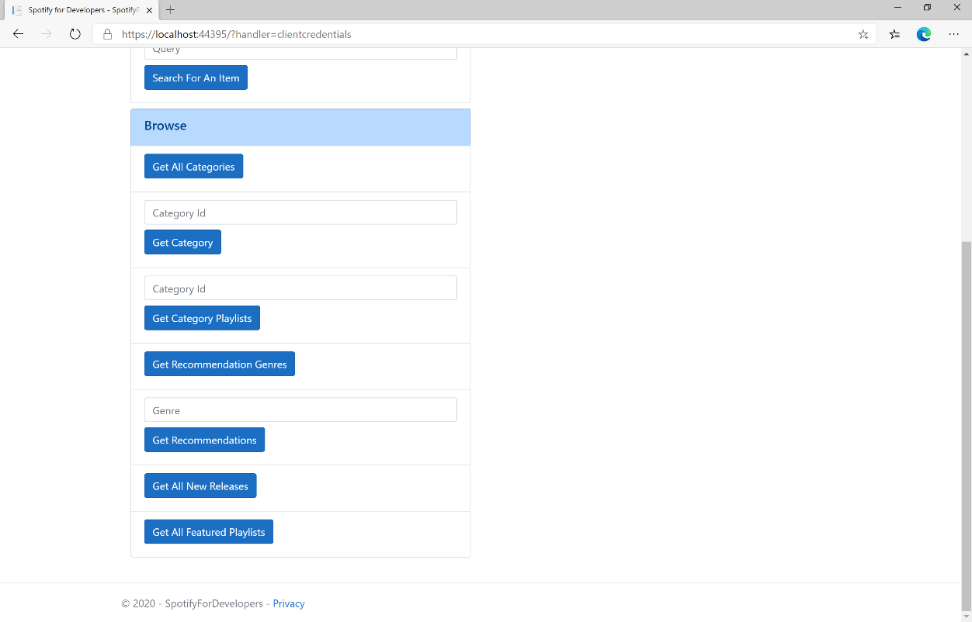

### Step 10

You can then select **Get All Featured Playlists** and scroll down to view **Results** like the following:

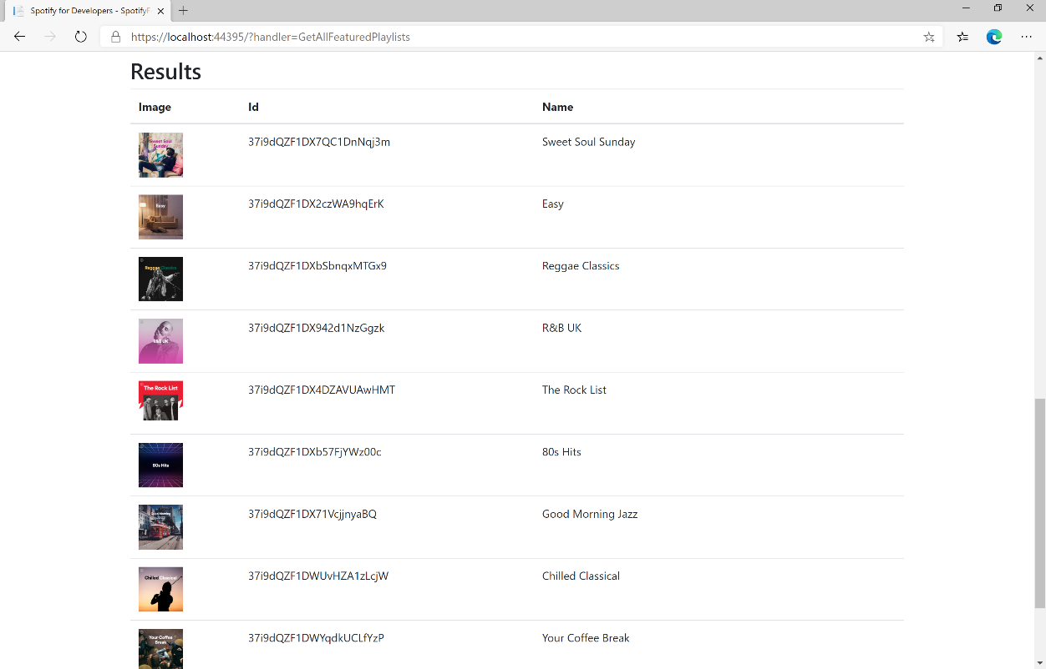

### Step 11

|  |  |
| --- | --- |
|  | You can stop the **web application** in **Visual Studio 2019** by selecting the **Stop debugging** button |

### Step 12

|  |  |
| --- | --- |
|  | You can exit **Visual Studio 2019** by selecting the **Close** button in the top right of the **application** as that completes thispart of the workshop |

# Artists, Albums & Tracks

## Get Multiple Artists

Get Spotify catalogue information for several artists based on their Spotify Ids.

|  |  |
| --- | --- |
| GET https://api.spotify.com/v1/artists | |
| Header | |
| Authorization | Valid Access Token from Spotify Accounts service |
| Query Parameter | |
| ids | Maximum of 50 comma-separated list of artist Spotify Ids |

|  |  |
| --- | --- |
| Header | Response |
| Success | |
| HTTP Status 200 OK | Artists as Array of Artist Objects |
| Error | |
| Error Code | Error Object |

### Step 1

|  |  |
| --- | --- |
|  | In **Windows 10** choose **Start**, and then from the **Start Menu** find and select **Visual Studio 2019** |
|  | Once done, from the **Get started** screen for **Visual Studio 2019** select **Open a project or solution** |
|  | Then locate and select **SpotifyForDevelopers.sln** and select **Open** if you don’t have this file already then please follow the previous parts of the workshop including **Getting Started**, **Authorisation Guide**, **Search** **&** **Browse** |

### Step 2

|  |  |
| --- | --- |
|  | Once opened, in the **Solution Explorer** open the **Pages** section, then open the **Index.cshtml** section and select **Index.cshtml.cs** |

### Step 3

|  |  |
| --- | --- |
|  | Then from the **Menu** choose **View** and then **Open** |

### Step 4

In the **Code View** for **Index.cshtml.cs** below the **method** for public async Task<IActionResult> OnPostGetAllFeaturedPlaylistsAsync() { ... } enter the following **method**:

|  |
| --- |
| public async Task<IActionResult> OnPostGetMultipleArtistsAsync(string value)  {  LoadToken();  var values = value.Split(",").ToList();  var results = await Api.GetMultipleArtistsAsync(values);  if (results != null)  {  Results = results.Select(result => new Result()  {  Id = result.Id,  Name = result.Name,  Image = result?.Images?.FirstOrDefault()?.Url  });  }  return Page(); } |

The **method** for OnPostGetMultipleArtistsAsync is used to get **artists** by multiple **Artist Id** on Spotify with the value and populate the **property** for Results accordingly.

### Step 5

|  |  |
| --- | --- |
|  | In the **Solution Explorer** in the **Pages** section select **Index.cshtml** |

### Step 6

|  |  |
| --- | --- |
|  | Then from the **Menu** choose **View** and then **Open** |

### Step 7

Once in the **Code View** for **Index.cshtml** above <!-- Spotify Web API App Authorisation --> enter the following:

|  |
| --- |
| <ul class="list-group mb-2">  <li class="list-group-item list-group-item-primary">  <h5 class="list-group-item-heading">Artists</h5>  </li>  <li class="list-group-item">  <form **asp-page-handler**="GetMultipleArtists" method="post">  <input **asp-for**="Value" placeholder="Artist Ids" class="form-control mb-2" />  <button class="btn btn-primary mb-2">  Get Multiple Artists  </button>  </form>  </li>  <!-- Artists -->  </ul> |

This form will **post** to the **method** for OnPostGetMultipleArtistsAsync with the Value as the **Artist Ids** and will output to the **Results**.

### Step 8

|  |  |
| --- | --- |
|  | Finally, in **Visual Studio 2019** select **IIS Application** to run the **Web Application** |

### Step 9

Once the **Web Application** is running and you select **Client Credentials Flow Login** and scroll down you should see something like the following:

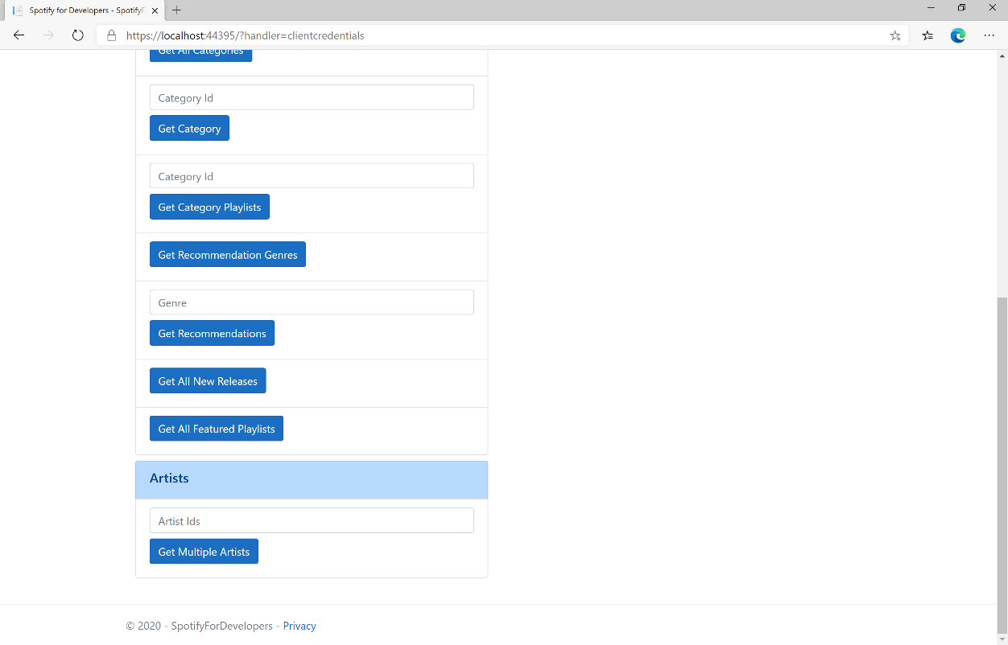

### Step 10

You can then enter an **Artist Id** or if multiple ones separate them with a **comma** from **Get All New Releases** and select **Get Multiple Artists** and scroll down to view **Results** like the following:

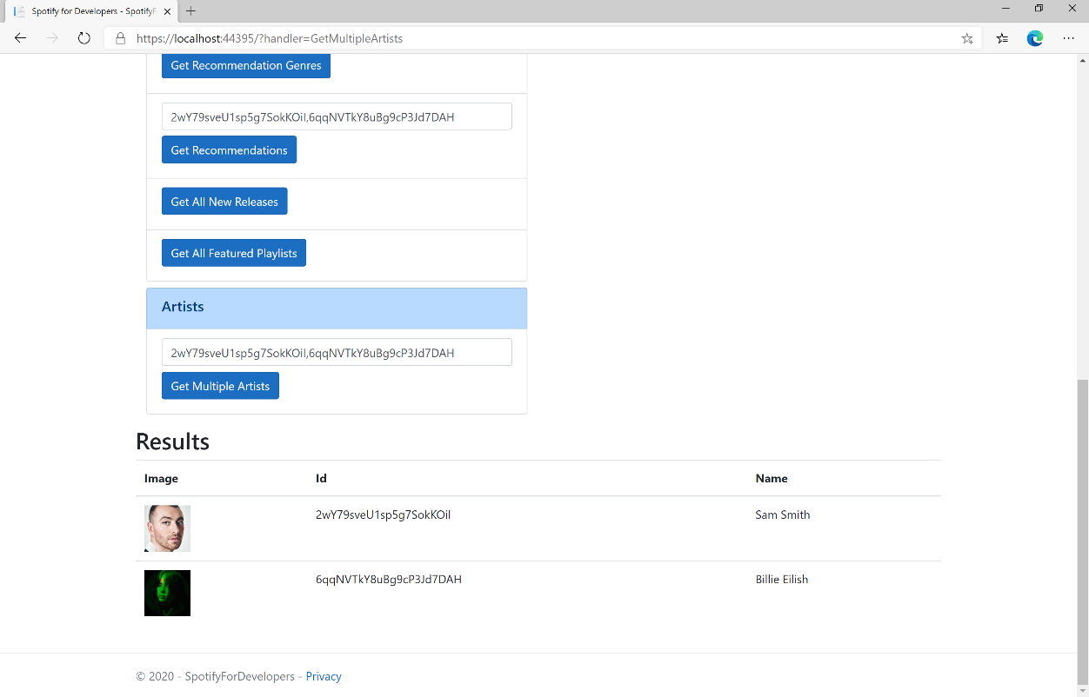

### Step 11

|  |  |
| --- | --- |
|  | You can stop the **web application** in **Visual Studio 2019** by selecting the **Stop debugging** button |

### Step 12

|  |  |
| --- | --- |
|  | You can exit **Visual Studio 2019** by selecting the **Close** button in the top right of the **application** as that completes thispart of the workshop |

## Get an Artist

Get Spotify catalogue information for a single artist identified by their unique Spotify Id.

|  |  |
| --- | --- |
| GET https://api.spotify.com/v1/artists/{id} | |
| Header | |
| Authorization | Valid Access Token from Spotify Accounts service |
| Path Parameter | |
| id | Spotify Id of the artist |

|  |  |
| --- | --- |
| Header | Response |
| Success | |
| HTTP Status 200 OK | Artist Object |
| Error | |
| Error Code | Error Object |

### Step 1

|  |  |
| --- | --- |
|  | If you chose to close **Visual Studio 2019** previously, in **Windows 10** choose **Start**, and then from the **Start Menu** find and select **Visual Studio 2019** |
|  | Once done, from the **Get started** screen for **Visual Studio 2019** select **Open a project or solution** |
|  | Then locate and select **SpotifyForDevelopers.sln** and select **Open** if you don’t have this file already then please follow the previous parts of the workshop including **Getting Started**, **Authorisation Guide**, **Search** **&** **Browse** and **Artists, Albums & Tracks** |

### Step 2

|  |  |
| --- | --- |
|  | Once opened, in the **Solution Explorer** open the **Pages** section, then open the **Index.cshtml** section and select **Index.cshtml.cs** |

### Step 3

|  |  |
| --- | --- |
|  | Then from the **Menu** choose **View** and then **Open** |

### Step 4

In the **Code View** for **Index.cshtml.cs** below the **method** for public async Task<IActionResult> OnPostGetMultipleArtistsAsync(...) { ... } enter the following **method**:

|  |
| --- |
| public async Task<IActionResult> OnPostGetArtistAsync(string value)  {  LoadToken();  var result = await Api.GetArtistAsync(value);  if (result != null)  {  Results = new List<Result> { new Result()  {  Id = result.Id,  Name = result.Name,  Image = result?.Images?.FirstOrDefault()?.Url  }};  }  return Page();  } |

The **method** for OnPostGetArtistAsync is used to get an **artist** by **Artist Id** on Spotify with the value and populate the **property** for Results accordingly.

### Step 5

|  |  |
| --- | --- |
|  | In the **Solution Explorer** in the **Pages** section select **Index.cshtml** |

### Step 6

|  |  |
| --- | --- |
|  | Then from the **Menu** choose **View** and then **Open** |

### Step 7

Once in the **Code View** for **Index.cshtml** above <!-- Artists --> enter the following:

|  |
| --- |
| <li class="list-group-item">  <form **asp-page-handler**="GetArtist" method="post">  <input **asp-for**="Value" placeholder="Artist Id" class="form-control mb-2" />  <button class="btn btn-primary mb-2">  Get an Artist  </button>  </form>  </li> |

This form will **post** to the **method** for OnPostGetArtistAsync with the Value as the **Artist Id** and will output to the **Results**.

### Step 8

|  |  |
| --- | --- |
|  | Finally, in **Visual Studio 2019** select **IIS Application** to run the **Web Application** |

### Step 9

Once the **Web Application** is running and you select **Client Credentials Flow Login** and scroll down you should see something like the following:

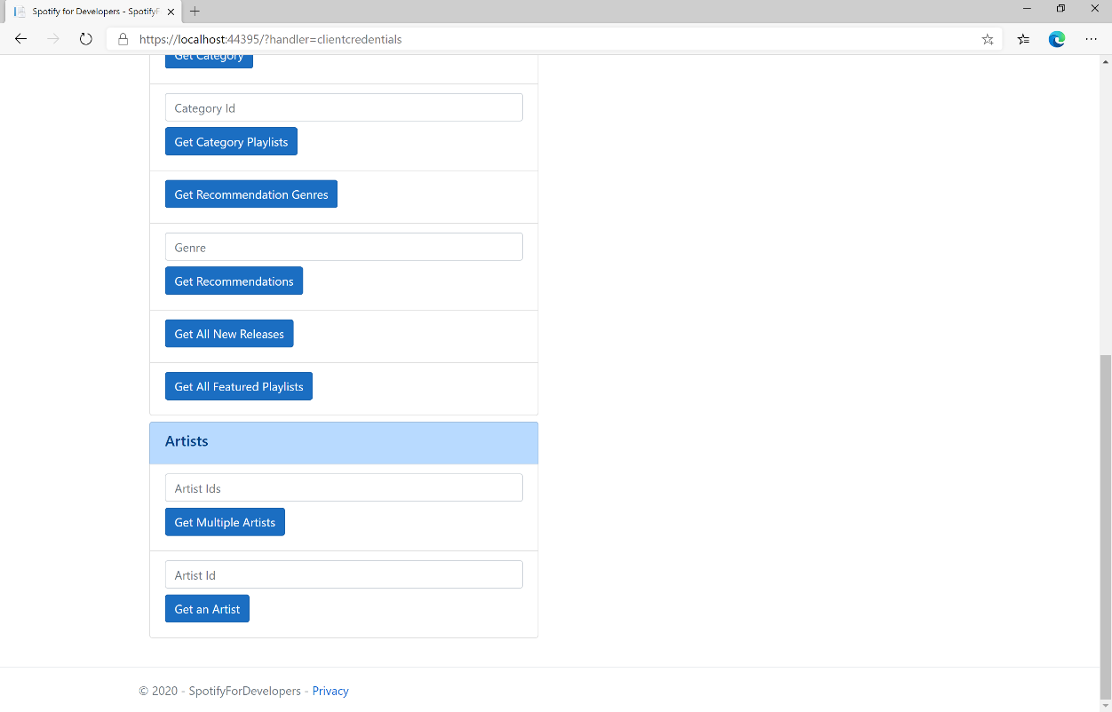

### Step 10

You can then enter an **Artist Id** from **Get All New Releases** and select **Get an Artist** and scroll down to view **Results** like the following:

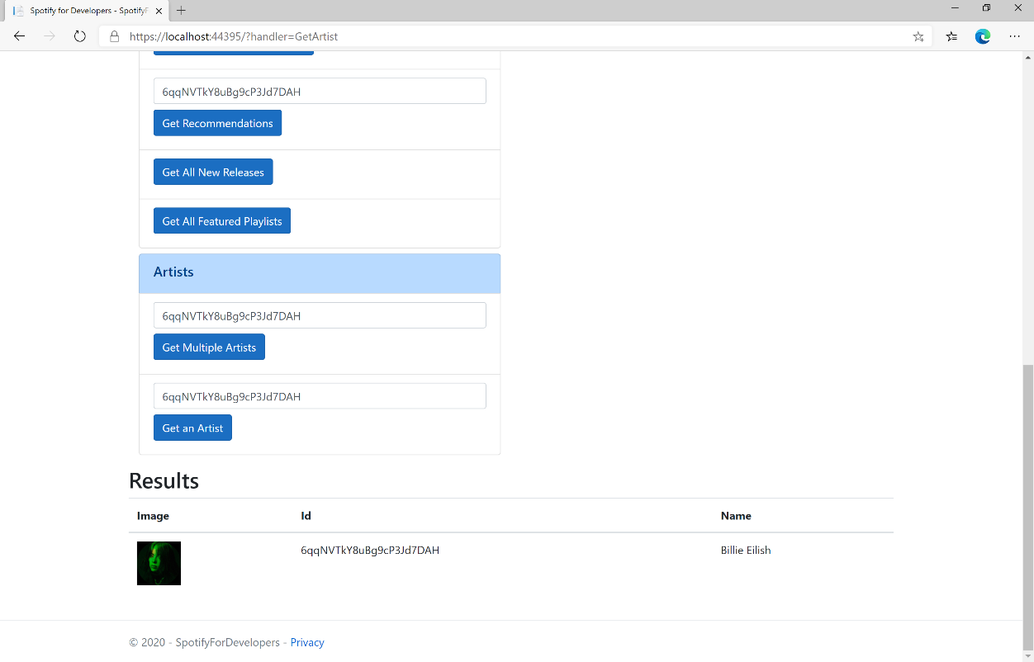

### Step 11

|  |  |
| --- | --- |
|  | You can stop the **web application** in **Visual Studio 2019** by selecting the **Stop debugging** button |

### Step 12

|  |  |
| --- | --- |
|  | You can choose to exit **Visual Studio 2019** by selecting the **Close** button in the top right of the **application** as that completes thispart of the workshop |

## Get an Artist's Albums

Get Spotify catalogue information about an artist’s albums. Optional parameters can be specified to filter and sort the response.

|  |  |
| --- | --- |
| GET https://api.spotify.com/v1/artists/{id}/albums | |
| Header | |
| Authorization | Valid Access Token from Spotify Accounts service |
| Path Parameter | |
| id | Spotify ID of the artist |
| Query Parameters | |
| include_groups | Comma-separated list of keywords that will be used to filter the response from: album, single, appears_on and compilation |
| market | ISO 3166-1 alpha-2 country code e.g. “GB” or “from_token” if omitted all releases for all countries will be returned which may include duplicates |
| limit | Maximum number of results to return |
| offset | Index of first result to return |

|  |  |
| --- | --- |
| Header | Response |
| Success | |
| HTTP Status 200 OK | Array of Simplified Album Objects wrapped in a Paging Object |
| Error | |
| Error Code | Error Object |

### Step 1

|  |  |
| --- | --- |
|  | If you chose to close **Visual Studio 2019** previously, in **Windows 10** choose **Start**, and then from the **Start Menu** find and select **Visual Studio 2019** |
|  | Once done, from the **Get started** screen for **Visual Studio 2019** select **Open a project or solution** |
|  | Then locate and select **SpotifyForDevelopers.sln** and select **Open** if you don’t have this file already then please follow the previous parts of the workshop including **Getting Started**, **Authorisation Guide**, **Search** **&** **Browse** and **Artists, Albums & Tracks** |

### Step 2

|  |  |
| --- | --- |
|  | Once opened, in the **Solution Explorer** open the **Pages** section, then open the **Index.cshtml** section and select **Index.cshtml.cs** |

### Step 3

|  |  |
| --- | --- |
|  | Then from the **Menu** choose **View** and then **Open** |

### Step 4

In the **Code View** for **Index.cshtml.cs** below the **method** for public async Task<IActionResult> OnPostGetArtistAsync(...) { ... } enter the following **method**:

|  |
| --- |
| public async Task<IActionResult> OnPostGetArtistAlbumsAsync(string value)  {  LoadToken();  var results = await Api.GetArtistAlbumsAsync(value);  if (results?.Items != null)  {  Results = results.Items.Select(result => new Result()  {  Id = result.Id,  Name = result.Name,  Image = result?.Images?.FirstOrDefault()?.Url  });  }  return Page();  } |

The **method** for OnPostGetArtistAlbumsAsync is used to get the **albums** of an **artist** by **Artist Id** on Spotify with the value and populate the **property** for Results accordingly.

### Step 5

|  |  |
| --- | --- |
|  | In the **Solution Explorer** in the **Pages** section select **Index.cshtml** |

### Step 6

|  |  |
| --- | --- |
|  | Then from the **Menu** choose **View** and then **Open** |

### Step 7

Once in the **Code View** for **Index.cshtml** above <!-- Artists --> enter the following:

|  |
| --- |
| <li class="list-group-item">  <form **asp-page-handler**="GetArtistAlbums" method="post">  <input **asp-for**="Value" placeholder="Artist Id" class="form-control mb-2" />  <button class="btn btn-primary mb-2">  Get an Artist's Albums  </button>  </form>  </li> |

This form will **post** to the **method** for OnPostGetArtistAlbumsAsync with the Value as the **Artist Id** and will output to the **Results**.

### Step 8

|  |  |
| --- | --- |
|  | Finally, in **Visual Studio 2019** select **IIS Application** to run the **Web Application** |

### Step 9

Once the **Web Application** is running and you select **Client Credentials Flow Login** and scroll down you should see something like the following:

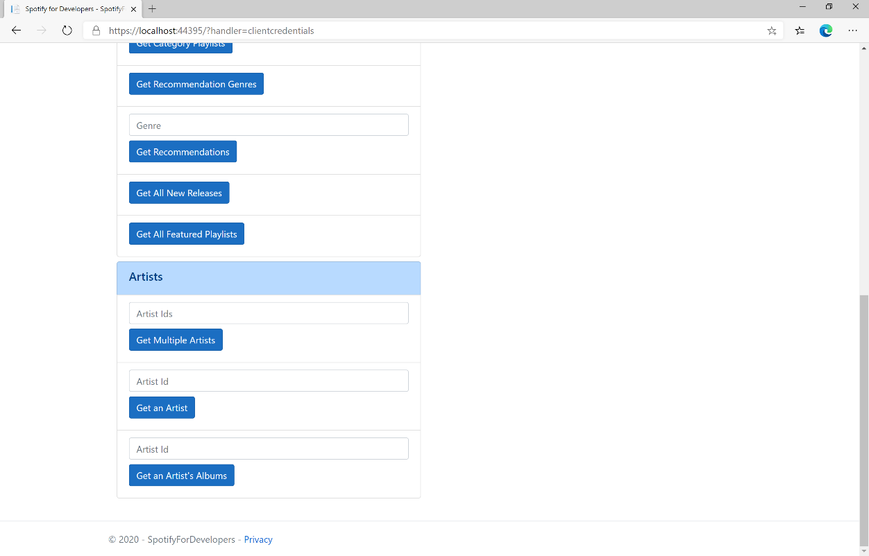

### Step 10

You can then enter an **Artist Id** from **Get All New Releases** and select **Get an Artist's Albums** and scroll down to view **Results** like the following:

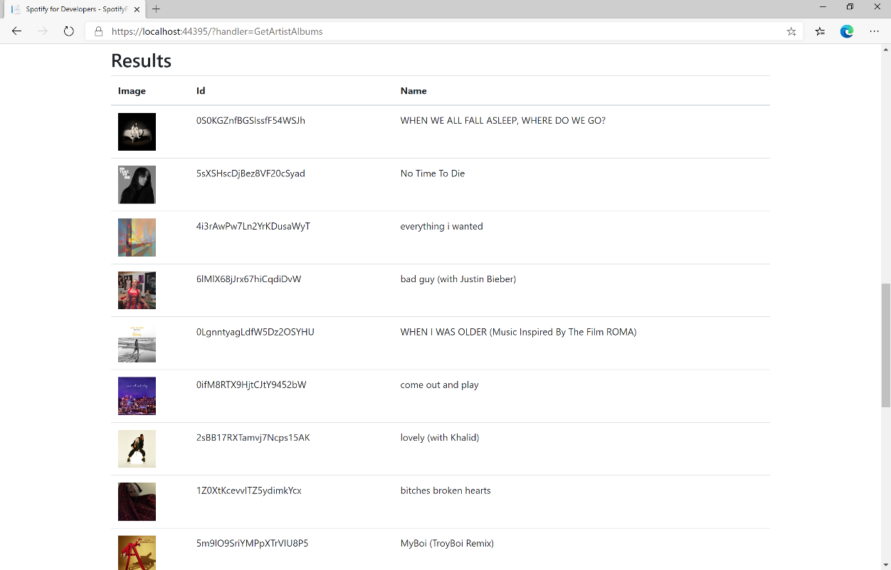

### Step 11

|  |  |
| --- | --- |
|  | You can stop the **web application** in **Visual Studio 2019** by selecting the **Stop debugging** button |

### Step 12

|  |  |
| --- | --- |
|  | You can choose to exit **Visual Studio 2019** by selecting the **Close** button in the top right of the **application** as that completes thispart of the workshop |

## Get an Artist's Top Tracks

Get Spotify catalogue information about an artist’s top tracks by country.

|  |  |
| --- | --- |
| GET https://api.spotify.com/v1/artists/{id}/top-tracks | |
| Header | |
| Authorization | Valid Access Token from Spotify Accounts service |
| Path Parameter | |
| id | Spotify Id of the artist |
| Query Parameters | |
| market | ISO 3166-1 alpha-2 country code e.g. “GB” or “from_token” |

|  |  |
| --- | --- |
| Header | Response |
| Success | |
| HTTP Status 200 OK | Tracks as Array of up to 10 Track Objects |
| Error | |
| Error Code | Error Object |

### Step 1

|  |  |
| --- | --- |
|  | If you chose to close **Visual Studio 2019** previously, in **Windows 10** choose **Start**, and then from the **Start Menu** find and select **Visual Studio 2019** |
|  | Once done, from the **Get started** screen for **Visual Studio 2019** select **Open a project or solution** |
|  | Then locate and select **SpotifyForDevelopers.sln** and select **Open** if you don’t have this file already then please follow the previous parts of the workshop including **Getting Started**, **Authorisation Guide**, **Search** **&** **Browse** and **Artists, Albums & Tracks** |

### Step 2

|  |  |
| --- | --- |
|  | Once opened, in the **Solution Explorer** open the **Pages** section, then open the **Index.cshtml** section and select **Index.cshtml.cs** |

### Step 3

|  |  |
| --- | --- |
|  | Then from the **Menu** choose **View** and then **Open** |

### Step 4

In the **Code View** for **Index.cshtml.cs** below the **method** for public async Task<IActionResult> OnPostGetArtistAlbumsAsync(...) { ... } enter the following **method**:

|  |
| --- |
| public async Task<IActionResult> OnPostGetArtistTopTracksAsync(string value)  {  LoadToken();  var results = await Api.GetArtistTopTracksAsync(value, country);  if (results != null)  {  Results = results.Select(result => new Result()  {  Id = result.Id,  Name = result.Name,  Image = result?.Album?.Images?.FirstOrDefault()?.Url,  Inner = new Result()  {  Id = result?.Album?.Id,  Name = result?.Album?.Name  }  });  }  return Page();  } |

The **method** for OnPostGetArtistTopTracksAsync is used to get the top **tracks** of an **artist** by **Artist Id** on Spotify with the value and populate the **property** for Results accordingly.

### Step 5

|  |  |
| --- | --- |
|  | In the **Solution Explorer** in the **Pages** section select **Index.cshtml** |

### Step 6

|  |  |
| --- | --- |
|  | Then from the **Menu** choose **View** and then **Open** |

### Step 7

Once in the **Code View** for **Index.cshtml** above <!-- Artists --> enter the following:

|  |
| --- |
| <li class="list-group-item">  <form **asp-page-handler**="GetArtistTopTracks" method="post">  <input **asp-for**="Value" placeholder="Artist Id" class="form-control mb-2" />  <button class="btn btn-primary mb-2">  Get an Artist's Top Tracks  </button>  </form>  </li> |

This form will **post** to the **method** for OnPostGetArtistTopTracksAsync with the Value as the **Artist Id** and will output to the **Results**.

### Step 8

|  |  |
| --- | --- |
|  | Finally, in **Visual Studio 2019** select **IIS Application** to run the **Web Application** |

### Step 9

Once the **Web Application** is running and you select **Client Credentials Flow Login** and scroll down you should see something like the following:

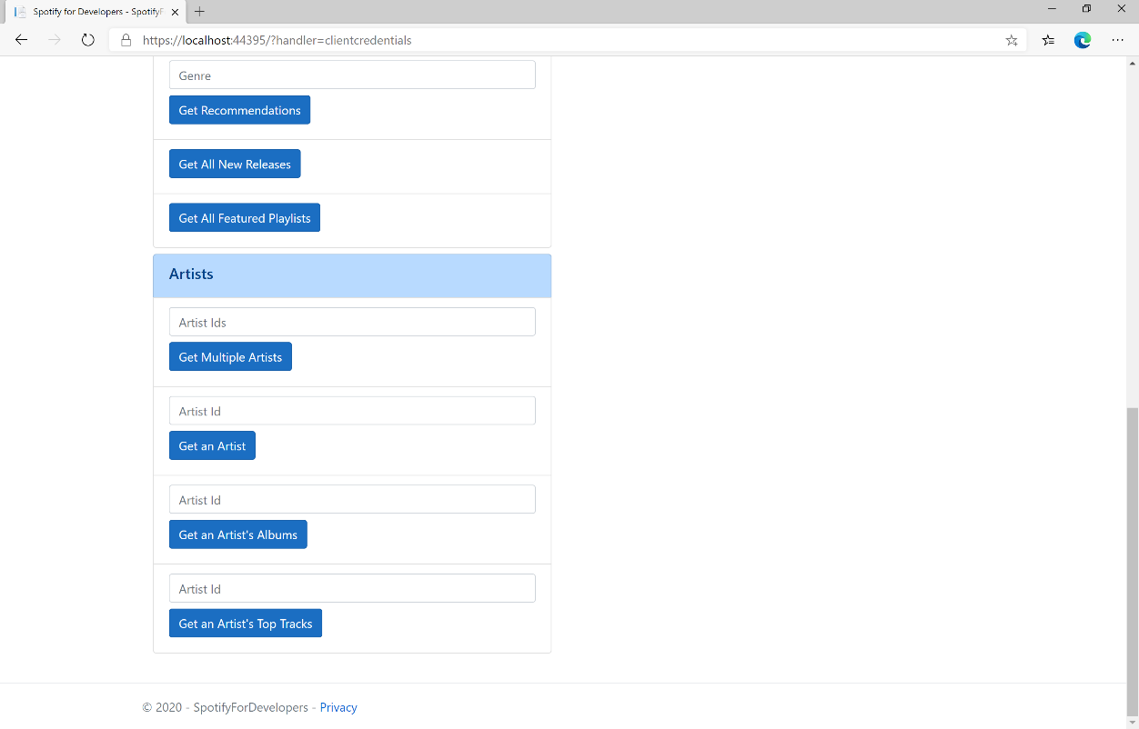

### Step 10

You can then enter an **Artist Id** from **Get All New Releases** and select **Get an Artist's Top Tracks** and scroll down to view **Results** like the following:

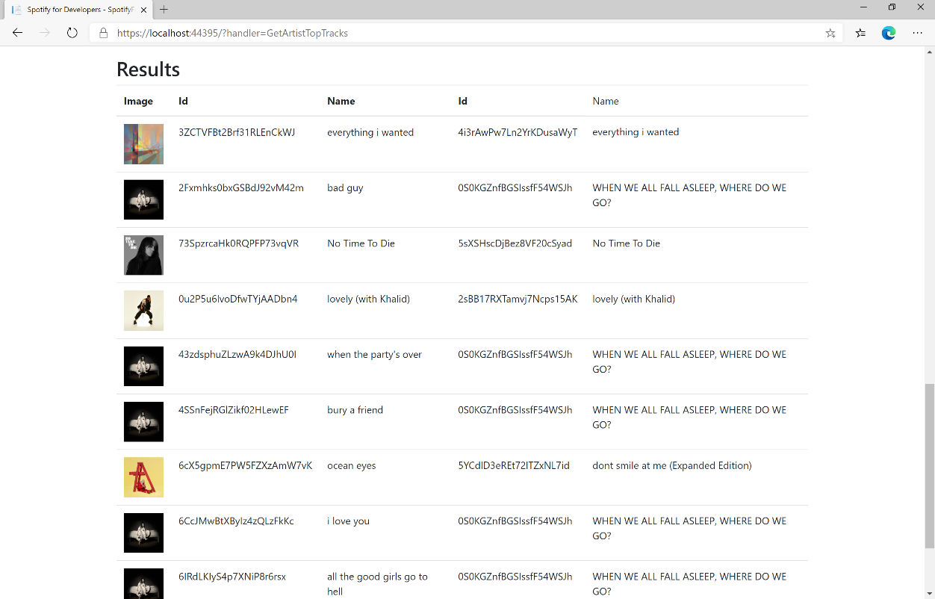

### Step 11

|  |  |
| --- | --- |
|  | You can stop the **web application** in **Visual Studio 2019** by selecting the **Stop debugging** button |

### Step 12

|  |  |
| --- | --- |
|  | You can choose to exit **Visual Studio 2019** by selecting the **Close** button in the top right of the **application** as that completes thispart of the workshop |

## Get an Artist's Related Artists

Get Spotify catalogue information about artists like a given artist. Similarity is based on analysis of the Spotify community’s listening history.

|  |  |
| --- | --- |
| GET https://api.spotify.com/v1/artists/{id}/top-tracks | |
| Header | |
| Authorization | Valid Access Token from Spotify Accounts service |
| Path Parameter | |
| id | Spotify Id of the artist |

|  |  |
| --- | --- |
| Header | Response |
| Success | |
| HTTP Status 200 OK | Artists as Array of up to 20 Artist Objects |
| Error | |
| Error Code | Error Object |

### Step 1

|  |  |
| --- | --- |
|  | If you chose to close **Visual Studio 2019** previously, in **Windows 10** choose **Start**, and then from the **Start Menu** find and select **Visual Studio 2019** |
|  | Once done, from the **Get started** screen for **Visual Studio 2019** select **Open a project or solution** |
|  | Then locate and select **SpotifyForDevelopers.sln** and select **Open** if you don’t have this file already then please follow the previous parts of the workshop including **Getting Started**, **Authorisation Guide**, **Search** **&** **Browse** and **Artists, Albums & Tracks** |

### Step 2

|  |  |
| --- | --- |
|  | Once opened, in the **Solution Explorer** open the **Pages** section, then open the **Index.cshtml** section and select **Index.cshtml.cs** |

### Step 3

|  |  |
| --- | --- |
|  | Then from the **Menu** choose **View** and then **Open** |

### Step 4

In the **Code View** for **Index.cshtml.cs** below the **method** for public async Task<IActionResult> OnPostGetArtistTopTracksAsync(...) { ... } enter the following **method**:

|  |
| --- |
| public async Task<IActionResult> OnPostGetArtistRelatedArtistsAsync(string value)  {  LoadToken();  var results = await Api.GetArtistRelatedArtistsAsync(value);  if (results != null)  {  Results = results.Select(result => new Result()  {  Id = result.Id,  Name = result.Name,  Image = result?.Images?.FirstOrDefault()?.Url  });  }  return Page();  } |

The **method** for OnPostGetArtistRelatedArtistsAsync is used to get the related **artists** of an **artist** by **Artist Id** on Spotify with the value and populate the **property** for Results accordingly.

### Step 5

|  |  |
| --- | --- |
|  | In the **Solution Explorer** in the **Pages** section select **Index.cshtml** |

### Step 6

|  |  |
| --- | --- |
|  | Then from the **Menu** choose **View** and then **Open** |

### Step 7

Once in the **Code View** for **Index.cshtml** above <!-- Artists --> enter the following:

|  |
| --- |
| <li class="list-group-item">  <form **asp-page-handler**="GetArtistRelatedArtists" method="post">  <input **asp-for**="Value" placeholder="Artist Id" class="form-control mb-2" />  <button class="btn btn-primary mb-2">  Get an Artist's Related Artists  </button>  </form>  </li> |

This form will **post** to the **method** for OnPostGetArtistRelatedArtistsAsync with the Value as the **Artist Id** and will output to the **Results**.

### Step 8

|  |  |
| --- | --- |
|  | Finally, in **Visual Studio 2019** select **IIS Application** to run the **Web Application** |

### Step 9

Once the **Web Application** is running and you select **Client Credentials Flow Login** and scroll down you should see something like the following:

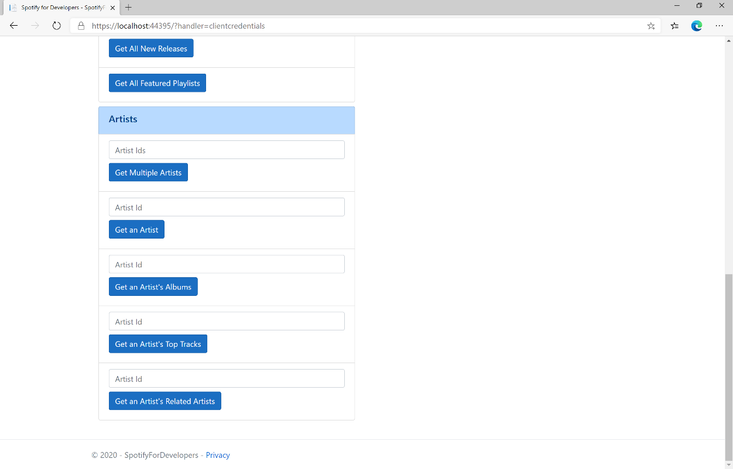

### Step 10

You can then enter an **Artist Id** from **Get All New Releases** and select **Get an Artist's Related Artists** and scroll down to view **Results** like the following:

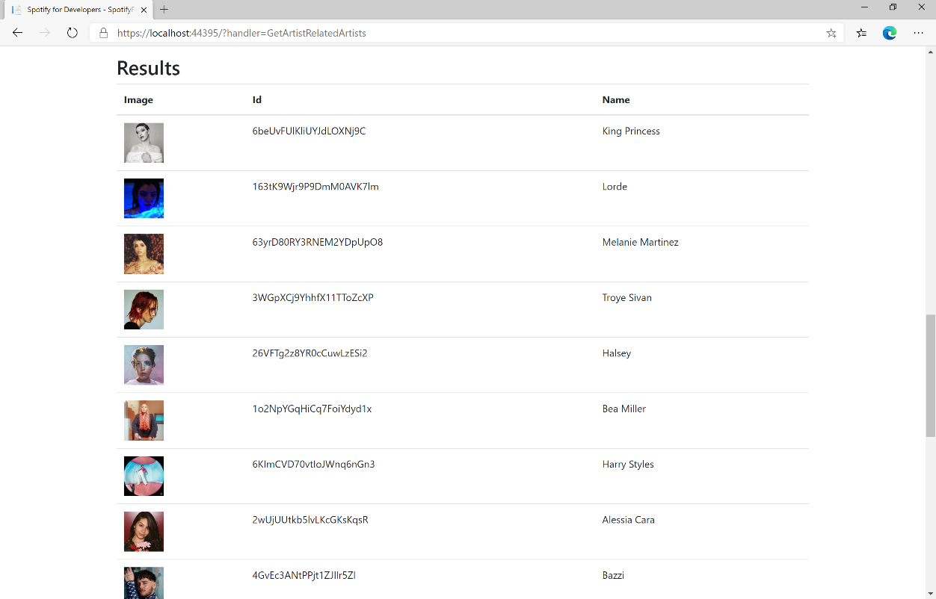

### Step 11

|  |  |
| --- | --- |
|  | You can stop the **web application** in **Visual Studio 2019** by selecting the **Stop debugging** button |

### Step 12

|  |  |
| --- | --- |
|  | You can choose to exit **Visual Studio 2019** by selecting the **Close** button in the top right of the **application** as that completes thispart of the workshop |

## Get Multiple Albums

Get Spotify catalogue information for several albums based on their Spotify Ids.

|  |  |
| --- | --- |
| GET https://api.spotify.com/v1/albums | |
| Header | |
| Authorization | Valid Access Token from Spotify Accounts service |
| Query Parameter | |
| ids | Maximum of 20 comma-separated list of album Spotify Ids |
| market | ISO 3166-1 alpha-2 country code or “from_token” Provide to apply Track Relinking. |

|  |  |
| --- | --- |
| Header | Response |
| Success | |
| HTTP Status 200 OK | Albums as Array of Album Objects |
| Error | |
| Error Code | Error Object |

### Step 1

|  |  |
| --- | --- |
|  | If you chose to close **Visual Studio 2019** previously, in **Windows 10** choose **Start**, and then from the **Start Menu** find and select **Visual Studio 2019** |
|  | Once done, from the **Get started** screen for **Visual Studio 2019** select **Open a project or solution** |
|  | Then locate and select **SpotifyForDevelopers.sln** and select **Open** if you don’t have this file already then please follow the previous parts of the workshop including **Getting Started**, **Authorisation Guide**, **Search** **&** **Browse** and **Artists, Albums & Tracks** |

### Step 2

|  |  |
| --- | --- |
|  | Once opened, in the **Solution Explorer** open the **Pages** section, then open the **Index.cshtml** section and select **Index.cshtml.cs** |

### Step 3

|  |  |
| --- | --- |
|  | Then from the **Menu** choose **View** and then **Open** |

### Step 4

In the **Code View** for **Index.cshtml.cs** below the **method** for public async Task<IActionResult> OnPostGetArtistRelatedArtistsAsync(...) { ... } enter the following **method**:

|  |
| --- |
| public async Task<IActionResult> OnPostGetMultipleAlbumsAsync(string value)  {  LoadToken();  var values = value.Split(",").ToList();  var results = await Api.GetMultipleAlbumsAsync(values);  if (results != null)  {  Results = results.Select(result => new Result()  {  Id = result.Id,  Name = result.Name,  Image = result?.Images?.FirstOrDefault()?.Url  });  }  return Page();  } |

The **method** for OnPostGetMultipleAlbumsAsync is used to get **albums** by multiple **Album Id** on Spotify with the value and populate the **property** for Results accordingly.

### Step 5

|  |  |
| --- | --- |
|  | In the **Solution Explorer** in the **Pages** section select **Index.cshtml** |

### Step 6

|  |  |
| --- | --- |
|  | Then from the **Menu** choose **View** and then **Open** |

### Step 7

Once in the **Code View** for **Index.cshtml** above <!-- Spotify Web API App Authorisation --> enter the following:

|  |
| --- |
| <ul class="list-group mb-2">  <li class="list-group-item list-group-item-primary">  <h5 class="list-group-item-heading">Albums</h5>  </li>  <li class="list-group-item">  <form **asp-page-handler**="GetMultipleAlbums" method="post">  <input **asp-for**="Value" placeholder="Album Ids" class="form-control mb-2" />  <button class="btn btn-primary mb-2">  Get Multiple Albums  </button>  </form>  </li>  <!-- Albums -->  </ul> |

This form will **post** to the **method** for OnPostGetMultipleAlbumsAsync with the Value as the **Album Ids** and will output to the **Results**.

### Step 8

|  |  |
| --- | --- |
|  | Finally, in **Visual Studio 2019** select **IIS Application** to run the **Web Application** |

### Step 9

Once the **Web Application** is running and you select **Client Credentials Flow Login** and scroll down you should see something like the following:

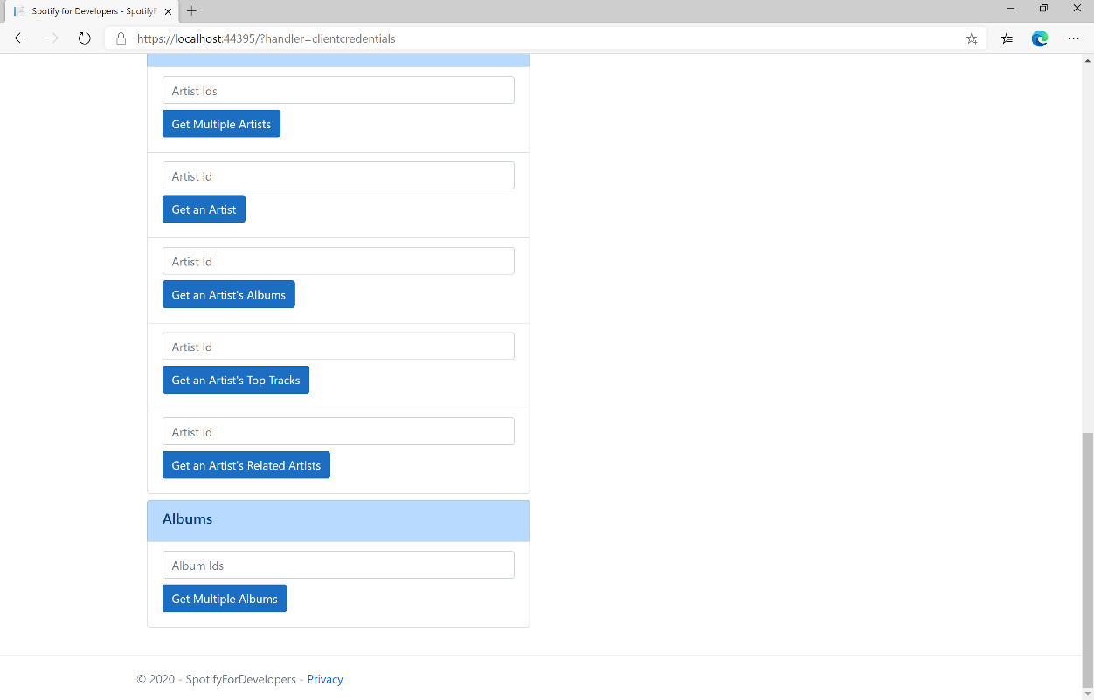

### Step 10

You can then enter an **Album Id** or if multiple ones separate them with a **comma** from **Get All New Releases** and select **Get Multiple Albums** and scroll down to view **Results** like the following:

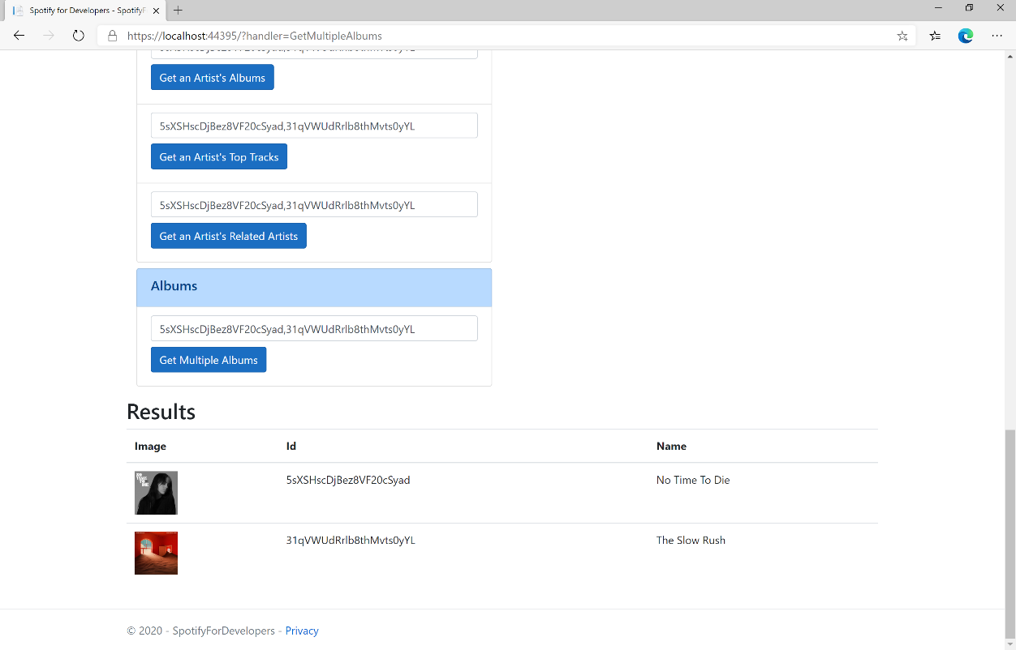

### Step 11

|  |  |
| --- | --- |
|  | You can stop the **web application** in **Visual Studio 2019** by selecting the **Stop debugging** button |

### Step 12

|  |  |
| --- | --- |
|  | You can choose to exit **Visual Studio 2019** by selecting the **Close** button in the top right of the **application** as that completes thispart of the workshop |

## Get an Album

Get Spotify catalogue information for a single album identified by its unique Spotify Id.

|  |  |
| --- | --- |
| GET https://api.spotify.com/v1/albums/{id} | |
| Header | |
| Authorization | Valid Access Token from Spotify Accounts service |
| Path Parameter | |
| id | Spotify Id of the album |
| market | ISO 3166-1 alpha-2 country code e.g. “GB” |

|  |  |
| --- | --- |
| Header | Response |
| Success | |
| HTTP Status 200 OK | Album Object |
| Error | |
| Error Code | Error Object |

### Step 1

|  |  |
| --- | --- |
|  | If you chose to close **Visual Studio 2019** previously, in **Windows 10** choose **Start**, and then from the **Start Menu** find and select **Visual Studio 2019** |
|  | Once done, from the **Get started** screen for **Visual Studio 2019** select **Open a project or solution** |
|  | Then locate and select **SpotifyForDevelopers.sln** and select **Open** if you don’t have this file already then please follow the previous parts of the workshop including **Getting Started**, **Authorisation Guide**, **Search** **&** **Browse** and **Artists, Albums & Tracks** |

### Step 2

|  |  |
| --- | --- |
|  | Once opened, in the **Solution Explorer** open the **Pages** section, then open the **Index.cshtml** section and select **Index.cshtml.cs** |

### Step 3

|  |  |
| --- | --- |
|  | Then from the **Menu** choose **View** and then **Open** |

### Step 4

In the **Code View** for **Index.cshtml.cs** below the **method** for public async Task<IActionResult> OnPostGetMultipleAlbumsAsync(...) { ... } enter the following **method**:

|  |
| --- |
| public async Task<IActionResult> OnPostGetAlbumAsync(string value)  {  LoadToken();  var result = await Api.GetAlbumAsync(value);  if (result != null)  {  Results = new List<Result> { new Result()  {  Id = result.Id,  Name = result.Name,  Image = result?.Images?.FirstOrDefault()?.Url,  Inner = new Result()  {  Id = result?.Artists?.FirstOrDefault()?.Id,  Name = result?.Artists?.FirstOrDefault()?.Name  }  }};  }  return Page();  } |

The **method** for OnPostGetAlbumAsync is used to get an **album** by **Album Id** on Spotify with the value and populate the **property** for Results accordingly.

### Step 5

|  |  |
| --- | --- |
|  | In the **Solution Explorer** in the **Pages** section select **Index.cshtml** |

### Step 6

|  |  |
| --- | --- |
|  | Then from the **Menu** choose **View** and then **Open** |

### Step 7

Once in the **Code View** for **Index.cshtml** above <!-- Albums --> enter the following:

|  |
| --- |
| <li class="list-group-item">  <form **asp-page-handler**="GetAlbum" method="post">  <input **asp-for**="Value" placeholder="Album Id" class="form-control mb-2" />  <button class="btn btn-primary mb-2">  Get an Album  </button>  </form>  </li> |

This form will **post** to the **method** for OnPostGetAlbumAsync with the Value as the **Album Id** and will output to the **Results**.

### Step 8

|  |  |
| --- | --- |
|  | Finally, in **Visual Studio 2019** select **IIS Application** to run the **Web Application** |

### Step 9

Once the **Web Application** is running and you select **Client Credentials Flow Login** and scroll down you should see something like the following:

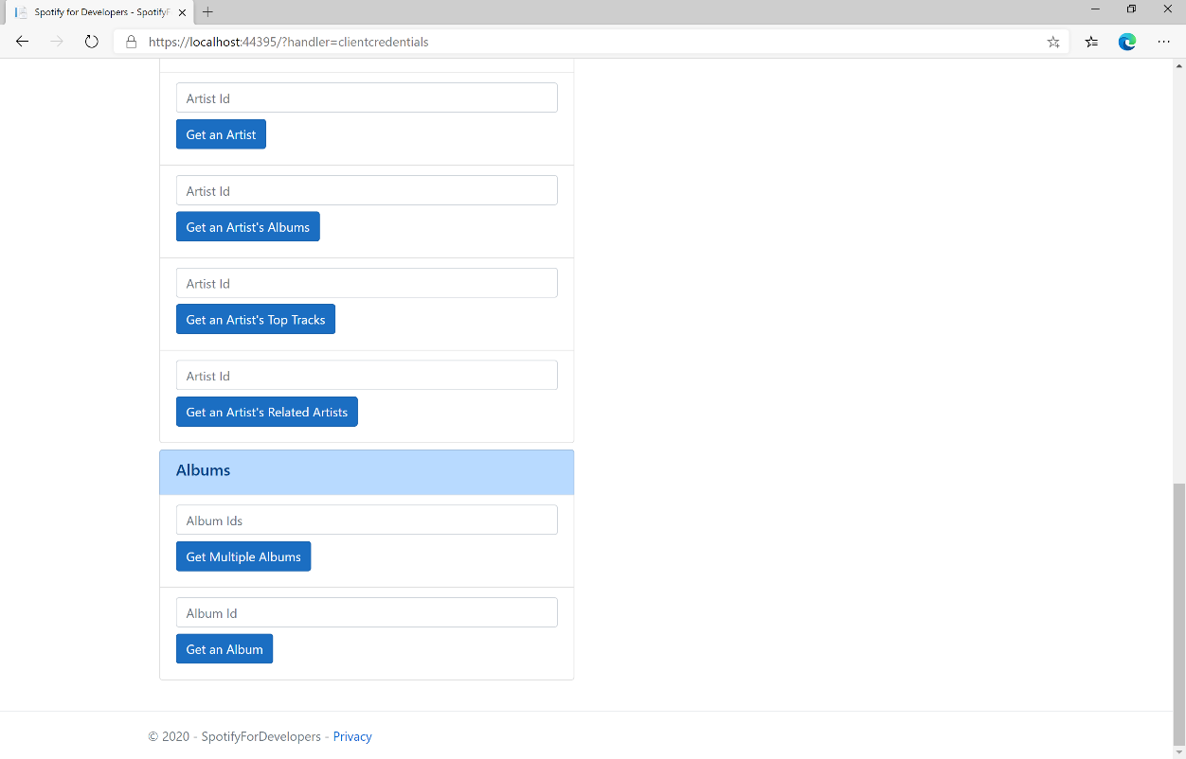

### Step 10

You can then enter an **Album Id** from **Get All New Releases** and select **Get an Album** and scroll down to view **Results** like the following:

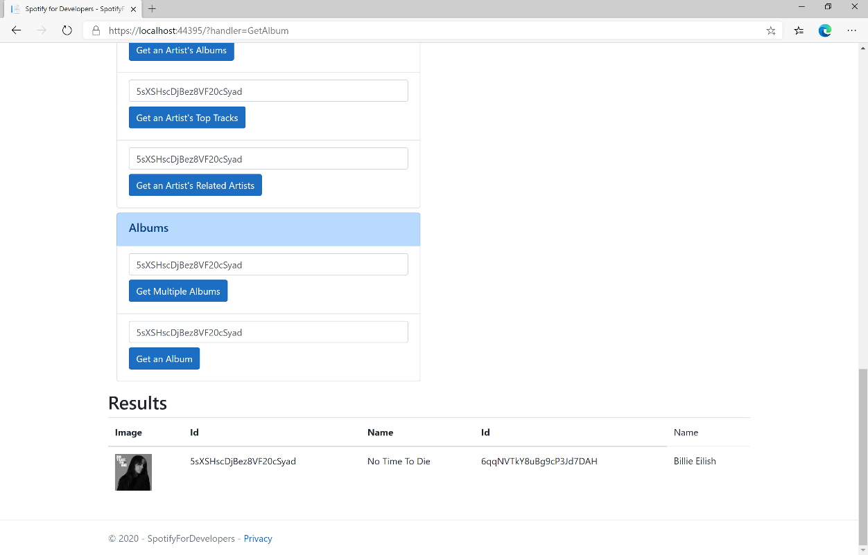

### Step 11

|  |  |
| --- | --- |
|  | You can stop the **web application** in **Visual Studio 2019** by selecting the **Stop debugging** button |

### Step 12

|  |  |
| --- | --- |
|  | You can choose to exit **Visual Studio 2019** by selecting the **Close** button in the top right of the **application** as that completes thispart of the workshop |

## Get an Album's Tracks

Get Spotify catalogue information about an album’s tracks. Optional parameters can be used to limit the number of tracks returned.

|  |  |
| --- | --- |
| GET https://api.spotify.com/v1/albums/{id}/tracks | |
| Header | |
| Authorization | Valid Access Token from Spotify Accounts service |
| Path Parameter | |
| id | Spotify Id of the album |
| Query Parameters | |
| limit | Maximum number of results to return |
| offset | Index of first result to return |
| market | ISO 3166-1 alpha-2 country code e.g. “GB” or “from_token”.  Provide to apply Track Relinking |

|  |  |
| --- | --- |
| Header | Response |
| Success | |
| HTTP Status 200 OK | Array of Simplified Track Objects wrapped in a Paging Object |
| Error | |
| Error Code | Error Object |

### Step 1

|  |  |
| --- | --- |
|  | If you chose to close **Visual Studio 2019** previously, in **Windows 10** choose **Start**, and then from the **Start Menu** find and select **Visual Studio 2019** |
|  | Once done, from the **Get started** screen for **Visual Studio 2019** select **Open a project or solution** |
|  | Then locate and select **SpotifyForDevelopers.sln** and select **Open** if you don’t have this file already then please follow the previous parts of the workshop including **Getting Started**, **Authorisation Guide**, **Search** **&** **Browse** and **Artists, Albums & Tracks** |

### Step 2

|  |  |
| --- | --- |
|  | Once opened, in the **Solution Explorer** open the **Pages** section, then open the **Index.cshtml** section and select **Index.cshtml.cs** |

### Step 3

|  |  |
| --- | --- |
|  | Then from the **Menu** choose **View** and then **Open** |

### Step 4

In the **Code View** for **Index.cshtml.cs** below the **method** for public async Task<IActionResult> OnPostGetAlbumAsync(...) { ... } enter the following **method**:

|  |
| --- |
| public async Task<IActionResult> OnPostGetAlbumTracksAsync(string value)  {  LoadToken();  var results = await Api.GetAlbumTracksAsync(value, country);  if (results?.Items != null)  {  Results = results.Items.Select(result => new Result()  {  Id = result.Id,  Name = result.Name,  Image = result?.Album?.Images?.FirstOrDefault()?.Url,  Inner = new Result()  {  Id = result?.Artists?.FirstOrDefault()?.Id,  Name = result?.Artists?.FirstOrDefault()?.Name  }  });  }  return Page();  } |

The **method** for OnPostGetAlbumTracksAsync is used to get the **tracks** of an **album** by **Album Id** on Spotify with the value and populate the **property** for Results accordingly.

### Step 5

|  |  |
| --- | --- |
|  | In the **Solution Explorer** in the **Pages** section select **Index.cshtml** |

### Step 6

|  |  |
| --- | --- |
|  | Then from the **Menu** choose **View** and then **Open** |

### Step 7

Once in the **Code View** for **Index.cshtml** above <!-- Albums --> enter the following:

|  |
| --- |
| <li class="list-group-item">  <form **asp-page-handler**="GetAlbumTracks" method="post">  <input **asp-for**="Value" placeholder="Album Id" class="form-control mb-2" />  <button class="btn btn-primary mb-2">  Get an Album's Tracks  </button>  </form>  </li> |

This form will **post** to the **method** for OnPostGetAlbumTracksAsync with the Value as the **Album Id** and will output to the **Results**.

### Step 8

|  |  |
| --- | --- |
|  | Finally, in **Visual Studio 2019** select **IIS Application** to run the **Web Application** |

### Step 9

Once the **Web Application** is running and you select **Client Credentials Flow Login** and scroll down you should see something like the following:

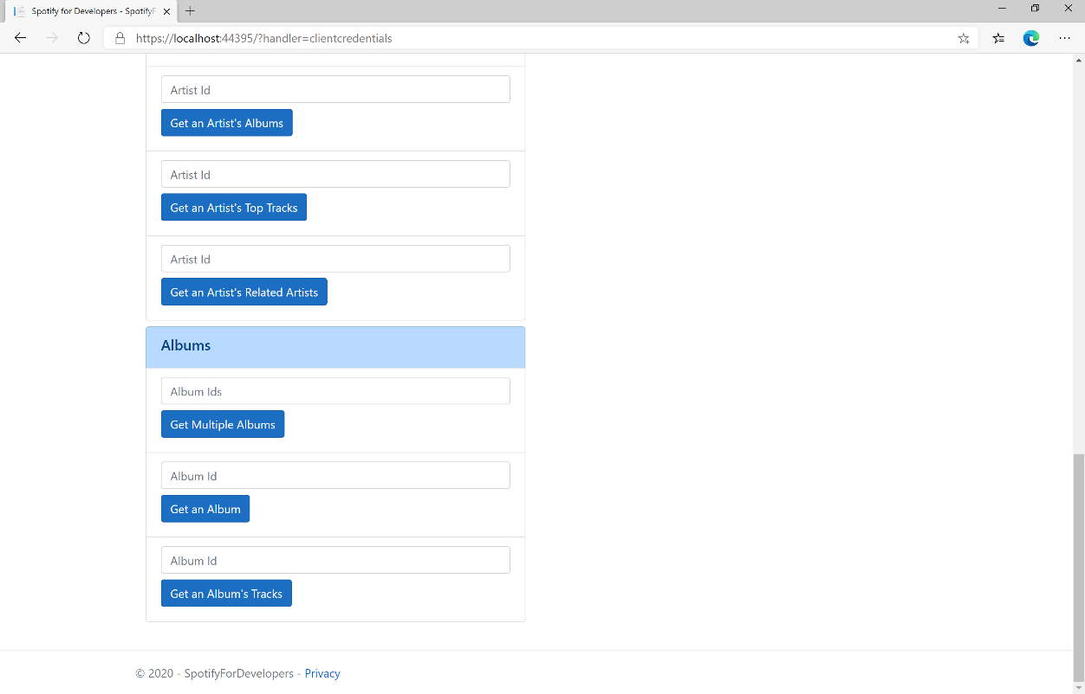

### Step 10

You can then enter an **Album Id** from **Get All New Releases** and select **Get an Album's Tracks** and scroll down to view **Results** like the following:

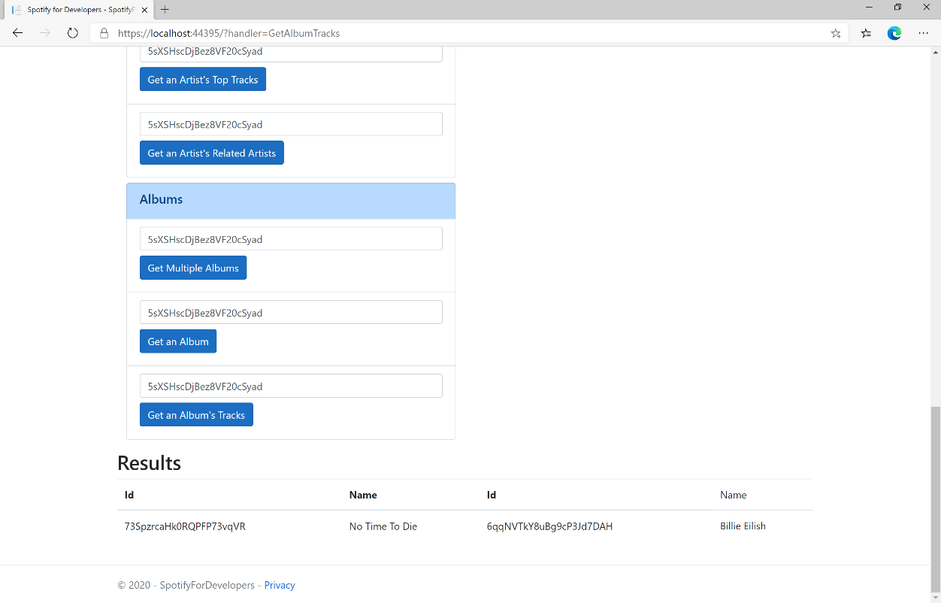

### Step 11

|  |  |
| --- | --- |
|  | You can stop the **web application** in **Visual Studio 2019** by selecting the **Stop debugging** button |

### Step 12

|  |  |
| --- | --- |
|  | You can choose to exit **Visual Studio 2019** by selecting the **Close** button in the top right of the **application** as that completes thispart of the workshop |

## Get Multiple Tracks

Get Spotify catalogue information for multiple tracks based on their Spotify Ids.

|  |  |
| --- | --- |
| GET https://api.spotify.com/v1/tracks | |
| Header | |
| Authorization | Valid Access Token from Spotify Accounts service |
| Query Parameter | |
| ids | Maximum of 50 comma-separated list of track Spotify Ids |
| market | ISO 3166-1 alpha-2 country code e.g. “GB”. Provide to apply Track Relinking |

|  |  |
| --- | --- |
| Header | Response |
| Success | |
| HTTP Status 200 OK | Tracks as Array of Track Objects |
| Error | |
| Error Code | Error Object |

### Step 1

|  |  |
| --- | --- |
|  | If you chose to close **Visual Studio 2019** previously, in **Windows 10** choose **Start**, and then from the **Start Menu** find and select **Visual Studio 2019** |
|  | Once done, from the **Get started** screen for **Visual Studio 2019** select **Open a project or solution** |
|  | Then locate and select **SpotifyForDevelopers.sln** and select **Open** if you don’t have this file already then please follow the previous parts of the workshop including **Getting Started**, **Authorisation Guide**, **Search** **&** **Browse** and **Artists, Albums & Tracks** |

### Step 2

|  |  |
| --- | --- |
|  | Once opened, in the **Solution Explorer** open the **Pages** section, then open the **Index.cshtml** section and select **Index.cshtml.cs** |

### Step 3

|  |  |
| --- | --- |
|  | Then from the **Menu** choose **View** and then **Open** |

### Step 4

In the **Code View** for **Index.cshtml.cs** below the **method** for public async Task<IActionResult> OnPostGetAlbumTracksAsync(...) { ... } enter the following **method**:

|  |
| --- |
| public async Task<IActionResult> OnPostGetSeveralTracksAsync(string value)  {  LoadToken();  var values = value.Split(",").ToList();  var results = await Api.GetSeveralTracksAsync(values);  if (results != null)  {  Results = results.Select(result => new Result()  {  Id = result.Id,  Name = result.Name,  Image = result?.Album?.Images?.FirstOrDefault()?.Url  });  }  return Page(); } |

The **method** for OnPostGetSeveralTracksAsync is used to get **tracks** by multiple **Track Ids** on Spotify with the value and populate the **property** for Results accordingly.

### Step 5

|  |  |
| --- | --- |
|  | In the **Solution Explorer** in the **Pages** section select **Index.cshtml** |

### Step 6

|  |  |
| --- | --- |
|  | Then from the **Menu** choose **View** and then **Open** |

### Step 7

Once in the **Code View** for **Index.cshtml** above <!-- Spotify Web API App Authorisation --> enter the following:

|  |
| --- |
| <ul class="list-group mb-2">  <li class="list-group-item list-group-item-primary">  <h5 class="list-group-item-heading">Tracks</h5>  </li>  <li class="list-group-item">  <form **asp-page-handler**="GetSeveralTracks" method="post">  <input **asp-for**="Value" placeholder="Track Ids" class="form-control mb-2" />  <button class="btn btn-primary mb-2">  Get Multiple Tracks  </button>  </form>  </li>  <!-- Tracks --> </ul> |

This form will **post** to the **method** for OnPostGetSeveralTracksAsync with the Value as the **Track Ids** and will output to the **Results**.

### Step 8

|  |  |
| --- | --- |
|  | Finally, in **Visual Studio 2019** select **IIS Application** to run the **Web Application** |

### Step 9

Once the **Web Application** is running and you select **Client Credentials Flow Login** and scroll down you should see something like the following:

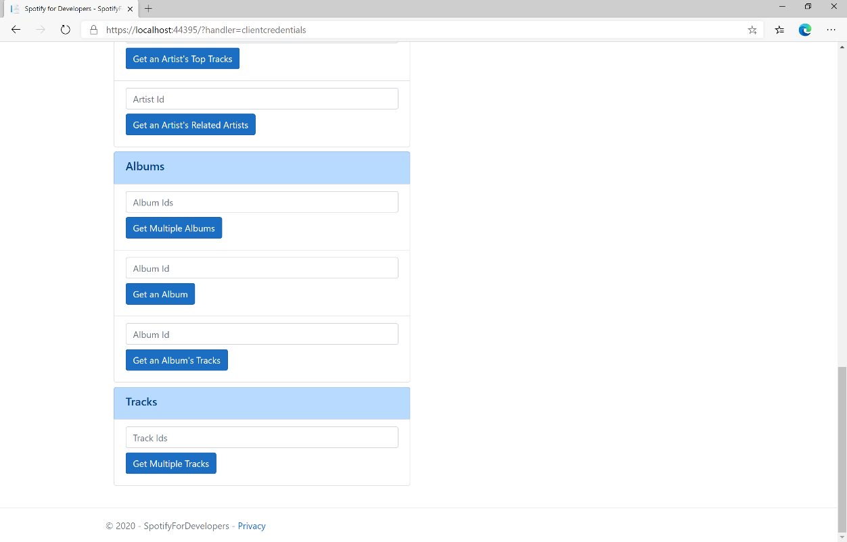

### Step 10

You can then enter an **Album Id** from **Get All New Releases** select **Get an Album's Tracks** and copy some **Track Ids** to use and select **Get Multiple Tracks** and scroll down to view **Results** like the following:

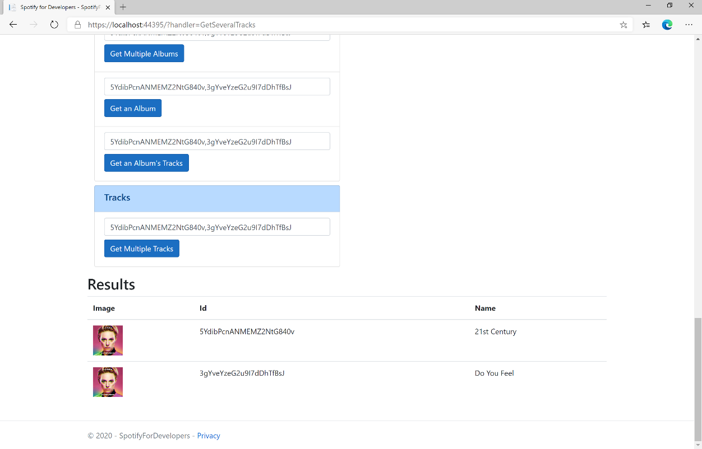

### Step 11

|  |  |
| --- | --- |
|  | You can stop the **web application** in **Visual Studio 2019** by selecting the **Stop debugging** button |

### Step 12

|  |  |
| --- | --- |
|  | You can choose to exit **Visual Studio 2019** by selecting the **Close** button in the top right of the **application** as that completes thispart of the workshop |

## Get a Track

Get Spotify catalogue information for a single track identified by its unique Spotify Id.

|  |  |
| --- | --- |
| GET https://api.spotify.com/v1/tracks/{id} | |
| Header | |
| Authorization | Valid Access Token from Spotify Accounts service |
| Path Parameter | |
| id | Spotify Id of the track |
| market | ISO 3166-1 alpha-2 country code e.g. “GB”. Provide to apply Track Relinking |

|  |  |
| --- | --- |
| Header | Response |
| Success | |
| HTTP Status 200 OK | Track Object |
| Error | |
| Error Code | Error Object |

### Step 1

|  |  |
| --- | --- |
|  | If you chose to close **Visual Studio 2019** previously, in **Windows 10** choose **Start**, and then from the **Start Menu** find and select **Visual Studio 2019** |
|  | Once done, from the **Get started** screen for **Visual Studio 2019** select **Open a project or solution** |
|  | Then locate and select **SpotifyForDevelopers.sln** and select **Open** if you don’t have this file already then please follow the previous parts of the workshop including **Getting Started**, **Authorisation Guide**, **Search** **&** **Browse** and **Artists, Albums & Tracks** |

### Step 2

|  |  |
| --- | --- |
|  | Once opened, in the **Solution Explorer** open the **Pages** section, then open the **Index.cshtml** section and select **Index.cshtml.cs** |

### Step 3

|  |  |
| --- | --- |
|  | Then from the **Menu** choose **View** and then **Open** |

### Step 4

In the **Code View** for **Index.cshtml.cs** below the **method** for public async Task<IActionResult> OnPostGetSeveralTracksAsync(...) { ... } enter the following **method**:

|  |
| --- |
| public async Task<IActionResult> OnPostGetTrackAsync(string value)  {  LoadToken();  var result = await Api.GetTrackAsync(value);  if (result != null)  {  Results = new List<Result> { new Result()  {  Id = result.Id,  Name = result.Name,  Image = result?.Album?.Images?.FirstOrDefault()?.Url,  Inner = new Result()  {  Id = result?.Artists?.FirstOrDefault()?.Id,  Name = result?.Artists?.FirstOrDefault()?.Name  }  }};  }  return Page(); } |

The **method** for OnPostGetTrackAsync is used to get a **track** by **Track Id** on Spotify with the value and populate the **property** for Results accordingly.

### Step 5

|  |  |
| --- | --- |
|  | In the **Solution Explorer** in the **Pages** section select **Index.cshtml** |

### Step 6

|  |  |
| --- | --- |
|  | Then from the **Menu** choose **View** and then **Open** |

### Step 7

Once in the **Code View** for **Index.cshtml** above <!-- Tracks --> enter the following:

|  |
| --- |
| <li class="list-group-item">  <form **asp-page-handler**="GetTrack" method="post">  <input **asp-for**="Value" placeholder="Track Id" class="form-control mb-2" />  <button class="btn btn-primary mb-2">  Get a Track  </button>  </form> </li> |

This form will **post** to the **method** for OnPostGetTrackAsync with the Value as the **Track Id** and will output to the **Results**.

### Step 8

|  |  |
| --- | --- |
|  | Finally, in **Visual Studio 2019** select **IIS Application** to run the **Web Application** |

### Step 9

Once the **Web Application** is running and you select **Client Credentials Flow Login** and scroll down you should see something like the following:

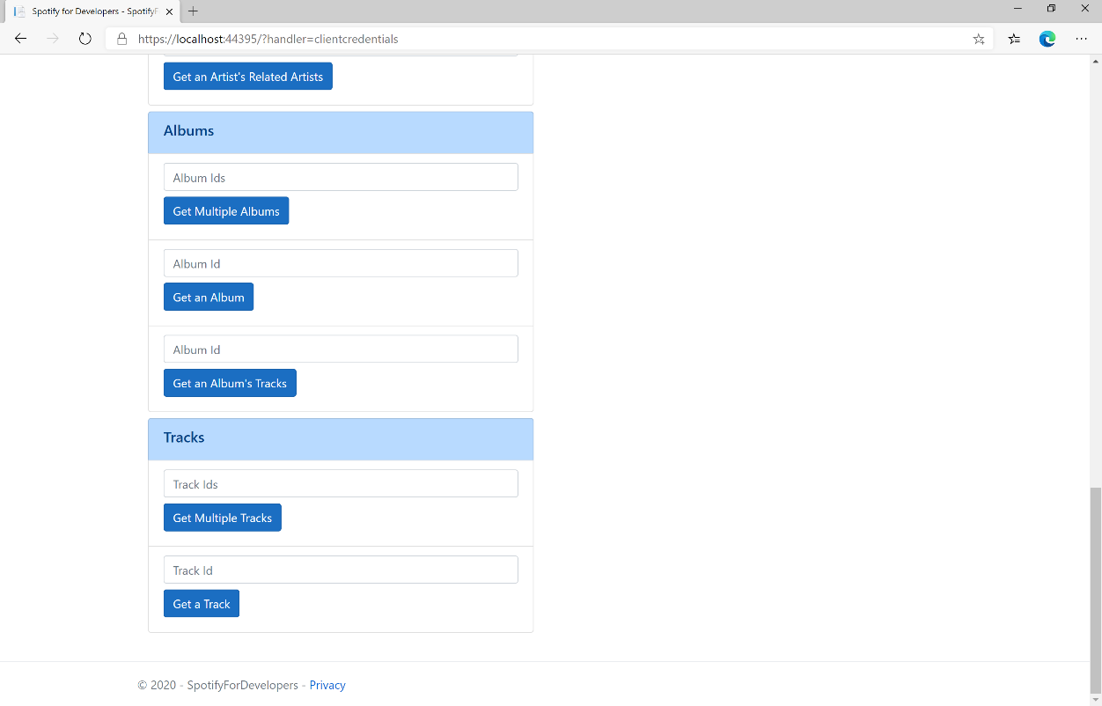

### Step 10

You can then enter an **Album Id** from **Get All New Releases** select **Get an Album's Tracks** and copy a **Track Id** to use and select **Get a Track** and scroll down to view **Results** like the following:

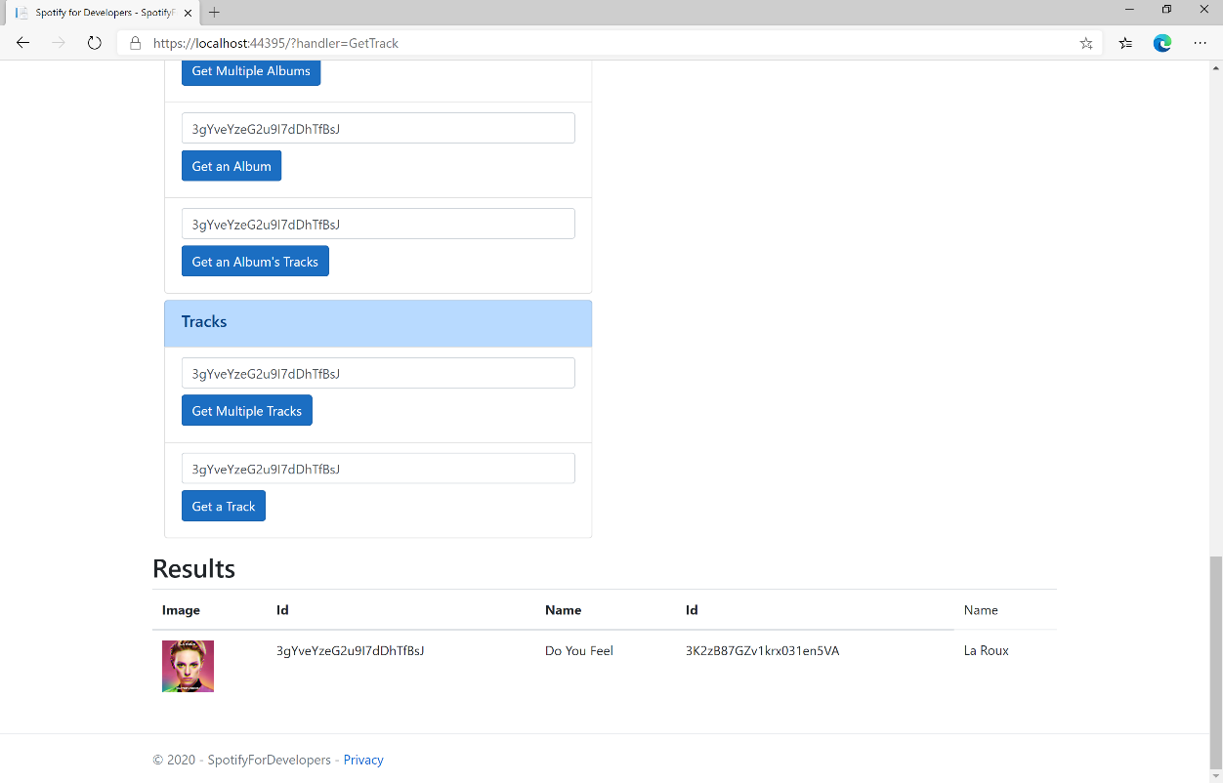

### Step 11

|  |  |
| --- | --- |
|  | You can stop the **web application** in **Visual Studio 2019** by selecting the **Stop debugging** button |

### Step 12

|  |  |
| --- | --- |
|  | You can choose to exit **Visual Studio 2019** by selecting the **Close** button in the top right of the **application** as that completes thispart of the workshop |

## Get Audio Features for Several Tracks

Get audio feature information for a single track identified by its unique Spotify Id.

|  |  |
| --- | --- |
| https://api.spotify.com/v1/audio-features | |
| Header | |
| Authorization | Valid Access Token from Spotify Accounts service |
| Path Parameter | |
| ids | Maximum of 100 comma-separated list of track Spotify Ids |

|  |  |
| --- | --- |
| Header | Response |
| Success | |
| HTTP Status 200 OK | Audio Features with Array of Audio Features Object |
| Error | |
| Error Code | Error Object |

### Step 1

|  |  |
| --- | --- |
|  | If you chose to close **Visual Studio 2019** previously, in **Windows 10** choose **Start**, and then from the **Start Menu** find and select **Visual Studio 2019** |
|  | Once done, from the **Get started** screen for **Visual Studio 2019** select **Open a project or solution** |
|  | Then locate and select **SpotifyForDevelopers.sln** and select **Open** if you don’t have this file already then please follow the previous parts of the workshop including **Getting Started**, **Authorisation Guide**, **Search** **&** **Browse** and **Artists, Albums & Tracks** |

### Step 2

|  |  |
| --- | --- |
|  | Once opened, in the **Solution Explorer** open the **Pages** section, then open the **Index.cshtml** section and select **Index.cshtml.cs** |

### Step 3

|  |  |
| --- | --- |
|  | Then from the **Menu** choose **View** and then **Open** |

### Step 4

In the **Code View** for **Index.cshtml.cs** below the **method** for public async Task<IActionResult> OnPostGetTrackAsync(...) { ... } enter the following **method**:

|  |
| --- |
| public async Task<IActionResult> OnPostGetAudioFeaturesForSeveralTracksAsync(string value)  {  LoadToken();  var values = value.Split(",").ToList();  var results = await Api.GetSeveralTracksAudioFeaturesAsync(values);  if (results != null)  {  Results = results.Select(result => new Result()  {  Name = System.Text.Json.JsonSerializer.Serialize(result,  new System.Text.Json.JsonSerializerOptions()  { WriteIndented = true })  });  }  return Page(); } |

The **method** for OnPostGetAudioFeaturesForSeveralTracksAsync is used to get **audio features** for **tracks** by multiple **Track Ids** on Spotify with the value and populate the **property** for Results accordingly.

### Step 5

|  |  |
| --- | --- |
|  | In the **Solution Explorer** in the **Pages** section select **Index.cshtml** |

### Step 6

|  |  |
| --- | --- |
|  | Then from the **Menu** choose **View** and then **Open** |

### Step 7

Once in the **Code View** for **Index.cshtml** above <!-- Tracks --> enter the following:

|  |
| --- |
| <li class="list-group-item">  <form **asp-page-handler**="GetAudioFeaturesForSeveralTracks" method="post">  <input **asp-for**="Value" placeholder="Track Ids" class="form-control mb-2" />  <button class="btn btn-primary mb-2">  Get Audio Features for Several Tracks  </button>  </form> </li> |

This form will **post** to the **method** for GetAudioFeaturesForSeveralTracks with the Value as the **Track Ids** and will output to the **Results**.

### Step 8

|  |  |
| --- | --- |
|  | Finally, in **Visual Studio 2019** select **IIS Application** to run the **Web Application** |

### Step 9

Once the **Web Application** is running and you select **Client Credentials Flow Login** and scroll down you should see something like the following:

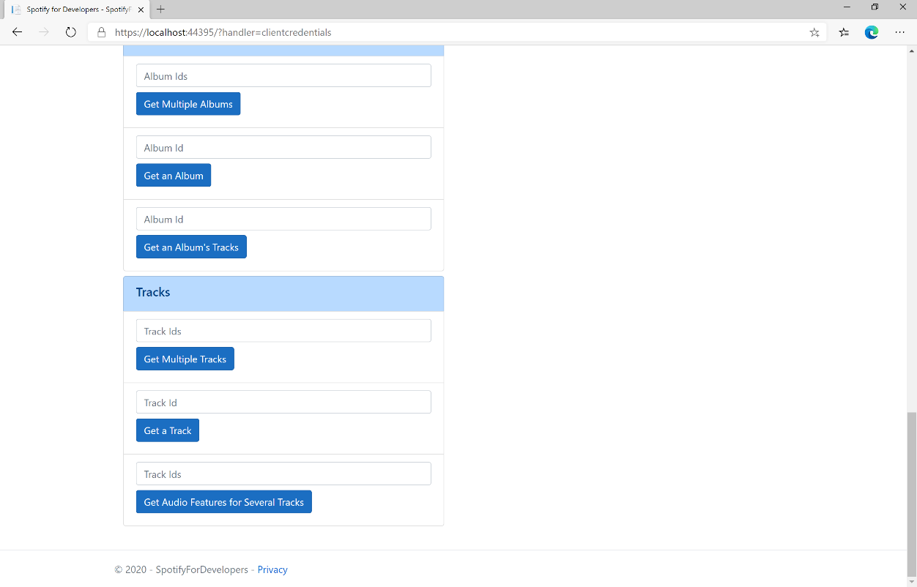

### Step 10

You can then enter an **Album Id** from **Get All New Releases** select **Get an Album's Tracks** and copy some **Track Ids** to use and select **Get Audio Features for Several Tracks** and scroll down to view **Results** like the following:

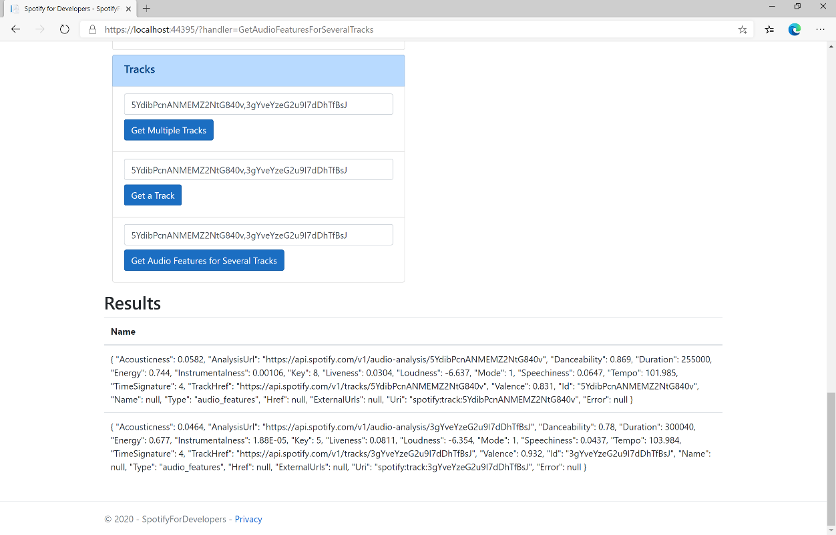

### Step 11

|  |  |
| --- | --- |
|  | You can stop the **web application** in **Visual Studio 2019** by selecting the **Stop debugging** button |

### Step 12

|  |  |
| --- | --- |
|  | You can choose to exit **Visual Studio 2019** by selecting the **Close** button in the top right of the **application** as that completes thispart of the workshop |

## Get Audio Features for a Track

Get audio feature information for a single track identified by its unique Spotify Id.

|  |  |
| --- | --- |
| GET https://api.spotify.com/v1/audio-features/{id} | |
| Header | |
| Authorization | Valid Access Token from Spotify Accounts service |
| Path Parameter | |
| id | Spotify Id of the track |

|  |  |
| --- | --- |
| Header | Response |
| Success | |
| HTTP Status 200 OK | Audio Features Object |
| Error | |
| Error Code | Error Object |

### Step 1

|  |  |
| --- | --- |
|  | If you chose to close **Visual Studio 2019** previously, in **Windows 10** choose **Start**, and then from the **Start Menu** find and select **Visual Studio 2019** |
|  | Once done, from the **Get started** screen for **Visual Studio 2019** select **Open a project or solution** |
|  | Then locate and select **SpotifyForDevelopers.sln** and select **Open** if you don’t have this file already then please follow the previous parts of the workshop including **Getting Started**, **Authorisation Guide**, **Search** **&** **Browse** and **Artists, Albums & Tracks** |

### Step 2

|  |  |
| --- | --- |
|  | Once opened, in the **Solution Explorer** open the **Pages** section, then open the **Index.cshtml** section and select **Index.cshtml.cs** |

### Step 3

|  |  |
| --- | --- |
|  | Then from the **Menu** choose **View** and then **Open** |

### Step 4

In the **Code View** for **Index.cshtml.cs** below the **method** for public async Task<IActionResult> OnPostGetAudioFeaturesForSeveralTracksAsync(...) { ... } enter the following **method**:

|  |
| --- |
| public async Task<IActionResult> OnPostGetAudioFeaturesForTrackAsync(string value)  {  LoadToken();  var result = await Api.GetTrackAudioFeaturesAsync(value);  if (result != null)  {  Results = new List<Result>() { new Result()  {  Name = System.Text.Json.JsonSerializer.Serialize(result,  new System.Text.Json.JsonSerializerOptions()  { WriteIndented = true })  }};  }  return Page(); } |

The **method** for OnPostGetAudioFeaturesForTrackAsync is used to get **audio features** for **track** by **Track Id** on Spotify with the value and populate the **property** for Results accordingly.

### Step 5

|  |  |
| --- | --- |
|  | In the **Solution Explorer** in the **Pages** section select **Index.cshtml** |

### Step 6

|  |  |
| --- | --- |
|  | Then from the **Menu** choose **View** and then **Open** |

### Step 7

Once in the **Code View** for **Index.cshtml** above <!-- Tracks --> enter the following:

|  |
| --- |
| <li class="list-group-item">  <form **asp-page-handler**="GetAudioFeaturesForTrack" method="post">  <input **asp-for**="Value" placeholder="Track Id" class="form-control mb-2" />  <button class="btn btn-primary mb-2">  Get Audio Features for a Track  </button>  </form> </li> |

This form will **post** to the **method** for OnPostGetAudioFeaturesForTrackAsync with the Value as **Track Id** and will output to the **Results**.

### Step 8

|  |  |
| --- | --- |
|  | Finally, in **Visual Studio 2019** select **IIS Application** to run the **Web Application** |

### Step 9

Once the **Web Application** is running and you select **Client Credentials Flow Login** and scroll down you should see something like the following:

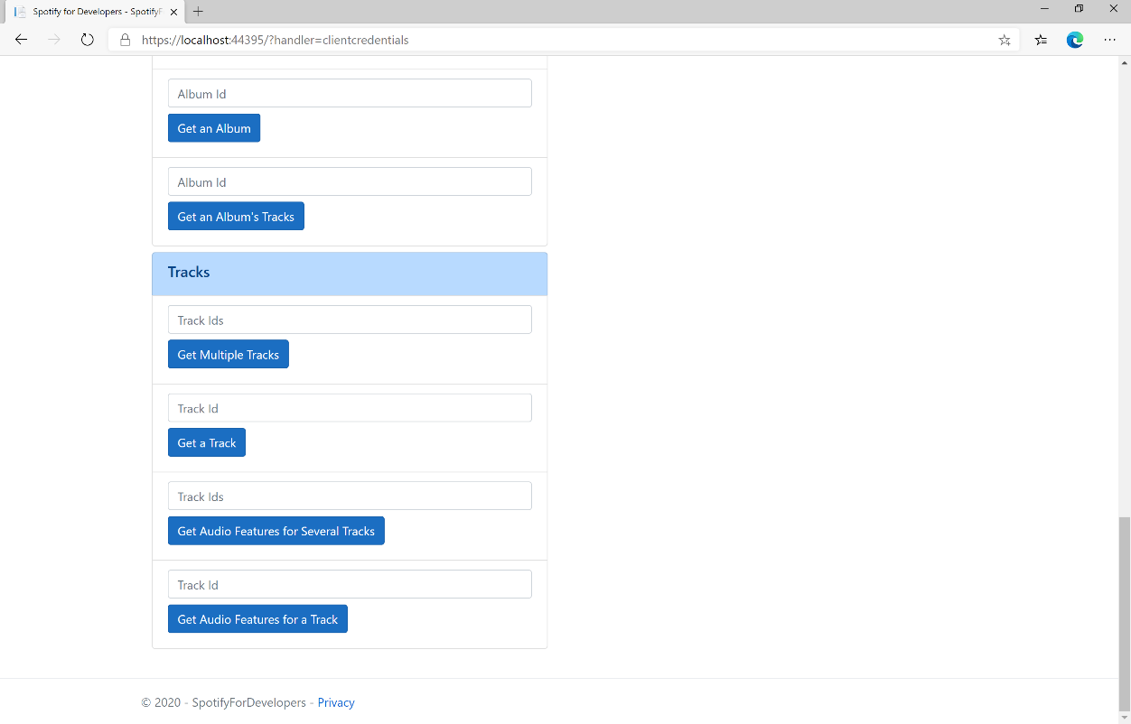

### Step 10

You can then enter an **Album Id** from **Get All New Releases** select **Get an Album's Tracks** and copy a **Track Id** to use and select **Get Audio Features for a Track** and scroll down to view **Results** like the following:

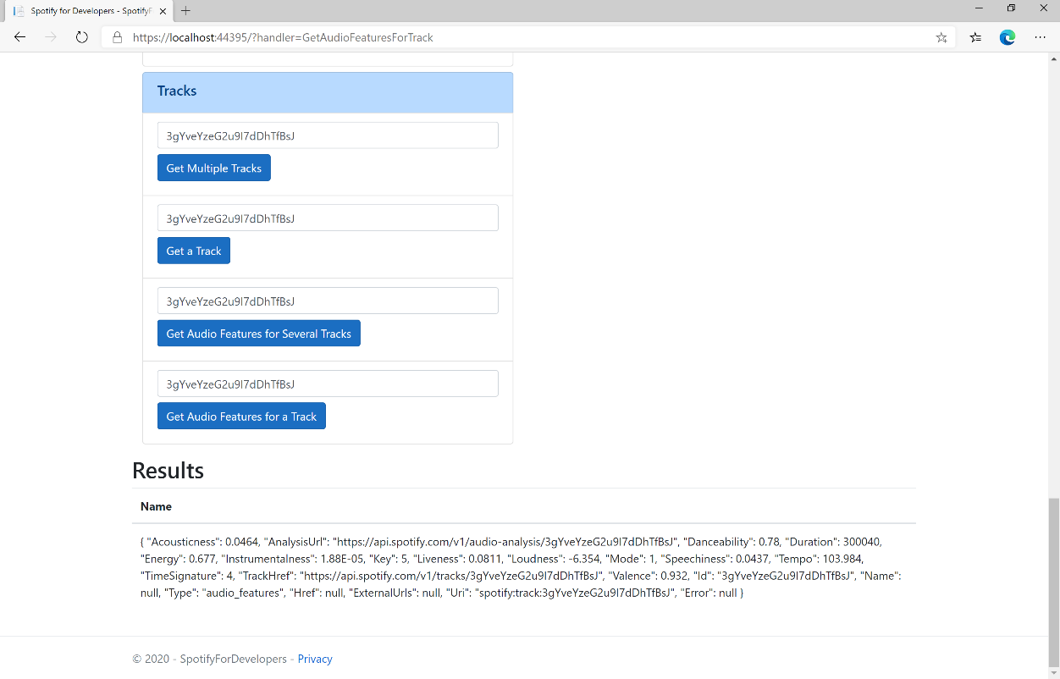

### Step 11

|  |  |
| --- | --- |
|  | You can stop the **web application** in **Visual Studio 2019** by selecting the **Stop debugging** button |

### Step 12

|  |  |
| --- | --- |
|  | You can choose to exit **Visual Studio 2019** by selecting the **Close** button in the top right of the **application** as that completes thispart of the workshop |

## Get Audio Analysis for a Track

Get a detailed audio analysis for a single track identified by its unique Spotify Id.

|  |  |
| --- | --- |
| GET https://api.spotify.com/v1/audio-analysis/{id} | |
| Header | |
| Authorization | Valid Access Token from Spotify Accounts service |
| Path Parameter | |
| id | Spotify Id of the track |

|  |  |
| --- | --- |
| Header | Response |
| Success | |
| HTTP Status 200 OK | Audio Analysis Object |
| Error | |
| Error Code | Error Object |

### Step 1

|  |  |
| --- | --- |
|  | If you chose to close **Visual Studio 2019** previously, in **Windows 10** choose **Start**, and then from the **Start Menu** find and select **Visual Studio 2019** |
|  | Once done, from the **Get started** screen for **Visual Studio 2019** select **Open a project or solution** |
|  | Then locate and select **SpotifyForDevelopers.sln** and select **Open** if you don’t have this file already then please follow the previous parts of the workshop including **Getting Started**, **Authorisation Guide**, **Search** **&** **Browse** and **Artists, Albums & Tracks** |

### Step 2

|  |  |
| --- | --- |
|  | Once opened, in the **Solution Explorer** open the **Pages** section, then open the **Index.cshtml** section and select **Index.cshtml.cs** |

### Step 3

|  |  |
| --- | --- |
|  | Then from the **Menu** choose **View** and then **Open** |

### Step 4

In the **Code View** for **Index.cshtml.cs** below the **method** for public async Task<IActionResult> OnPostGetAudioFeaturesForTrackAsync(...) { ... } enter the following **method**:

|  |
| --- |
| public async Task<IActionResult> OnPostGetTrackAudioAnalysisAsync(string value)  {  LoadToken();  var result = await Api.GetTrackAudioAnalysisAsync(value);  if (result != null)  {  Results = new List<Result>() { new Result()  {  Name = System.Text.Json.JsonSerializer.Serialize(result,  new System.Text.Json.JsonSerializerOptions()  { WriteIndented = true })  }};  }  return Page();  } |

The **method** for OnPostGetTrackAudioAnalysisAsync is used to get **audio analysis** for **track** by **Track Id** on Spotify with the value and populate the **property** for Results accordingly.

### Step 5

|  |  |
| --- | --- |
|  | In the **Solution Explorer** in the **Pages** section select **Index.cshtml** |

### Step 6

|  |  |
| --- | --- |
|  | Then from the **Menu** choose **View** and then **Open** |

### Step 7

Once in the **Code View** for **Index.cshtml** above <!-- Tracks --> enter the following:

|  |
| --- |
| <li class="list-group-item">  <form **asp-page-handler**="GetTrackAudioAnalysis" method="post">  <input **asp-for**="Value" placeholder="Track Id" class="form-control mb-2" />  <button class="btn btn-primary mb-2">  Get Audio Analysis for a Track  </button>  </form>  </li> |

This form will **post** to the **method** for GetTrackAudioAnalysis with the Value as **Track Id** and will output to the **Results**.

### Step 8

|  |  |
| --- | --- |
|  | Finally, in **Visual Studio 2019** select **IIS Application** to run the **Web Application** |

### Step 9

Once the **Web Application** is running and you select **Client Credentials Flow Login** and scroll down you should see something like the following:

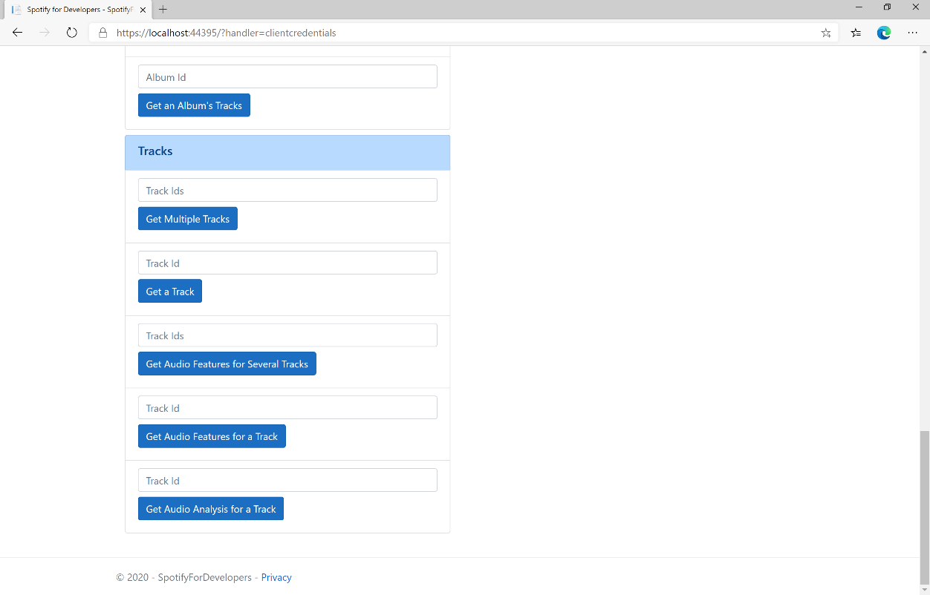

### Step 10

You can then enter an **Album Id** from **Get All New Releases** select **Get an Album's Tracks** and copy a **Track Id** to use and select **Get Audio Analysis for a Track** and scroll down to view **Results** like the following:

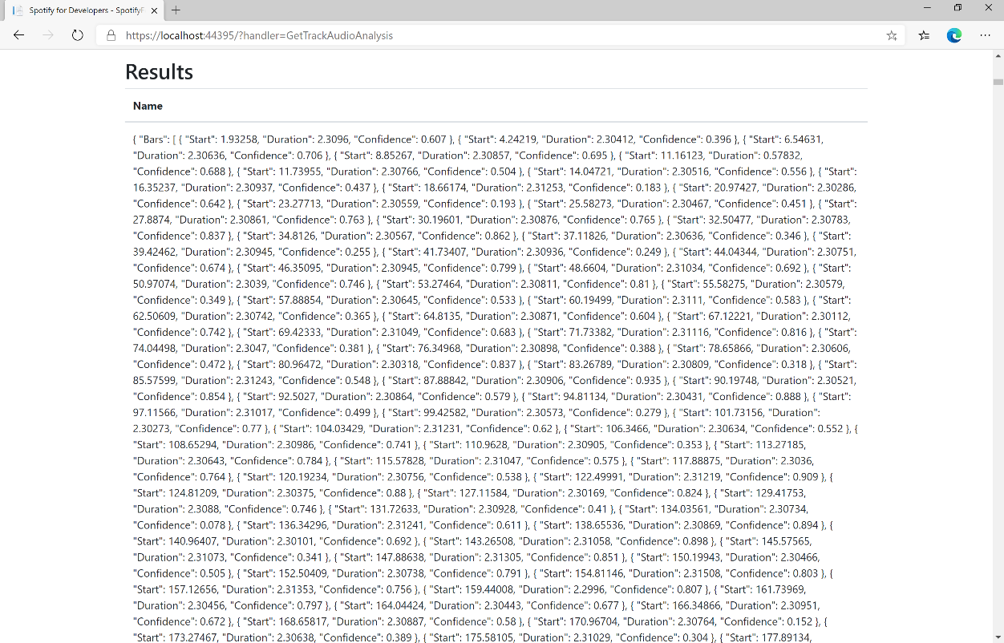

### Step 11

|  |  |
| --- | --- |
|  | You can stop the **web application** in **Visual Studio 2019** by selecting the **Stop debugging** button |

### Step 12

|  |  |
| --- | --- |
|  | You can exit **Visual Studio 2019** by selecting the **Close** button in the top right of the **application** as that completes thispart of the workshop |

# Episodes & Shows

## Get an Episode

Get Spotify catalogue information for a single episode identified by its unique Spotify Id.

|  |  |
| --- | --- |
| GET https://api.spotify.com/v1/episodes/{id} | |
| Header | |
| Authorization | Valid Access Token or User Token from Spotify Accounts service with **user-read-playback-position** scope to read user’s resume points on episode objects |
| Path Parameter | |
| id | The Spotify Id for the episode |
| market | An ISO 3166-1 alpha-2 country code. If a country code is specified, only shows and episodes that are available in that market will be returned.  If a valid user access token is specified in the request header, the country associated with the user account will take priority over this parameter. If neither market nor user country are provided, the content is considered unavailable for the client. Users can view the country that is associated with their account in the account settings. |

|  |  |
| --- | --- |
| Header | Response |
| Success | |
| HTTP Status 200 OK | Episode Object |
| Error | |
| Error Code | Error Object |

### Step 1

|  |  |
| --- | --- |
|  | In **Windows 10** choose **Start**, and then from the **Start Menu** find and select **Visual Studio 2019** |
|  | Once done, from the **Get started** screen for **Visual Studio 2019** select **Open a project or solution** |
|  | Then locate and select **SpotifyForDevelopers.sln** and select **Open** if you don’t have this file already then please follow the previous parts of the workshop including **Getting Started**, **Authorisation Guide**, **Search** **&** **Browse** and **Artists, Albums & Tracks** |

### Step 2

|  |  |
| --- | --- |
|  | Once opened, in the **Solution Explorer** open the **Pages** section, then open the **Index.cshtml** section and select **Index.cshtml.cs** |

### Step 3

|  |  |
| --- | --- |
|  | Then from the **Menu** choose **View** and then **Open** |

### Step 4

In the **Code View** for **Index.cshtml.cs** below the **method** for public async Task<IActionResult> OnPostGetTrackAudioAnalysisAsync(...) { ... } enter the following **method**:

|  |
| --- |
| public async Task<IActionResult> OnPostGetEpisodeAsync(string value)  {  LoadToken();  var result = await Api.GetEpisodeAsync(value, country);  if (result != null)  {  Results = new List<Result> { new Result()  {  Id = result.Id,  Name = result.Name,  Image = result?.Images?.FirstOrDefault()?.Url  }};  }  return Page();  } |

The **method** for OnPostGetEpisodeAsync is used to get an **episode** by **Episode Id** on Spotify with the value and populate the **property** for Results accordingly.

### Step 5

|  |  |
| --- | --- |
|  | In the **Solution Explorer** in the **Pages** section select **Index.cshtml** |

### Step 6

|  |  |
| --- | --- |
|  | Then from the **Menu** choose **View** and then **Open** |

### Step 7

Once in the **Code View** for **Index.cshtml** above <!-- Spotify Web API App Authorisation --> enter the following:

|  |
| --- |
| <ul class="list-group mb-2">  <li class="list-group-item list-group-item-primary">  <h5 class="list-group-item-heading">Episodes</h5>  </li>  <li class="list-group-item">  <form **asp-page-handler**="GetEpisode" method="post">  <input **asp-for**="Value" placeholder="Episode Id" class="form-control mb-2" />  <button class="btn btn-primary mb-2">  Get an Episode  </button>  </form>  </li>  <!-- Episodes -->  </ul> |

This form will **post** to the **method** for GetEpisode with the Value as **Episode Id** and will output to the **Results**.

### Step 8

|  |  |
| --- | --- |
|  | Finally, in **Visual Studio 2019** select **IIS Application** to run the **Web Application** |

### Step 9

Once the **Web Application** is running and you select **Client Credentials Flow Login** and scroll down you should see something like the following:

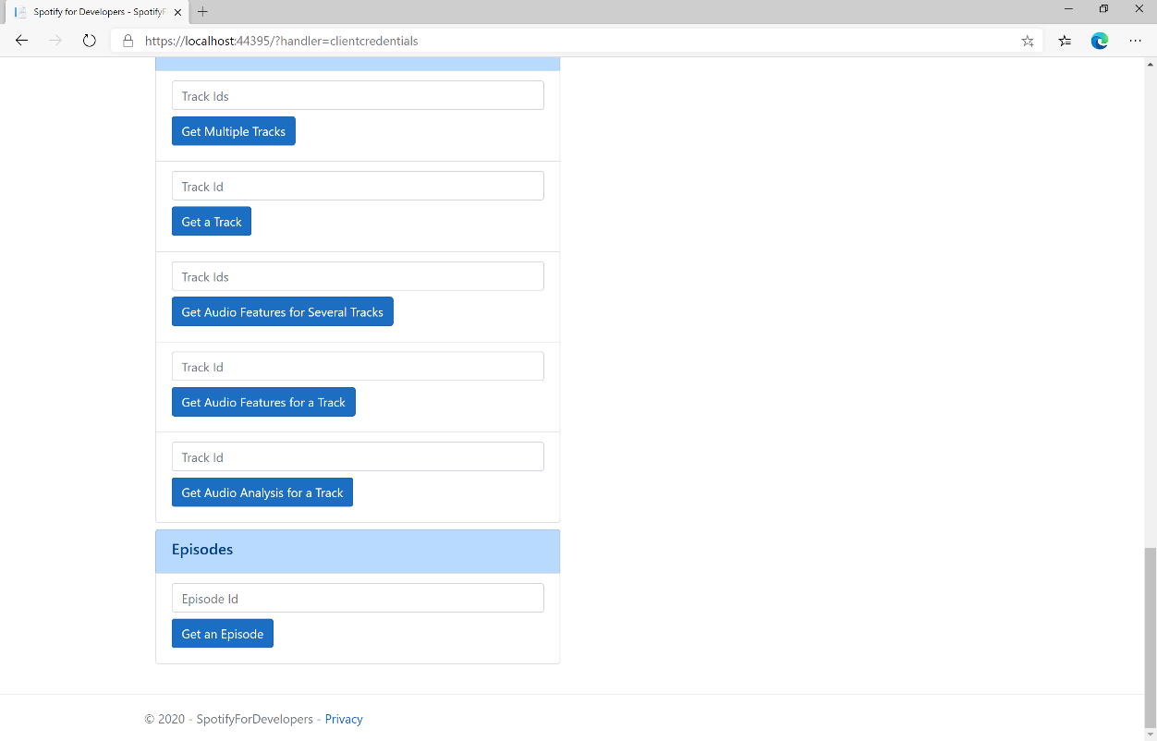

### Step 10

You can get an **Episode Id** by using **Search for an Item** and pick **Episodes** then into **Query** enter a **Podcast Episode** then copy an **Episode Id** to use and select **Get an Episode** and scroll down to view **Results** like the following:

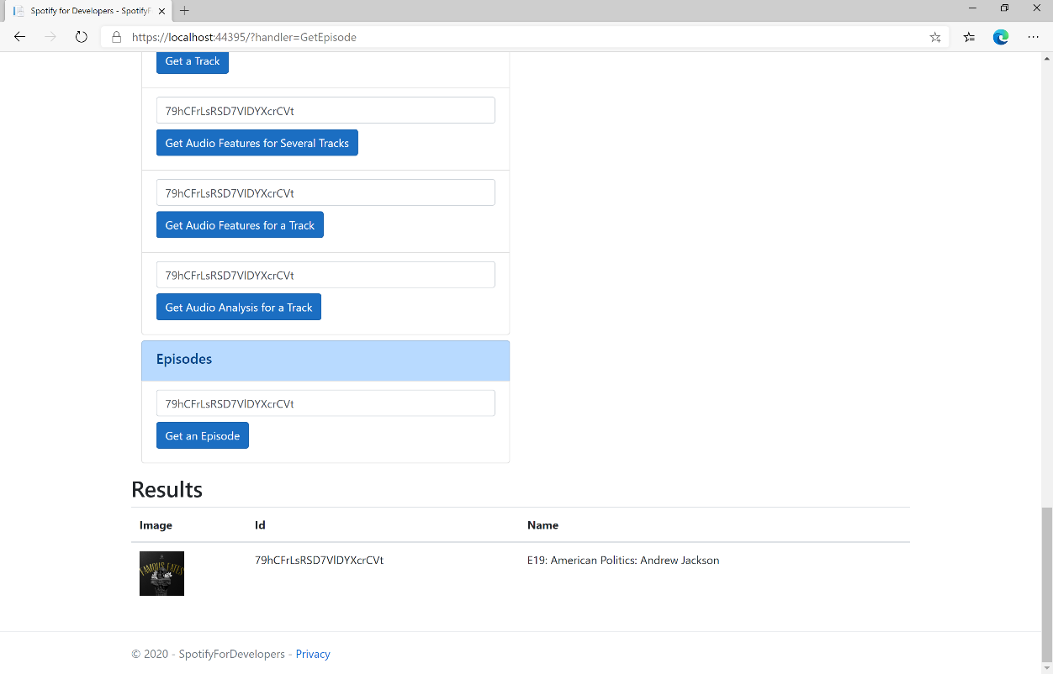

### Step 11

|  |  |
| --- | --- |
|  | You can stop the **web application** in **Visual Studio 2019** by selecting the **Stop debugging** button |

### Step 12

|  |  |
| --- | --- |
|  | You can choose to exit **Visual Studio 2019** by selecting the **Close** button in the top right of the **application** as that completes thispart of the workshop |

## Get Multiple Episodes

Get Spotify catalogue information for several episodes based on their Spotify Ids.

|  |  |
| --- | --- |
| GET https://api.spotify.com/v1/episodes | |
| Header | |
| Authorization | Valid Access Token or User Token from Spotify Accounts service with **user-read-playback-position** scope to read user’s resume points on episode objects |
| Path Parameter | |
| ids | A comma-separated list of the Spotify Ids for the episodes. Maximum: 50 IDs. |
| market | An ISO 3166-1 alpha-2 country code. If a country code is specified, only shows and episodes that are available in that market will be returned.  If a valid user access token is specified in the request header, the country associated with the user account will take priority over this parameter.  If neither market nor user country are provided, the content is considered unavailable for the client. Users can view the country that is associated with their account in the account settings. |

|  |  |
| --- | --- |
| Header | Response |
| Success | |
| HTTP Status 200 OK | Episodes as Array of Episode Object |
| Error | |
| Error Code | Error Object |

### Step 1

|  |  |
| --- | --- |
|  | If you chose to close **Visual Studio 2019** previously, in **Windows 10** choose **Start**, and then from the **Start Menu** find and select **Visual Studio 2019** |
|  | Once done, from the **Get started** screen for **Visual Studio 2019** select **Open a project or solution** |
|  | Then locate and select **SpotifyForDevelopers.sln** and select **Open** if you don’t have this file already then please follow the previous parts of the workshop including **Getting Started**, **Authorisation Guide**, **Search** **&** **Browse**, **Artists, Albums & Tracks** and **Episodes & Shows** |

### Step 2

|  |  |
| --- | --- |
|  | Once opened, in the **Solution Explorer** open the **Pages** section, then open the **Index.cshtml** section and select **Index.cshtml.cs** |

### Step 3

|  |  |
| --- | --- |
|  | Then from the **Menu** choose **View** and then **Open** |

### Step 4

In the **Code View** for **Index.cshtml.cs** below the **method** for public async Task<IActionResult> OnPostGetEpisodeAsync(...) { ... } enter the following **method**:

|  |
| --- |
| public async Task<IActionResult> OnPostGetMultipleEpisodesAsync(string value)  {  LoadToken();  var values = value.Split(",").ToList();  var results = await Api.GetMultipleEpisodesAsync(values, country);  if (results != null)  {  Results = results.Select(result => new Result()  {  Id = result.Id,  Name = result.Name,  Image = result?.Images?.FirstOrDefault()?.Url  });  }  return Page();  } |

The **method** for OnPostGetMultipleEpisodesAsync is used to get **episodes** by multiple **Episode Ids** on Spotify with the value and populate the **property** for Results accordingly.

### Step 5

|  |  |
| --- | --- |
|  | In the **Solution Explorer** in the **Pages** section select **Index.cshtml** |

### Step 6

|  |  |
| --- | --- |
|  | Then from the **Menu** choose **View** and then **Open** |

### Step 7

Once in the **Code View** for **Index.cshtml** above <!-- Episodes --> enter the following:

|  |
| --- |
| <li class="list-group-item">  <form **asp-page-handler**="GetMultipleEpisodes" method="post">  <input **asp-for**="Value" placeholder="Episode Ids" class="form-control mb-2" />  <button class="btn btn-primary mb-2">  Get Multiple Episodes  </button>  </form>  </li> |

This form will **post** to the **method** for GetMultipleEpisodes with the Value as **Episode Ids** and will output to the **Results**.

### Step 8

|  |  |
| --- | --- |
|  | Finally, in **Visual Studio 2019** select **IIS Application** to run the **Web Application** |

### Step 9

Once the **Web Application** is running and you select **Client Credentials Flow Login** and scroll down you should see something like the following:

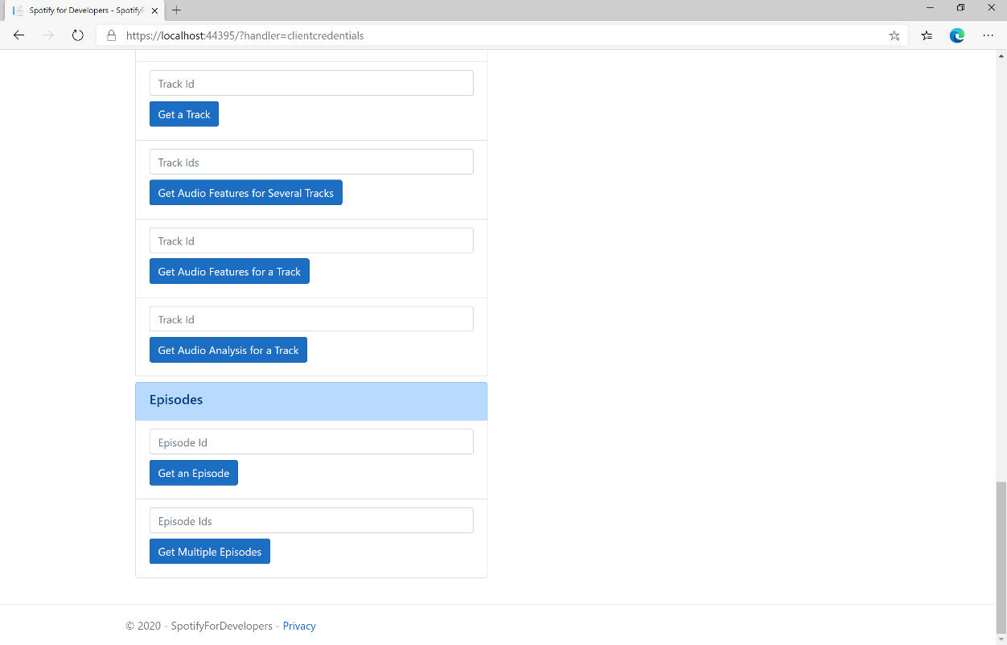

### Step 10

You can get some **Episode Ids** by using **Search for an Item** and pick **Episodes** then into **Query** enter some **Podcast Episodes** then copy some **Episode Ids** to use and select **Get Multiple Episodes** and scroll down to view **Results** like the following:

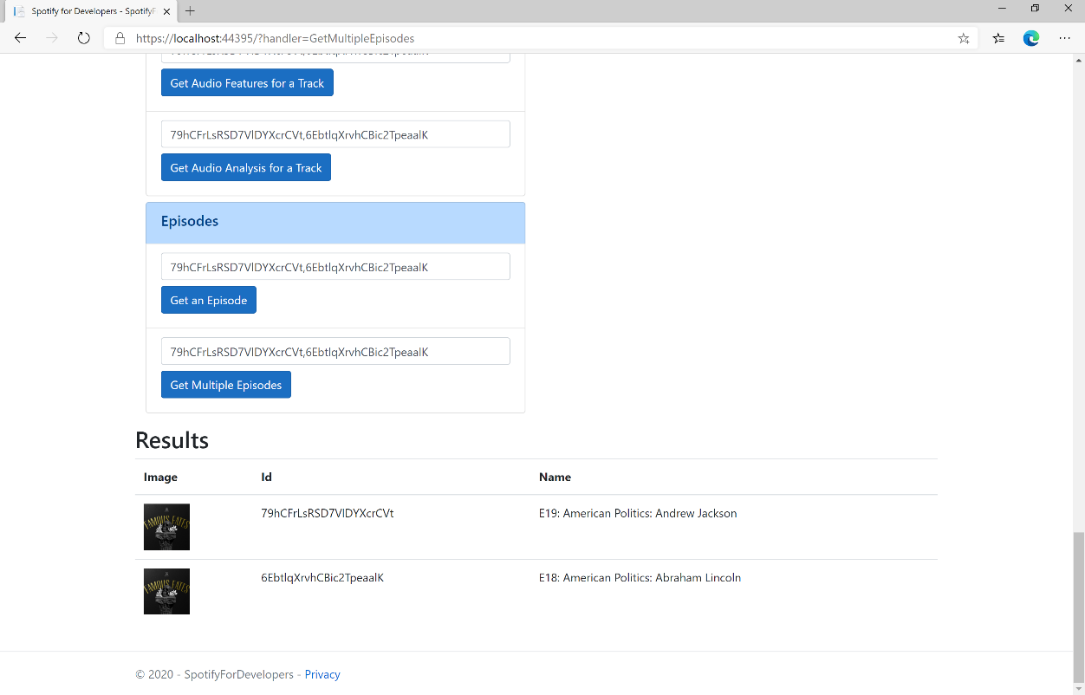

### Step 11

|  |  |
| --- | --- |
|  | You can stop the **web application** in **Visual Studio 2019** by selecting the **Stop debugging** button |

### Step 12

|  |  |
| --- | --- |
|  | You can choose to exit **Visual Studio 2019** by selecting the **Close** button in the top right of the **application** as that completes thispart of the workshop |

## Get a Show

Get Spotify catalogue information for a single show identified by its unique Spotify Id.

|  |  |
| --- | --- |
| GET https://api.spotify.com/v1/shows/{id} | |
| Header | |
| Authorization | Valid Access Token or User Token from Spotify Accounts service with **user-read-playback-position** scope to read user’s resume points on episode objects |
| Path Parameter | |
| id | The Spotify Id for the show |
| market | An ISO 3166-1 alpha-2 country code. If a country code is specified, only shows and episodes that are available in that market will be returned.  If a valid user access token is specified in the request header, the country associated with the user account will take priority over this parameter.  If neither market nor user country are provided, the content is considered unavailable for the client. Users can view the country that is associated with their account in the account settings. |

|  |  |
| --- | --- |
| Header | Response |
| Success | |
| HTTP Status 200 OK | Show Object |
| Error | |
| Error Code | Error Object |

### Step 1

|  |  |
| --- | --- |
|  | If you chose to close **Visual Studio 2019** previously, in **Windows 10** choose **Start**, and then from the **Start Menu** find and select **Visual Studio 2019** |
|  | Once done, from the **Get started** screen for **Visual Studio 2019** select **Open a project or solution** |
|  | Then locate and select **SpotifyForDevelopers.sln** and select **Open** if you don’t have this file already then please follow the previous parts of the workshop including **Getting Started**, **Authorisation Guide**, **Search** **&** **Browse**, **Artists, Albums & Tracks** and **Episodes & Shows** |

### Step 2

|  |  |
| --- | --- |
|  | Once opened, in the **Solution Explorer** open the **Pages** section, then open the **Index.cshtml** section and select **Index.cshtml.cs** |

### Step 3

|  |  |
| --- | --- |
|  | Then from the **Menu** choose **View** and then **Open** |

### Step 4

In the **Code View** for **Index.cshtml.cs** below the **method** for public async Task<IActionResult> OnPostGetMultipleEpisodesAsync(...) { ... } enter the following **method**:

|  |
| --- |
| public async Task<IActionResult> OnPostGetShowAsync(string value)  {  LoadToken();  var result = await Api.GetShowAsync(value, country);  if (result != null)  {  Results = new List<Result> { new Result()  {  Id = result.Id,  Name = result.Name,  Image = result?.Images?.FirstOrDefault()?.Url  }};  }  return Page();  } |

The **method** for OnPostGetShowAsync is used to get a **show** by **Show Id** on Spotify with the value and populate the **property** for Results accordingly.

### Step 5

|  |  |
| --- | --- |
|  | In the **Solution Explorer** in the **Pages** section select **Index.cshtml** |

### Step 6

|  |  |
| --- | --- |
|  | Then from the **Menu** choose **View** and then **Open** |

### Step 7

Once in the **Code View** for **Index.cshtml** above <!-- Spotify Web API App Authorisation --> enter the following:

|  |
| --- |
| <ul class="list-group mb-2">  <li class="list-group-item list-group-item-primary">  <h5 class="list-group-item-heading">Shows</h5>  </li>  <li class="list-group-item">  <form **asp-page-handler**="GetShow" method="post">  <input **asp-for**="Value" placeholder="Show Id" class="form-control mb-2" />  <button class="btn btn-primary mb-2">  Get a Show  </button>  </form>  </li>  <!-- Shows -->  </ul> |

This form will **post** to the **method** for GetShow with the Value as **Show Id** and will output to the **Results**.

### Step 8

|  |  |
| --- | --- |
|  | Finally, in **Visual Studio 2019** select **IIS Application** to run the **Web Application** |

### Step 9

Once the **Web Application** is running and you select **Client Credentials Flow Login** and scroll down you should see something like the following:

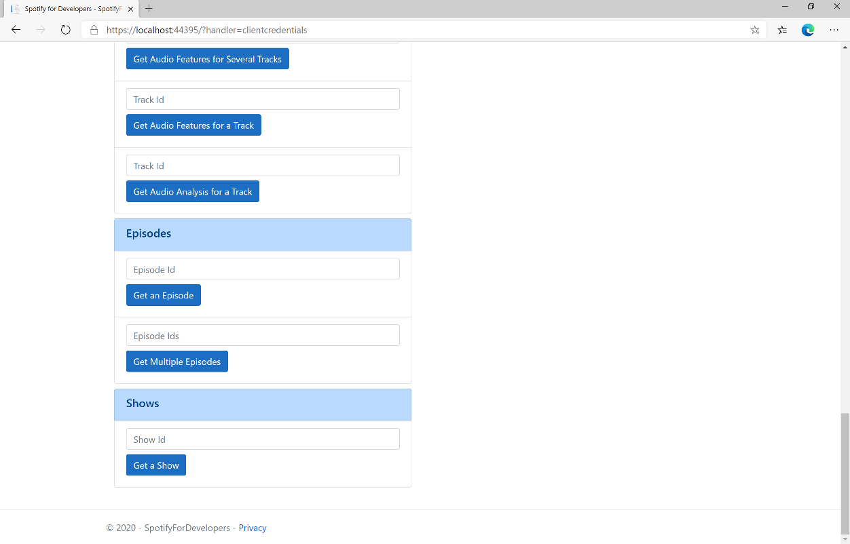

### Step 10

You can get a **Show Id** by using **Search for an Item** and pick **Shows** then into **Query** enter a **Podcast Name** then copy a **Show Id** to use and select **Get a Show** and scroll down to view **Results** like the following:

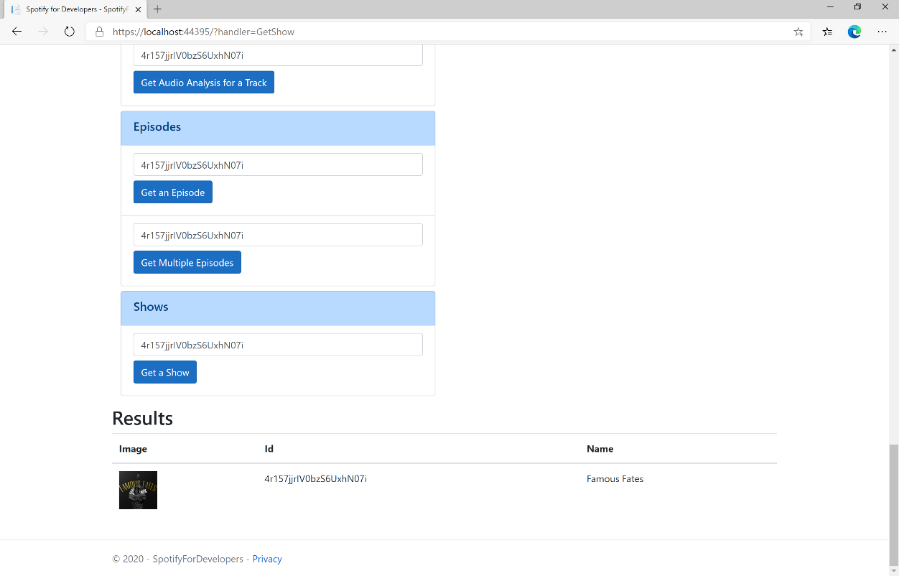

### Step 11

|  |  |
| --- | --- |
|  | You can stop the **web application** in **Visual Studio 2019** by selecting the **Stop debugging** button |

### Step 12

|  |  |
| --- | --- |
|  | You can choose to exit **Visual Studio 2019** by selecting the **Close** button in the top right of the **application** as that completes thispart of the workshop |

## Get Multiple Shows

Get Spotify catalogue information for several shows based on their Spotify Ids.

|  |  |
| --- | --- |
| GET https://api.spotify.com/v1/episodes | |
| Header | |
| Authorization | Valid Access Token or User Token from Spotify Accounts service with **user-read-playback-position** scope to read user’s resume points on episode objects |
| Path Parameter | |
| ids | A comma-separated list of the Spotify Ids for the shows. Maximum: 50 Ids. |
| market | An ISO 3166-1 alpha-2 country code. If a country code is specified, only shows and episodes that are available in that market will be returned.  If a valid user access token is specified in the request header, the country associated with the user account will take priority over this parameter.  If neither market nor user country are provided, the content is considered unavailable for the client. Users can view the country that is associated with their account in the account settings. |

|  |  |
| --- | --- |
| Header | Response |
| Success | |
| HTTP Status 200 OK | Shows as Array of Show Object |
| Error | |
| Error Code | Error Object |

### Step 1

|  |  |
| --- | --- |
|  | If you chose to close **Visual Studio 2019** previously, in **Windows 10** choose **Start**, and then from the **Start Menu** find and select **Visual Studio 2019** |
|  | Once done, from the **Get started** screen for **Visual Studio 2019** select **Open a project or solution** |
|  | Then locate and select **SpotifyForDevelopers.sln** and select **Open** if you don’t have this file already then please follow the previous parts of the workshop including **Getting Started**, **Authorisation Guide**, **Search** **&** **Browse**, **Artists, Albums & Tracks** and **Episodes & Shows** |

### Step 2

|  |  |
| --- | --- |
|  | Once opened, in the **Solution Explorer** open the **Pages** section, then open the **Index.cshtml** section and select **Index.cshtml.cs** |

### Step 3

|  |  |
| --- | --- |
|  | Then from the **Menu** choose **View** and then **Open** |

### Step 4

In the **Code View** for **Index.cshtml.cs** below the **method** for public async Task<IActionResult> OnPostGetShowAsync(...) { ... } enter the following **method**:

|  |
| --- |
| public async Task<IActionResult> OnPostGetMultipleShowsAsync(string value)  {  LoadToken();  var values = value.Split(",").ToList();  var results = await Api.GetMultipleShowsAsync(values, country);  if (results != null)  {  Results = results.Select(result => new Result()  {  Id = result.Id,  Name = result.Name,  Image = result?.Images?.FirstOrDefault()?.Url  });  }  return Page();  } |

The **method** for OnPostGetMultipleShowsAsync is used to get **shows** by multiple **Show Ids** on Spotify with the value and populate the **property** for Results accordingly.

### Step 5

|  |  |
| --- | --- |
|  | In the **Solution Explorer** in the **Pages** section select **Index.cshtml** |

### Step 6

|  |  |
| --- | --- |
|  | Then from the **Menu** choose **View** and then **Open** |

### Step 7

Once in the **Code View** for **Index.cshtml** above <!-- Shows --> enter the following:

|  |
| --- |
| <li class="list-group-item">  <form **asp-page-handler**="GetMultipleShows" method="post">  <input **asp-for**="Value" placeholder="Show Ids" class="form-control mb-2" />  <button class="btn btn-primary mb-2">  Get Multiple Shows  </button>  </form>  </li> |

This form will **post** to the **method** for GetMultipleShows with the Value as **Show Ids** and will output to the **Results**.

### Step 8

|  |  |
| --- | --- |
|  | Finally, in **Visual Studio 2019** select **IIS Application** to run the **Web Application** |

### Step 9

Once the **Web Application** is running and you select **Client Credentials Flow Login** and scroll down you should see something like the following:

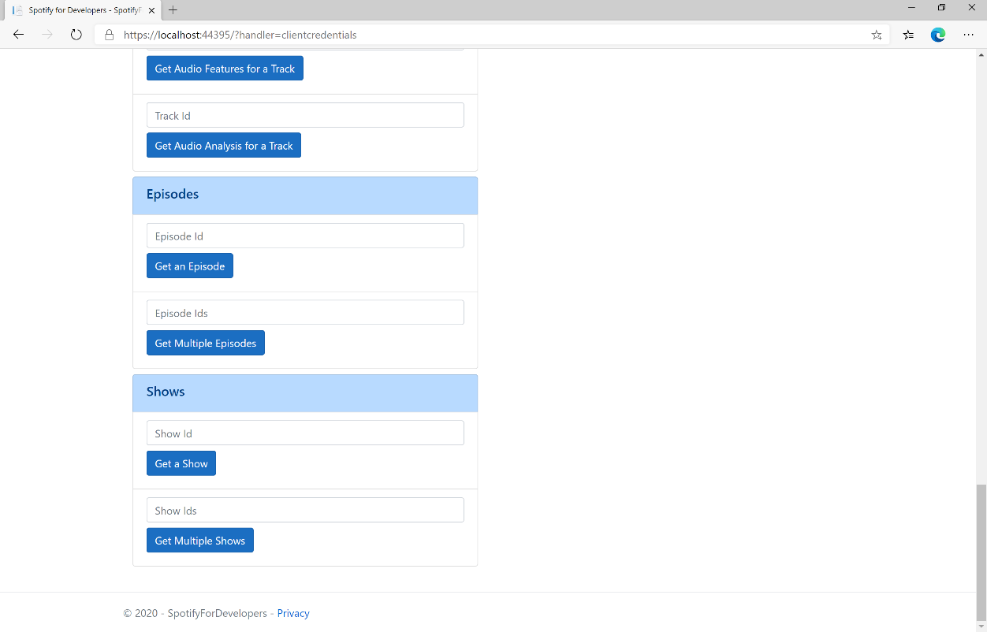

### Step 10

You can get some **Shows Ids** by using **Search for an Item** and pick **Shows** then into **Query** enter some **Podcast Names** then copy some **Shows Ids** to use and select **Get Multiple Shows** and scroll down to view **Results** like the following:

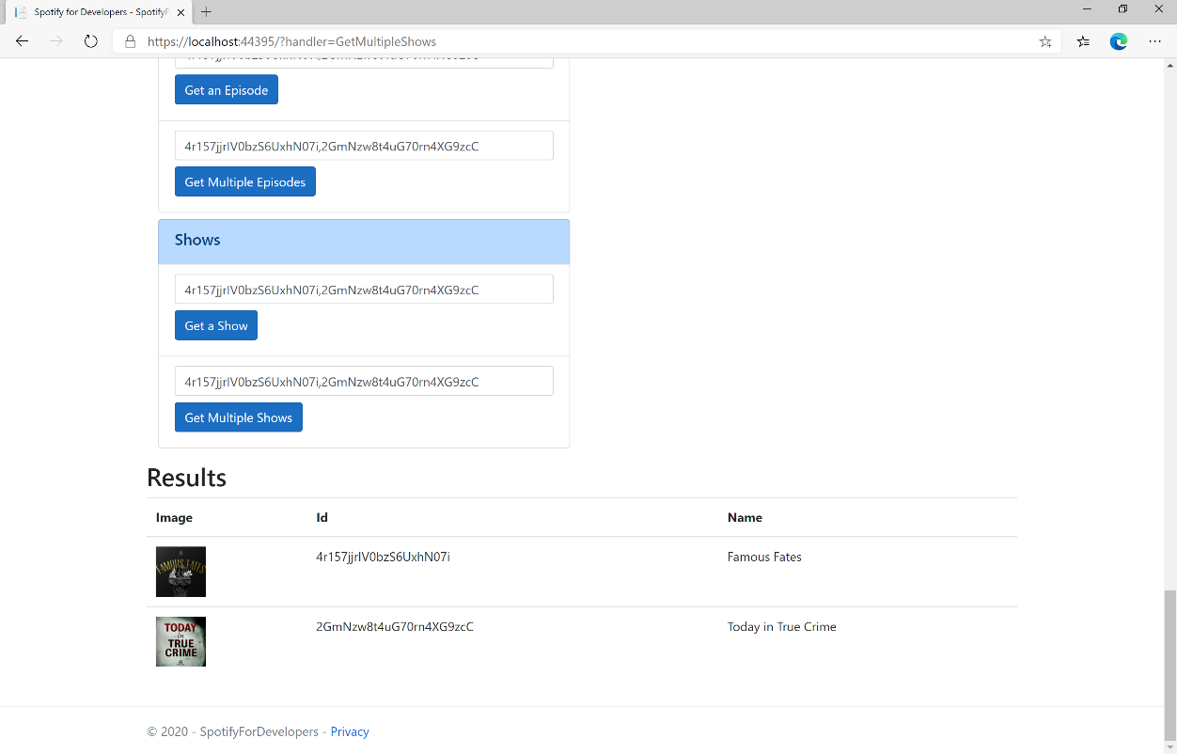

### Step 11

|  |  |
| --- | --- |
|  | You can stop the **web application** in **Visual Studio 2019** by selecting the **Stop debugging** button |

### Step 12

|  |  |
| --- | --- |
|  | You can choose to exit **Visual Studio 2019** by selecting the **Close** button in the top right of the **application** as that completes thispart of the workshop |

## Get a Show's Episodes

Get Spotify catalogue information about a show’s episodes. Optional parameters can be used to limit the number of episodes returned.

|  |  |
| --- | --- |
| GET https://api.spotify.com/v1/shows/{id}/episodes | |
| Header | |
| Authorization | Valid Access Token or User Token from Spotify Accounts service with **user-read-playback-position** scope to read user’s resume points on episode objects |
| Path Parameter | |
| id | The Spotify Id for the show |
| limit | The maximum number of episodes to return. Default: 20. Minimum: 1. Maximum: 50. |
| offset | The index of the first episode to return. Default: 0 (the first object). Use with limit to get the next set of episodes. |
| market | An ISO 3166-1 alpha-2 country code. If a country code is specified, only shows and episodes that are available in that market will be returned.  If a valid user access token is specified in the request header, the country associated with the user account will take priority over this parameter.  Note: If neither market nor user country are provided, the content is considered unavailable for the client.  Users can view the country that is associated with their account in the account settings. |

|  |  |
| --- | --- |
| Header | Response |
| Success | |
| HTTP Status 200 OK | Array of Simplified Episode Objects wrapped in a Paging Object |
| Error | |
| Error Code | Error Object |

### Step 1

|  |  |
| --- | --- |
|  | If you chose to close **Visual Studio 2019** previously, in **Windows 10** choose **Start**, and then from the **Start Menu** find and select **Visual Studio 2019** |
|  | Once done, from the **Get started** screen for **Visual Studio 2019** select **Open a project or solution** |
|  | Then locate and select **SpotifyForDevelopers.sln** and select **Open** if you don’t have this file already then please follow the previous parts of the workshop including **Getting Started**, **Authorisation Guide**, **Search** **&** **Browse**, **Artists, Albums & Tracks** and **Episodes & Shows** |

### Step 2

|  |  |
| --- | --- |
|  | Once opened, in the **Solution Explorer** open the **Pages** section, then open the **Index.cshtml** section and select **Index.cshtml.cs** |

### Step 3

|  |  |
| --- | --- |
|  | Then from the **Menu** choose **View** and then **Open** |

### Step 4

In the **Code View** for **Index.cshtml.cs** below the **method** for public async Task<IActionResult> OnPostGetMultipleShowsAsync(...) { ... } enter the following **method**:

|  |
| --- |
| public async Task<IActionResult> OnPostGetShowEpisodesAsync(string value)  {  LoadToken();  var results = await Api.GetShowEpisodesAsync(value, country);  if (results != null)  {  Results = results.Items.Select(result => new Result()  {  Id = result.Id,  Name = result.Name,  Image = result?.Images?.FirstOrDefault()?.Url  });  }  return Page();  } |

The **method** for OnPostGetShowEpisodesAsync is used to get **episodes** by **Show Id** on Spotify with the value and populate the **property** for Results accordingly.

### Step 5

|  |  |
| --- | --- |
|  | In the **Solution Explorer** in the **Pages** section select **Index.cshtml** |

### Step 6

|  |  |
| --- | --- |
|  | Then from the **Menu** choose **View** and then **Open** |

### Step 7

Once in the **Code View** for **Index.cshtml** above <!-- Shows --> enter the following:

|  |
| --- |
| <li class="list-group-item">  <form **asp-page-handler**="GetShowEpisodes" method="post">  <input **asp-for**="Value" placeholder="Show Id" class="form-control mb-2" />  <button class="btn btn-primary mb-2">  Get a Show's Episodes  </button>  </form>  </li> |

This form will **post** to the **method** for GetShowEpisodes with the Value as **Show Id** and will output to the **Results**.

### Step 8

|  |  |
| --- | --- |
|  | Finally, in **Visual Studio 2019** select **IIS Application** to run the **Web Application** |

### Step 9

Once the **Web Application** is running and you select **Client Credentials Flow Login** and scroll down you should see something like the following:

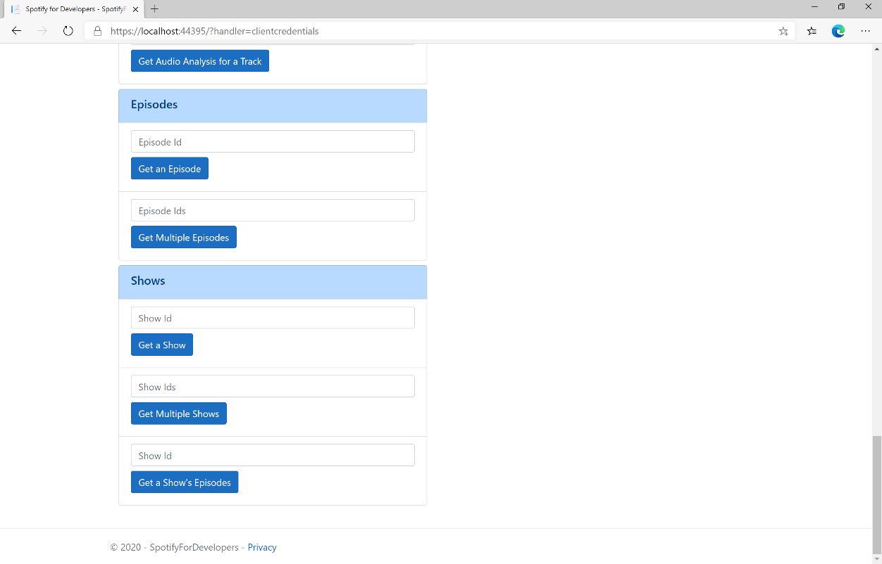

### Step 10

You can get a **Show Id** by using **Search for an Item** and pick **Shows** then into **Query** enter a **Podcast Name** then copy a **Show Id** to use and select **Get a Show's Episodes** and scroll down to view **Results** like the following:

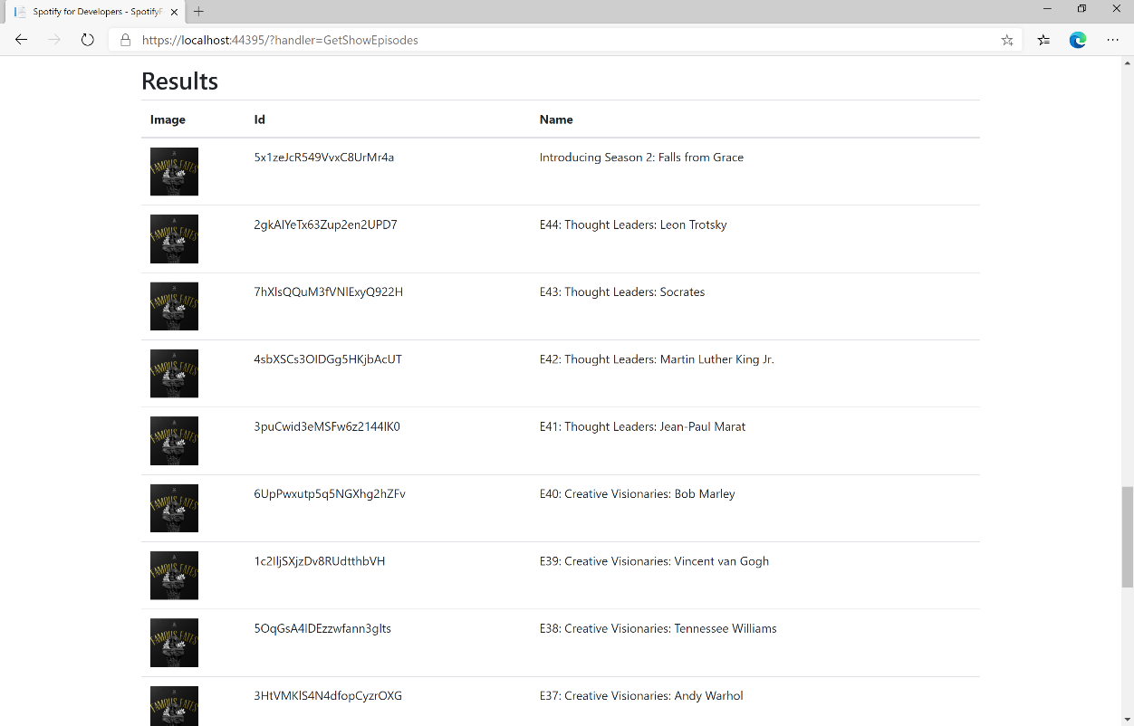

### Step 11

|  |  |
| --- | --- |
|  | You can stop the **web application** in **Visual Studio 2019** by selecting the **Stop debugging** button |

### Step 12

|  |  |
| --- | --- |
|  | You can exit **Visual Studio 2019** by selecting the **Close** button in the top right of the **application** as that completes thispart of the workshop |

# Follow

## Follow Artists or Users

Add the current user as a follower of one or more artists or other Spotify users.

|  |  |
| --- | --- |
| PUT https://api.spotify.com/v1/me/following | |
| Header | |
| Authorization | User Token from Spotify Accounts service with **user-follow-modify** scope |
| Query Parameter | |
| type | Type of artist or user |
| ids | Comma-separated list of the artist or the user Spotify Ids - maximum 50 |

|  |  |
| --- | --- |
| Header | Response |
| Success | |
| HTTP Status 204  No Content | Empty Response Body |
| Error | |
| Error Code | Error Object |

### Step 1

|  |  |
| --- | --- |
|  | In **Windows 10** choose **Start**, and then from the **Start Menu** find and select **Visual Studio 2019** |
|  | Once done, from the **Get started** screen for **Visual Studio 2019** select **Open a project or solution** |
|  | Then locate and select **SpotifyForDevelopers.sln** and select **Open** if you don’t have this file already then please follow the previous parts of the workshop including **Getting Started**, **Authorisation Guide**, **Search & Browse**, **Playlists & Artists**, **Albums & Tracks** and **Episodes & Shows** |

### Step 2

|  |  |
| --- | --- |
|  | Once opened, in the **Solution Explorer** open the **Pages** section, then open the **Index.cshtml** section and select **Index.cshtml.cs** |

### Step 3

|  |  |
| --- | --- |
|  | Then from the **Menu** choose **View** and then **Open** |

### Step 4

In the **Code View** for **Index.cshtml.cs** below the **method** for public async Task<IActionResult> OnPostGetShowEpisodesAsync(...) { ... } enter the following **method**:

|  |
| --- |
| public async Task<IActionResult> OnPostFollowArtistsOrUsersAsync(string value, FollowType option)  {  LoadToken();  var values = value.Split(",").ToList();  var result = await Api.FollowArtistsOrUsersAsync(values, option);  if (result != null)  {  Results = new List<Result>() { new Result()  {  Name = result.Success.ToString()  }};  }  return Page();  } |

The **method** for OnPostFollowArtistsOrUsersAsync is used to set the **following state** for an **artist** or **user** by **Artist Id** or **User Id** on Spotify with the value and selected option and populate the **property** for Results accordingly with the **success** of the operation.

### Step 5

|  |  |
| --- | --- |
|  | In the **Solution Explorer** in the **Pages** section select **Index.cshtml** |

### Step 6

|  |  |
| --- | --- |
|  | Then from the **Menu** choose **View** and then **Open** |

### Step 7

Once in the **Code View** for **Index.cshtml** above <!-- Spotify Web API User Authorisation --> enter the following:

|  |
| --- |
| <ul class="list-group mb-2">  <li class="list-group-item list-group-item-primary">  <h5 class="list-group-item-heading">Follow</h5>  </li>  <li class="list-group-item">  <form **asp-page-handler**="FollowArtistsOrUsers" method="post">  <select **asp-for**="Option" class="form-control mb-2"  **asp-items**="Html.GetEnumSelectList<Spotify.NetStandard.Enums.FollowType>()">  </select>  <input **asp-for**="Value" placeholder="Ids" class="form-control mb-2" />  <button class="btn btn-primary mb-2">  Follow Artists or Users  </button>  </form>  </li>  <!-- Follow -->  </ul> |

This form will **post** to the **method** for FollowArtistsOrUsers with the Value of the **Ids** and the Option for the **Artist** or **User** and will output to the **Results**.

### Step 8

|  |  |
| --- | --- |
|  | Finally, in **Visual Studio 2019** select **IIS Application** to run the **Web Application** |

### Step 9

Once the **Web Application** is running and you select **Authorisation Code Flow Login** or **Implicit Grant Flow Login** you should see something like the following:

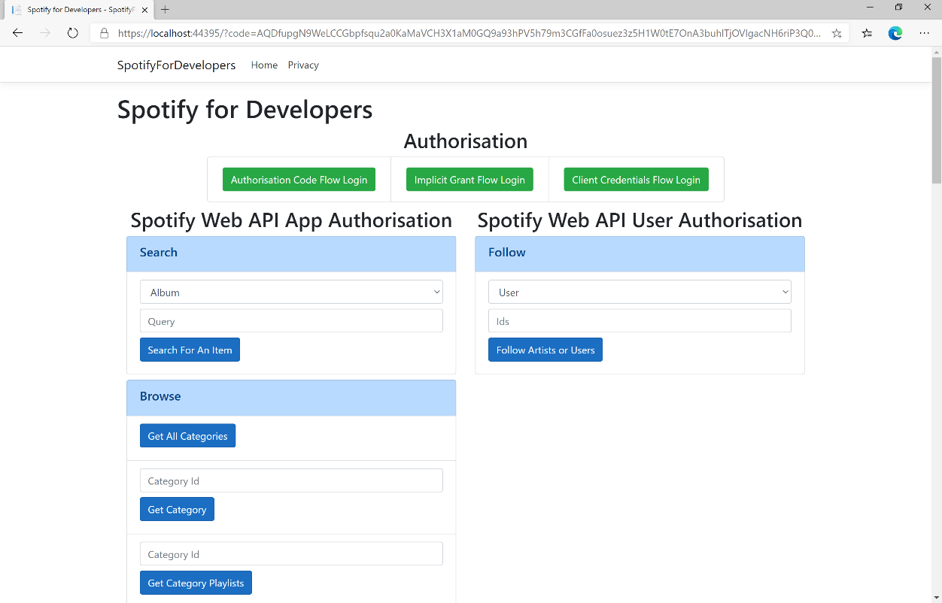

### Step 10

You can then enter an **Artist Id** from **Get All New Releases** and copy an **Artist Id** to use and above **Follow Artists or Users** choose **Artist** and then select **Follow Artists or Users** and scroll down to view **Results** like the following:

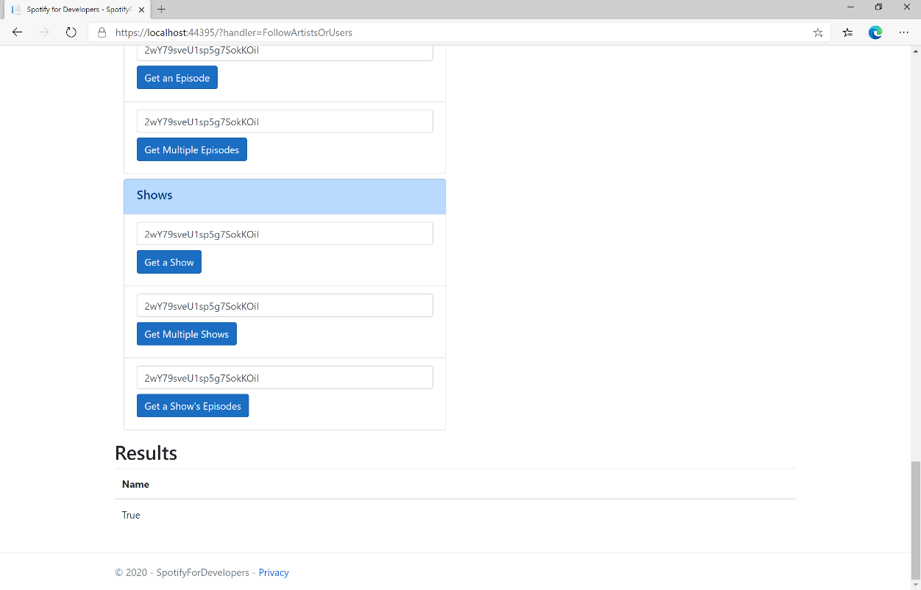

### Step 11

|  |  |
| --- | --- |
|  | You can stop the **web application** in **Visual Studio 2019** by selecting the **Stop debugging** button |

### Step 12

|  |  |
| --- | --- |
|  | You can choose to exit **Visual Studio 2019** by selecting the **Close** button in the top right of the **application** as that completes thispart of the workshop |

## Follow a Playlist

Add the current user as a follower of a playlist.

|  |  |
| --- | --- |
| PUT https://api.spotify.com/v1/playlists/{playlist_id}/followers | |
| Header | |
| Authorization | User Token from Spotify Accounts service with **user-follow-modify** scope |
| Path Parameter | |
| playlist_id | Spotify Id of the playlist |
| Body Parameter | |
| public | Defaults to true. If true the Playlist will be included in the User’s public Playlists, if false it will remain private |

|  |  |
| --- | --- |
| Header | Response |
| Success | |
| HTTP Status 200 OK | Empty Response Body |
| Error | |
| Error Code | Error Object |

### Step 1

|  |  |
| --- | --- |
|  | If you chose to close **Visual Studio 2019** previously, in **Windows 10** choose **Start**, and then from the **Start Menu** find and select **Visual Studio 2019** |
|  | Once done, from the **Get started** screen for **Visual Studio 2019** select **Open a project or solution** |
|  | Then locate and select **SpotifyForDevelopers.sln** and select **Open** if you don’t have this file already then please follow the previous parts of the workshop including **Getting Started**, **Authorisation Guide**, **Search & Browse**, **Playlists & Artists**, **Albums & Tracks**, **Episodes & Shows** and **Follow** |

### Step 2

|  |  |
| --- | --- |
|  | Once opened, in the **Solution Explorer** open the **Pages** section, then open the **Index.cshtml** section and select **Index.cshtml.cs** |

### Step 3

|  |  |
| --- | --- |
|  | Then from the **Menu** choose **View** and then **Open** |

### Step 4

In the **Code View** for **Index.cshtml.cs** below the **method** for public async Task<IActionResult> OnPostFollowArtistsOrUsersAsync(...) { ... } enter the following **method**:

|  |
| --- |
| public async Task<IActionResult> OnPostFollowPlaylistAsync(string value)  {  LoadToken();  var result = await Api.FollowPlaylistAsync(value);  if (result != null)  {  Results = new List<Result>() { new Result()  {  Name = result.Success.ToString()  }};  }  return Page();  } |

The **method** for OnPostFollowPlaylistAsync is used to set the **following state** for a **playlist** by **Playlist Id** on Spotify with the value and populate the **property** for Results accordingly with the **success** of the operation.

### Step 5

|  |  |
| --- | --- |
|  | In the **Solution Explorer** in the **Pages** section select **Index.cshtml** |

### Step 6

|  |  |
| --- | --- |
|  | Then from the **Menu** choose **View** and then **Open** |

### Step 7

Once in the **Code View** for **Index.cshtml** above <!-- Follow --> enter the following:

|  |
| --- |
| <li class="list-group-item">  <form **asp-page-handler**="FollowPlaylist" method="post">  <input **asp-for**="Value" placeholder="Playlist Id" class="form-control mb-2" />  <button class="btn btn-primary mb-2">  Follow a Playlist  </button>  </form>  </li> |

This form will **post** to the **method** for FollowPlaylist with the Value of the **Playlist Id** and will output to the **Results**.

### Step 8

|  |  |
| --- | --- |
|  | Finally, in **Visual Studio 2019** select **IIS Application** to run the **Web Application** |

### Step 9

Once the **Web Application** is running and you select **Authorisation Code Flow Login** or **Implicit Grant Flow Login** you should see something like the following:

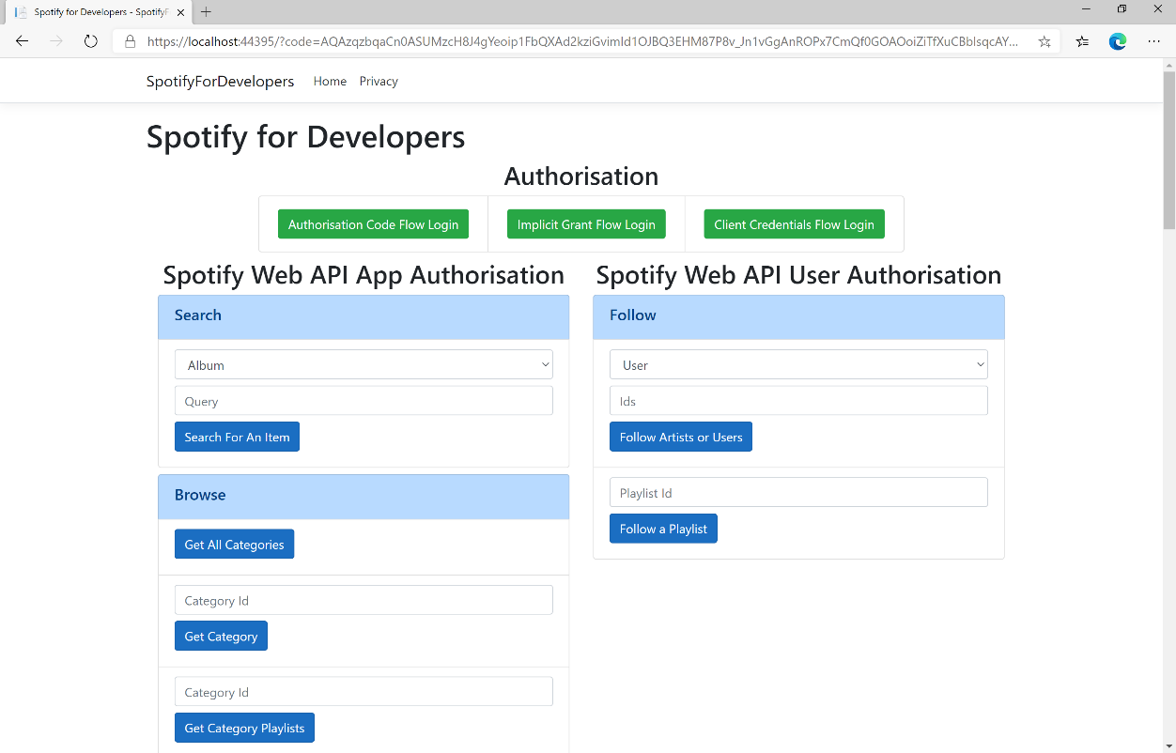

### Step 10

You can then enter a **Playlist Id** from **Get All Featured Playlists** and copy a **Playlist Id** to use and select **Follow a Playlist** and scroll down to view **Results** like the following:

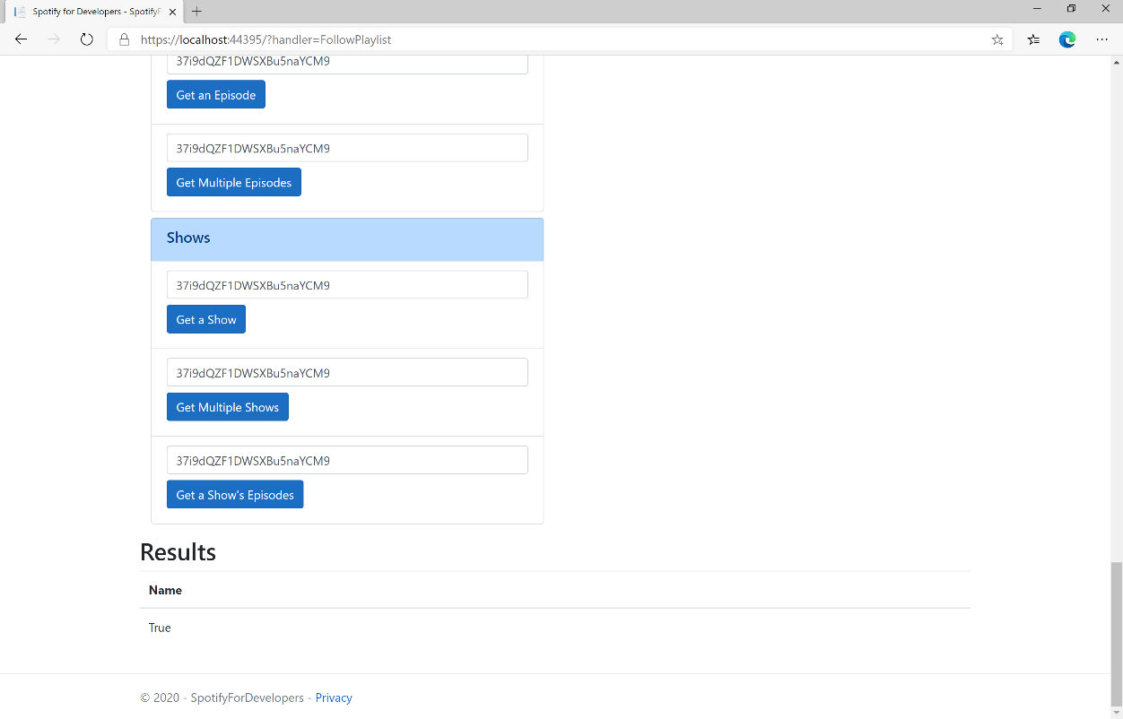

### Step 11

|  |  |
| --- | --- |
|  | You can stop the **web application** in **Visual Studio 2019** by selecting the **Stop debugging** button |

### Step 12

|  |  |
| --- | --- |
|  | You can choose to exit **Visual Studio 2019** by selecting the **Close** button in the top right of the **application** as that completes thispart of the workshop |

## Get Following State for Artists/Users

Check to see if the current user is following one or more artists or other Spotify users.

|  |  |
| --- | --- |
| GET https://api.spotify.com/v1/me/following/contains | |
| Header | |
| Authorization | User Token from Spotify Accounts service with **user-follow-read** scope |
| Query Parameter | |
| type | Type of artist or user |
| ids | Comma-separated list of the artist or the user Spotify Ids to check |

|  |  |
| --- | --- |
| Header | Response |
| Success | |
| HTTP Status 200 OK | Array of true or false values in same order as in which the Ids were provided |
| Error | |
| Error Code | Error Object |

### Step 1

|  |  |
| --- | --- |
|  | If you chose to close **Visual Studio 2019** previously, in **Windows 10** choose **Start**, and then from the **Start Menu** find and select **Visual Studio 2019** |
|  | Once done, from the **Get started** screen for **Visual Studio 2019** select **Open a project or solution** |
|  | Then locate and select **SpotifyForDevelopers.sln** and select **Open** if you don’t have this file already then please follow the previous parts of the workshop including **Getting Started**, **Authorisation Guide**, **Search & Browse**, **Playlists & Artists**, **Albums & Tracks**, **Episodes & Shows** and **Follow** |

### Step 2

|  |  |
| --- | --- |
|  | Once opened, in the **Solution Explorer** open the **Pages** section, then open the **Index.cshtml** section and select **Index.cshtml.cs** |

### Step 3

|  |  |
| --- | --- |
|  | Then from the **Menu** choose **View** and then **Open** |

### Step 4

In the **Code View** for **Index.cshtml.cs** below the **method** for public async Task<IActionResult> OnPostFollowPlaylistAsync(...) { ... } enter the following **method**:

|  |
| --- |
| public async Task<IActionResult> OnPostGetFollowingStateForArtistsOrUsersAsync(string value, FollowType option)  {  LoadToken();  var values = value.Split(",").ToList();  var results = await Api.GetFollowingStateForArtistsOrUsersAsync(values, option);  if (results != null)  {  Results = results.Select(result => new Result()  {  Name = result.ToString()  });  }  return Page();  } |

The **method** for OnPostGetFollowingStateForArtistsOrUsersAsync is used to get the **following state** for a **artist** or **user** by **Artist Id** or **User Id** on Spotify with the value and selected option and populate the **property** for Results accordingly.

### Step 5

|  |  |
| --- | --- |
|  | In the **Solution Explorer** in the **Pages** section select **Index.cshtml** |

### Step 6

|  |  |
| --- | --- |
|  | Then from the **Menu** choose **View** and then **Open** |

### Step 7

Once in the **Code View** for **Index.cshtml** above <!-- Follow --> enter the following:

|  |
| --- |
| <li class="list-group-item">  <form **asp-page-handler**="GetFollowingStateForArtistsOrUsers" method="post">  <select **asp-for**="Option" class="form-control mb-2"  **asp-items**="Html.GetEnumSelectList<Spotify.NetStandard.Enums.FollowType>()">  </select>  <input **asp-for**="Value" placeholder="Ids" class="form-control mb-2" />  <button class="btn btn-primary mb-2">  Get Following State for Artists or Users  </button>  </form>  </li> |

This form will **post** to the **method** for GetFollowingStateForArtistsOrUsers with the Value of the **Ids** and the Option for the **Artist** or **User** and will output to the **Results**.

### Step 8

|  |  |
| --- | --- |
|  | Finally, in **Visual Studio 2019** select **IIS Application** to run the **Web Application** |

### Step 9

Once the **Web Application** is running and you select **Authorisation Code Flow Login** or **Implicit Grant Flow Login** you should see something like the following:

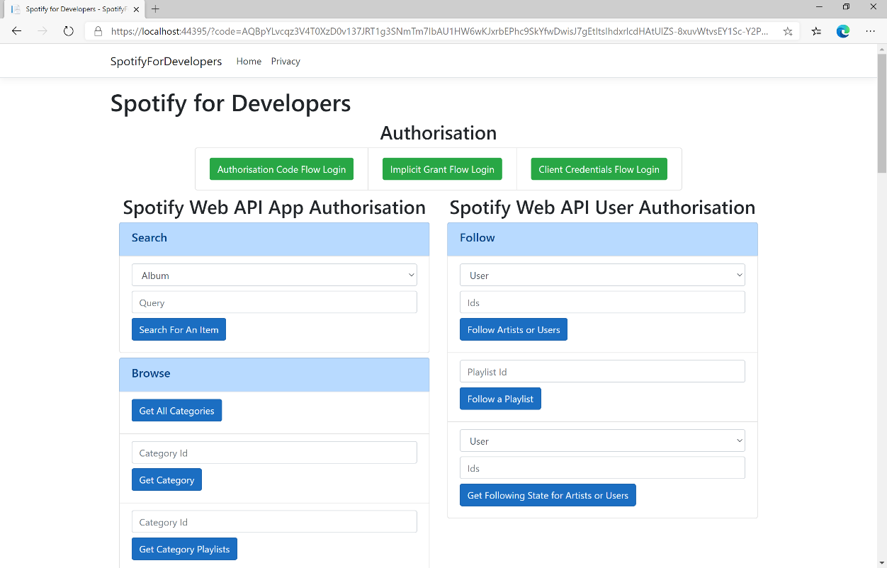

### Step 10

You can then enter an **Artist Id** from **Get All New Releases** or copy the same **Artist Id** from **Follow Artists or Users** to use and above **Get Following State for Artists or Users** choose **Artist** and then select **Get Following State for Artists or Users** and scroll down to view **Results** like the following:

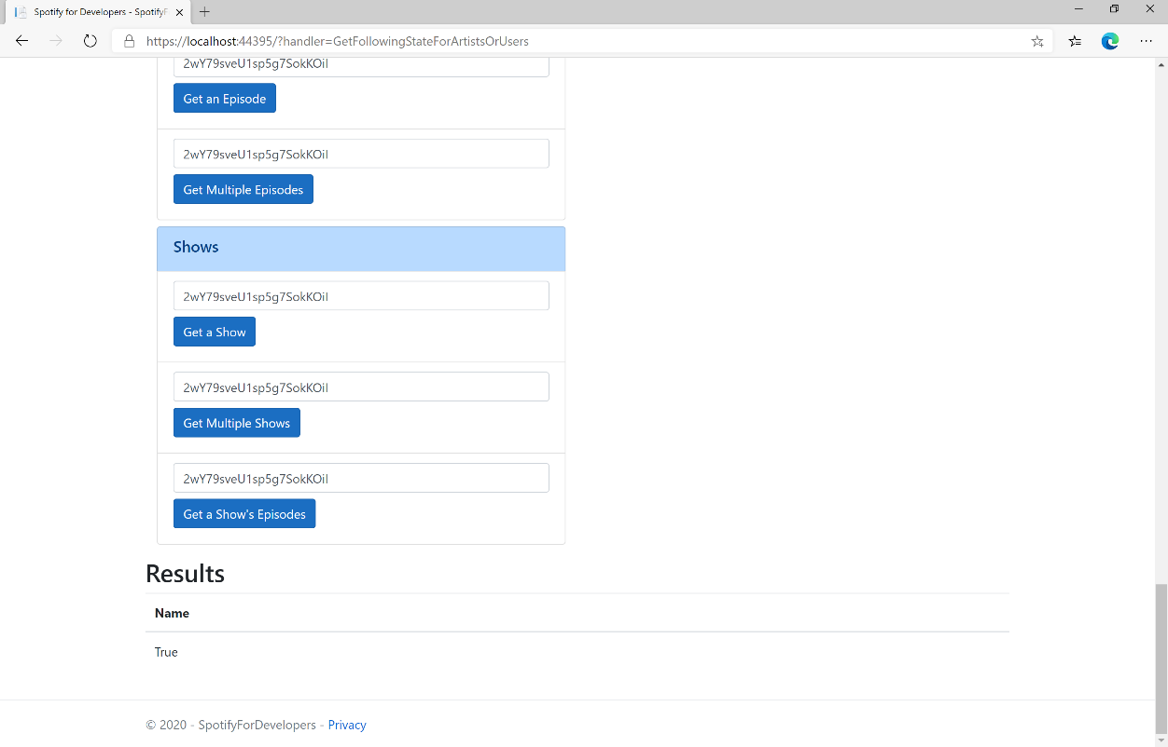

### Step 11

|  |  |
| --- | --- |
|  | You can stop the **web application** in **Visual Studio 2019** by selecting the **Stop debugging** button |

### Step 12

|  |  |
| --- | --- |
|  | You can choose to exit **Visual Studio 2019** by selecting the **Close** button in the top right of the **application** as that completes thispart of the workshop |

## Check if Users Follow a Playlist

Check to see if one or more Spotify users are following a specified playlist.

|  |  |
| --- | --- |
| GET https://api.spotify.com/v1/playlists/{playlist_id}/followers/contains | |
| Header | |
| Authorization | User Token from Spotify Accounts service with **playlist-read-private** scope if a private playlist is requested |
| Path Parameter | |
| playlist_id | Spotify Id of the playlist. |
| Query Parameter | |
| ids | Comma-separated list of Spotify User Ids you want to check to see if they follow the playlist |

|  |  |
| --- | --- |
| Header | Response |
| Success | |
| HTTP Status 200 OK | Array of true or false values in same order as in which the Ids were provided |
| Error | |
| Error Code | Error Object |

### Step 1

|  |  |
| --- | --- |
|  | If you chose to close **Visual Studio 2019** previously, in **Windows 10** choose **Start**, and then from the **Start Menu** find and select **Visual Studio 2019** |
|  | Once done, from the **Get started** screen for **Visual Studio 2019** select **Open a project or solution** |
|  | Then locate and select **SpotifyForDevelopers.sln** and select **Open** if you don’t have this file already then please follow the previous parts of the workshop including **Getting Started**, **Authorisation Guide**, **Search & Browse**, **Playlists & Artists**, **Albums & Tracks**, **Episodes & Shows** and **Follow** |

### Step 2

|  |  |
| --- | --- |
|  | Once opened, in the **Solution Explorer** open the **Pages** section, then open the **Index.cshtml** section and select **Index.cshtml.cs** |

### Step 3

|  |  |
| --- | --- |
|  | Then from the **Menu** choose **View** and then **Open** |

### Step 4

In the **Code View** for **Index.cshtml.cs** below the **method** for public async Task<IActionResult> OnPostGetFollowingStateForArtistsOrUsersAsync(...) { ... } enter the following **method**:

|  |
| --- |
| public async Task<IActionResult> OnPostCheckUsersFollowingPlaylistAsync(string value, string option)  {  LoadToken();  var values = value.Split(",").ToList();  var results = await Api.CheckUsersFollowingPlaylistAsync(values, option);  if (results != null)  {  Results = results.Select(result => new Result()  {  Name = result.ToString()  });  }  return Page();  } |

The **method** for OnPostCheckUsersFollowingPlaylistAsync is used to get the **following state** for a **playlist** by **Artist Id** for the **users** by **User Id** on Spotify with the value and option and populate the **property** for Results accordingly.

### Step 5

|  |  |
| --- | --- |
|  | In the **Solution Explorer** in the **Pages** section select **Index.cshtml** |

### Step 6

|  |  |
| --- | --- |
|  | Then from the **Menu** choose **View** and then **Open** |

### Step 7

Once in the **Code View** for **Index.cshtml** above <!-- Follow --> enter the following:

|  |
| --- |
| <li class="list-group-item">  <form **asp-page-handler**="CheckUsersFollowingPlaylist" method="post">  <input **asp-for**="Option" placeholder="Playlist Id" class="form-control mb-2" />  <input **asp-for**="Value" placeholder="User Ids" class="form-control mb-2" />  <button class="btn btn-primary mb-2">  Check if Users Follow a Playlist  </button>  </form>  </li> |

This form will **post** to the **method** for CheckUsersFollowingPlaylist with the Value of the **Playlist Id** and the Option for the **User Id** and will output to the **Results**.

### Step 8

|  |  |
| --- | --- |
|  | Finally, in **Visual Studio 2019** select **IIS Application** to run the **Web Application** |

### Step 9

Once the **Web Application** is running and you select **Authorisation Code Flow Login** or **Implicit Grant Flow Login** and scroll down you should see something like the following:

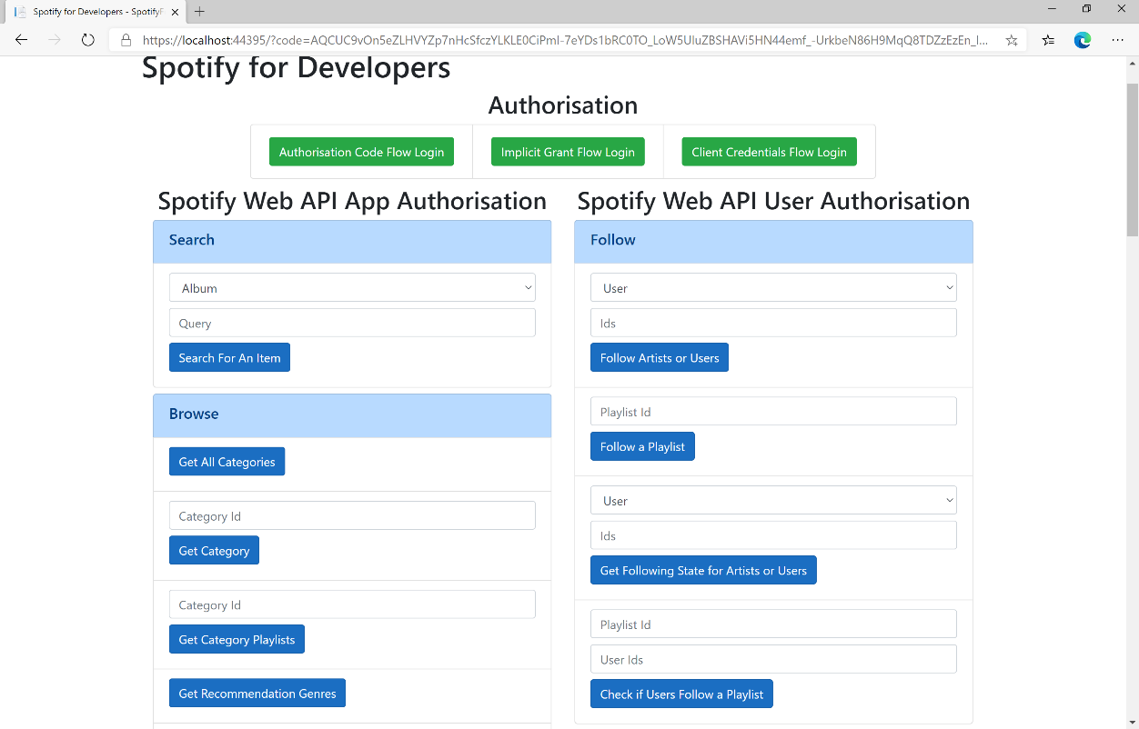

### Step 10

Use the same **Playlist Id** from **Follow a Playlist** and use your own **User Id**, to get this in **Spotify** select your **Username** then **...** and **Copy Spotify URI** your **User Id** will be after **spotify:user:** then enter this above **Check if Users Follow a Playlist** and then select **Check if Users Follow a Playlist** and scroll down to view **Results** like the following:

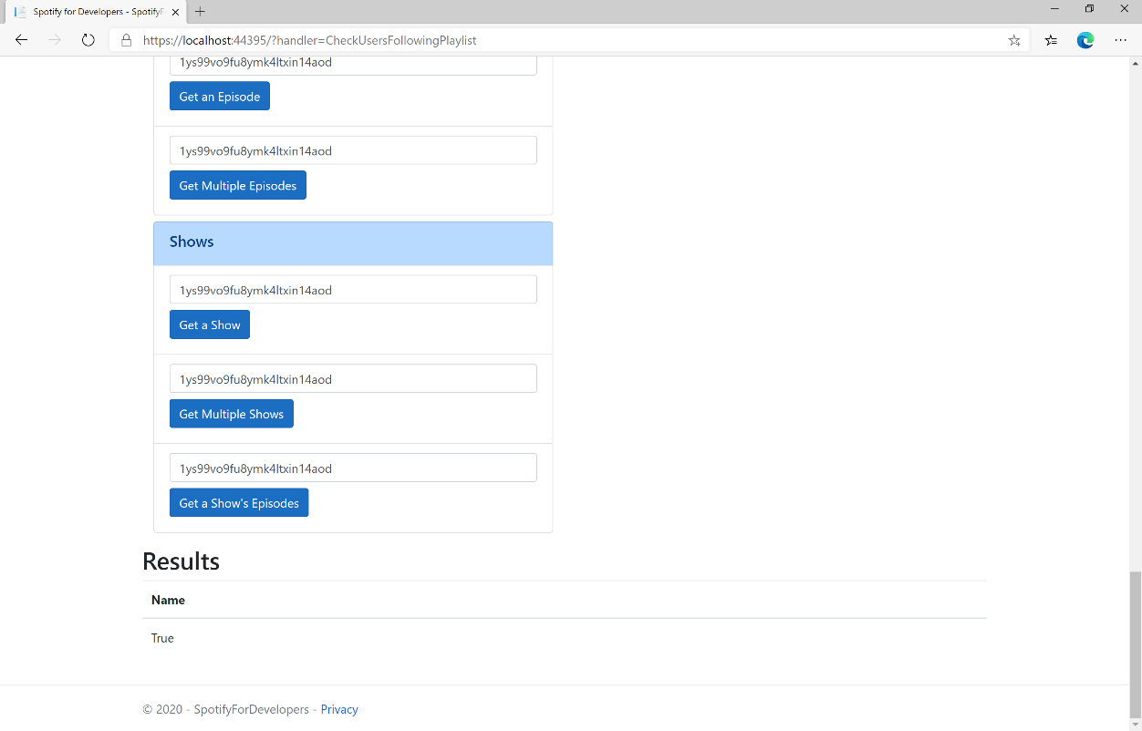

### Step 11

|  |  |
| --- | --- |
|  | You can stop the **web application** in **Visual Studio 2019** by selecting the **Stop debugging** button |

### Step 12

|  |  |
| --- | --- |
|  | You can choose to exit **Visual Studio 2019** by selecting the **Close** button in the top right of the **application** as that completes thispart of the workshop |

## Get User's Followed Artists

Get the current user’s followed artists.

|  |  |
| --- | --- |
| GET https://api.spotify.com/v1/me/following | |
| Header | |
| Authorization | User Token from Spotify Accounts service with **user-follow-modify** scope |
| Query Parameter | |
| type | Id type, only artist is currently supported |
| limit | Maximum number of items to return. Default: 20. Minimum: 1. Maximum: 50. |
| after | Last artist Id retrieved from the previous request. |

|  |  |
| --- | --- |
| Header | Response |
| Success | |
| HTTP Status 200 OK | Object containing a cursor-based paging object of Artist Objects |
| Error | |
| Error Code | Error Object |

### Step 1

|  |  |
| --- | --- |
|  | If you chose to close **Visual Studio 2019** previously, in **Windows 10** choose **Start**, and then from the **Start Menu** find and select **Visual Studio 2019** |
|  | Once done, from the **Get started** screen for **Visual Studio 2019** select **Open a project or solution** |
|  | Then locate and select **SpotifyForDevelopers.sln** and select **Open** if you don’t have this file already then please follow the previous parts of the workshop including **Getting Started**, **Authorisation Guide**, **Search & Browse**, **Playlists & Artists**, **Albums & Tracks**, **Episodes & Shows** and **Follow** |

### Step 2

|  |  |
| --- | --- |
|  | Once opened, in the **Solution Explorer** open the **Pages** section, then open the **Index.cshtml** section and select **Index.cshtml.cs** |

### Step 3

|  |  |
| --- | --- |
|  | Then from the **Menu** choose **View** and then **Open** |

### Step 4

In the **Code View** for **Index.cshtml.cs** below the **method** for public async Task<IActionResult> OnPostCheckUsersFollowingPlaylistAsync(...) { ... } enter the following **method**:

|  |
| --- |
| public async Task<IActionResult> OnPostGetUsersFollowedArtistsAsync()  {  LoadToken();  var results = await Api.GetUsersFollowedArtistsAsync();  if (results != null)  {  Results = results.Items.Select(result => new Result()  {  Id = result.Id,  Name = result.Name,  Image = result?.Images?.FirstOrDefault()?.Url  });  }  return Page();  } |

The **method** for OnPostGetUsersFollowedArtistsAsync is used to get the **followed artists** for the logged in **user** and populate the **property** for Results accordingly.

### Step 5

|  |  |
| --- | --- |
|  | In the **Solution Explorer** in the **Pages** section select **Index.cshtml** |

### Step 6

|  |  |
| --- | --- |
|  | Then from the **Menu** choose **View** and then **Open** |

### Step 7

Once in the **Code View** for **Index.cshtml** above <!-- Follow --> enter the following:

|  |
| --- |
| <li class="list-group-item">  <form **asp-page-handler**="GetUsersFollowedArtists" method="post">  <button class="btn btn-primary mb-2">  Get User's Followed Artists  </button>  </form>  </li> |

This form will **post** to the **method** for GetUsersFollowedArtists and will output to the **Results**.

### Step 8

|  |  |
| --- | --- |
|  | Finally, in **Visual Studio 2019** select **IIS Application** to run the **Web Application** |

### Step 9

Once the **Web Application** is running and you select **Authorisation Code Flow Login** or **Implicit Grant Flow Login** and scroll down you should see something like the following:

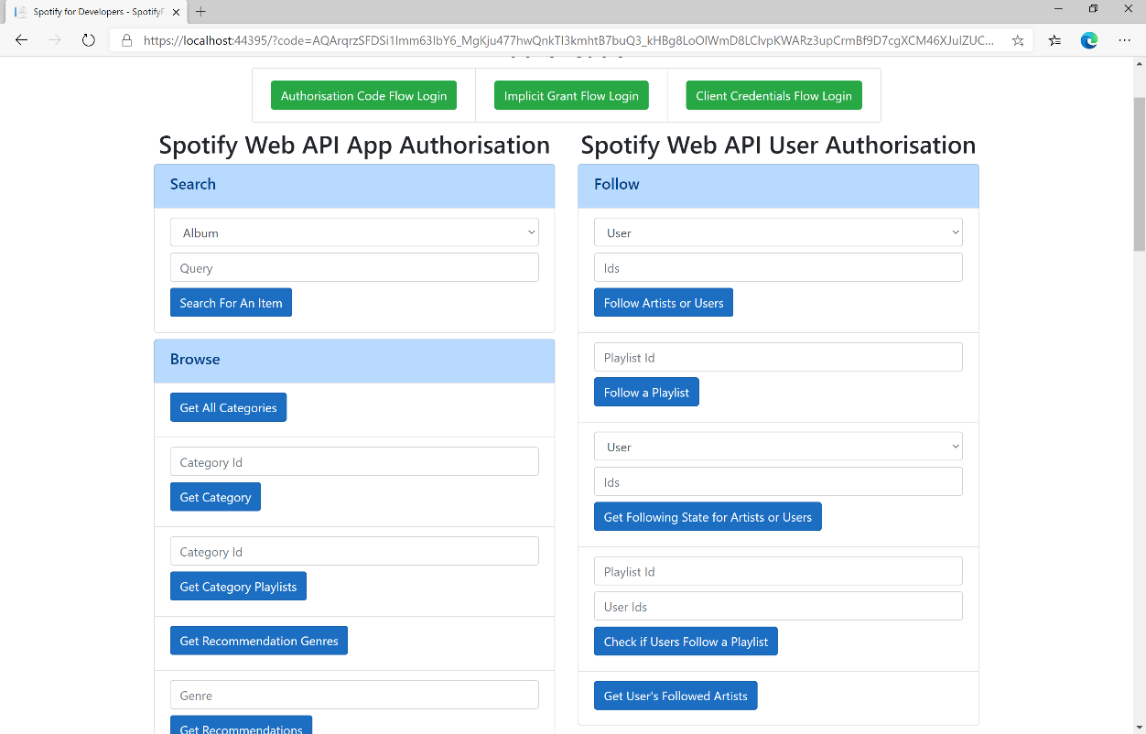

### Step 10

You can select **Get User's Followed Artists** and scroll down to view **Results** like the following:

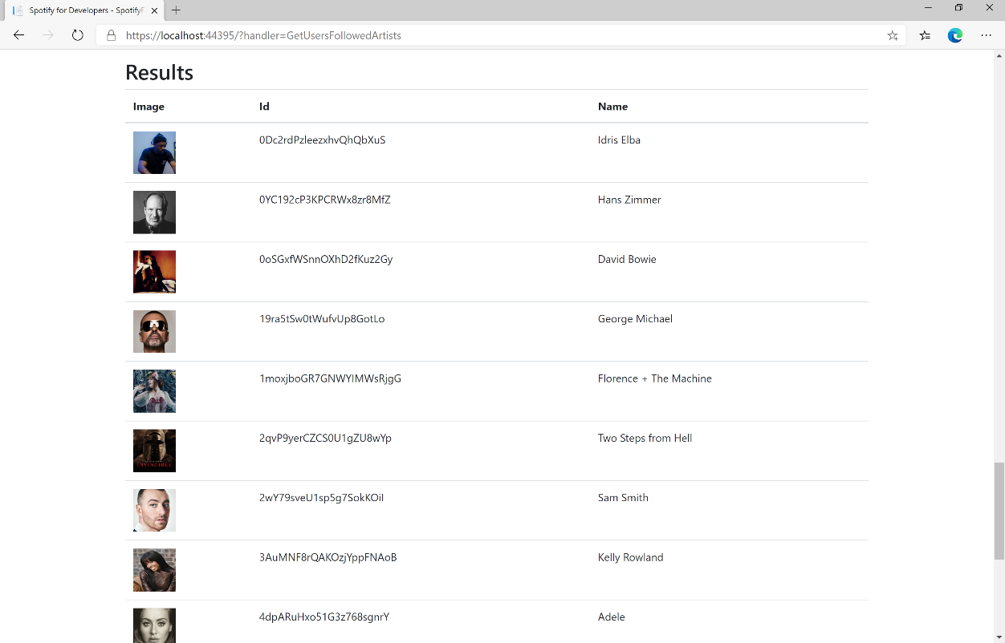

### Step 11

|  |  |
| --- | --- |
|  | You can stop the **web application** in **Visual Studio 2019** by selecting the **Stop debugging** button |

### Step 12

|  |  |
| --- | --- |
|  | You can choose to exit **Visual Studio 2019** by selecting the **Close** button in the top right of the **application** as that completes thispart of the workshop |

## Unfollow Artists or Users

Remove the current user as a follower of one or more artists or other Spotify users.

|  |  |
| --- | --- |
| DELETE https://api.spotify.com/v1/me/following | |
| Header | |
| Authorization | User Token from Spotify Accounts service with **user-follow-modify** scope |
| Query Parameter | |
| type | Type of artist or user |
| ids | Comma-separated list of the artist or the user Spotify Ids - maximum 50 |

|  |  |
| --- | --- |
| Header | Response |
| Success | |
| HTTP Status 204  No Content | Empty Response Body |
| Error | |
| Error Code | Error Object |

### Step 1

|  |  |
| --- | --- |
|  | If you chose to close **Visual Studio 2019** previously, in **Windows 10** choose **Start**, and then from the **Start Menu** find and select **Visual Studio 2019** |
|  | Once done, from the **Get started** screen for **Visual Studio 2019** select **Open a project or solution** |
|  | Then locate and select **SpotifyForDevelopers.sln** and select **Open** if you don’t have this file already then please follow the previous parts of the workshop including **Getting Started**, **Authorisation Guide**, **Search & Browse**, **Playlists & Artists**, **Albums & Tracks**, **Episodes & Shows** and **Follow** |

### Step 2

|  |  |
| --- | --- |
|  | Once opened, in the **Solution Explorer** open the **Pages** section, then open the **Index.cshtml** section and select **Index.cshtml.cs** |

### Step 3

|  |  |
| --- | --- |
|  | Then from the **Menu** choose **View** and then **Open** |

### Step 4

In the **Code View** for **Index.cshtml.cs** below the **method** for public async Task<IActionResult> OnPostGetUsersFollowedArtistsAsync(...) { ... } enter the following **method**:

|  |
| --- |
| public async Task<IActionResult> OnPostUnfollowArtistsOrUsersAsync(string value, FollowType option)  {  LoadToken();  var values = value.Split(",").ToList();  var result = await Api.UnfollowArtistsOrUsersAsync(values, option);  if (result != null)  {  Results = new List<Result>() { new Result()  {  Name = result.Success.ToString()  }};  }  return Page();  } |

The **method** for OnPostUnfollowArtistsOrUsersAsync is used to **unfollow** an **artist** or **user** by **Artist Id** or **User Id** on Spotify with the value and selected option and populate the **property** for Results accordingly with the **success** of the operation.

### Step 5

|  |  |
| --- | --- |
|  | In the **Solution Explorer** in the **Pages** section select **Index.cshtml** |

### Step 6

|  |  |
| --- | --- |
|  | Then from the **Menu** choose **View** and then **Open** |

### Step 7

Once in the **Code View** for **Index.cshtml** above <!-- Follow --> enter the following:

|  |
| --- |
| <li class="list-group-item">  <form **asp-page-handler**="UnfollowArtistsOrUsers" method="post">  <select **asp-for**="Option" class="form-control mb-2"  **asp-items**="Html.GetEnumSelectList<Spotify.NetStandard.Enums.FollowType>()">  </select>  <input **asp-for**="Value" placeholder="Id" class="form-control mb-2" />  <button class="btn btn-primary mb-2">  Unfollow Artists or Users  </button>  </form>  </li> |

This form will **post** to the **method** for UnfollowArtistsOrUsers with the Value of the **Ids** and the Option for the **Artist** or **User** and will output to the **Results**.

### Step 8

|  |  |
| --- | --- |
|  | Finally, in **Visual Studio 2019** select **IIS Application** to run the **Web Application** |

### Step 9

Once the **Web Application** is running and you select **Authorisation Code Flow Login** or **Implicit Grant Flow Login** and scroll down you should see something like the following:

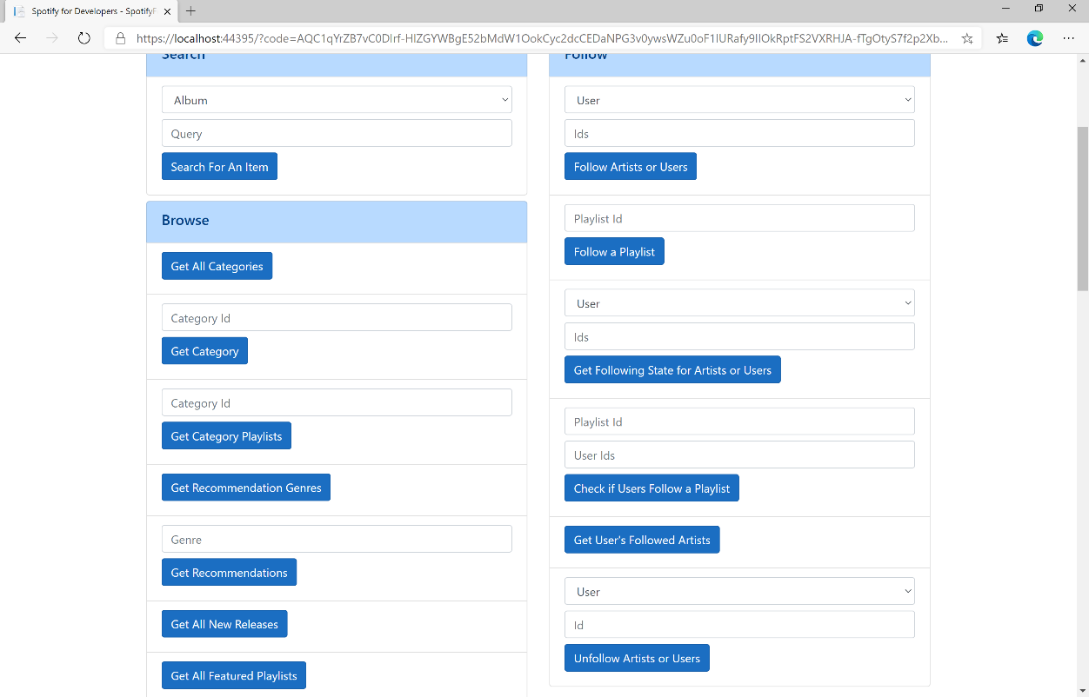

### Step 10

You can then enter an **Artist Id** from **Get All New Releases** or the same **Artist Id** from **Follow Artists or Users** to use and above **Unfollow Artists or Users** choose **Artist** and then select **Unfollow Artists or Users** and scroll down to view **Results** like the following:

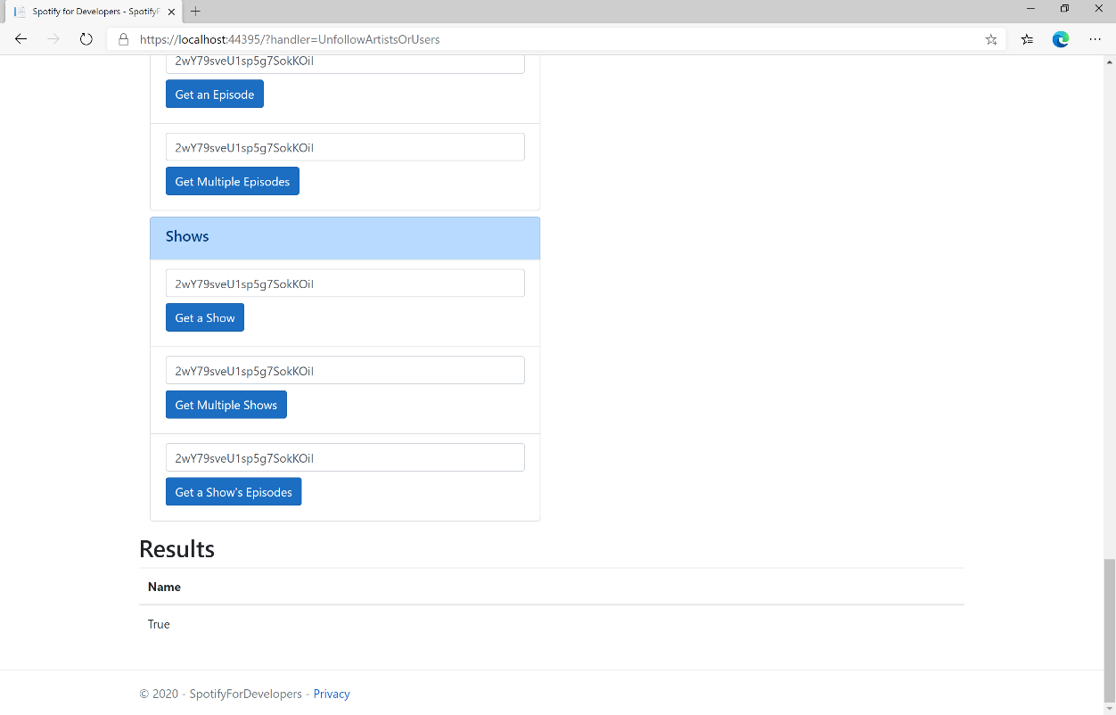

### Step 11

|  |  |
| --- | --- |
|  | You can stop the **web application** in **Visual Studio 2019** by selecting the **Stop debugging** button |

### Step 12

|  |  |
| --- | --- |
|  | You can choose to exit **Visual Studio 2019** by selecting the **Close** button in the top right of the **application** as that completes thispart of the workshop |

## Unfollow Playlist

Remove the current user as a follower of a playlist.

|  |  |
| --- | --- |
| DELETE https://api.spotify.com/v1/playlists/{playlist_id}/followers | |
| Header | |
| Authorization | User Token from Spotify Accounts service with **playlist-modify-public** scope for publicly followed playlist and **playlist-modify-private** for a privately followed playlist |
| Path Parameter | |
| playlist_id | Spotify Id of the playlist |

|  |  |
| --- | --- |
| Header | Response |
| Success | |
| HTTP Status 200 OK | Empty Response Body |
| Error | |
| Error Code | Error Object |

### Step 1

|  |  |
| --- | --- |
|  | If you chose to close **Visual Studio 2019** previously, in **Windows 10** choose **Start**, and then from the **Start Menu** find and select **Visual Studio 2019** |
|  | Once done, from the **Get started** screen for **Visual Studio 2019** select **Open a project or solution** |
|  | Then locate and select **SpotifyForDevelopers.sln** and select **Open** if you don’t have this file already then please follow the previous parts of the workshop including **Getting Started**, **Authorisation Guide**, **Search & Browse**, **Playlists & Artists**, **Albums & Tracks**, **Episodes & Shows** and **Follow** |

### Step 2

|  |  |
| --- | --- |
|  | Once opened, in the **Solution Explorer** open the **Pages** section, then open the **Index.cshtml** section and select **Index.cshtml.cs** |

### Step 3

|  |  |
| --- | --- |
|  | Then from the **Menu** choose **View** and then **Open** |

### Step 4

In the **Code View** for **Index.cshtml.cs** below the **method** for public async Task<IActionResult> OnPostUnfollowArtistsOrUsersAsync(...) { ... } enter the following **method**:

|  |
| --- |
| public async Task<IActionResult> OnPostUnfollowPlaylistAsync(string value)  {  LoadToken();  var result = await Api.UnfollowPlaylistAsync(value);  if (result != null)  {  Results = new List<Result>() { new Result()  {  Name = result.Success.ToString()  }};  }  return Page();  } |

The **method** for OnPostUnfollowPlaylistAsync is used to **unfollow** a **playlist** by **Playlist Id** on Spotify with the value and populate the **property** for Results accordingly with the **success** of the operation.

### Step 5

|  |  |
| --- | --- |
|  | In the **Solution Explorer** in the **Pages** section select **Index.cshtml** |

### Step 6

|  |  |
| --- | --- |
|  | Then from the **Menu** choose **View** and then **Open** |

### Step 7

Once in the **Code View** for **Index.cshtml** above <!-- Follow --> enter the following:

|  |
| --- |
| <li class="list-group-item">  <form **asp-page-handler**="UnfollowPlaylist" method="post">  <input **asp-for**="Value" placeholder="Playlist Id" class="form-control mb-2" />  <button class="btn btn-primary mb-2">  Unfollow a Playlist  </button>  </form>  </li> |

This form will **post** to the **method** for UnfollowPlaylist with the Value of the **Playlist Id** and will output to the **Results**.

### Step 8

|  |  |
| --- | --- |
|  | Finally, in **Visual Studio 2019** select **IIS Application** to run the **Web Application** |

### Step 9

Once the **Web Application** is running and you select **Authorisation Code Flow Login** or **Implicit Grant Flow Login** and scroll down you should see something like the following:

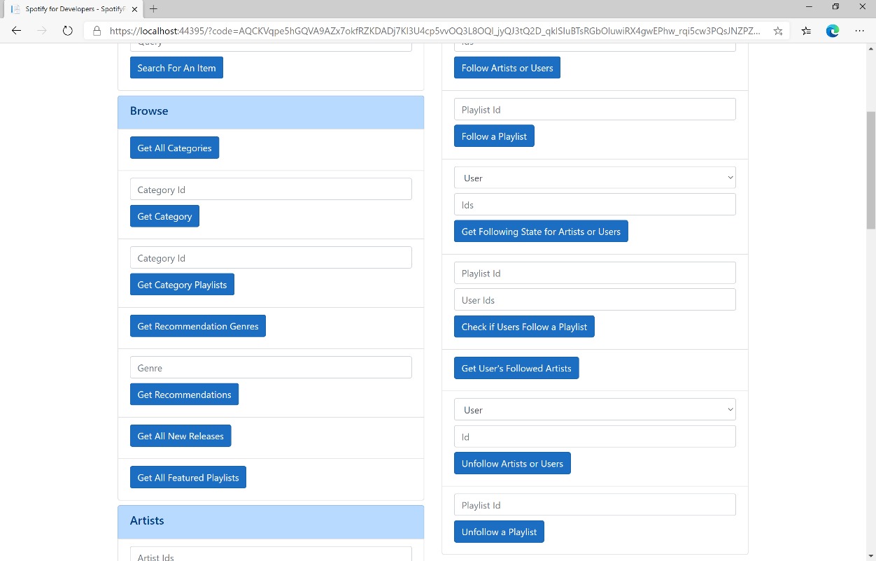

### Step 10

You can then enter a **Playlist Id** from **Get All Featured Playlists** or the same **Playlist Id** from **Follow a Playlist** to use and select **Unfollow a Playlist** and scroll down to view **Results** like the following:

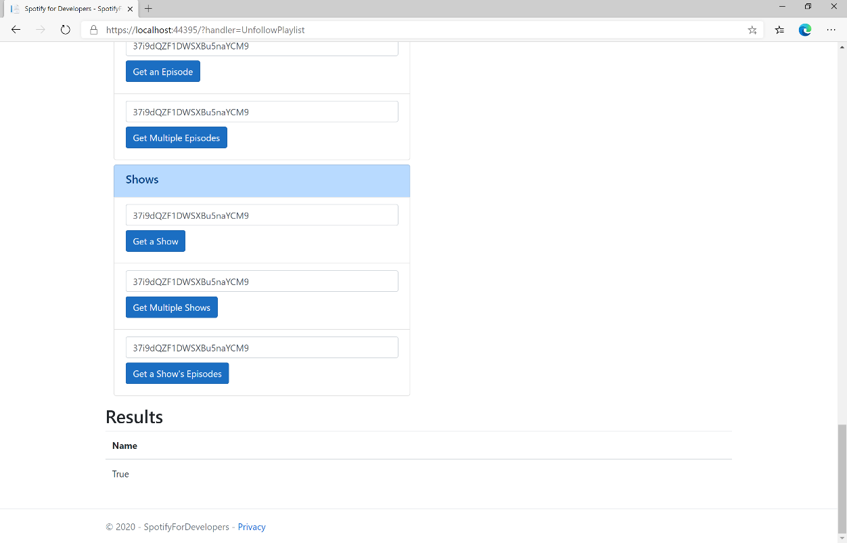

### Step 11

|  |  |
| --- | --- |
|  | You can stop the **web application** in **Visual Studio 2019** by selecting the **Stop debugging** button |

### Step 12

|  |  |
| --- | --- |
|  | You can exit **Visual Studio 2019** by selecting the **Close** button in the top right of the **application** as that completes thispart of the workshop |

# Playlists

## Get a Playlist

Get a playlist owned by a Spotify user.

|  |  |
| --- | --- |
| https://api.spotify.com/v1/playlists/{playlist_id} | |
| Header | |
| Authorization | Valid Access Token from Spotify Accounts service |
| Path Parameter | |
| playlist_id | Spotify Id for the playlist |
| Query Parameter | |
| fields | Filters for the query: comma-separated list of fields to return e.g. description, uri |
| market | ISO 3166-1 alpha-2 country code e.g. “GB”. Provide to apply Track Relinking |

|  |  |
| --- | --- |
| Header | Response |
| Success | |
| HTTP Status 200 OK | Playlist Object |
| Error | |
| Error Code | Error Object |

### Step 1

|  |  |
| --- | --- |
|  | In **Windows 10** choose **Start**, and then from the **Start Menu** find and select **Visual Studio 2019** |
|  | Once done, from the **Get started** screen for **Visual Studio 2019** select **Open a project or solution** |
|  | Then locate and select **SpotifyForDevelopers.sln** and select **Open** if you don’t have this file already then please follow the previous parts of the workshop including **Getting Started**, **Authorisation Guide**, **Search & Browse**, **Playlists & Artists**, **Albums & Tracks**, **Episodes & Shows** and **Follow** |

### Step 2

|  |  |
| --- | --- |
|  | Once opened, in the **Solution Explorer** open the **Pages** section, then open the **Index.cshtml** section and select **Index.cshtml.cs** |

### Step 3

|  |  |
| --- | --- |
|  | Then from the **Menu** choose **View** and then **Open** |

### Step 4

In the **Code View** for **Index.cshtml.cs** below the **method** for public async Task<IActionResult> OnPostUnfollowPlaylistAsync() { ... } enter the following **method**:

|  |
| --- |
| public async Task<IActionResult> OnPostGetPlaylistAsync(string value)  {  LoadToken();  var result = await Api.GetPlaylistAsync(value);  if (result != null)  {  Results = new List<Result> { new Result()  {  Id = result.Id,  Name = result.Name,  Image = result?.Images?.FirstOrDefault()?.Url  }};  }  return Page();  } |

The **method** for OnPostGetPlaylistAsync is used to get a **playlist** by **Playlist Id** on Spotify with the value and populate the **property** for Results accordingly.

### Step 5

|  |  |
| --- | --- |
|  | In the **Solution Explorer** in the **Pages** section select **Index.cshtml** |

### Step 6

|  |  |
| --- | --- |
|  | Then from the **Menu** choose **View** and then **Open** |

### Step 7

Once in the **Code View** for **Index.cshtml** above <!-- Spotify Web API User Authorisation --> enter the following:

|  |
| --- |
| <ul class="list-group mb-2">  <li class="list-group-item list-group-item-primary">  <h5 class="list-group-item-heading">Playlists</h5>  </li>  <li class="list-group-item">  <form **asp-page-handler**="GetPlaylist" method="post">  <input **asp-for**="Value" placeholder="Playlist Id" class="form-control mb-2" />  <button class="btn btn-primary mb-2">  Get a Playlist  </button>  </form>  </li>  <!-- Playlists -->  </ul> |

This form will **post** to the **method** for OnPostGetPlaylistAsync with the Value as the **Playlist Id** and will output to the **Results**. This form could also be used with **Spotify Web API App Authorisation** as it does not require a **User Token**

### Step 8

|  |  |
| --- | --- |
|  | Finally, in **Visual Studio 2019** select **IIS Application** to run the **Web Application** |

### Step 9

Once the **Web Application** is running and you select **Authorisation Code Flow Login** or **Implicit Grant Flow Login** and scroll down you should see something like the following:

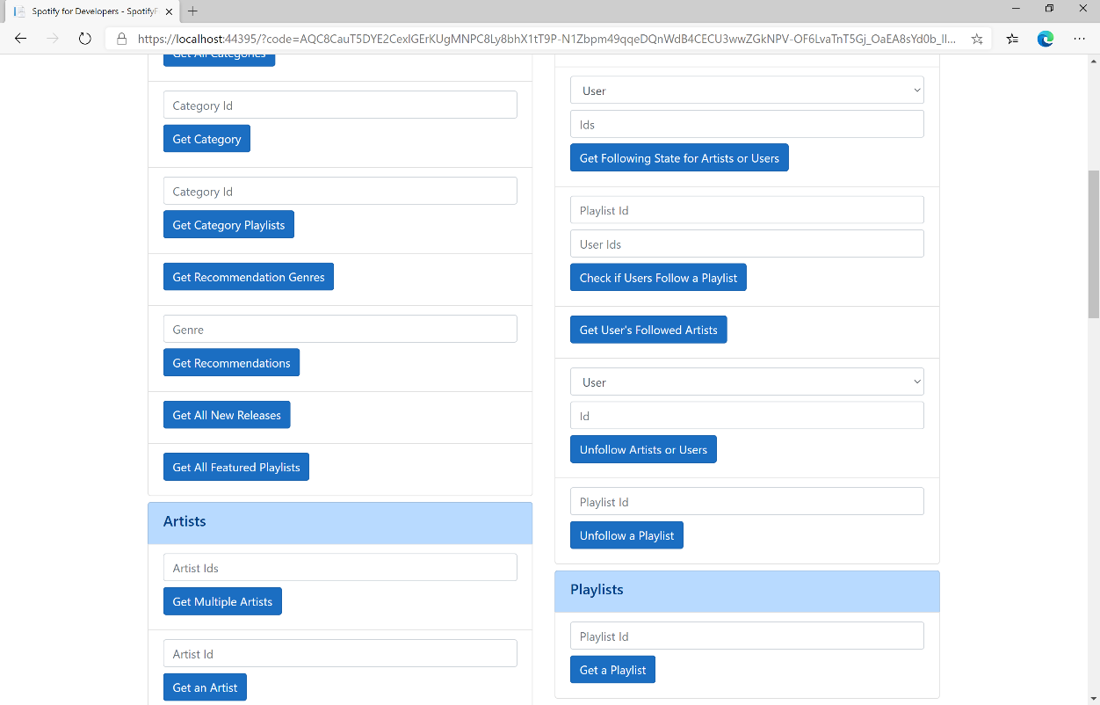

### Step 10

You can then enter a **Playlist Id** from **Get All Featured Playlists** and select **Get a Playlist** and scroll down to view **Results** like the following:

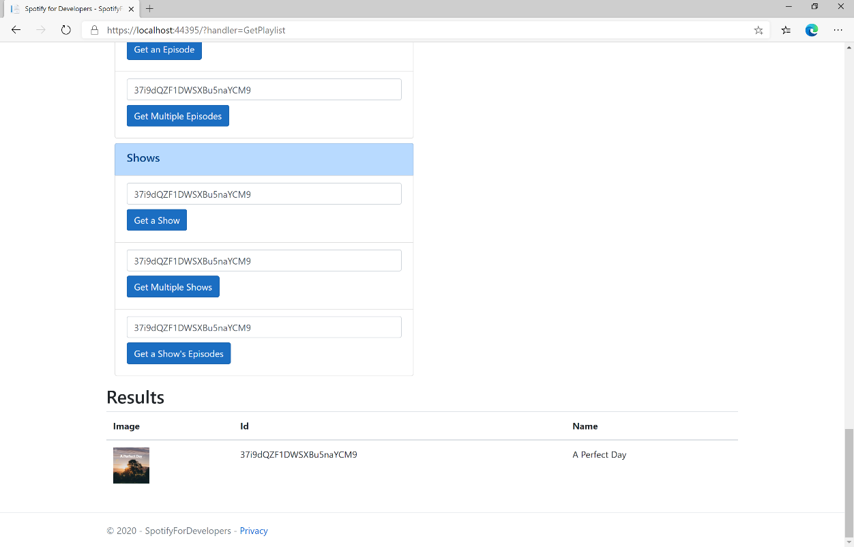

### Step 11

|  |  |
| --- | --- |
|  | You can stop the **web application** in **Visual Studio 2019** by selecting the **Stop debugging** button |

### Step 12

|  |  |
| --- | --- |
|  | You can choose to exit **Visual Studio 2019** by selecting the **Close** button in the top right of the **application** as that completes thispart of the workshop |

## Get a Playlist’s Tracks

Get full details of the tracks of a playlist owned by a Spotify user.

|  |  |
| --- | --- |
| GET https://api.spotify.com/v1/playlists/{playlist_id}/tracks | |
| Header | |
| Authorization | Valid Access Token from Spotify Accounts service |
| Path Parameter | |
| playlist_id | Spotify Id for the playlist |
| Query Parameter | |
| fields | Filters for the query: comma-separated list of fields to return e.g. total, limit |
| limit | Maximum number of results to return |
| offset | Index of first result to return |
| market | ISO 3166-1 alpha-2 country code e.g. “GB”. Provide to apply Track Relinking |

|  |  |
| --- | --- |
| Header | Response |
| Success | |
| HTTP Status 200 OK | Array of Playlist Track Objects wrapped in a Paging Object |
| Error | |
| Error Code | Error Object |

### Step 1

|  |  |
| --- | --- |
|  | If you chose to close **Visual Studio 2019** previously, in **Windows 10** choose **Start**, and then from the **Start Menu** find and select **Visual Studio 2019** |
|  | Once done, from the **Get started** screen for **Visual Studio 2019** select **Open a project or solution** |
|  | Then locate and select **SpotifyForDevelopers.sln** and select **Open** if you don’t have this file already then please follow the previous parts of the workshop including **Getting Started**, **Authorisation Guide**, **Search & Browse**, **Playlists & Artists**, **Albums & Tracks**, **Episodes & Shows**, **Follow** and **Playlists** |

### Step 2

|  |  |
| --- | --- |
|  | Once opened, in the **Solution Explorer** open the **Pages** section, then open the **Index.cshtml** section and select **Index.cshtml.cs** |

### Step 3

|  |  |
| --- | --- |
|  | Then from the **Menu** choose **View** and then **Open** |

### Step 4

In the **Code View** for **Index.cshtml.cs** below the **method** for public async Task<IActionResult> OnPostGetPlaylistAsync(...) { ... } enter the following **method**:

|  |
| --- |
| public async Task<IActionResult> OnPostGetPlaylistTracksAsync(string value)  {  LoadToken();  var results = await Api.GetPlaylistTracksAsync(value);  if (results?.Items != null)  {  Results = results.Items.Select(result => new Result()  {  Id = result?.Track.Id,  Name = result?.Track.Name,  Image = result?.Track.Album?.Images?.FirstOrDefault()?.Url,  Inner = new Result()  {  Id = result?.Track?.Artists?.FirstOrDefault()?.Id,  Name = result?.Track?.Artists?.FirstOrDefault()?.Name  }  });  }  return Page();  } |

The **method** for OnPostGetPlaylistTracksAsync is used to get the **tracks** for a **playlist** by **Playlist Id** on Spotify with the value and populate the **property** for Results accordingly.

### Step 5

|  |  |
| --- | --- |
|  | In the **Solution Explorer** in the **Pages** section select **Index.cshtml** |

### Step 6

|  |  |
| --- | --- |
|  | Then from the **Menu** choose **View** and then **Open** |

### Step 7

Once in the **Code View** for **Index.cshtml** above <!-- Playlists --> enter the following:

|  |
| --- |
| <li class="list-group-item">  <form **asp-page-handler**="GetPlaylistTracks" method="post">  <input **asp-for**="Value" placeholder="Playlist Id" class="form-control mb-2" />  <button class="btn btn-primary mb-2">  Get a Playlist's Tracks  </button>  </form>  </li> |

This form will **post** to the **method** for OnPostGetPlaylistTracksAsync with the Value as the **Playlist Id** and will output to the **Results**. This form could also be used with **Spotify Web API App Authorisation** as it does not require a **User Token**.

### Step 8

|  |  |
| --- | --- |
|  | Finally, in **Visual Studio 2019** select **IIS Application** to run the **Web Application** |

### Step 9

Once the **Web Application** is running and you select **Authorisation Code Flow Login** or **Implicit Grant Flow Login** and scroll down you should see something like the following:

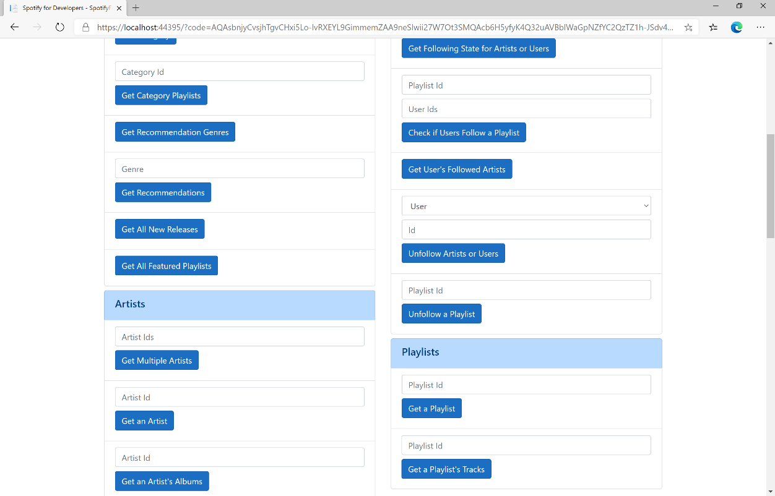

### Step 10

You can then enter a **Playlist Id** from **Get All Featured Playlists** and select **Get Playlist Tracks** and scroll down to view **Results** like the following:

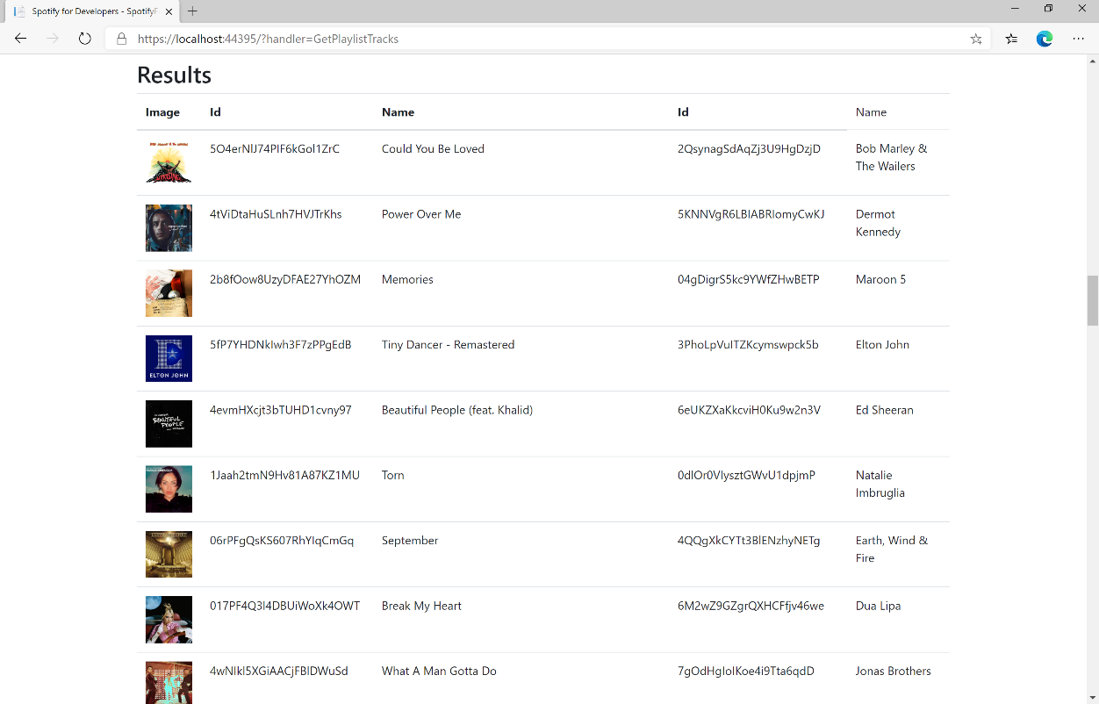

### Step 11

|  |  |
| --- | --- |
|  | You can stop the **web application** in **Visual Studio 2019** by selecting the **Stop debugging** button |

### Step 12

|  |  |
| --- | --- |
|  | You can choose to exit **Visual Studio 2019** by selecting the **Close** button in the top right of the **application** as that completes thispart of the workshop |

## Create a Playlist

Create a playlist for a Spotify user

|  |  |
| --- | --- |
| POST https://api.spotify.com/v1/users/{user_id}/playlists | |
| Header | |
| Authorization | User Token from Spotify Accounts service with **playlist-modify-public** scope for publicly followed playlist and **playlist-modify-private** for a privately followed playlist |
| Path Parameter | |
| user_id | User’s Spotify User Id |
| Body Parameter | |
| name | Name for the new playlist |
| public | If true, the playlist will be public, if false it will be private |
| collaborative | If true, the playlist will be collaborative and other users will be able to modify the playlist |
| description | Playlist description |

|  |  |
| --- | --- |
| Header | Response |
| Success | |
| HTTP Status 200 OK |  |
| Http Status 201  Created |  |
| Error | |
| HTTP Status 403  Forbidden | Returned when not Authorised |
| Error Code | Error Object |

### Step 1

|  |  |
| --- | --- |
|  | If you chose to close **Visual Studio 2019** previously, in **Windows 10** choose **Start**, and then from the **Start Menu** find and select **Visual Studio 2019** |
|  | Once done, from the **Get started** screen for **Visual Studio 2019** select **Open a project or solution** |
|  | Then locate and select **SpotifyForDevelopers.sln** and select **Open** if you don’t have this file already then please follow the previous parts of the workshop including **Getting Started**, **Authorisation Guide**, **Search & Browse**, **Playlists & Artists**, **Albums & Tracks**, **Episodes & Shows**, **Follow** and **Playlists** |

### Step 2

|  |  |
| --- | --- |
|  | Once opened, in the **Solution Explorer** open the **Pages** section, then open the **Index.cshtml** section and select **Index.cshtml.cs** |

### Step 3

|  |  |
| --- | --- |
|  | Then from the **Menu** choose **View** and then **Open** |

### Step 4

In the **Code View** for **Index.cshtml.cs** below the **method** for public async Task<IActionResult> OnPostGetPlaylistTracksAsync(...) { ... } enter the following **method**:

|  |
| --- |
| public async Task<IActionResult> OnPostCreatePlaylistAsync(string value, string option)  {  LoadToken();  var result = await Api.CreatePlaylistAsync(value, option);  if (result != null)  {  Results = new List<Result> { new Result()  {  Id = result.Id,  Name = result.Name  }};  }  return Page();  } |

The **method** for OnPostCreatePlaylistAsync is used to **create** a **playlist** for a **user** by **User Id** with the value and option with a given **Name** on Spotify and populate the **property** for Results accordingly.

### Step 5

|  |  |
| --- | --- |
|  | In the **Solution Explorer** in the **Pages** section select **Index.cshtml** |

### Step 6

|  |  |
| --- | --- |
|  | Then from the **Menu** choose **View** and then **Open** |

### Step 7

Once in the **Code View** for **Index.cshtml** above <!-- Playlists --> enter the following:

|  |
| --- |
| <li class="list-group-item">  <form **asp-page-handler**="CreatePlaylist" method="post">  <input **asp-for**="Value" placeholder="User Id" class="form-control mb-2" />  <input **asp-for**="Option" placeholder="Name" class="form-control mb-2" />  <button class="btn btn-primary mb-2">  Create a Playlist  </button>  </form>  </li> |

This form will **post** to the **method** for CreatePlaylist with the Value of the **User Id** and the Option of the **Name** and will output to the **Results**.

### Step 8

|  |  |
| --- | --- |
|  | Finally, in **Visual Studio 2019** select **IIS Application** to run the **Web Application** |

### Step 9

Once the **Web Application** is running and you select **Authorisation Code Flow Login** or **Implicit Grant Flow Login** and scroll down you should see something like the following:

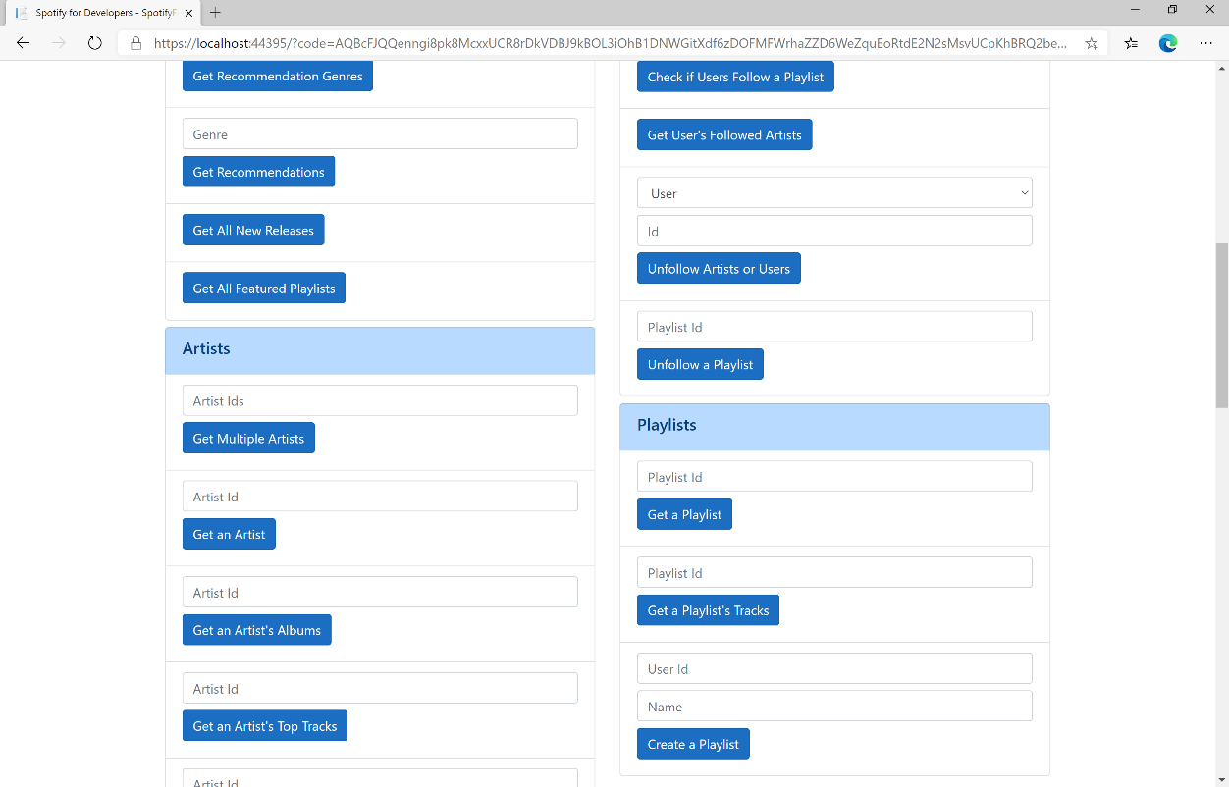

### Step 10

You can then enter above **Create a Playlist** your **User Id**, to get this in **Spotify** select your **Username** then **...** and **Copy Spotify URI** your **User Id** will be after **spotify:user:**, and a **Name** then select **Create a Playlist** and scroll down to view **Results** like the following and copy the **Id** for use later:

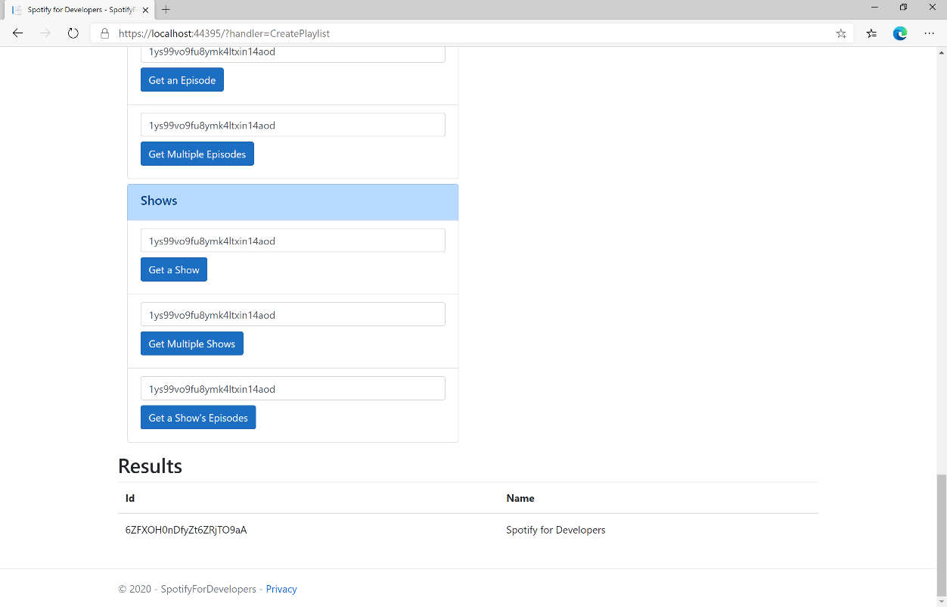

### Step 11

|  |  |
| --- | --- |
|  | You can stop the **web application** in **Visual Studio 2019** by selecting the **Stop debugging** button |

### Step 12

|  |  |
| --- | --- |
|  | You can choose to exit **Visual Studio 2019** by selecting the **Close** button in the top right of the **application** as that completes thispart of the workshop |

## Get a List of Current User's Playlists

Get a list of the playlists owned or followed by the current Spotify user.

|  |  |
| --- | --- |
| GET https://api.spotify.com/v1/me/playlists | |
| Header | |
| Authorization | User Token from Spotify Accounts service with **playlist-read-private** scope for playlists for the current user and **playlist-read-collaborative** for collaborative playlists |
| Query Parameter | |
| limit | Maximum number of playlists to return. Default: 20. Minimum: 1. Maximum: 50 |
| offset | Index of the first playlist to return. Default: 0 (the first object). Maximum offset: 100,000. Use with limit to get the next set of playlists. |

|  |  |
| --- | --- |
| Header | Response |
| Success | |
| HTTP Status 200 OK | Array of Simplified Playlist Object wrapped in a Paging Object |
| Error | |
| Error Code | Error Object |

### Step 1

|  |  |
| --- | --- |
|  | If you chose to close **Visual Studio 2019** previously, in **Windows 10** choose **Start**, and then from the **Start Menu** find and select **Visual Studio 2019** |
|  | Once done, from the **Get started** screen for **Visual Studio 2019** select **Open a project or solution** |
|  | Then locate and select **SpotifyForDevelopers.sln** and select **Open** if you don’t have this file already then please follow the previous parts of the workshop including **Getting Started**, **Authorisation Guide**, **Search & Browse**, **Playlists & Artists**, **Albums & Tracks**, **Episodes & Shows**, **Follow** and **Playlists** |

### Step 2

|  |  |
| --- | --- |
|  | Once opened, in the **Solution Explorer** open the **Pages** section, then open the **Index.cshtml** section and select **Index.cshtml.cs** |

### Step 3

|  |  |
| --- | --- |
|  | Then from the **Menu** choose **View** and then **Open** |

### Step 4

In the **Code View** for **Index.cshtml.cs** below the **method** for public async Task<IActionResult> OnPostCreatePlaylistAsync(...) { ... } enter the following **method**:

|  |
| --- |
| public async Task<IActionResult> OnPostGetCurrentUserPlaylistsAsync()  {  LoadToken();  var results = await Api.GetUserPlaylistsAsync();  if (results?.Items != null)  {  Results = results.Items.Select(result => new Result()  {  Id = result.Id,  Name = result.Name,  Image = result?.Images?.FirstOrDefault()?.Url  });  }  return Page();  } |

The **method** for OnPostGetCurrentUserPlaylistsAsync is used to list the **playlists** for the logged in **user** on Spotify and populate the **property** for Results accordingly.

### Step 5

|  |  |
| --- | --- |
|  | In the **Solution Explorer** in the **Pages** section select **Index.cshtml** |

### Step 6

|  |  |
| --- | --- |
|  | Then from the **Menu** choose **View** and then **Open** |

### Step 7

Once in the **Code View** for **Index.cshtml** above <!-- Playlists --> enter the following:

|  |
| --- |
| <li class="list-group-item">  <form **asp-page-handler**="GetCurrentUserPlaylists" method="post">  <button class="btn btn-primary mb-2">  Get a List of Current User's Playlists  </button>  </form>  </li> |

This form will **post** to the **method** for GetCurrentUserPlaylists and will output to the **Results**.

### Step 8

|  |  |
| --- | --- |
|  | Finally, in **Visual Studio 2019** select **IIS Application** to run the **Web Application** |

### Step 9

Once the **Web Application** is running and you select **Authorisation Code Flow Login** or **Implicit Grant Flow Login** and scroll down you should see something like the following:

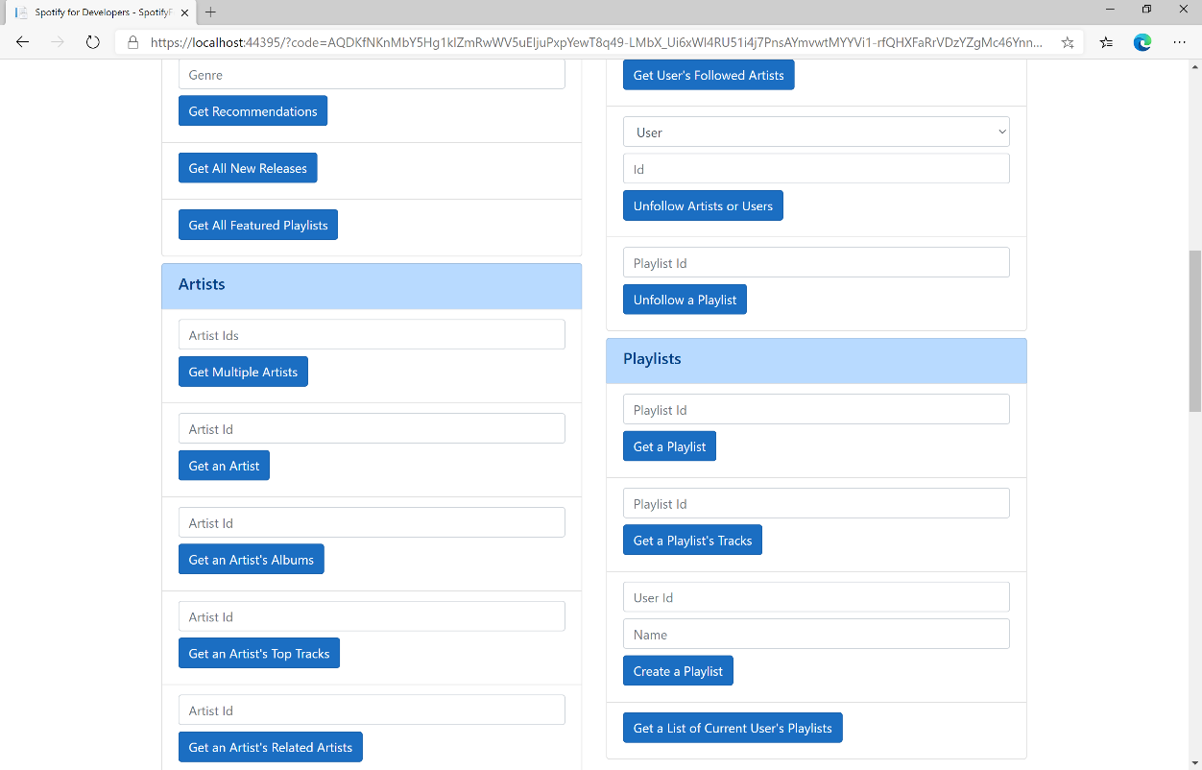

### Step 10

You can then select **Get a List of Current User's Playlists** and scroll down to view **Results** like the following:

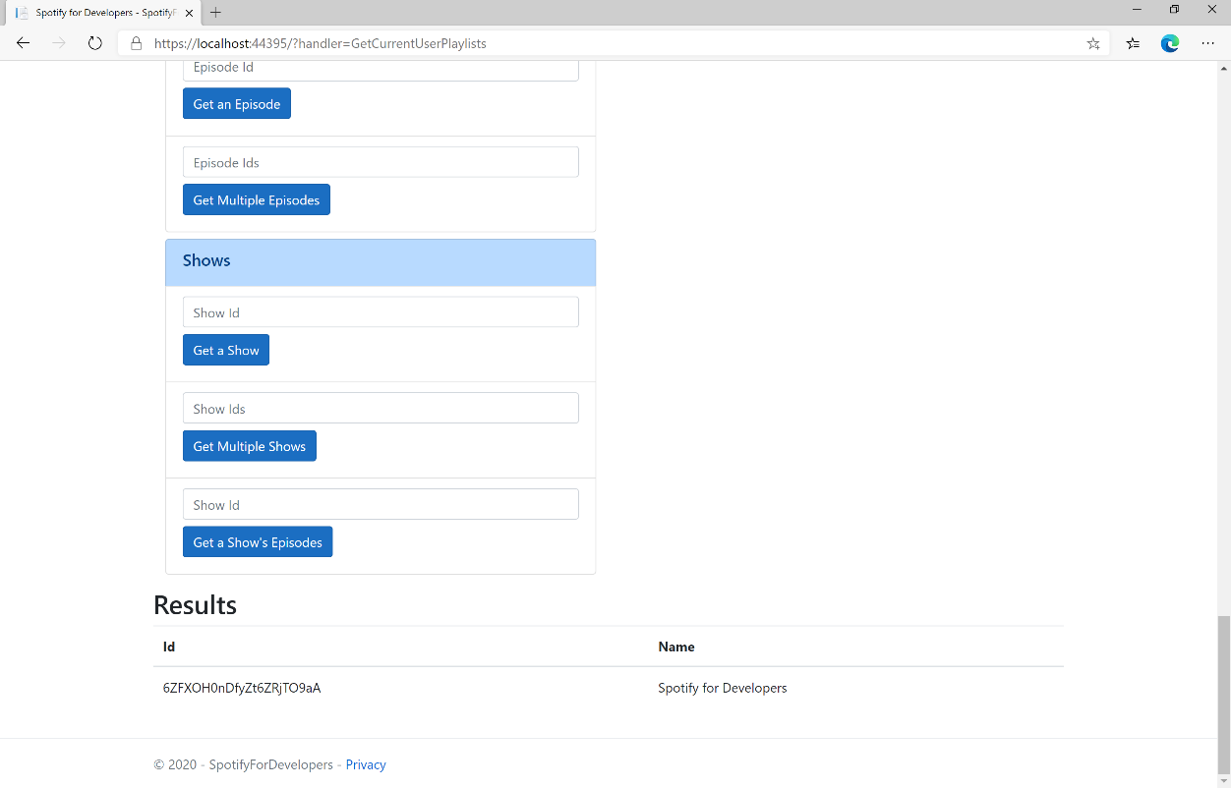

### Step 11

|  |  |
| --- | --- |
|  | You can stop the **web application** in **Visual Studio 2019** by selecting the **Stop debugging** button |

### Step 12

|  |  |
| --- | --- |
|  | You can choose to exit **Visual Studio 2019** by selecting the **Close** button in the top right of the **application** as that completes thispart of the workshop |

## Get a List of a User's Playlists

Get a list of the playlists owned or followed by a Spotify user.

|  |  |
| --- | --- |
| GET https://api.spotify.com/v1/users/{user_id}/playlists | |
| Header | |
| Authorization | User Token from Spotify Accounts service with **playlist-read-private** scope for playlists for the current user and **playlist-read-collaborative** for collaborative playlists |
| Path Parameter | |
| user_id | User’s Spotify User Id |
| Query Parameter | |
| limit | Maximum number of playlists to return. Default: 20. Minimum: 1. Maximum: 50 |
| offset | Index of the first playlist to return. Default: 0 (the first object). Maximum offset: 100,000. Use with limit to get the next set of playlists. |

|  |  |
| --- | --- |
| Header | Response |
| Success | |
| HTTP Status 200 OK | Array of Simplified Playlist Object wrapped in a Paging Object |
| Error | |
| Error Code | Error Object |

### Step 1

|  |  |
| --- | --- |
|  | If you chose to close **Visual Studio 2019** previously, in **Windows 10** choose **Start**, and then from the **Start Menu** find and select **Visual Studio 2019** |
|  | Once done, from the **Get started** screen for **Visual Studio 2019** select **Open a project or solution** |
|  | Then locate and select **SpotifyForDevelopers.sln** and select **Open** if you don’t have this file already then please follow the previous parts of the workshop including **Getting Started**, **Authorisation Guide**, **Search & Browse**, **Playlists & Artists**, **Albums & Tracks**, **Episodes & Shows**, **Follow** and **Playlists** |

### Step 2

|  |  |
| --- | --- |
|  | Once opened, in the **Solution Explorer** open the **Pages** section, then open the **Index.cshtml** section and select **Index.cshtml.cs** |

### Step 3

|  |  |
| --- | --- |
|  | Then from the **Menu** choose **View** and then **Open** |

### Step 4

In the **Code View** for **Index.cshtml.cs** below the **method** for public async Task<IActionResult> OnPostGetCurrentUserPlaylistsAsync() { ... } enter the following **method**:

|  |
| --- |
| public async Task<IActionResult> OnPostGetUserPlaylistsAsync(string value)  {  LoadToken();  var results = await Api.GetUserPlaylistsAsync(value);  if (results?.Items != null)  {  Results = results.Items.Select(result => new Result()  {  Id = result.Id,  Name = result.Name,  Image = result?.Images?.FirstOrDefault()?.Url  });  }  return Page();  } |

The **method** for OnPostGetUserPlaylistsAsync is used to list the **playlists** for a **user** by **User Id** on Spotify and populate the **property** for Results accordingly.

### Step 5

|  |  |
| --- | --- |
|  | In the **Solution Explorer** in the **Pages** section select **Index.cshtml** |

### Step 6

|  |  |
| --- | --- |
|  | Then from the **Menu** choose **View** and then **Open** |

### Step 7

Once in the **Code View** for **Index.cshtml** above <!-- Playlists --> enter the following:

|  |
| --- |
| <li class="list-group-item">  <form **asp-page-handler**="GetUserPlaylists" method="post">  <input **asp-for**="Value" placeholder="User Id" class="form-control mb-2" />  <button class="btn btn-primary mb-2">  Get a List of a User's Playlists  </button>  </form>  </li> |

This form will **post** to the **method** for GetUserPlaylists with the Value of the **User Id** and will output to the **Results**.

### Step 8

|  |  |
| --- | --- |
|  | Finally, in **Visual Studio 2019** select **IIS Application** to run the **Web Application** |

### Step 9

Once the **Web Application** is running and you select **Authorisation Code Flow Login** or **Implicit Grant Flow Login** and scroll down you should see something like the following:

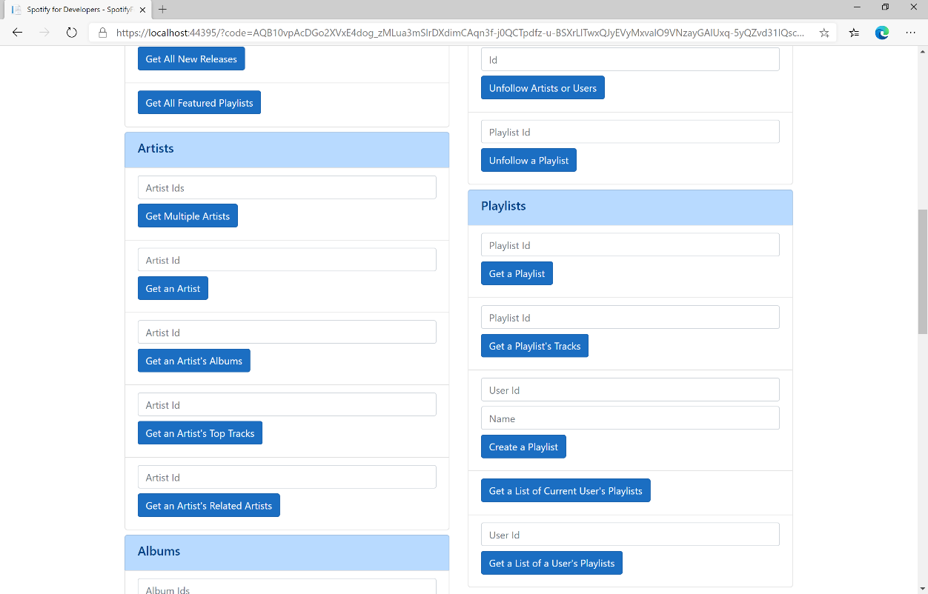

### Step 10

You can then above **Get a List of a User's Playlists** enter your own **User Id**, to get this in **Spotify** select your **Username** then **...** and **Copy Spotify URI** your **User Id** will be after **spotify:user**:, and then select **Get a List of a User's Playlists** and scroll down to view **Results** like the following:

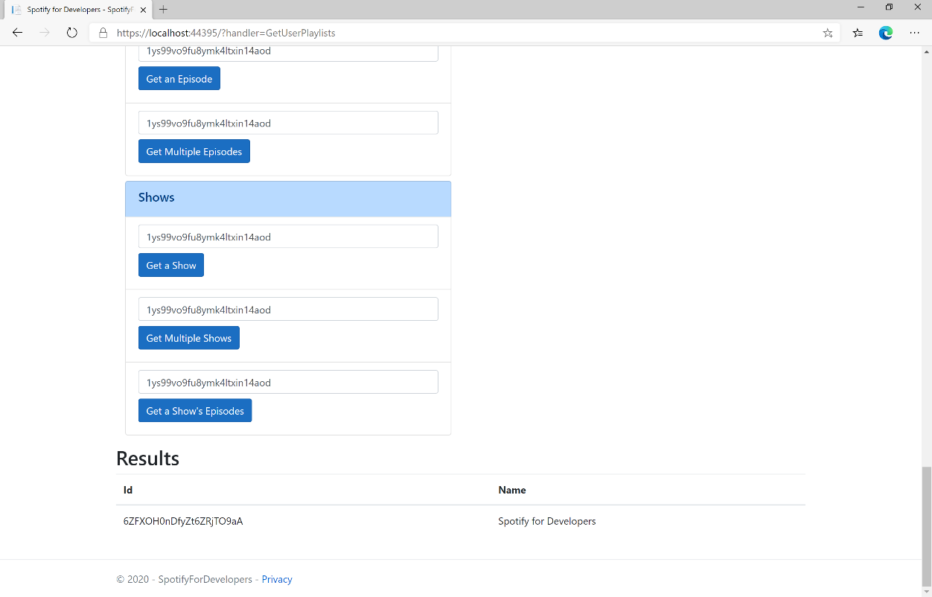

### Step 11

|  |  |
| --- | --- |
|  | You can stop the **web application** in **Visual Studio 2019** by selecting the **Stop debugging** button |

### Step 12

|  |  |
| --- | --- |
|  | You can choose to exit **Visual Studio 2019** by selecting the **Close** button in the top right of the **application** as that completes thispart of the workshop |

## Add Tracks to a Playlist

Add one or more tracks to a user’s playlist.

|  |  |
| --- | --- |
| POST https://api.spotify.com/v1/playlists/{playlist_id}/tracks | |
| Header | |
| Authorization | User Token from Spotify Accounts service with **playlist-modify-public** scope for publicly followed playlist and **playlist-modify-private** for a privately followed playlist |
| Path Parameter | |
| playlist_id | Spotify Id for the Playlist |
| Query Parameter | |
| uri | Comma-separated list of Spotify Track URIs to add – maximum 100 |
| position | Position to insert the tracks, a zero-based index. |

|  |  |
| --- | --- |
| Header | Response |
| Success | |
| HTTP Status 201 Created | snapshot_id |
| Error | |
| HTTP Status 403  Forbidden | Returned when not Authorised or more than 10,000 tracks in Playlist |
| Error Code | Error Object |

### Step 1

|  |  |
| --- | --- |
|  | If you chose to close **Visual Studio 2019** previously, in **Windows 10** choose **Start**, and then from the **Start Menu** find and select **Visual Studio 2019** |
|  | Once done, from the **Get started** screen for **Visual Studio 2019** select **Open a project or solution** |
|  | Then locate and select **SpotifyForDevelopers.sln** and select **Open** if you don’t have this file already then please follow the previous parts of the workshop including **Getting Started**, **Authorisation Guide**, **Search & Browse**, **Playlists & Artists**, **Albums & Tracks**, **Episodes & Shows**, **Follow** and **Playlists** |

### Step 2

|  |  |
| --- | --- |
|  | Once opened, in the **Solution Explorer** open the **Pages** section, then open the **Index.cshtml** section and select **Index.cshtml.cs** |

### Step 3

|  |  |
| --- | --- |
|  | Then from the **Menu** choose **View** and then **Open** |

### Step 4

In the **Code View** for **Index.cshtml.cs** below the **method** for public async Task<IActionResult> OnPostGetUserPlaylistsAsync(...) { ... } enter the following **method**:

|  |
| --- |
| public async Task<IActionResult> OnPostAddTracksToPlaylistAsync(string value, string option)  {  LoadToken();  var values = value.Split(",").Select(value => $"spotify:track:{value}").ToList();  var result = await Api.AddTracksToPlaylistAsync(option, values);  if (result != null)  {  Results = new List<Result>() { new Result()  {  Id = result.SnapshotId,  Name = result.Success.ToString()  }};  }  return Page();  } |

The **method** for OnPostAddTracksToPlaylistAsync is used add **tracks** by **Track Ids** to a **playlist** by **Playlist Id** on Spotify and populate the **property** for Results accordingly.

### Step 5

|  |  |
| --- | --- |
|  | In the **Solution Explorer** in the **Pages** section select **Index.cshtml** |

### Step 6

|  |  |
| --- | --- |
|  | Then from the **Menu** choose **View** and then **Open** |

### Step 7

Once in the **Code View** for **Index.cshtml** above <!-- Playlists --> enter the following:

|  |
| --- |
| <li class="list-group-item">  <form **asp-page-handler**="AddTracksToPlaylist" method="post">  <input **asp-for**="Value" placeholder="Track Ids" class="form-control mb-2" />  <input **asp-for**="Option" placeholder="Playlist Id" class="form-control mb-2" />  <button class="btn btn-primary mb-2">  Add Tracks to a Playlist  </button>  </form>  </li> |

This form will **post** to the **method** for AddTracksToPlaylist with the Value of the **Track Ids** and the Option of the **Playlist Id** and will output to the **Results**.

### Step 8

|  |  |
| --- | --- |
|  | Finally, in **Visual Studio 2019** select **IIS Application** to run the **Web Application** |

### Step 9

Once the **Web Application** is running and you select **Authorisation Code Flow Login** or **Implicit Grant Flow Login** and scroll down you should see something like the following:

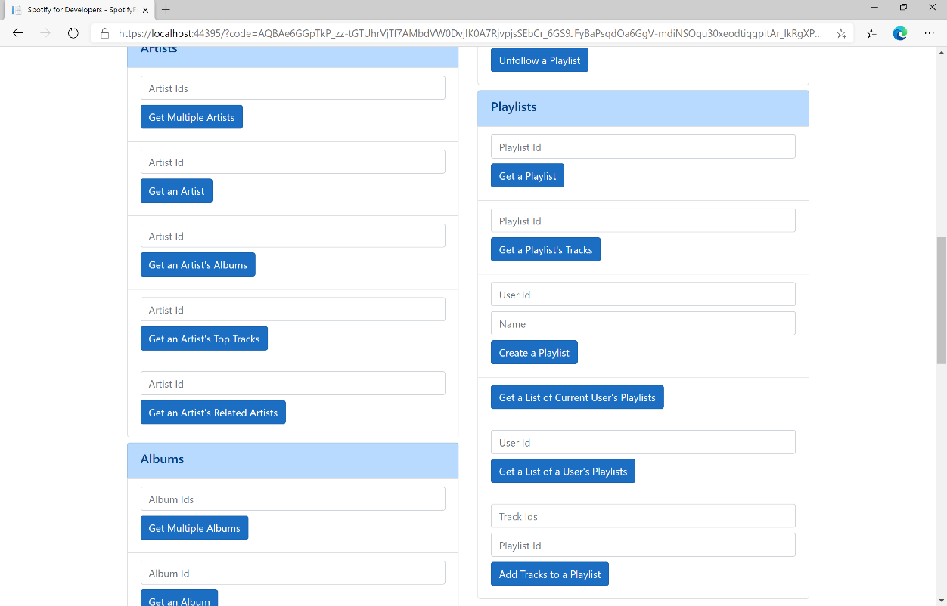

### Step 10

You can then enter some **Track Ids** from an **Album Id** from **Get All New Releases** using **Get an Album's Tracks** into **Track Ids** above **Add Tracks to a Playlist** and the **Playlist Id** from **Create a Playlist** then select **Add Tracks to a Playlist** and scroll down to view **Results** like the following:

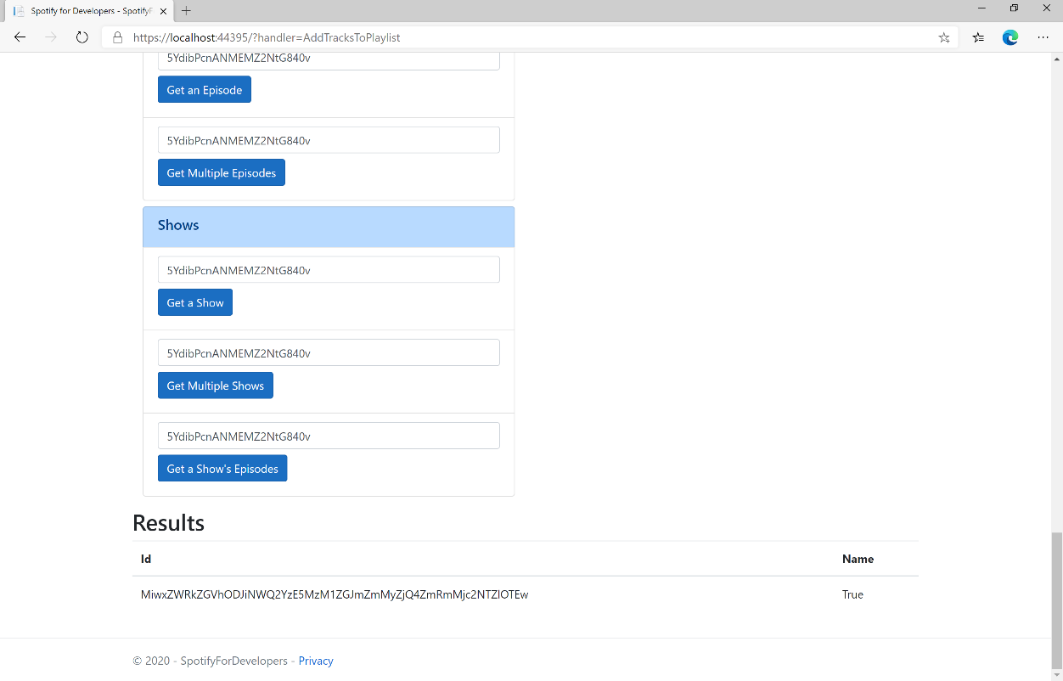

### Step 11

|  |  |
| --- | --- |
|  | You can stop the **web application** in **Visual Studio 2019** by selecting the **Stop debugging** button |

### Step 12

|  |  |
| --- | --- |
|  | You can choose to exit **Visual Studio 2019** by selecting the **Close** button in the top right of the **application** as that completes thispart of the workshop |

## Remove Tracks from a Playlist

Remove one or more tracks from a user’s playlist.

|  |  |
| --- | --- |
| DELETE https://api.spotify.com/v1/playlists/{playlist_id}/tracks | |
| Header | |
| Authorization | User Token from Spotify Accounts service with **playlist-modify-public** scope for publicly followed playlist and **playlist-modify-private** for a privately followed playlist |
| Path Parameter | |
| playlist_id | Spotify Id for the Playlist |
| Query Parameter | |
| tracks | Comma-separated list of Spotify Track URIs to add – maximum 100 |
| snapshot_id | Playlist’s snapshot Id against which you want to make the changes |

|  |  |
| --- | --- |
| Header | Response |
| Success | |
| HTTP Status 200 OK | snapshot_id |
| Error | |
| HTTP Status 403  Forbidden | Returned when not Authorised |
| HTTP Status 400  Bad Request | Client Errors including specified invalid positions |
| Error Code | Error Object |

### Step 1

|  |  |
| --- | --- |
|  | If you chose to close **Visual Studio 2019** previously, in **Windows 10** choose **Start**, and then from the **Start Menu** find and select **Visual Studio 2019** |
|  | Once done, from the **Get started** screen for **Visual Studio 2019** select **Open a project or solution** |
|  | Then locate and select **SpotifyForDevelopers.sln** and select **Open** if you don’t have this file already then please follow the previous parts of the workshop including **Getting Started**, **Authorisation Guide**, **Search & Browse**, **Playlists & Artists**, **Albums & Tracks**, **Episodes & Shows**, **Follow** and **Playlists** |

### Step 2

|  |  |
| --- | --- |
|  | Once opened, in the **Solution Explorer** open the **Pages** section, then open the **Index.cshtml** section and select **Index.cshtml.cs** |

### Step 3

|  |  |
| --- | --- |
|  | Then from the **Menu** choose **View** and then **Open** |

### Step 4

In the **Code View** for **Index.cshtml.cs** below the **method** for public async Task<IActionResult> OnPostAddTracksToPlaylistAsync(...) { ... } enter the following **method**:

|  |
| --- |
| public async Task<IActionResult> OnPostRemoveTracksFromPlaylistAsync(string value, string option)  {  LoadToken();  var values = value.Split(",").Select(value => $"spotify:track:{value}").ToList();  var result = await Api.RemoveTracksFromPlaylistAsync(option, values);  if (result != null)  {  Results = new List<Result>() { new Result()  {  Id = result.SnapshotId,  Name = result.Success.ToString()  }};  }  return Page();  } |

The **method** for OnPostRemoveTracksFromPlaylistAsync is used remove **tracks** by **Track Ids** from a **playlist** by **Playlist Id** on Spotify and populate the **property** for Results of the **success** of the operation accordingly.

### Step 5

|  |  |
| --- | --- |
|  | In the **Solution Explorer** in the **Pages** section select **Index.cshtml** |

### Step 6

|  |  |
| --- | --- |
|  | Then from the **Menu** choose **View** and then **Open** |

### Step 7

Once in the **Code View** for **Index.cshtml** above <!-- Playlists --> enter the following:

|  |
| --- |
| <li class="list-group-item">  <form **asp-page-handler**="RemoveTracksFromPlaylist" method="post">  <input **asp-for**="Value" placeholder="Track Ids" class="form-control mb-2" />  <input **asp-for**="Option" placeholder="Playlist Id" class="form-control mb-2" />  <button class="btn btn-primary mb-2">  Remove Tracks from a Playlist  </button>  </form>  </li> |

This form will **post** to the **method** for RemoveTracksFromPlaylist with the Value of the **Track Ids** and the Option of the **Playlist Id** and will output to the **Results**.

### Step 8

|  |  |
| --- | --- |
|  | Finally, in **Visual Studio 2019** select **IIS Application** to run the **Web Application** |

### Step 9

Once the **Web Application** is running and you select **Authorisation Code Flow Login** or **Implicit Grant Flow Login** and scroll down you should see something like the following:

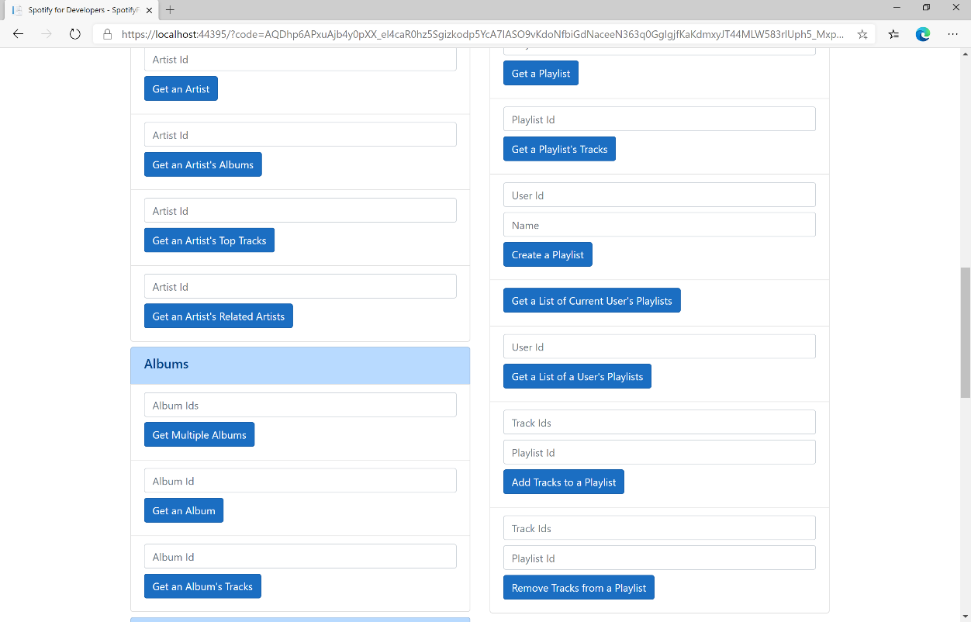

### Step 10

You can use **Get a Playlist's Tracks** and the **Playlist Id** from **Create a Playlist** to get the **Track Ids** to enter into **Track Ids** above **Remove Tracks from a Playlist** and the **Playlist Id** then select **Remove Tracks from a Playlist** and scroll down to view **Results** like the following:

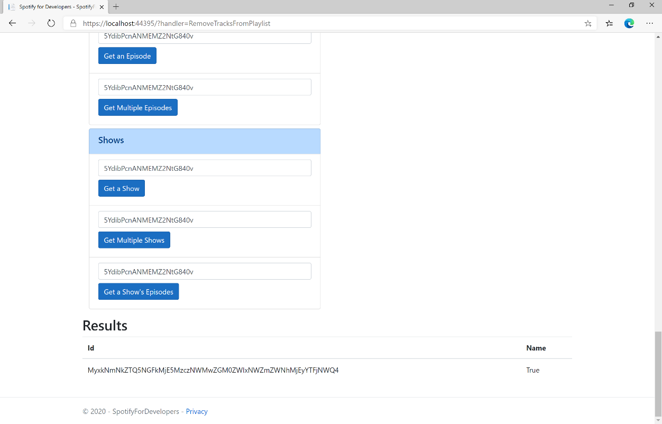

### Step 11

|  |  |
| --- | --- |
|  | You can stop the **web application** in **Visual Studio 2019** by selecting the **Stop debugging** button |

### Step 12

|  |  |
| --- | --- |
|  | You can choose to exit **Visual Studio 2019** by selecting the **Close** button in the top right of the **application** as that completes thispart of the workshop |

## Upload a Custom Playlist Cover Image

Replace the image used to represent a specific playlist.

|  |  |
| --- | --- |
| PUT https://api.spotify.com/v1/playlists/{playlist_id}/images | |
| Header | |
| Authorization | User Token from Spotify Accounts service with **ugc-image-upload**, **playlist-modify-public** scope for publicly followed playlist and **playlist-modify-private** for a privately followed playlist |
| Path Parameter | |
| playlist_id | Spotify Id for the Playlist |
| Body | |
|  | Base 64 Encoded JPEG with a maximum size of 256KB |

|  |  |
| --- | --- |
| Header | Response |
| Success | |
| HTTP Status 200 OK |  |
| Error | |
| HTTP Status 429  Too Many Requests | Returned when have sent too many requests |
| Error Code | Error Object |

### Step 1

|  |  |
| --- | --- |
|  | If you chose to close **Visual Studio 2019** previously, in **Windows 10** choose **Start**, and then from the **Start Menu** find and select **Visual Studio 2019** |
|  | Once done, from the **Get started** screen for **Visual Studio 2019** select **Open a project or solution** |
|  | Then locate and select **SpotifyForDevelopers.sln** and select **Open** if you don’t have this file already then please follow the previous parts of the workshop including **Getting Started**, **Authorisation Guide**, **Search & Browse**, **Playlists & Artists**, **Albums & Tracks**, **Episodes & Shows**, **Follow** and **Playlists** |

### Step 2

|  |  |
| --- | --- |
|  | Once opened, in the **Solution Explorer** open the **Pages** section, then open the **Index.cshtml** section and select **Index.cshtml.cs** |

### Step 3

|  |  |
| --- | --- |
|  | Then from the **Menu** choose **View** and then **Open** |

### Step 4

In the **Code View** for **Index.cshtml.cs** below the **method** for public async Task<IActionResult> OnPostRemoveTracksFromPlaylistAsync(...) { ... } enter the following **method**:

|  |
| --- |
| public async Task<IActionResult> OnPostUploadCustomPlaylistCoverImageAsync(string value)  {  LoadToken();  System.IO.MemoryStream stream = new System.IO.MemoryStream();  Upload.OpenReadStream().CopyTo(stream);  var file = stream.ToArray();  var result = await Api.UploadCustomPlaylistCoverImageAsync(value, file);  if (result != null)  {  Results = new List<Result>() { new Result()  {  Id = result.Code.ToString(),  Name = result.Success.ToString()  }};  }  return Page();  } |

The **method** for OnPostUploadCustomPlaylistCoverImageAsync is **upload** an **image** with Upload for a **Playlist** by **Playlist Id** with Value on Spotify and populate the **property** for Results of the **success** of the operation accordingly.

### Step 5

|  |  |
| --- | --- |
|  | In the **Solution Explorer** in the **Pages** section select **Index.cshtml** |

### Step 6

|  |  |
| --- | --- |
|  | Then from the **Menu** choose **View** and then **Open** |

### Step 7

Once in the **Code View** for **Index.cshtml** above <!-- Playlists --> enter the following:

|  |
| --- |
| <li class="list-group-item">  <form **asp-page-handler**="UploadCustomPlaylistCoverImage"  enctype="multipart/form-data" method="post">  <input **asp-for**="Value" placeholder="Playlist Id" class="form-control mb-2" />  <input **asp-for**="Upload" class="form-control mb-2" />  <button class="btn btn-primary mb-2">  Upload a Custom Playlist Cover Image  </button>  </form>  </li> |

This form will **post** to the **method** for UploadCustomPlaylistCoverImage with the Value of the **Playlist Id** and the Upload of the **File** and will output to the **Results**.

### Step 8

|  |  |
| --- | --- |
|  | Finally, in **Visual Studio 2019** select **IIS Application** to run the **Web Application** |

### Step 9

Once the **Web Application** is running and you select **Authorisation Code Flow Login** or **Implicit Grant Flow Login** and scroll down you should see something like the following:

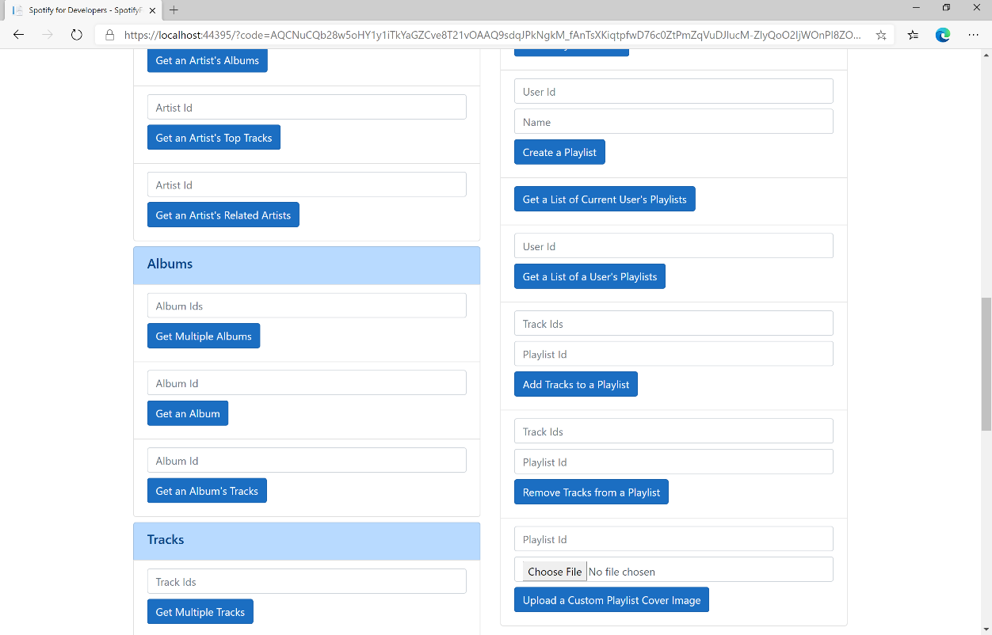

### Step 10

You can then enter the **Playlist Id** from **Create a Playlist** into **Playlist Id** above **Upload a Custom Playlist Cover Image** and choose a **JPEG** file of **256KB** or smaller to upload and **Playlist Id** from **Create a Playlist** then select **Upload a Custom Playlist Cover Image** and scroll down to view **Results** like the following:

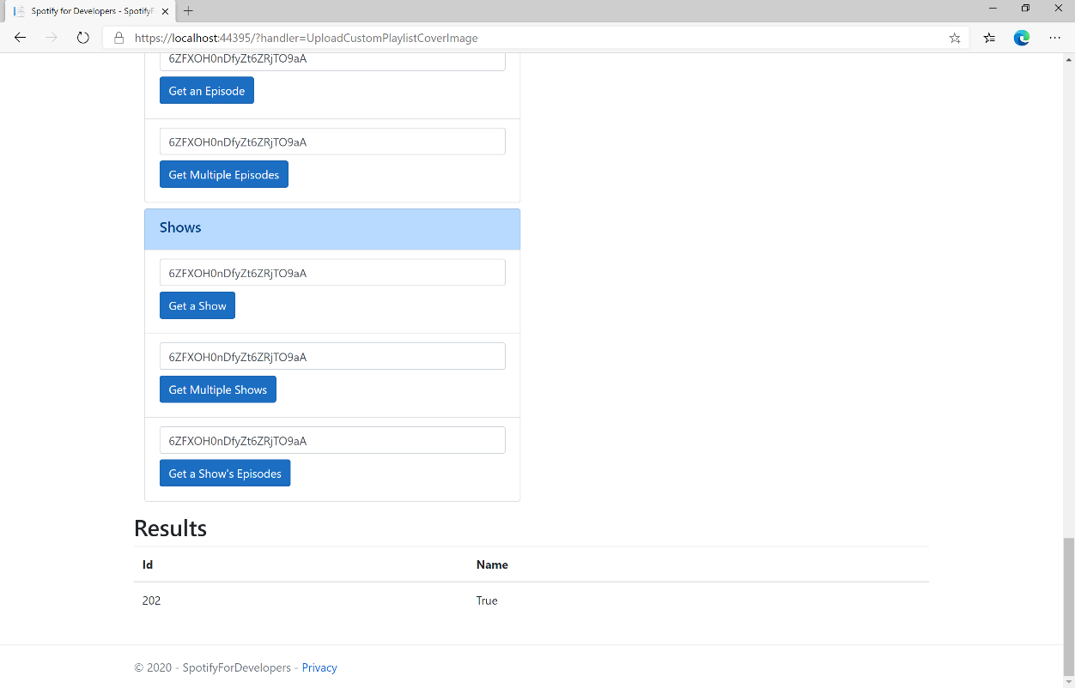

### Step 11

|  |  |
| --- | --- |
|  | You can stop the **web application** in **Visual Studio 2019** by selecting the **Stop debugging** button |

### Step 12

|  |  |
| --- | --- |
|  | You can choose to exit **Visual Studio 2019** by selecting the **Close** button in the top right of the **application** as that completes thispart of the workshop |

## Get a Playlist Cover Image

Get the current image associated with a specific playlist.

|  |  |
| --- | --- |
| GET https://api.spotify.com/v1/playlists/{playlist_id}/images | |
| Header | |
| Authorization | User Token from Spotify Accounts service |
| Path Parameter | |
| playlist_id | Spotify Id for the Playlist |

|  |  |
| --- | --- |
| Header | Response |
| Success | |
| HTTP Status 200 OK | List of Image Objects |
| Error | |
| Error Code | Error Object |

### Step 1

|  |  |
| --- | --- |
|  | If you chose to close **Visual Studio 2019** previously, in **Windows 10** choose **Start**, and then from the **Start Menu** find and select **Visual Studio 2019** |
|  | Once done, from the **Get started** screen for **Visual Studio 2019** select **Open a project or solution** |
|  | Then locate and select **SpotifyForDevelopers.sln** and select **Open** if you don’t have this file already then please follow the previous parts of the workshop including **Getting Started**, **Authorisation Guide**, **Search & Browse**, **Playlists & Artists**, **Albums & Tracks**, **Episodes & Shows**, **Follow** and **Playlists** |

### Step 2

|  |  |
| --- | --- |
|  | Once opened, in the **Solution Explorer** open the **Pages** section, then open the **Index.cshtml** section and select **Index.cshtml.cs** |

### Step 3

|  |  |
| --- | --- |
|  | Then from the **Menu** choose **View** and then **Open** |

### Step 4

In the **Code View** for **Index.cshtml.cs** below the **method** for public async Task<IActionResult> OnPostUploadCustomPlaylistCoverImageAsync(...) { ... } enter the following **method**:

|  |
| --- |
| public async Task<IActionResult> OnPostGetPlaylistCoverImageAsync(string value)  {  LoadToken();  var results = await Api.GetPlaylistCoverImageAsync(value);  if (results != null)  {  Results = results.Select(result => new Result()  {  Image = result.Url  });  }  return Page();  } |

The **method** for OnPostGetPlaylistCoverImageAsync gets an **image** for a **Playlist** by **Playlist Id** with Value on Spotify and populate the **property** for Results accordingly.

### Step 5

|  |  |
| --- | --- |
|  | In the **Solution Explorer** in the **Pages** section select **Index.cshtml** |

### Step 6

|  |  |
| --- | --- |
|  | Then from the **Menu** choose **View** and then **Open** |

### Step 7

Once in the **Code View** for **Index.cshtml** above <!-- Playlists --> enter the following:

|  |
| --- |
| <li class="list-group-item">  <form **asp-page-handler**="GetPlaylistCoverImage" method="post">  <input **asp-for**="Value" placeholder="Playlist Id" class="form-control mb-2" />  <button class="btn btn-primary mb-2">  Get a Playlist Cover Image  </button>  </form>  </li> |

This form will **post** to the **method** for GetPlaylistCoverImage with the Value of the **Playlist Id** and the Upload of the **File** and will output to the **Results**.

### Step 8

|  |  |
| --- | --- |
|  | Finally, in **Visual Studio 2019** select **IIS Application** to run the **Web Application** |

### Step 9

Once the **Web Application** is running and you select **Authorisation Code Flow Login** or **Implicit Grant Flow Login** and scroll down you should see something like the following:

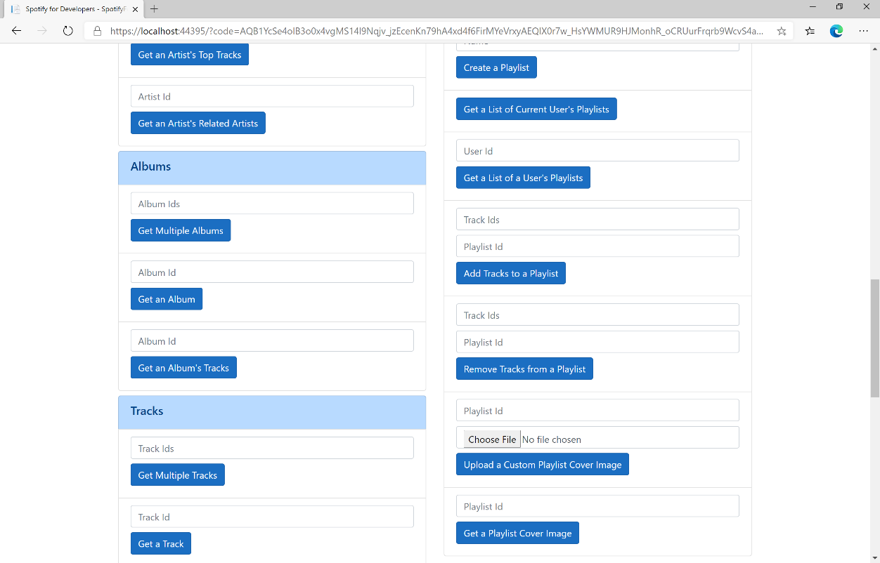

### Step 10

You can then enter the **Playlist Id** from **Create a Playlist** into **Playlist Id** above **Get a Playlist Cover Image** then select **Get a Playlist Cover Image** and scroll down to view **Results** like the following:

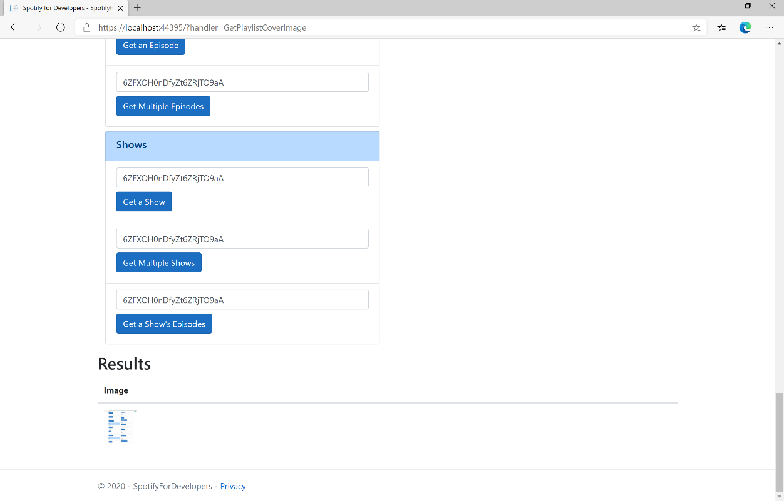

### Step 11

|  |  |
| --- | --- |
|  | You can stop the **web application** in **Visual Studio 2019** by selecting the **Stop debugging** button |

### Step 12

|  |  |
| --- | --- |
|  | You can choose to exit **Visual Studio 2019** by selecting the **Close** button in the top right of the **application** as that completes thispart of the workshop |

## Change a Playlist's Details

Change a playlist’s name and public/private state of a playlist owned by a user

|  |  |
| --- | --- |
| PUT https://api.spotify.com/v1/playlists/{playlist_id} | |
| Header | |
| Authorization | User Token from Spotify Accounts service with **playlist-modify-public** scope for publicly followed playlist and **playlist-modify-private** for a privately followed playlist |
| Path Parameter | |
| playlist_id | Spotify Id for the Playlist |
| Body Parameter | |
| name | New name for the playlist |
| public | If true, the playlist will be public, if false it will be private |
| collaborative | If true, the playlist will be collaborative and other users will be able to modify the playlist |
| description | Playlist description |

|  |  |
| --- | --- |
| Header | Response |
| Success | |
| HTTP Status 200 OK |  |
| Error | |
| HTTP Status 403  Forbidden | Returned when not Authorised |
| Error Code | Error Object |

### Step 1

|  |  |
| --- | --- |
|  | If you chose to close **Visual Studio 2019** previously, in **Windows 10** choose **Start**, and then from the **Start Menu** find and select **Visual Studio 2019** |
|  | Once done, from the **Get started** screen for **Visual Studio 2019** select **Open a project or solution** |
|  | Then locate and select **SpotifyForDevelopers.sln** and select **Open** if you don’t have this file already then please follow the previous parts of the workshop including **Getting Started**, **Authorisation Guide**, **Search & Browse**, **Playlists & Artists**, **Albums & Tracks**, **Episodes & Shows**, **Follow** and **Playlists** |

### Step 2

|  |  |
| --- | --- |
|  | Once opened, in the **Solution Explorer** open the **Pages** section, then open the **Index.cshtml** section and select **Index.cshtml.cs** |

### Step 3

|  |  |
| --- | --- |
|  | Then from the **Menu** choose **View** and then **Open** |

### Step 4

In the **Code View** for **Index.cshtml.cs** below the **method** for public async Task<IActionResult> OnPostGetPlaylistCoverImageAsync(...) { ... } enter the following **method**:

|  |
| --- |
| public async Task<IActionResult> OnPostChangePlaylistDetailsAsync(string value, string option)  {  LoadToken();  var result = await Api.ChangePlaylistDetailsAsync(value, option);  if (result != null)  {  Results = new List<Result>() { new Result()  {  Id = result.Code.ToString(),  Name = result.Success.ToString()  }};  }  return Page();  } |

The **method** for OnPostChangePlaylistDetailsAsync sets the **Name** for a **Playlist** of Option by **Playlist Id** with Value on Spotify and populate the **property** for Results of the **success** of the operation accordingly.

### Step 5

|  |  |
| --- | --- |
|  | In the **Solution Explorer** in the **Pages** section select **Index.cshtml** |

### Step 6

|  |  |
| --- | --- |
|  | Then from the **Menu** choose **View** and then **Open** |

### Step 7

Once in the **Code View** for **Index.cshtml** above <!-- Playlists --> enter the following:

|  |
| --- |
| <li class="list-group-item">  <form **asp-page-handler**="ChangePlaylistDetails" method="post">  <input **asp-for**="Value" placeholder="Playlist Id" class="form-control mb-2" />  <input **asp-for**="Option" placeholder="Name" class="form-control mb-2" />  <button class="btn btn-primary mb-2">  Change a Playlist's Details  </button>  </form>  </li> |

This form will **post** to the **method** for ChangePlaylistDetails with the Value of the **Playlist Id** and the Option of the **Name** and will output to the **Results**.

### Step 8

|  |  |
| --- | --- |
|  | Finally, in **Visual Studio 2019** select **IIS Application** to run the **Web Application** |

### Step 9

Once the **Web Application** is running and you select **Authorisation Code Flow Login** or **Implicit Grant Flow Login** and scroll down you should see something like the following:

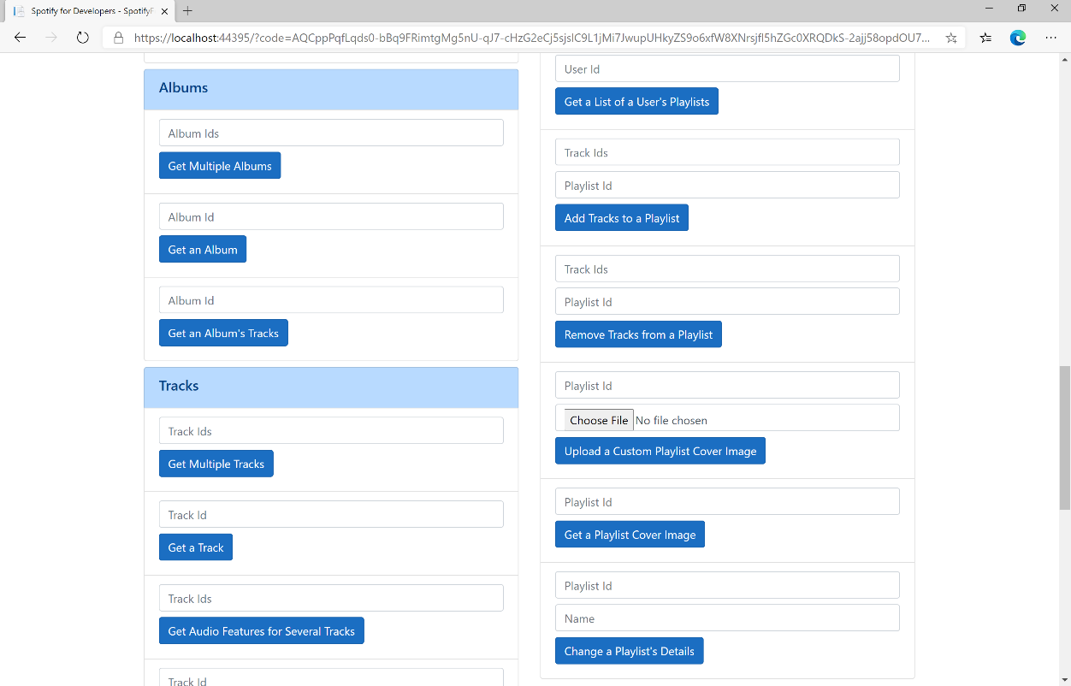

### Step 10

You can then enter the **Playlist Id** from **Create a Playlist** into **Playlist Id** above **Change a Playlist's Details** and a new **Name** then select **Change a Playlist's Details** and scroll down to view **Results** like the following:

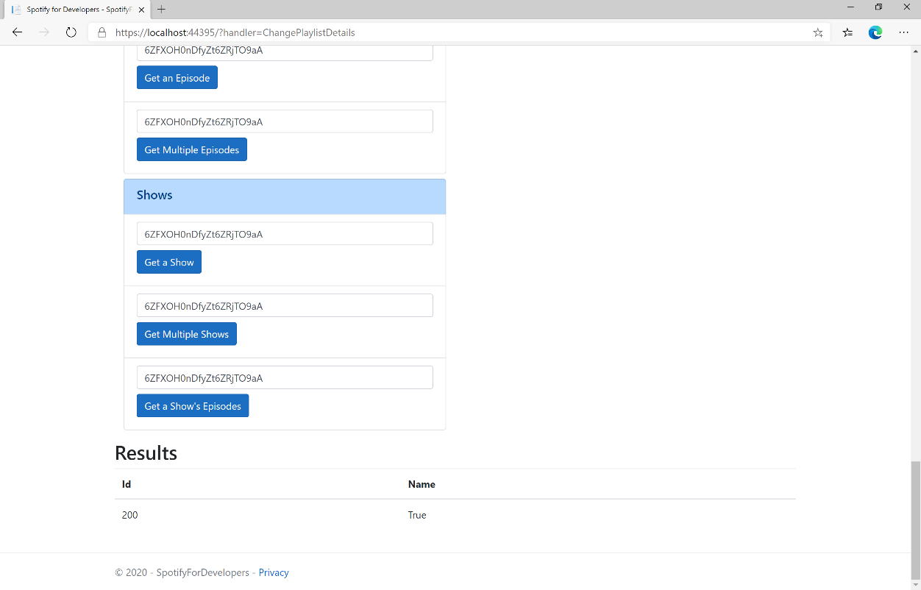

### Step 11

|  |  |
| --- | --- |
|  | You can stop the **web application** in **Visual Studio 2019** by selecting the **Stop debugging** button |

### Step 12

|  |  |
| --- | --- |
|  | You can exit **Visual Studio 2019** by selecting the **Close** button in the top right of the **application** as that completes thispart of the workshop |

## Replace a Playlist's Tracks

Replace all the tracks in a playlist, overwriting its existing tracks.

|  |  |
| --- | --- |
| PUT https://api.spotify.com/v1/playlists/{playlist_id}/tracks | |
| Header | |
| Authorization | User Token from Spotify Accounts service with **playlist-modify-public** scope for publicly followed playlist and **playlist-modify-private** for a privately followed playlist |
| Path Parameter | |
| playlist_id | Spotify Id for the playlist |
| Query Parameter | |
| uris | Comma-separated list of Spotify track URIs to set – maximum of 100 |

|  |  |
| --- | --- |
| Header | Response |
| Success | |
| Http Status 201  Created |  |
| Error | |
| HTTP Status 403  Forbidden | Returned when not Authorised |
| Error Code | Error Object |

### Step 1

|  |  |
| --- | --- |
|  | If you chose to close **Visual Studio 2019** previously, in **Windows 10** choose **Start**, and then from the **Start Menu** find and select **Visual Studio 2019** |
|  | Once done, from the **Get started** screen for **Visual Studio 2019** select **Open a project or solution** |
|  | Then locate and select **SpotifyForDevelopers.sln** and select **Open** if you don’t have this file already then please follow the previous parts of the workshop including **Getting Started**, **Authorisation Guide**, **Search & Browse**, **Playlists & Artists**, **Albums & Tracks**, **Episodes & Shows**, **Follow** and **Playlists** |

### Step 2

|  |  |
| --- | --- |
|  | Once opened, in the **Solution Explorer** open the **Pages** section, then open the **Index.cshtml** section and select **Index.cshtml.cs** |

### Step 3

|  |  |
| --- | --- |
|  | Then from the **Menu** choose **View** and then **Open** |

### Step 4

In the **Code View** for **Index.cshtml.cs** below the **method** for public async Task<IActionResult> OnPostChangePlaylistDetailsAsync(...) { ... } enter the following **method**:

|  |
| --- |
| public async Task<IActionResult> OnPostReplacePlaylistTracksAsync(string value, string option)  {  LoadToken();  var values = value.Split(",").Select(value => $"spotify:track:{value}").ToList();  var result = await Api.ReplacePlaylistTracksAsync(option, values);  if (result != null)  {  Results = new List<Result>() { new Result()  {  Id = result.Code.ToString(),  Name = result.Success.ToString()  }};  }  return Page();  } |

The **method** for OnPostReplacePlaylistTracksAsync replaces the **tracks** for a **Playlist** with Value of the **Track Ids** and the **Playlist Id** of Option on Spotify and populate the **property** for Results of the **success** of the operation accordingly.

### Step 5

|  |  |
| --- | --- |
|  | In the **Solution Explorer** in the **Pages** section select **Index.cshtml** |

### Step 6

|  |  |
| --- | --- |
|  | Then from the **Menu** choose **View** and then **Open** |

### Step 7

Once in the **Code View** for **Index.cshtml** above <!-- Playlists --> enter the following:

|  |
| --- |
| <li class="list-group-item">  <form **asp-page-handler**="ReplacePlaylistTracks" method="post">  <input **asp-for**="Value" placeholder="Track Ids" class="form-control mb-2" />  <input **asp-for**="Option" placeholder="Playlist Id" class="form-control mb-2" />  <button class="btn btn-primary mb-2">  Replace a Playlist's Tracks  </button>  </form>  </li> |

This form will **post** to the **method** for ReplacePlaylistTracks with the Value of the **Track Ids** and the Option of the **Playlist Id** and will output to the **Results**.

### Step 8

|  |  |
| --- | --- |
|  | Finally, in **Visual Studio 2019** select **IIS Application** to run the **Web Application** |

### Step 9

Once the **Web Application** is running and you select **Authorisation Code Flow Login** or **Implicit Grant Flow Login** and scroll down you should see something like the following:

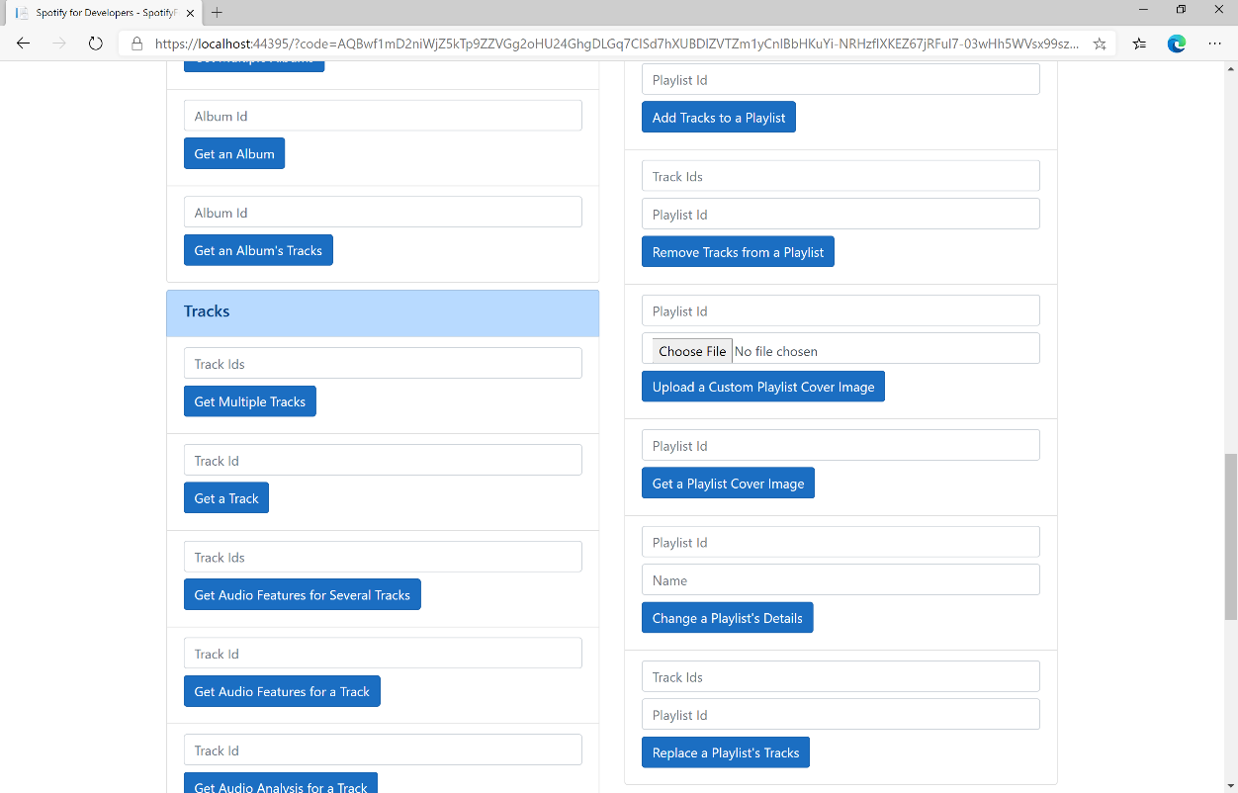

### Step 10

You can then enter some **Track Ids** from an **Album Id** from **Get All New Releases** using **Get an Album's Tracks** into **Track Ids** above **Replace a Playlist's Tracks** and enter the **Playlist Id** from **Create a Playlist** into **Playlist Id** and then select **Replace a Playlist's Tracks** and scroll down to view **Results** like the following:

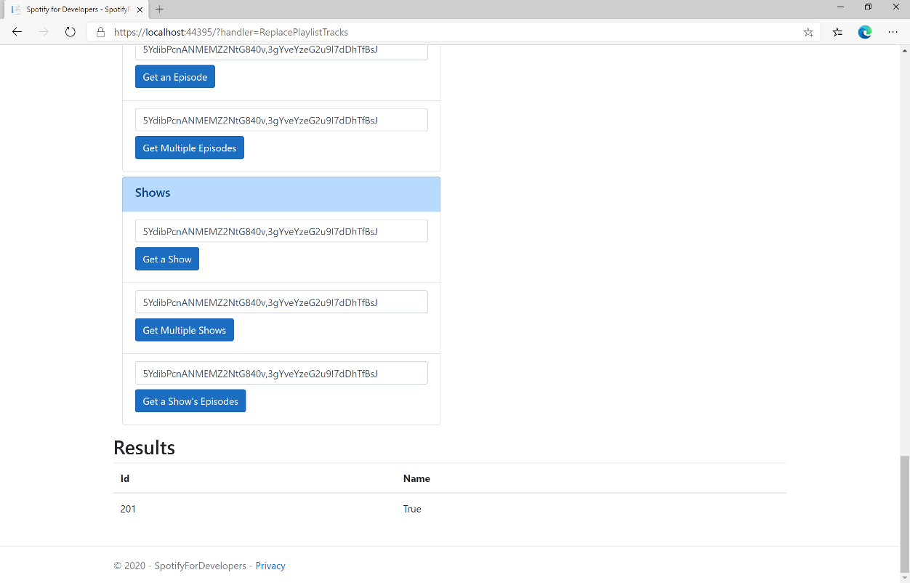

### Step 11

|  |  |
| --- | --- |
|  | You can stop the **web application** in **Visual Studio 2019** by selecting the **Stop debugging** button |

### Step 12

|  |  |
| --- | --- |
|  | You can choose to exit **Visual Studio 2019** by selecting the **Close** button in the top right of the **application** as that completes thispart of the workshop |

## Reorder a Playlist's Tracks

Reorder a track or a group of tracks in a playlist.

|  |  |
| --- | --- |
| PUT https://api.spotify.com/v1/playlists/{playlist_id}/tracks | |
| Header | |
| Authorization | User Token from Spotify Accounts service with **playlist-modify-public** scope for publicly followed playlist and **playlist-modify-private** for a privately followed playlist |
| Path Parameter | |
| playlist_id | Spotify Id for the playlist |
| Body Parameter | |
| range_start | Position of the first track to be reordered |
| insert_before | Position where the tracks should be inserted |
| range_length | Number of tracks to be reordered. Defaults to 1 if not set. |
| snapshot_id | Playlist’s snapshot ID against which you want to make the changes |

|  |  |
| --- | --- |
| Header | Response |
| Success | |
| Http Status 200 OK |  |
| Error | |
| Error Code | Error Object |

### Step 1

|  |  |
| --- | --- |
|  | If you chose to close **Visual Studio 2019** previously, in **Windows 10** choose **Start**, and then from the **Start Menu** find and select **Visual Studio 2019** |
|  | Once done, from the **Get started** screen for **Visual Studio 2019** select **Open a project or solution** |
|  | Then locate and select **SpotifyForDevelopers.sln** and select **Open** if you don’t have this file already then please follow the previous parts of the workshop including **Getting Started**, **Authorisation Guide**, **Search & Browse**, **Playlists & Artists**, **Albums & Tracks**, **Episodes & Shows**, **Follow** and **Playlists** |

### Step 2

|  |  |
| --- | --- |
|  | Once opened, in the **Solution Explorer** open the **Pages** section, then open the **Index.cshtml** section and select **Index.cshtml.cs** |

### Step 3

|  |  |
| --- | --- |
|  | Then from the **Menu** choose **View** and then **Open** |

### Step 4

In the **Code View** for **Index.cshtml.cs** below the **method** for public async Task<IActionResult> OnPostReplacePlaylistTracksAsync(...) { ... } enter the following **method**:

|  |
| --- |
| public async Task<IActionResult> OnPostReorderPlaylistTracksAsync(string value, string option)  {  LoadToken();  var index = int.Parse(option);  var result = await Api.ReorderPlaylistTracksAsync(value, index, 0, 1);  if (result != null)  {  Results = new List<Result>() { new Result()  {  Id = result.SnapshotId.ToString(),  Name = result.Success.ToString()  }};  }  return Page();  } |

The **method** for OnPostReorderPlaylistTracksAsync **reorders** the **tracks** in a **Playlist** with the Value of the **Playlist Id** on Spotify and the Option is the **Index** of the **track** to move to the first position and populate the **property** for Results of the **success** of the operation accordingly.

### Step 5

|  |  |
| --- | --- |
|  | In the **Solution Explorer** in the **Pages** section select **Index.cshtml** |

### Step 6

|  |  |
| --- | --- |
|  | Then from the **Menu** choose **View** and then **Open** |

### Step 7

Once in the **Code View** for **Index.cshtml** above <!-- Playlists --> enter the following:

|  |
| --- |
| <li class="list-group-item">  <form **asp-page-handler**="ReorderPlaylistTracks" method="post">  <input **asp-for**="Value" placeholder="Playlist Id" class="form-control mb-2" />  <input **asp-for**="Option" placeholder="Index" class="form-control mb-2" />  <button class="btn btn-primary mb-2">  Reorder a Playlist's Tracks  </button>  </form>  </li> |

This form will **post** to the **method** for ReorderPlaylistTracks with the Value of the **Playlist Id** and the Option of **Index** and will output to the **Results**.

### Step 8

|  |  |
| --- | --- |
|  | Finally, in **Visual Studio 2019** select **IIS Application** to run the **Web Application** |

### Step 9

Once the **Web Application** is running and you select **Authorisation Code Flow Login** or **Implicit Grant Flow Login** and scroll down you should see something like the following:

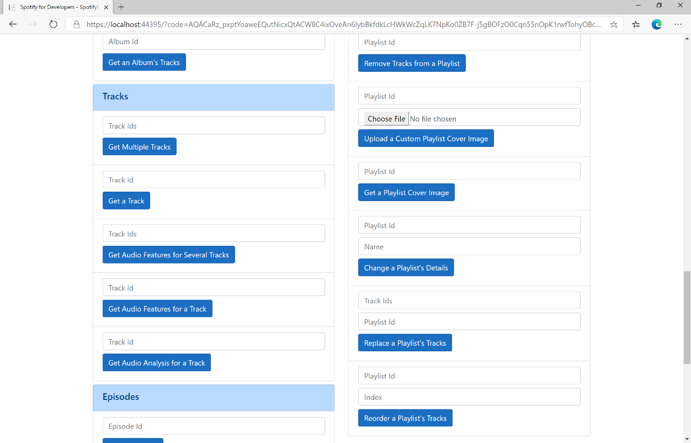

### Step 10

You can use **Get a Playlist's Tracks** and **Playlist Id** from **Create a Playlists** to check the **Order** of the **Tracks** in the **Playlist**. You can enter above **Reorder a Playlist's Tracks** the **Playlist Id** from **Create a Playlist** into **Playlist Id**, then enter an **Index** e.g. **1** and select **Reorder a Playlist's Tracks** and scroll down to view **Results** like the following:

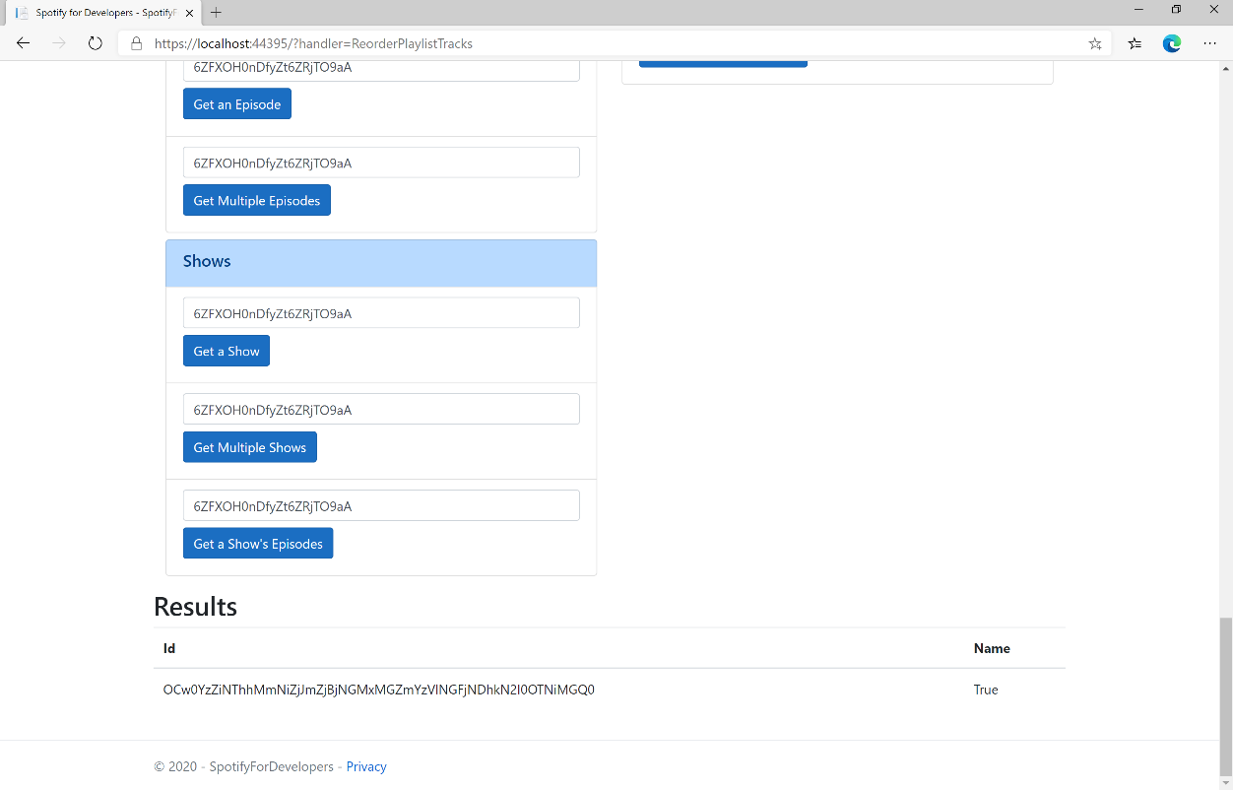

### Step 11

|  |  |
| --- | --- |
|  | You can stop the **web application** in **Visual Studio 2019** by selecting the **Stop debugging** button |

### Step 12

|  |  |
| --- | --- |
|  | You can exit **Visual Studio 2019** by selecting the **Close** button in the top right of the **application** as that completes thispart of the workshop |

# Library

## Save Albums for Current User

Save one or more albums to the current user’s ‘Your Music’ library.

|  |  |
| --- | --- |
| PUT https://api.spotify.com/v1/me/albums?ids={ids} | |
| Header | |
| Authorization | User Token from Spotify Accounts service with **user-library-modify** scope |
| Query Parameter | |
| ids | Comma-separated list of the Spotify Ids for the Albums. Maximum: 50 Ids. |

|  |  |
| --- | --- |
| Header | Response |
| Success | |
| Http Status 201  Created |  |
| Error | |
| HTTP Status 403  Forbidden | Returned when not Authorised |
| Error Code | Error Object |

### Step 1

|  |  |
| --- | --- |
|  | In **Windows 10** choose **Start**, and then from the **Start Menu** find and select **Visual Studio 2019** |
|  | Once done, from the **Get started** screen for **Visual Studio 2019** select **Open a project or solution** |
|  | Then locate and select **SpotifyForDevelopers.sln** and select **Open** if you don’t have this file already then please follow the previous parts of the workshop including **Getting Started**, **Authorisation Guide**, **Search & Browse**, **Playlists & Artists**, **Albums & Tracks**, **Episodes & Shows**, **Follow** and **Playlists** |

### Step 2

|  |  |
| --- | --- |
|  | Once opened, in the **Solution Explorer** open the **Pages** section, then open the **Index.cshtml** section and select **Index.cshtml.cs** |

### Step 3

|  |  |
| --- | --- |
|  | Then from the **Menu** choose **View** and then **Open** |

### Step 4

In the **Code View** for **Index.cshtml.cs** below the **method** for public async Task<IActionResult> OnPostReorderPlaylistTracksAsync(...) { ... } enter the following **method**:

|  |
| --- |
| public async Task<IActionResult> OnPostSaveUserAlbumsAsync(string value)  {  LoadToken();  var values = value.Split(",").ToList();  var result = await Api.SaveUserAlbumsAsync(values);  if (result != null)  {  Results = new List<Result>() { new Result()  {  Id = result.Code.ToString(),  Name = result.Success.ToString()  }};  }  return Page();  } |

The **method** for OnPostSaveUserAlbumsAsync **saves** the **albums** to the **Library** with Value of the **Album Ids** of the **album** and populate the **property** for Results of the **success** of the operation accordingly.

### Step 5

|  |  |
| --- | --- |
|  | In the **Solution Explorer** in the **Pages** section select **Index.cshtml** |

### Step 6

|  |  |
| --- | --- |
|  | Then from the **Menu** choose **View** and then **Open** |

### Step 7

Once in the **Code View** for **Index.cshtml** above <!-- Spotify Web API User Authorisation --> enter the following:

|  |
| --- |
| <ul class="list-group mb-2">  <li class="list-group-item list-group-item-primary">  <h5 class="list-group-item-heading">Library</h5>  </li>  <li class="list-group-item">  <form **asp-page-handler**="SaveUserAlbums" method="post">  <input **asp-for**="Value" placeholder="Album Ids" class="form-control mb-2" />  <button class="btn btn-primary mb-2">  Save Albums for Current User  </button>  </form>  </li>  <!-- Library -->  </ul> |

This form will **post** to the **method** for SaveUserAlbums with the Value of the **Album Ids** and will output to the **Results**.

### Step 8

|  |  |
| --- | --- |
|  | Finally, in **Visual Studio 2019** select **IIS Application** to run the **Web Application** |

### Step 9

Once the **Web Application** is running and you select **Authorisation Code Flow Login** or **Implicit Grant Flow Login** and scroll down you should see something like the following:

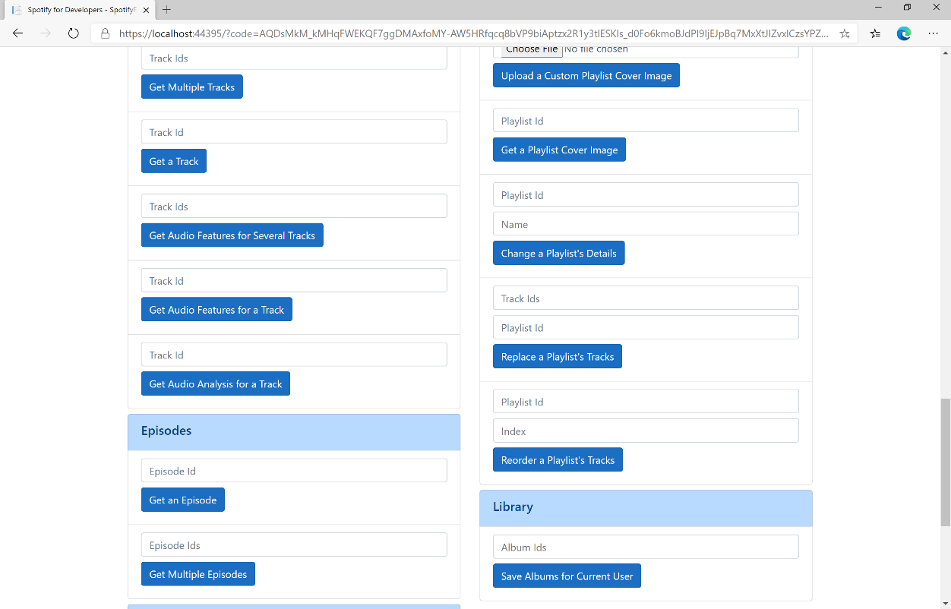

### Step 10

You can then enter some **Album Ids** from **Get All New Releases** above **Save Albums for Current User** and then select **Save Albums for Current User** and scroll down to view **Results** like the following:

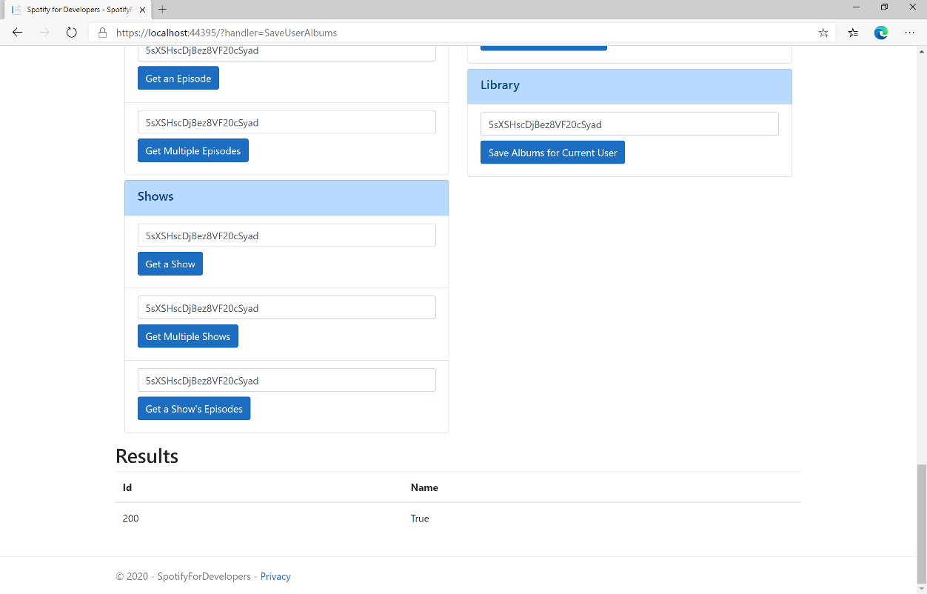

### Step 11

|  |  |
| --- | --- |
|  | You can stop the **web application** in **Visual Studio 2019** by selecting the **Stop debugging** button |

### Step 12

|  |  |
| --- | --- |
|  | You can choose to exit **Visual Studio 2019** by selecting the **Close** button in the top right of the **application** as that completes thispart of the workshop |

## Save Tracks for User

Save one or more tracks to the current user’s ‘Your Music’ library.

|  |  |
| --- | --- |
| PUT https://api.spotify.com/v1/me/tracks | |
| Header | |
| Authorization | User Token from Spotify Accounts service with **user-library-modify** scope |
| Query Parameter | |
| ids | Comma-separated list of the Spotify Ids for the Tracks. Maximum: 50 Ids. |

|  |  |
| --- | --- |
| Header | Response |
| Success | |
| Http Status 200 OK |  |
| Error | |
| HTTP Status 403  Forbidden | Returned when not Authorised or more than 10,000 tracks in Your Music |
| Error Code | Error Object |

### Step 1

|  |  |
| --- | --- |
|  | If you chose to close **Visual Studio 2019** previously, in **Windows 10** choose **Start**, and then from the **Start Menu** find and select **Visual Studio 2019** |
|  | Once done, from the **Get started** screen for **Visual Studio 2019** select **Open a project or solution** |
|  | Then locate and select **SpotifyForDevelopers.sln** and select **Open** if you don’t have this file already then please follow the previous parts of the workshop including **Getting Started**, **Authorisation Guide**, **Search & Browse**, **Playlists & Artists**, **Albums & Tracks**, **Episodes & Shows**, **Follow**, **Playlists** and **Library** |

### Step 2

|  |  |
| --- | --- |
|  | Once opened, in the **Solution Explorer** open the **Pages** section, then open the **Index.cshtml** section and select **Index.cshtml.cs** |

### Step 3

|  |  |
| --- | --- |
|  | Then from the **Menu** choose **View** and then **Open** |

### Step 4

In the **Code View** for **Index.cshtml.cs** below the **method** for public async Task<IActionResult> OnPostSaveUserAlbumsAsync(...) { ... } enter the following **method**:

|  |
| --- |
| public async Task<IActionResult> OnPostSaveUserTracksAsync(string value)  {  LoadToken();  var values = value.Split(",").ToList();  var result = await Api.SaveUserTracksAsync(values);  if (result != null)  {  Results = new List<Result>() { new Result()  {  Id = result.Code.ToString(),  Name = result.Success.ToString()  }};  }  return Page();  } |

The **method** for OnPostSaveUserTracksAsync **saves** the **tracks** to the **Library** with Value of the **Track Ids** of the **track** and populate the **property** for Results of the **success** of the operation accordingly.

### Step 5

|  |  |
| --- | --- |
|  | In the **Solution Explorer** in the **Pages** section select **Index.cshtml** |

### Step 6

|  |  |
| --- | --- |
|  | Then from the **Menu** choose **View** and then **Open** |

### Step 7

Once in the **Code View** for **Index.cshtml** above <!-- Library --> enter the following:

|  |
| --- |
| <li class="list-group-item">  <form **asp-page-handler**="SaveUserTracks" method="post">  <input **asp-for**="Value" placeholder="Track Ids" class="form-control mb-2" />  <button class="btn btn-primary mb-2">  Save Tracks for User  </button>  </form>  </li> |

This form will **post** to the **method** for SaveUserTracks with the Value of the **Track Ids** and will output to the **Results**.

### Step 8

|  |  |
| --- | --- |
|  | Finally, in **Visual Studio 2019** select **IIS Application** to run the **Web Application** |

### Step 9

Once the **Web Application** is running and you select **Authorisation Code Flow Login** or **Implicit Grant Flow Login** and scroll down you should see something like the following:

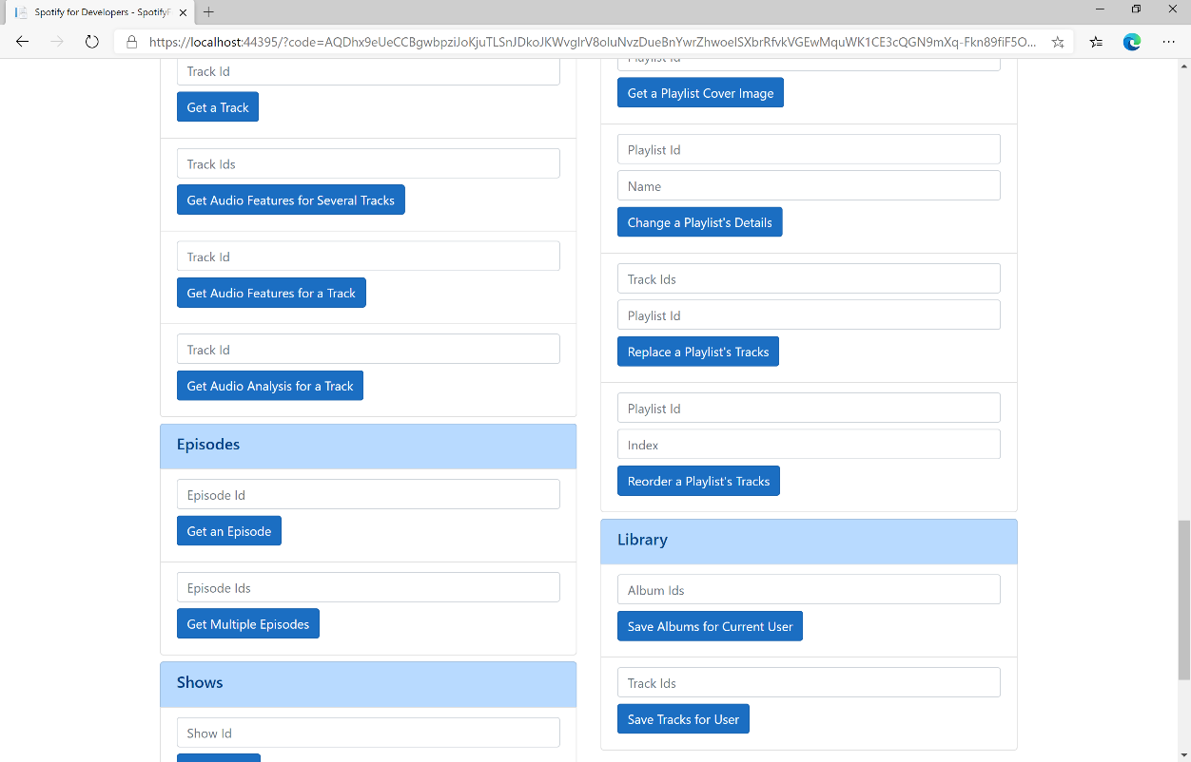

### Step 10

You can then enter some **Track Ids** from an **Album Id** from **Get All New Releases** using **Get an Album's Tracks** into **Track Ids** above **Save Tracks for User** and then select **Save Tracks for User** and scroll down to view **Results** like the following:

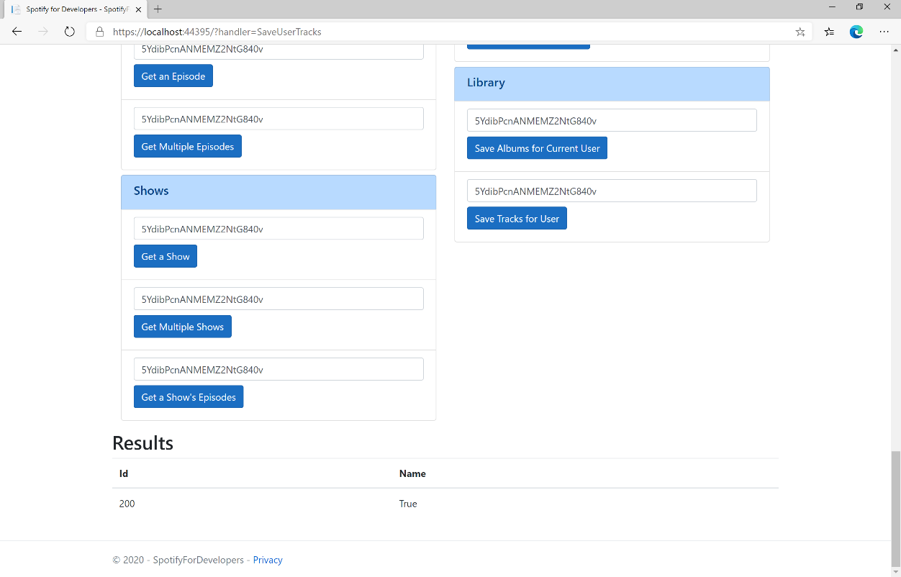

### Step 11

|  |  |
| --- | --- |
|  | You can stop the **web application** in **Visual Studio 2019** by selecting the **Stop debugging** button |

### Step 12

|  |  |
| --- | --- |
|  | You can choose to exit **Visual Studio 2019** by selecting the **Close** button in the top right of the **application** as that completes thispart of the workshop |

## Save Shows for Current User

Save one or more shows to current Spotify user’s library.

|  |  |
| --- | --- |
| PUT https://api.spotify.com/v1/me/shows | |
| Header | |
| Authorization | User Token from Spotify Accounts service with **user-library-modify** scope |
| Query Parameter | |
| ids | Comma-separated list of Spotify Ids for the shows to be added to the user’s library. |

|  |  |
| --- | --- |
| Header | Response |
| Success | |
| Http Status 200 OK |  |
| Error | |
| HTTP Status 403  Forbidden | Returned when not Authorised or more than 10,000 items saved in library |
| Error Code | Error Object |

### Step 1

|  |  |
| --- | --- |
|  | If you chose to close **Visual Studio 2019** previously, in **Windows 10** choose **Start**, and then from the **Start Menu** find and select **Visual Studio 2019** |
|  | Once done, from the **Get started** screen for **Visual Studio 2019** select **Open a project or solution** |
|  | Then locate and select **SpotifyForDevelopers.sln** and select **Open** if you don’t have this file already then please follow the previous parts of the workshop including **Getting Started**, **Authorisation Guide**, **Search & Browse**, **Playlists & Artists**, **Albums & Tracks**, **Episodes & Shows**, **Follow**, **Playlists** and **Library** |

### Step 2

|  |  |
| --- | --- |
|  | Once opened, in the **Solution Explorer** open the **Pages** section, then open the **Index.cshtml** section and select **Index.cshtml.cs** |

### Step 3

|  |  |
| --- | --- |
|  | Then from the **Menu** choose **View** and then **Open** |

### Step 4

In the **Code View** for **Index.cshtml.cs** below the **method** for public async Task<IActionResult> OnPostSaveUserTracksAsync(...) { ... } enter the following **method**:

|  |
| --- |
| public async Task<IActionResult> OnPostSaveUserShowsAsync(string value)  {  LoadToken();  var values = value.Split(",").ToList();  var result = await Api.SaveUserShowsAsync(values);  if (result != null)  {  Results = new List<Result>() { new Result()  {  Id = result.Code.ToString(),  Name = result.Success.ToString()  }};  }  return Page();  } |

The **method** for OnPostSaveUserShowsAsync **saves** the **shows** to the **Library** with Value of the **Show Ids** of the **show** and populate the **property** for Results of the **success** of the operation accordingly.

### Step 5

|  |  |
| --- | --- |
|  | In the **Solution Explorer** in the **Pages** section select **Index.cshtml** |

### Step 6

|  |  |
| --- | --- |
|  | Then from the **Menu** choose **View** and then **Open** |

### Step 7

Once in the **Code View** for **Index.cshtml** above <!-- Library --> enter the following:

|  |
| --- |
| <li class="list-group-item">  <form **asp-page-handler**="SaveUserShows" method="post">  <input **asp-for**="Value" placeholder="Show Ids" class="form-control mb-2" />  <button class="btn btn-primary mb-2">  Save Shows for User  </button>  </form>  </li> |

This form will **post** to the **method** for SaveUserTracks with the Value of the **Track Ids** and will output to the **Results**.

### Step 8

|  |  |
| --- | --- |
|  | Finally, in **Visual Studio 2019** select **IIS Application** to run the **Web Application** |

### Step 9

Once the **Web Application** is running and you select **Authorisation Code Flow Login** or **Implicit Grant Flow Login** and scroll down you should see something like the following:

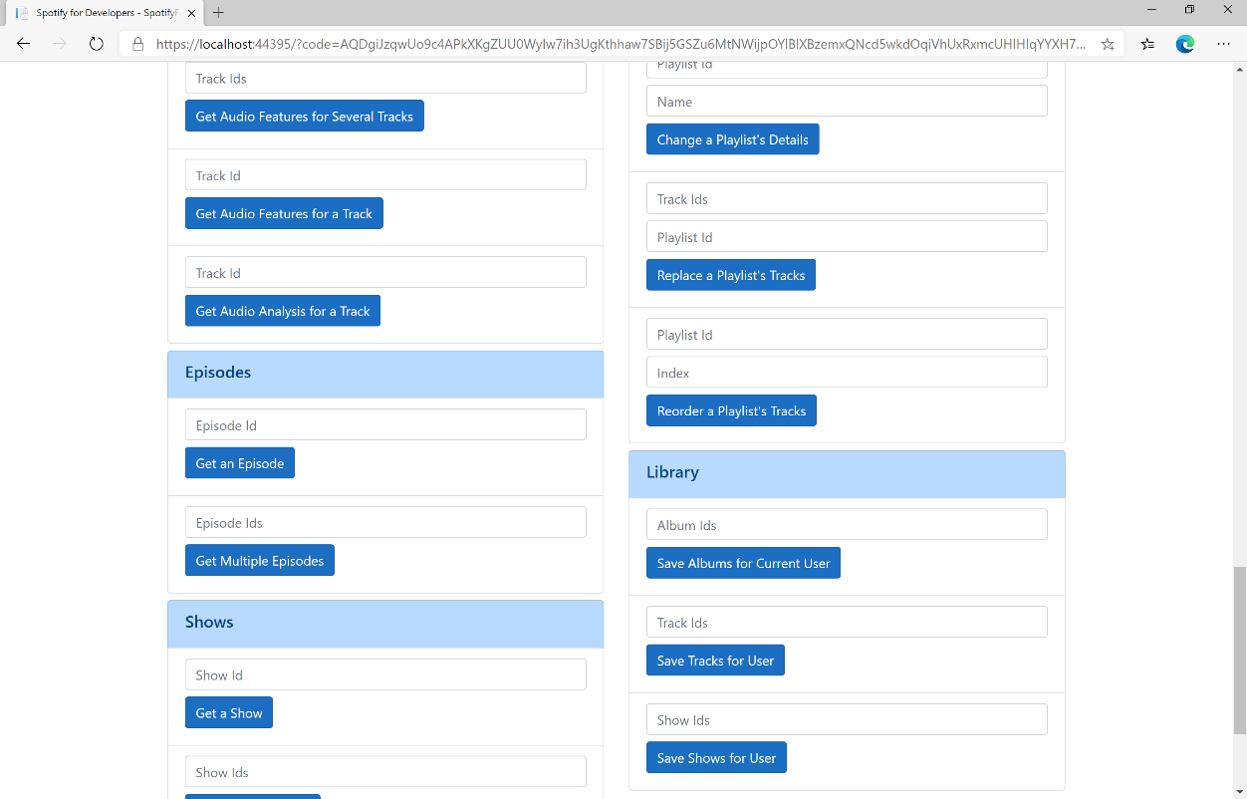

### Step 10

You can get a **Show Id** from **Search For An Item** using **Shows** and then enter this into **Show Ids** above **Save Shows for User** and then select **Save Shows for User** and scroll down to view **Results** like the following:

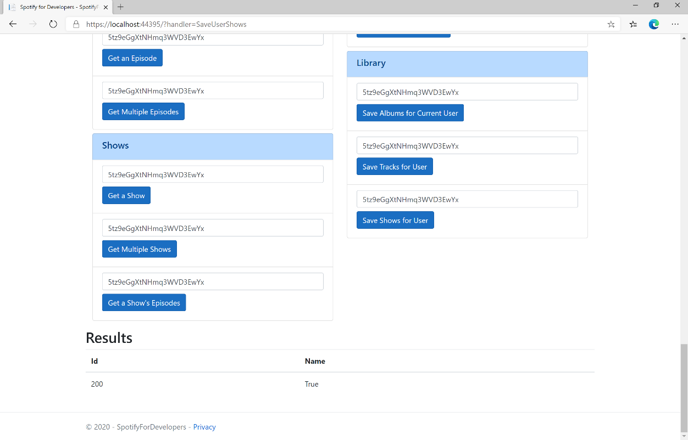

### Step 11

|  |  |
| --- | --- |
|  | You can stop the **web application** in **Visual Studio 2019** by selecting the **Stop debugging** button |

### Step 12

|  |  |
| --- | --- |
|  | You can choose to exit **Visual Studio 2019** by selecting the **Close** button in the top right of the **application** as that completes thispart of the workshop |

## Check User's Saved Albums

Check if one or more albums is already saved in the current Spotify user’s ‘Your Music’ library.

|  |  |
| --- | --- |
| GET https://api.spotify.com/v1/me/albums/contains | |
| Header | |
| Authorization | User Token from Spotify Accounts service with **user-library-read** scope |
| Query Parameter | |
| ids | Comma-separated list of the Spotify Ids for the Albums. Maximum: 50 Ids. |

|  |  |
| --- | --- |
| Header | Response |
| Success | |
| Http Status 200 OK | Array of true or false values in same order as in which the Ids were provided |
| Error | |
| Error Code | Error Object |

### Step 1

|  |  |
| --- | --- |
|  | If you chose to close **Visual Studio 2019** previously, in **Windows 10** choose **Start**, and then from the **Start Menu** find and select **Visual Studio 2019** |
|  | Once done, from the **Get started** screen for **Visual Studio 2019** select **Open a project or solution** |
|  | Then locate and select **SpotifyForDevelopers.sln** and select **Open** if you don’t have this file already then please follow the previous parts of the workshop including **Getting Started**, **Authorisation Guide**, **Search & Browse**, **Playlists & Artists**, **Albums & Tracks**, **Episodes & Shows**, **Follow**, **Playlists** and **Library** |

### Step 2

|  |  |
| --- | --- |
|  | Once opened, in the **Solution Explorer** open the **Pages** section, then open the **Index.cshtml** section and select **Index.cshtml.cs** |

### Step 3

|  |  |
| --- | --- |
|  | Then from the **Menu** choose **View** and then **Open** |

### Step 4

In the **Code View** for **Index.cshtml.cs** below the **method** for public async Task<IActionResult> OnPostSaveUserShowsAsync(...) { ... } enter the following **method**:

|  |
| --- |
| public async Task<IActionResult> OnPostCheckUserSavedAlbumsAsync(string value)  {  LoadToken();  var values = value.Split(",").ToList();  var results = await Api.CheckUserSavedAlbumsAsync(values);  if (results != null)  {  Results = results.Select(result => new Result()  {  Name = result.ToString()  });  }  return Page();  } |

The **method** for OnPostCheckUserSavedAlbumsAsync is used to get the **saved state** of **albums** in the **Library** with Value of the **Album Ids** of the **track** and populate the **property** for Results accordingly.

### Step 5

|  |  |
| --- | --- |
|  | In the **Solution Explorer** in the **Pages** section select **Index.cshtml** |

### Step 6

|  |  |
| --- | --- |
|  | Then from the **Menu** choose **View** and then **Open** |

### Step 7

Once in the **Code View** for **Index.cshtml** above <!-- Library --> enter the following:

|  |
| --- |
| <li class="list-group-item">  <form **asp-page-handler**="CheckUserSavedAlbums" method="post">  <input **asp-for**="Value" placeholder="Album Ids" class="form-control mb-2" />  <button class="btn btn-primary mb-2">  Check User's Saved Albums  </button>  </form>  </li> |

This form will **post** to the **method** for CheckUserSavedAlbums with the Value of the **Album Ids** and will output to the **Results**.

### Step 8

|  |  |
| --- | --- |
|  | Finally, in **Visual Studio 2019** select **IIS Application** to run the **Web Application** |

### Step 9

Once the **Web Application** is running and you select **Authorisation Code Flow Login** or **Implicit Grant Flow Login** and scroll down you should see something like the following:

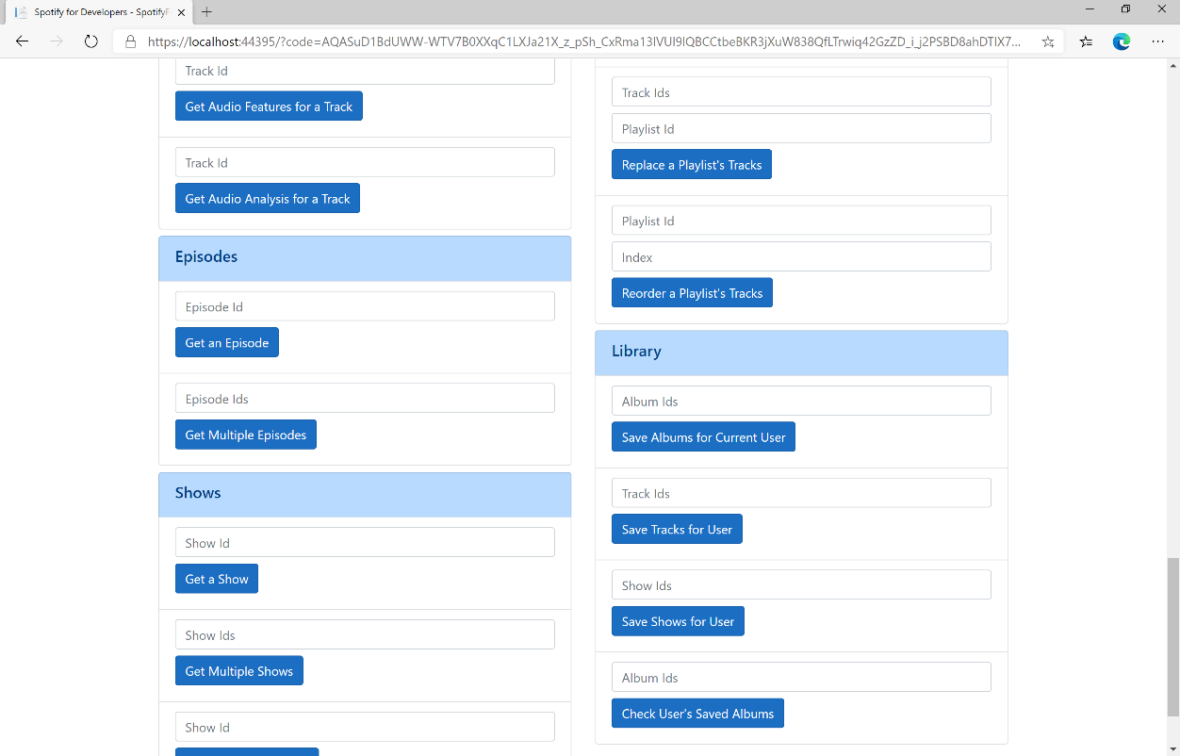

### Step 10

You can then enter some **Album Ids** from **Get All New Releases** or copy the same **Album Ids** used in **Save Albums for Current User** into **Album Ids** above **Check User's Saved Albums** and then select **Check User's Saved Albums** and scroll down to view **Results** like the following:

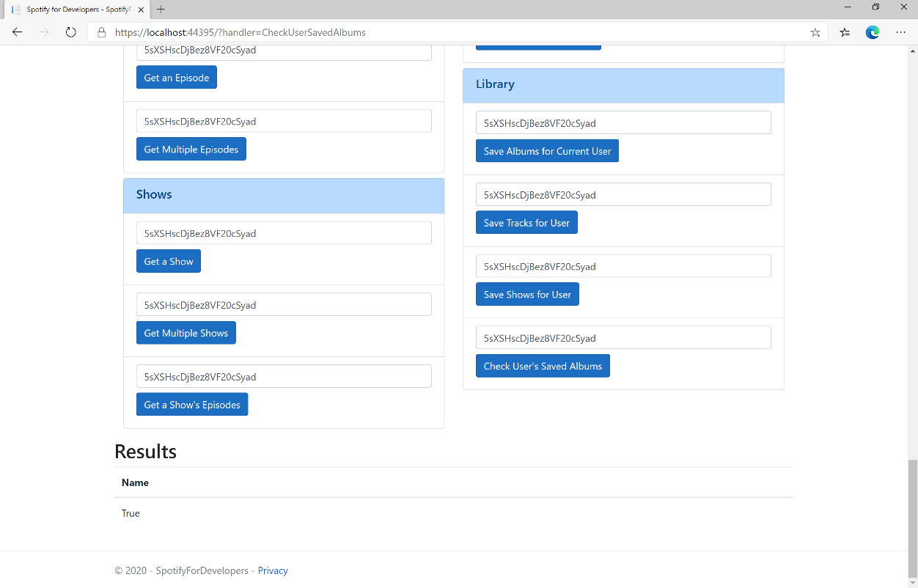

### Step 11

|  |  |
| --- | --- |
|  | You can stop the **web application** in **Visual Studio 2019** by selecting the **Stop debugging** button |

### Step 12

|  |  |
| --- | --- |
|  | You can choose to exit **Visual Studio 2019** by selecting the **Close** button in the top right of the **application** as that completes thispart of the workshop |

## Check User's Saved Tracks

Check if one or more tracks is already saved in the current Spotify user’s ‘Your Music’ library.

|  |  |
| --- | --- |
| GET https://api.spotify.com/v1/me/tracks/contains | |
| Header | |
| Authorization | User Token from Spotify Accounts service with **user-library-read** scope |
| Query Parameter | |
| ids | Comma-separated list of the Spotify Ids for the Tracks. Maximum: 50 Ids. |

|  |  |
| --- | --- |
| Header | Response |
| Success | |
| Http Status 200 OK | Array of true or false values in same order as in which the Ids were provided |
| Error | |
| Error Code | Error Object |

### Step 1

|  |  |
| --- | --- |
|  | If you chose to close **Visual Studio 2019** previously, in **Windows 10** choose **Start**, and then from the **Start Menu** find and select **Visual Studio 2019** |
|  | Once done, from the **Get started** screen for **Visual Studio 2019** select **Open a project or solution** |
|  | Then locate and select **SpotifyForDevelopers.sln** and select **Open** if you don’t have this file already then please follow the previous parts of the workshop including **Getting Started**, **Authorisation Guide**, **Search & Browse**, **Playlists & Artists**, **Albums & Tracks**, **Episodes & Shows**, **Follow**, **Playlists** and **Library** |

### Step 2

|  |  |
| --- | --- |
|  | Once opened, in the **Solution Explorer** open the **Pages** section, then open the **Index.cshtml** section and select **Index.cshtml.cs** |

### Step 3

|  |  |
| --- | --- |
|  | Then from the **Menu** choose **View** and then **Open** |

### Step 4

In the **Code View** for **Index.cshtml.cs** below the **method** for public async Task<IActionResult> OnPostCheckUserSavedAlbumsAsync(...) { ... } enter the following **method**:

|  |
| --- |
| public async Task<IActionResult> OnPostCheckUserSavedTracksAsync(string value)  {  LoadToken();  var values = value.Split(",").ToList();  var results = await Api.CheckUserSavedTracksAsync(values);  if (results != null)  {  Results = results.Select(result => new Result()  {  Name = result.ToString()  });  }  return Page();  } |

The **method** for OnPostCheckUserSavedTracksAsync is used to get the **saved state** of **tracks** in the **Library** with Value of the **Track Ids** of the **track** and populate the **property** for Results accordingly.

### Step 5

|  |  |
| --- | --- |
|  | In the **Solution Explorer** in the **Pages** section select **Index.cshtml** |

### Step 6

|  |  |
| --- | --- |
|  | Then from the **Menu** choose **View** and then **Open** |

### Step 7

Once in the **Code View** for **Index.cshtml** above <!-- Library --> enter the following:

|  |
| --- |
| <li class="list-group-item">  <form **asp-page-handler**="CheckUserSavedTracks" method="post">  <input **asp-for**="Value" placeholder="Track Ids" class="form-control mb-2" />  <button class="btn btn-primary mb-2">  Check User's Saved Tracks  </button>  </form>  </li> |

This form will **post** to the **method** for CheckUserSavedTracks with the Value of the **Track Ids** and will output to the **Results**.

### Step 8

|  |  |
| --- | --- |
|  | Finally, in **Visual Studio 2019** select **IIS Application** to run the **Web Application** |

### Step 9

Once the **Web Application** is running and you select **Authorisation Code Flow Login** or **Implicit Grant Flow Login** and scroll down you should see something like the following:

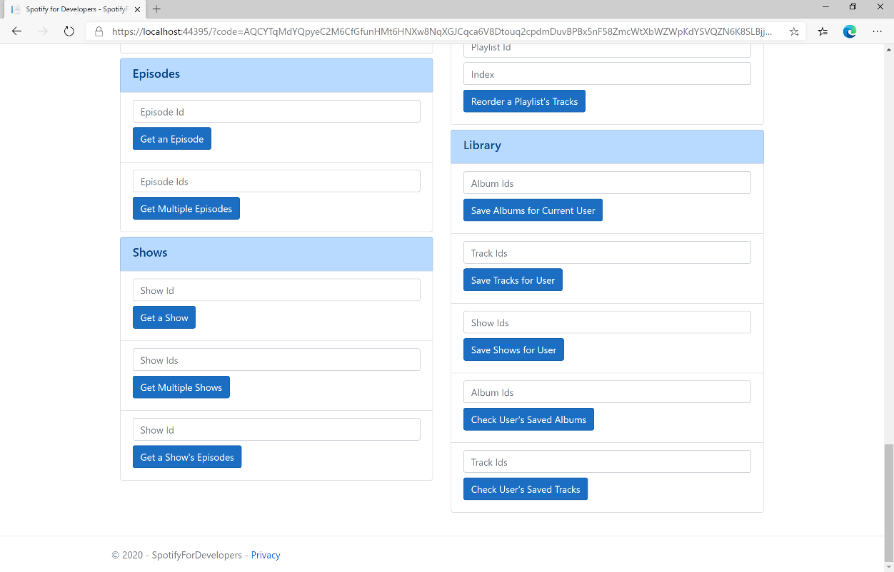

### Step 10

You can then enter some **Track Ids** from an **Album Id** from **Get All New Releases** using **Get an Album's Tracks** or copy the same **Track Ids** used in **Save Tracks for User** in **Track Ids** above **Check User's Saved Tracks** and then select **Check User's Saved Tracks** and scroll down to view **Results** like the following:

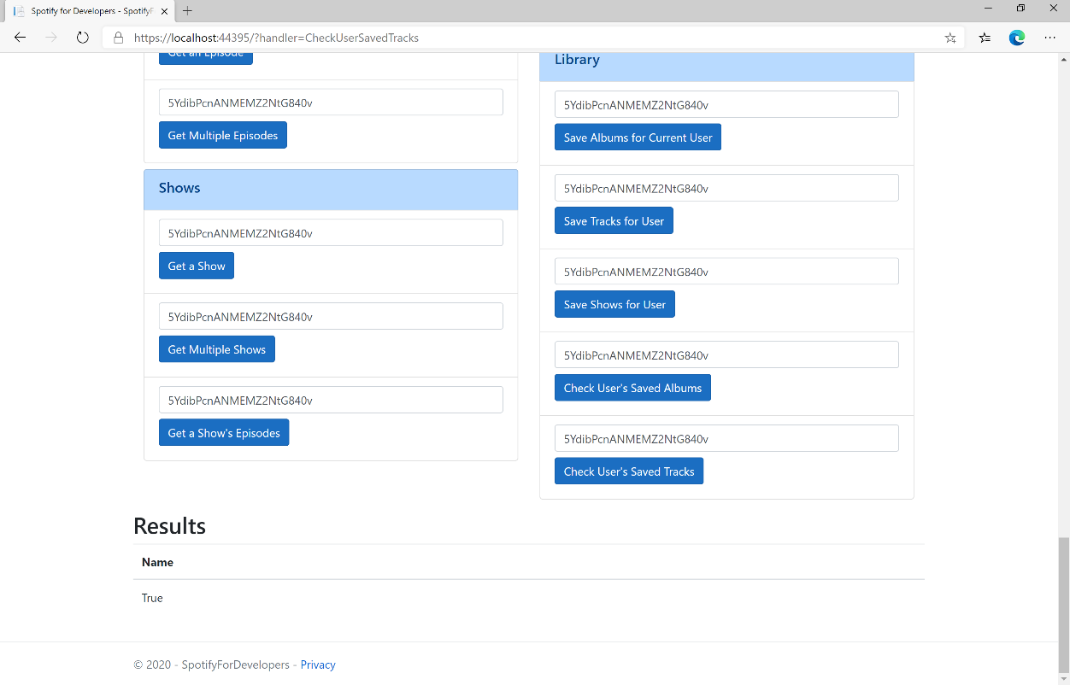

### Step 11

|  |  |
| --- | --- |
|  | You can stop the **web application** in **Visual Studio 2019** by selecting the **Stop debugging** button |

### Step 12

|  |  |
| --- | --- |
|  | You can choose to exit **Visual Studio 2019** by selecting the **Close** button in the top right of the **application** as that completes thispart of the workshop |

## Check User's Saved Shows

Check if one or more shows is already saved in the current Spotify user’s library

|  |  |
| --- | --- |
| GET https://api.spotify.com/v1/me/shows/contains | |
| Header | |
| Authorization | User Token from Spotify Accounts service with **user-library-read** scope |
| Query Parameter | |
| ids | Comma-separated list of the Spotify Ids for the shows. Maximum: 50 ids |

|  |  |
| --- | --- |
| Header | Response |
| Success | |
| Http Status 200 OK | Array of true or false values in same order as in which the Ids were provided |
| Error | |
| Error Code | Error Object |

### Step 1

|  |  |
| --- | --- |
|  | If you chose to close **Visual Studio 2019** previously, in **Windows 10** choose **Start**, and then from the **Start Menu** find and select **Visual Studio 2019** |
|  | Once done, from the **Get started** screen for **Visual Studio 2019** select **Open a project or solution** |
|  | Then locate and select **SpotifyForDevelopers.sln** and select **Open** if you don’t have this file already then please follow the previous parts of the workshop including **Getting Started**, **Authorisation Guide**, **Search & Browse**, **Playlists & Artists**, **Albums & Tracks**, **Episodes & Shows**, **Follow**, **Playlists** and **Library** |

### Step 2

|  |  |
| --- | --- |
|  | Once opened, in the **Solution Explorer** open the **Pages** section, then open the **Index.cshtml** section and select **Index.cshtml.cs** |

### Step 3

|  |  |
| --- | --- |
|  | Then from the **Menu** choose **View** and then **Open** |

### Step 4

In the **Code View** for **Index.cshtml.cs** below the **method** for public async Task<IActionResult> CheckUserSavedTracksAsync(...) { ... } enter the following **method**:

|  |
| --- |
| public async Task<IActionResult> OnPostCheckUserSavedShowsAsync(string value)  {  LoadToken();  var values = value.Split(",").ToList();  var results = await Api.CheckUserSavedShowsAsync(values);  if (results != null)  {  Results = results.Select(result => new Result()  {  Name = result.ToString()  });  }  return Page();  } |

The **method** for OnPostCheckUserSavedShowsAsync is used to get the **saved state** of **shows** in the **Library** with Value of the **Shows Ids** of the **show** and populate the **property** for Results accordingly.

### Step 5

|  |  |
| --- | --- |
|  | In the **Solution Explorer** in the **Pages** section select **Index.cshtml** |

### Step 6

|  |  |
| --- | --- |
|  | Then from the **Menu** choose **View** and then **Open** |

### Step 7

Once in the **Code View** for **Index.cshtml** above <!-- Library --> enter the following:

|  |
| --- |
| <li class="list-group-item">  <form **asp-page-handler**="CheckUserSavedShows" method="post">  <input **asp-for**="Value" placeholder="Show Ids" class="form-control mb-2" />  <button class="btn btn-primary mb-2">  Check User's Saved Shows  </button>  </form>  </li> |

This form will **post** to the **method** for CheckUserSavedShows with the Value of the **Show Ids** and will output to the **Results**.

### Step 8

|  |  |
| --- | --- |
|  | Finally, in **Visual Studio 2019** select **IIS Application** to run the **Web Application** |

### Step 9

Once the **Web Application** is running and you select **Authorisation Code Flow Login** or **Implicit Grant Flow Login** and scroll down you should see something like the following:

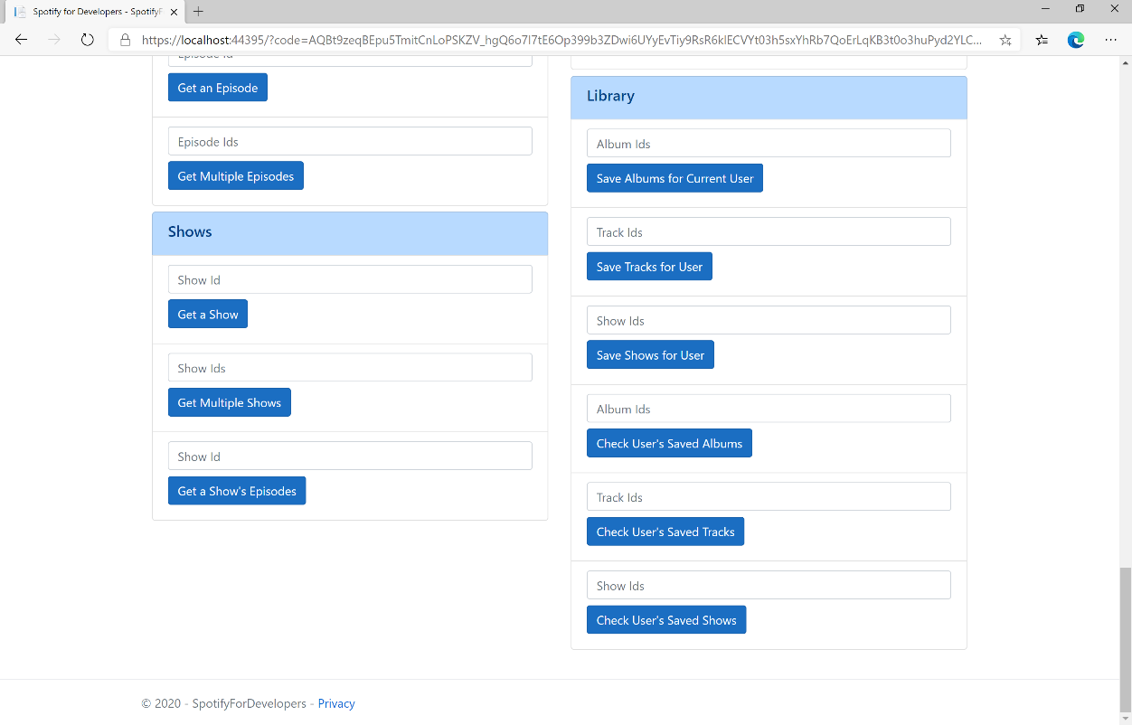

### Step 10

You can get a **Show Id** from **Search For An Item** using **Shows** or copy the same **Shows Ids** used in **Save Shows for User** in **Show Ids** above **Check User's Saved Shows** and then select **Check User's Saved Shows** and scroll down to view **Results** like the following:

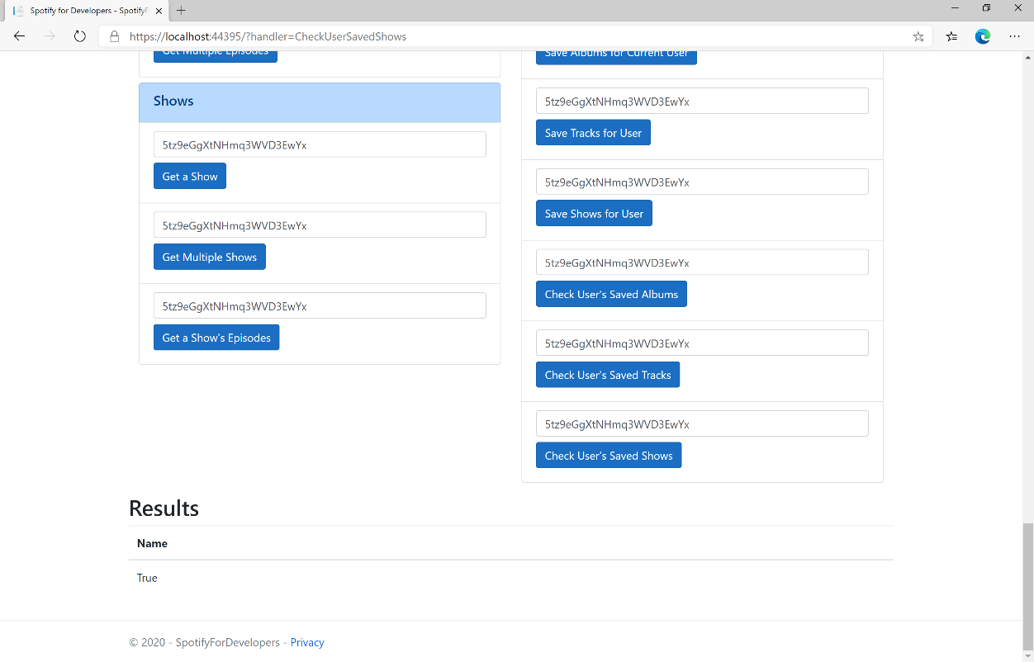

### Step 11

|  |  |
| --- | --- |
|  | You can stop the **web application** in **Visual Studio 2019** by selecting the **Stop debugging** button |

### Step 12

|  |  |
| --- | --- |
|  | You can choose to exit **Visual Studio 2019** by selecting the **Close** button in the top right of the **application** as that completes thispart of the workshop |

## Get User's Saved Albums

Get a list of the albums saved in the current Spotify user’s ‘Your Music’ library.

|  |  |
| --- | --- |
| GET https://api.spotify.com/v1/me/albums | |
| Header | |
| Authorization | User Token from Spotify Accounts service with **user-library-read** scope |
| Query Parameter | |
| limit | Maximum number of objects to return. Default: 20. Minimum: 1. Maximum: 50 |
| offset | Index of the first object to return. Default: 0 |
| market | ISO 3166-1 alpha-2 country code. Provide to apply Track Relinking |

|  |  |
| --- | --- |
| Header | Response |
| Success | |
| Http Status 200 OK | Array of Album Objects accompanied by a Timestamp wrapped in a Paging Object |
| Error | |
| Error Code | Error Object |

### Step 1

|  |  |
| --- | --- |
|  | If you chose to close **Visual Studio 2019** previously, in **Windows 10** choose **Start**, and then from the **Start Menu** find and select **Visual Studio 2019** |
|  | Once done, from the **Get started** screen for **Visual Studio 2019** select **Open a project or solution** |
|  | Then locate and select **SpotifyForDevelopers.sln** and select **Open** if you don’t have this file already then please follow the previous parts of the workshop including **Getting Started**, **Authorisation Guide**, **Search & Browse**, **Playlists & Artists**, **Albums & Tracks**, **Episodes & Shows**, **Follow**, **Playlists** and **Library** |

### Step 2

|  |  |
| --- | --- |
|  | Once opened, in the **Solution Explorer** open the **Pages** section, then open the **Index.cshtml** section and select **Index.cshtml.cs** |

### Step 3

|  |  |
| --- | --- |
|  | Then from the **Menu** choose **View** and then **Open** |

### Step 4

In the **Code View** for **Index.cshtml.cs** below the **method** for public async Task<IActionResult> OnPostCheckUserSavedShowsAsync(...) { ... } enter the following **method**:

|  |
| --- |
| public async Task<IActionResult> OnPostGetUserSavedAlbumsAsync()  {  LoadToken();  var results = await Api.GetUserSavedAlbumsAsync();  if (results?.Items != null)  {  Results = results.Items.Select(result => new Result()  {  Id = result.Album.Id,  Name = result.Album.Name,  Image = result?.Album?.Images?.FirstOrDefault()?.Url,  Inner = new Result()  {  Id = result?.Album?.Artists?.FirstOrDefault()?.Id,  Name = result?.Album?.Artists?.FirstOrDefault()?.Name  }  });  }  return Page();  } |

The **method** for OnPostGetUserSavedAlbumsAsync is used to get the **albums** in the **Library** and populate the **property** for Results accordingly.

### Step 5

|  |  |
| --- | --- |
|  | In the **Solution Explorer** in the **Pages** section select **Index.cshtml** |

### Step 6

|  |  |
| --- | --- |
|  | Then from the **Menu** choose **View** and then **Open** |

### Step 7

Once in the **Code View** for **Index.cshtml** above <!-- Library --> enter the following:

|  |
| --- |
| <li class="list-group-item">  <form **asp-page-handler**="GetUserSavedAlbums" method="post">  <button class="btn btn-primary mb-2">  Get User's Saved Albums  </button>  </form>  </li> |

This form will **post** to the **method** for GetUserSavedAlbums and will output to the **Results**.

### Step 8

|  |  |
| --- | --- |
|  | Finally, in **Visual Studio 2019** select **IIS Application** to run the **Web Application** |

### Step 9

Once the **Web Application** is running and you select **Authorisation Code Flow Login** or **Implicit Grant Flow Login** and scroll down you should see something like the following:

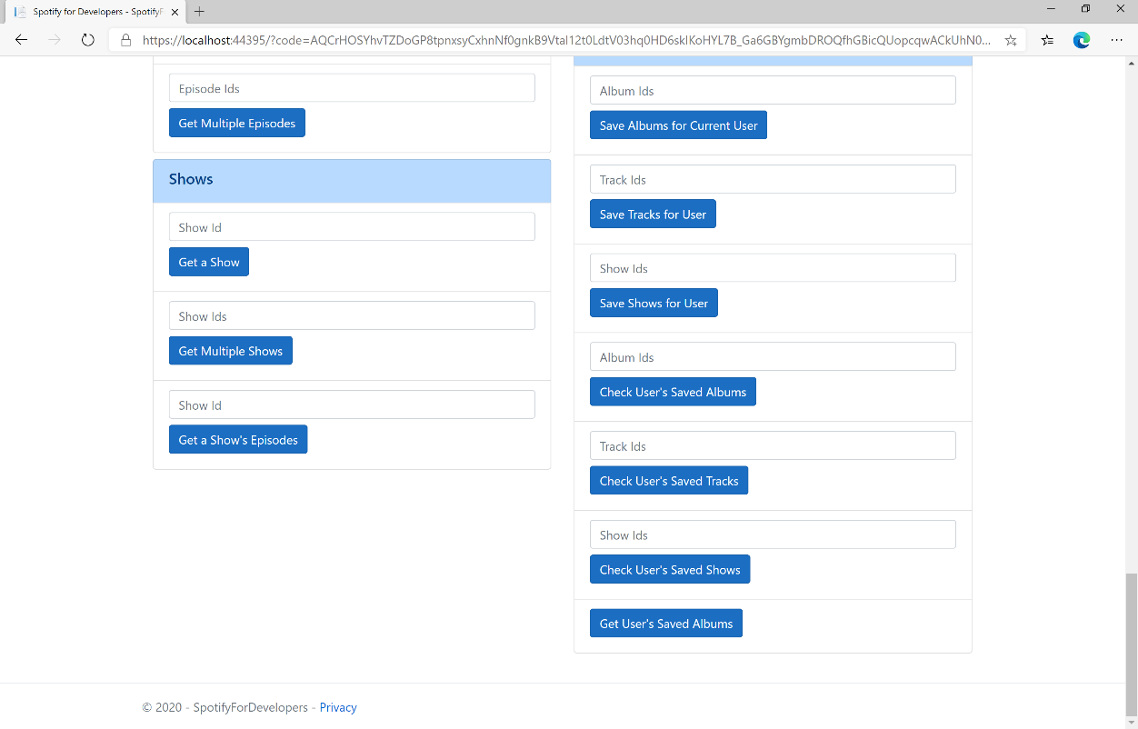

### Step 10

You can then select **Get User's Saved Albums** and scroll down to view **Results** like the following:

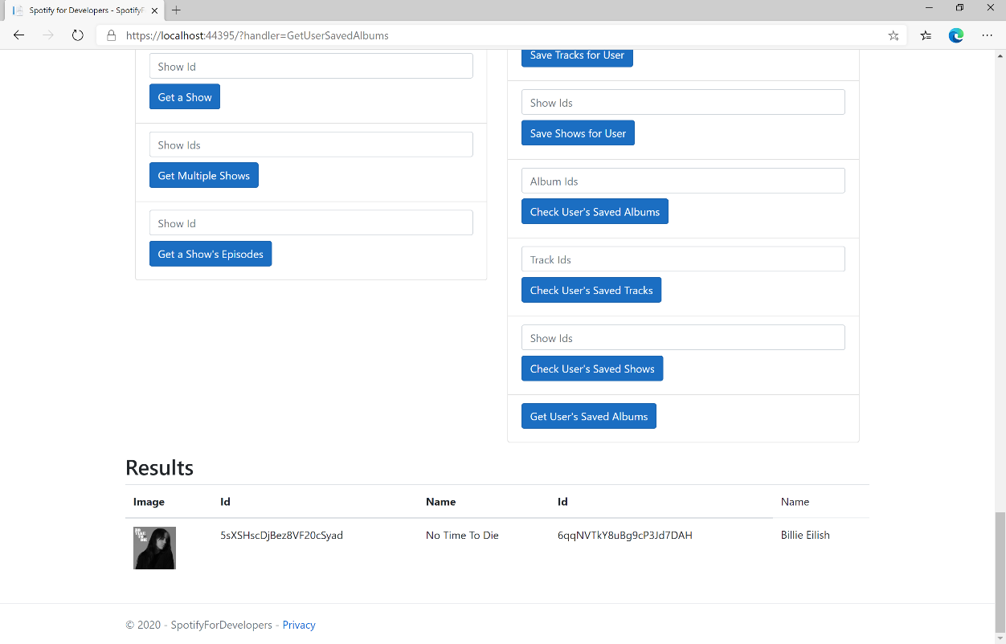

### Step 11

|  |  |
| --- | --- |
|  | You can stop the **web application** in **Visual Studio 2019** by selecting the **Stop debugging** button |

### Step 12

|  |  |
| --- | --- |
|  | You can choose to exit **Visual Studio 2019** by selecting the **Close** button in the top right of the **application** as that completes thispart of the workshop |

## Get User's Saved Tracks

Get a list of the songs saved in the current Spotify user’s ‘Your Music’ library.

|  |  |
| --- | --- |
| GET https://api.spotify.com/v1/me/tracks | |
| Header | |
| Authorization | User Token from Spotify Accounts service with **user-library-read** scope |
| Query Parameter | |
| limit | Maximum number of objects to return. Default: 20. Minimum: 1. Maximum: 50 |
| offset | Index of the first object to return. Default: 0 |
| market | ISO 3166-1 alpha-2 country code. Provide to apply Track Relinking |

|  |  |
| --- | --- |
| Header | Response |
| Success | |
| Http Status 200 OK | Array of Saved Track Objects wrapped in a Paging Object |
| Error | |
| Error Code | Error Object |

### Step 1

|  |  |
| --- | --- |
|  | If you chose to close **Visual Studio 2019** previously, in **Windows 10** choose **Start**, and then from the **Start Menu** find and select **Visual Studio 2019** |
|  | Once done, from the **Get started** screen for **Visual Studio 2019** select **Open a project or solution** |
|  | Then locate and select **SpotifyForDevelopers.sln** and select **Open** if you don’t have this file already then please follow the previous parts of the workshop including **Getting Started**, **Authorisation Guide**, **Search & Browse**, **Playlists & Artists**, **Albums & Tracks**, **Episodes & Shows**, **Follow**, **Playlists** and **Library** |

### Step 2

|  |  |
| --- | --- |
|  | Once opened, in the **Solution Explorer** open the **Pages** section, then open the **Index.cshtml** section and select **Index.cshtml.cs** |

### Step 3

|  |  |
| --- | --- |
|  | Then from the **Menu** choose **View** and then **Open** |

### Step 4

In the **Code View** for **Index.cshtml.cs** below the **method** for public async Task<IActionResult> OnPostGetUserSavedAlbumsAsync() { ... } enter the following **method**:

|  |
| --- |
| public async Task<IActionResult> OnPostGetUserSavedTracksAsync()  {  LoadToken();  var results = await Api.GetUserSavedTracksAsync();  if (results?.Items != null)  {  Results = results.Items.Select(result => new Result()  {  Id = result.Track.Id,  Name = result.Track.Name,  Image = result?.Track?.Album?.Images?.FirstOrDefault()?.Url,  Inner = new Result()  {  Id = result?.Track?.Album?.Artists?.FirstOrDefault()?.Id,  Name = result?.Track?.Album?.Artists?.FirstOrDefault()?.Name  }  });  }  return Page();  } |

The **method** for OnPostGetUserSavedTracksAsync is used to get the **tracks** in the **Library** and populate the **property** for Results accordingly.

### Step 5

|  |  |
| --- | --- |
|  | In the **Solution Explorer** in the **Pages** section select **Index.cshtml** |

### Step 6

|  |  |
| --- | --- |
|  | Then from the **Menu** choose **View** and then **Open** |

### Step 7

Once in the **Code View** for **Index.cshtml** above <!-- Library --> enter the following:

|  |
| --- |
| <li class="list-group-item">  <form **asp-page-handler**="GetUserSavedTracks" method="post">  <button class="btn btn-primary mb-2">  Get User's Saved Tracks  </button>  </form>  </li> |

This form will **post** to the **method** for GetUserSavedTracks and will output to the **Results**.

### Step 8

|  |  |
| --- | --- |
|  | Finally, in **Visual Studio 2019** select **IIS Application** to run the **Web Application** |

### Step 9

Once the **Web Application** is running and you select **Authorisation Code Flow Login** or **Implicit Grant Flow Login** and scroll down you should see something like the following:

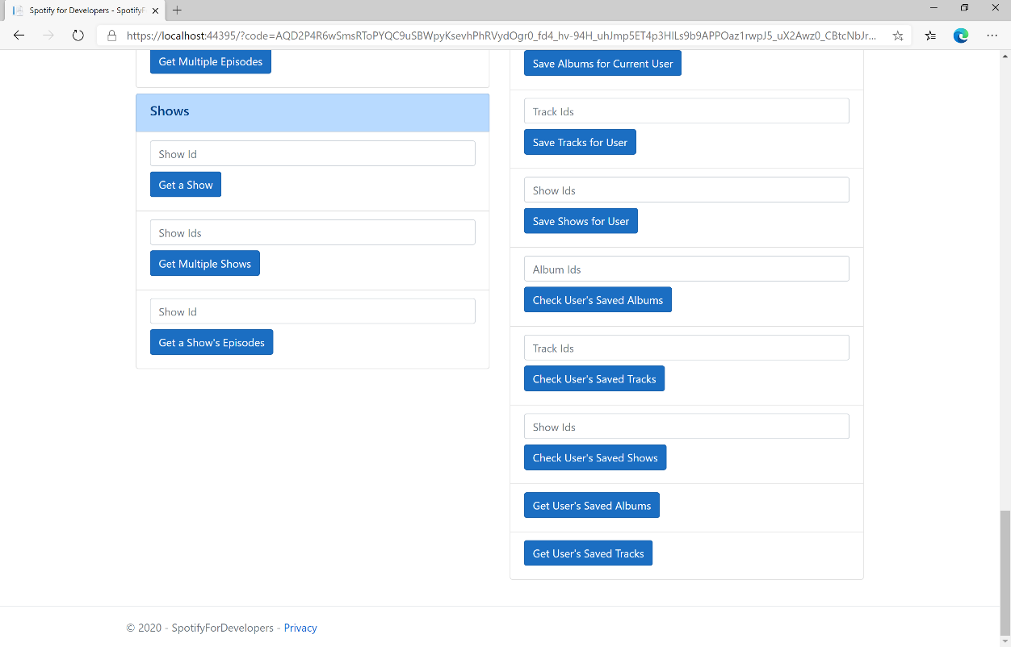

### Step 10

You can then select **Get User's Saved Tracks** and scroll down to view **Results** like the following:

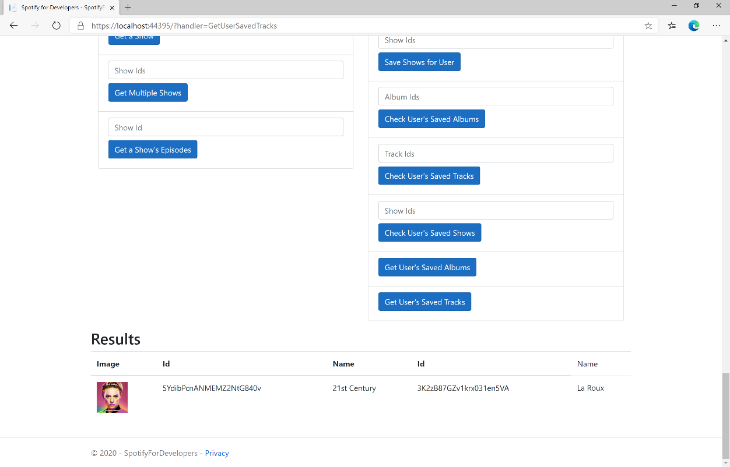

### Step 11

|  |  |
| --- | --- |
|  | You can stop the **web application** in **Visual Studio 2019** by selecting the **Stop debugging** button |

### Step 12

|  |  |
| --- | --- |
|  | You can choose to exit **Visual Studio 2019** by selecting the **Close** button in the top right of the **application** as that completes thispart of the workshop |

## Get User’s Saved Shows

Get a list of shows saved in the current Spotify user’s library.

|  |  |
| --- | --- |
| GET https://api.spotify.com/v1/me/shows | |
| Header | |
| Authorization | User Token from Spotify Accounts service with **user-library-read** scope |
| Query Parameter | |
| limit | Maximum number of shows to return. Default: 20. Minimum: 1. Maximum: 50 |
| offset | Index of the first object to return. Default: 0 |

|  |  |
| --- | --- |
| Header | Response |
| Success | |
| Http Status 200 OK | Array of Saved Show Objects wrapped in a Paging Object |
| Error | |
| Error Code | Error Object |

### Step 1

|  |  |
| --- | --- |
|  | If you chose to close **Visual Studio 2019** previously, in **Windows 10** choose **Start**, and then from the **Start Menu** find and select **Visual Studio 2019** |
|  | Once done, from the **Get started** screen for **Visual Studio 2019** select **Open a project or solution** |
|  | Then locate and select **SpotifyForDevelopers.sln** and select **Open** if you don’t have this file already then please follow the previous parts of the workshop including **Getting Started**, **Authorisation Guide**, **Search & Browse**, **Playlists & Artists**, **Albums & Tracks**, **Episodes & Shows**, **Follow**, **Playlists** and **Library** |

### Step 2

|  |  |
| --- | --- |
|  | Once opened, in the **Solution Explorer** open the **Pages** section, then open the **Index.cshtml** section and select **Index.cshtml.cs** |

### Step 3

|  |  |
| --- | --- |
|  | Then from the **Menu** choose **View** and then **Open** |

### Step 4

In the **Code View** for **Index.cshtml.cs** below the **method** for public async Task<IActionResult> OnPostGetUserSavedTracksAsync() { ... } enter the following **method**:

|  |
| --- |
| public async Task<IActionResult> OnPostGetUserSavedShowsAsync()  {  LoadToken();  var results = await Api.GetUserSavedShowsAsync();  if (results?.Items != null)  {  Results = results.Items.Select(result => new Result()  {  Id = result.Show.Id,  Name = result.Show.Name,  Image = result?.Show?.Images?.FirstOrDefault()?.Url  });  }  return Page();  } |

The **method** for OnPostGetUserSavedShowsAsync is used to get the **shows** in the **Library** and populate the **property** for Results accordingly.

### Step 5

|  |  |
| --- | --- |
|  | In the **Solution Explorer** in the **Pages** section select **Index.cshtml** |

### Step 6

|  |  |
| --- | --- |
|  | Then from the **Menu** choose **View** and then **Open** |

### Step 7

Once in the **Code View** for **Index.cshtml** above <!-- Library --> enter the following:

|  |
| --- |
| <li class="list-group-item">  <form **asp-page-handler**="GetUserSavedShows" method="post">  <button class="btn btn-primary mb-2">  Get User's Saved Shows  </button>  </form>  </li> |

This form will **post** to the **method** for GetUserSavedShows and will output to the **Results**.

### Step 8

|  |  |
| --- | --- |
|  | Finally, in **Visual Studio 2019** select **IIS Application** to run the **Web Application** |

### Step 9

Once the **Web Application** is running and you select **Authorisation Code Flow Login** or **Implicit Grant Flow Login** and scroll down you should see something like the following:

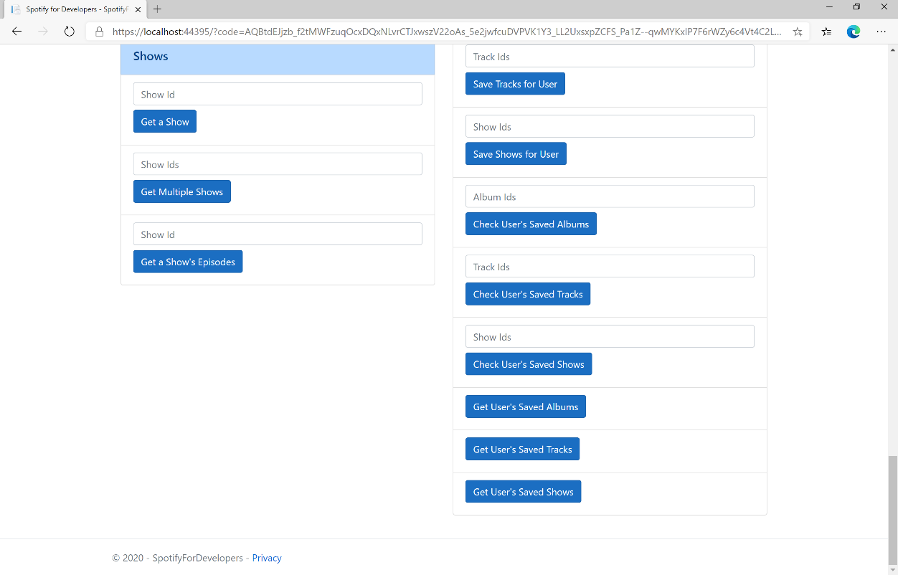

### Step 10

You can then select **Get User's Saved Shows** and scroll down to view **Results** like the following:

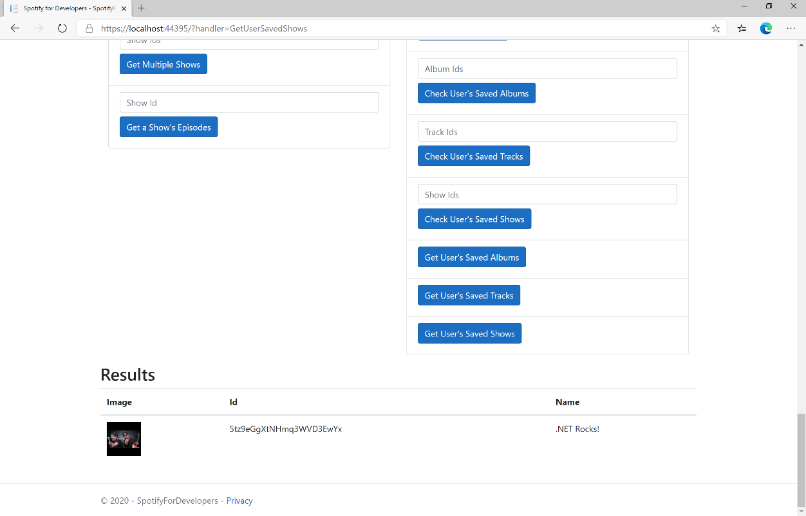

### Step 11

|  |  |
| --- | --- |
|  | You can stop the **web application** in **Visual Studio 2019** by selecting the **Stop debugging** button |

### Step 12

|  |  |
| --- | --- |
|  | You can choose to exit **Visual Studio 2019** by selecting the **Close** button in the top right of the **application** as that completes thispart of the workshop |

## Remove Albums for Current User

Remove one or more albums from the current user’s ‘Your Music’ library.

|  |  |
| --- | --- |
| DELETE https://api.spotify.com/v1/me/albums?ids={ids} | |
| Header | |
| Authorization | User Token from Spotify Accounts service with **user-library-modify** scope |
| Query Parameter | |
| ids | Comma-separated list of the Spotify Ids for the Albums. Maximum: 50 Ids. |

|  |  |
| --- | --- |
| Header | Response |
| Success | |
| Http Status 201  Created |  |
| Error | |
| HTTP Status 403  Forbidden | Returned when not Authorised |
| Error Code | Error Object |

### Step 1

|  |  |
| --- | --- |
|  | If you chose to close **Visual Studio 2019** previously, in **Windows 10** choose **Start**, and then from the **Start Menu** find and select **Visual Studio 2019** |
|  | Once done, from the **Get started** screen for **Visual Studio 2019** select **Open a project or solution** |
|  | Then locate and select **SpotifyForDevelopers.sln** and select **Open** if you don’t have this file already then please follow the previous parts of the workshop including **Getting Started**, **Authorisation Guide**, **Search & Browse**, **Playlists & Artists**, **Albums & Tracks**, **Episodes & Shows**, **Follow**, **Playlists** and **Library** |

### Step 2

|  |  |
| --- | --- |
|  | Once opened, in the **Solution Explorer** open the **Pages** section, then open the **Index.cshtml** section and select **Index.cshtml.cs** |

### Step 3

|  |  |
| --- | --- |
|  | Then from the **Menu** choose **View** and then **Open** |

### Step 4

In the **Code View** for **Index.cshtml.cs** below the **method** for public async Task<IActionResult> OnPostGetUserSavedShowsAsync() { ... } enter the following **method**:

|  |
| --- |
| public async Task<IActionResult> OnPostRemoveUserAlbumsAsync(string value)  {  LoadToken();  var values = value.Split(",").ToList();  var result = await Api.RemoveUserAlbumsAsync(values);  if (result != null)  {  Results = new List<Result>() { new Result()  {  Id = result.Code.ToString(),  Name = result.Success.ToString()  }};  }  return Page();  } |

The **method** for OnPostRemoveUserAlbumsAsync **removes** the **saved** **albums** from the **Library** with Value of the **Album Ids** of the **album** and populate the **property** for Results of the **success** of the operation accordingly.

### Step 5

|  |  |
| --- | --- |
|  | In the **Solution Explorer** in the **Pages** section select **Index.cshtml** |

### Step 6

|  |  |
| --- | --- |
|  | Then from the **Menu** choose **View** and then **Open** |

### Step 7

Once in the **Code View** for **Index.cshtml** above <!-- Library --> enter the following:

|  |
| --- |
| <li class="list-group-item">  <form **asp-page-handler**="RemoveUserAlbums" method="post">  <input **asp-for**="Value" placeholder="Album Ids" class="form-control mb-2" />  <button class="btn btn-primary mb-2">  Remove Albums for Current User  </button>  </form>  </li> |

This form will **post** to the **method** for RemoveUserAlbums with the Value of the **Album Ids** and will output to the **Results**.

### Step 8

|  |  |
| --- | --- |
|  | Finally, in **Visual Studio 2019** select **IIS Application** to run the **Web Application** |

### Step 9

Once the **Web Application** is running and you select **Authorisation Code Flow Login** or **Implicit Grant Flow Login** and scroll down you should see something like the following:

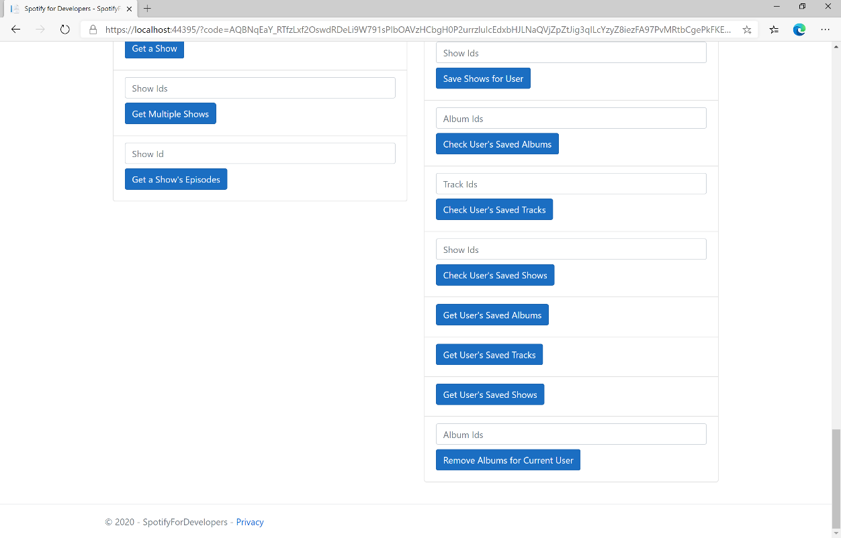

### Step 10

You can then enter some **Album Ids** from **Get All New Releases** or copy the same **Album Ids** used in **Save Albums for Current User** into **Album Ids** above **Remove Albums for Current User** and then select **Remove Albums for Current User** and scroll down to view **Results** like the following:

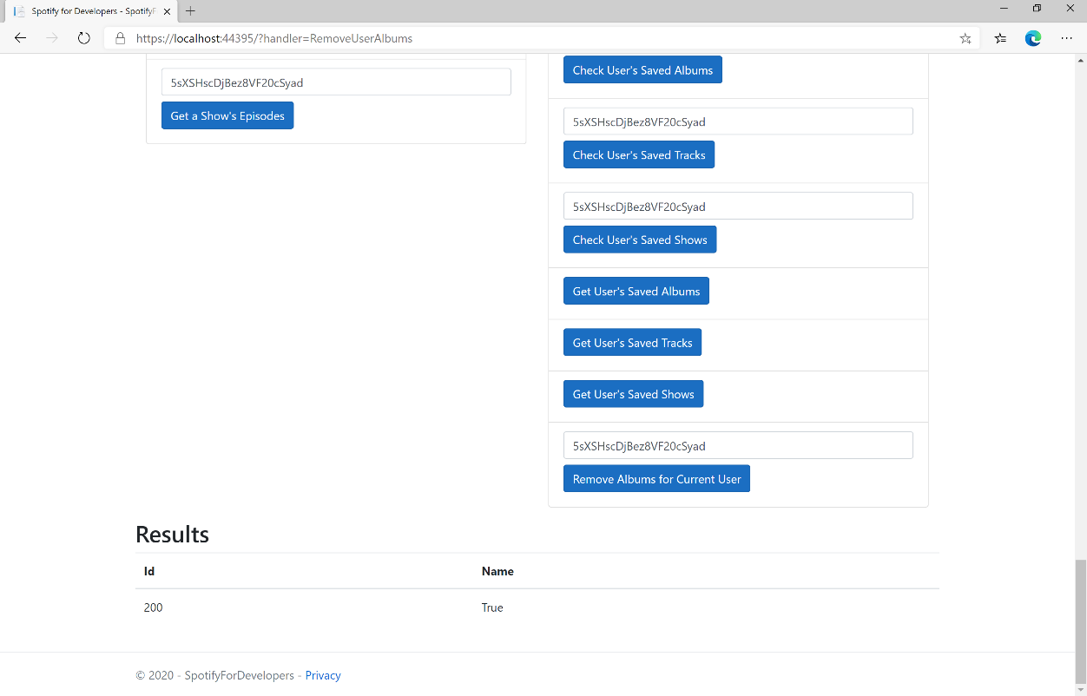

### Step 11

|  |  |
| --- | --- |
|  | You can stop the **web application** in **Visual Studio 2019** by selecting the **Stop debugging** button |

### Step 12

|  |  |
| --- | --- |
|  | You can choose to exit **Visual Studio 2019** by selecting the **Close** button in the top right of the **application** as that completes thispart of the workshop |

## Remove User's Saved Tracks

Remove one or more tracks from the current user’s ‘Your Music’ library.

|  |  |
| --- | --- |
| DELETE https://api.spotify.com/v1/me/tracks | |
| Header | |
| Authorization | User Token from Spotify Accounts service with **user-library-modify** scope |
| Query Parameter | |
| ids | Comma-separated list of the Spotify Ids for the Tracks. Maximum: 50 Ids. |

|  |  |
| --- | --- |
| Header | Response |
| Success | |
| Http Status 200 OK |  |
| Error | |
| HTTP Status 403  Forbidden | Returned when not Authorised |
| Error Code | Error Object |

### Step 1

|  |  |
| --- | --- |
|  | If you chose to close **Visual Studio 2019** previously, in **Windows 10** choose **Start**, and then from the **Start Menu** find and select **Visual Studio 2019** |
|  | Once done, from the **Get started** screen for **Visual Studio 2019** select **Open a project or solution** |
|  | Then locate and select **SpotifyForDevelopers.sln** and select **Open** if you don’t have this file already then please follow the previous parts of the workshop including **Getting Started**, **Authorisation Guide**, **Search & Browse**, **Playlists & Artists**, **Albums & Tracks**, **Episodes & Shows**, **Follow**, **Playlists** and **Library** |

### Step 2

|  |  |
| --- | --- |
|  | Once opened, in the **Solution Explorer** open the **Pages** section, then open the **Index.cshtml** section and select **Index.cshtml.cs** |

### Step 3

|  |  |
| --- | --- |
|  | Then from the **Menu** choose **View** and then **Open** |

### Step 4

In the **Code View** for **Index.cshtml.cs** below the **method** for public async Task<IActionResult> OnPostRemoveUserAlbumsAsync(...) { ... } enter the following **method**:

|  |
| --- |
| public async Task<IActionResult> OnPostRemoveUserTracksAsync(string value)  {  LoadToken();  var values = value.Split(",").ToList();  var result = await Api.RemoveUserTracksAsync(values);  if (result != null)  {  Results = new List<Result>() { new Result()  {  Id = result.Code.ToString(),  Name = result.Success.ToString()  }};  }  return Page();  } |

The **method** for OnPostRemoveUserTracksAsync **removes** the **saved track** from the **Library** with Value of the **Track Ids** of the **track** and populate the **property** for Results of the **success** of the operation accordingly.

### Step 5

|  |  |
| --- | --- |
|  | In the **Solution Explorer** in the **Pages** section select **Index.cshtml** |

### Step 6

|  |  |
| --- | --- |
|  | Then from the **Menu** choose **View** and then **Open** |

### Step 7

Once in the **Code View** for **Index.cshtml** above <!-- Library --> enter the following:

|  |
| --- |
| <li class="list-group-item">  <form **asp-page-handler**="RemoveUserTracks" method="post">  <input **asp-for**="Value" placeholder="Track Ids" class="form-control mb-2" />  <button class="btn btn-primary mb-2">  Remove User's Saved Tracks  </button>  </form>  </li> |

This form will **post** to the **method** for RemoveUserTracks with the Value of the **Track Ids** and will output to the **Results**.

### Step 8

|  |  |
| --- | --- |
|  | Finally, in **Visual Studio 2019** select **IIS Application** to run the **Web Application** |

### Step 9

Once the **Web Application** is running and you select **Authorisation Code Flow Login** or **Implicit Grant Flow Login** and scroll down you should see something like the following:

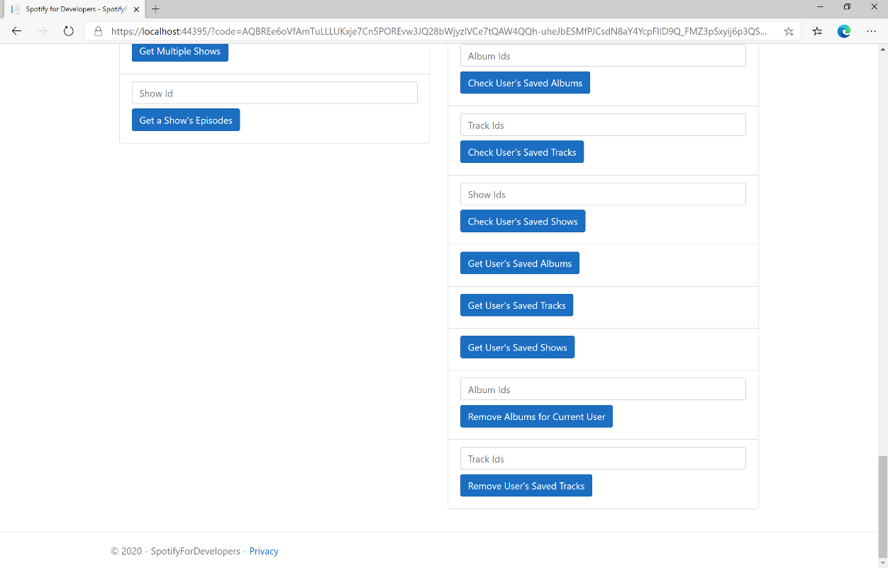

### Step 10

You can then enter some **Track Ids** from an **Album Id** from **Get All New Releases** using **Get an Album's Tracks** or copy the same **Track Ids** used in **Save Tracks for User** in **Track Ids** above **Remove User's Saved Tracks** and then select **Remove User's Saved Tracks** and scroll down to view **Results** like the following:

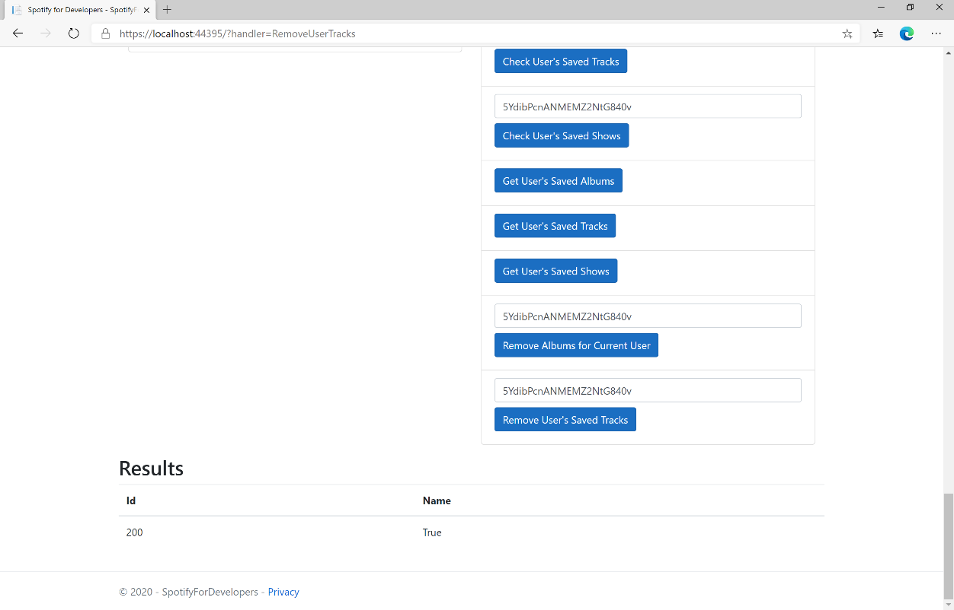

### Step 11

|  |  |
| --- | --- |
|  | You can stop the **web application** in **Visual Studio 2019** by selecting the **Stop debugging** button |

### Step 12

|  |  |
| --- | --- |
|  | You can choose to exit **Visual Studio 2019** by selecting the **Close** button in the top right of the **application** as that completes thispart of the workshop |

## Remove User's Saved Shows

Delete one or more shows from current Spotify user’s library.

|  |  |
| --- | --- |
| DELETE https://api.spotify.com/v1/me/shows | |
| Header | |
| Authorization | User Token from Spotify Accounts service with **user-library-modify** scope |
| Query Parameter | |
| ids | Comma-separated list of Spotify Ids for the shows to be deleted from the user’s library |
| market | An ISO 3166-1 alpha-2 country code. If a country code is specified, only shows that are available in that market will be removed.  If a valid user access token is specified in the request header, the country associated with the user account will take priority over this parameter.  If neither market nor user country are provided, the content is considered unavailable for the client. Users can view the country that is associated with their account in the account settings |

|  |  |
| --- | --- |
| Header | Response |
| Success | |
| Http Status 200 OK |  |
| Error | |
| HTTP Status 403  Forbidden | Returned when not Authorised |
| Error Code | Error Object |

### Step 1

|  |  |
| --- | --- |
|  | If you chose to close **Visual Studio 2019** previously, in **Windows 10** choose **Start**, and then from the **Start Menu** find and select **Visual Studio 2019** |
|  | Once done, from the **Get started** screen for **Visual Studio 2019** select **Open a project or solution** |
|  | Then locate and select **SpotifyForDevelopers.sln** and select **Open** if you don’t have this file already then please follow the previous parts of the workshop including **Getting Started**, **Authorisation Guide**, **Search & Browse**, **Playlists & Artists**, **Albums & Tracks**, **Episodes & Shows**, **Follow**, **Playlists** and **Library** |

### Step 2

|  |  |
| --- | --- |
|  | Once opened, in the **Solution Explorer** open the **Pages** section, then open the **Index.cshtml** section and select **Index.cshtml.cs** |

### Step 3

|  |  |
| --- | --- |
|  | Then from the **Menu** choose **View** and then **Open** |

### Step 4

In the **Code View** for **Index.cshtml.cs** below the **method** for public async Task<IActionResult> OnPostRemoveUserTracksAsync(...) { ... } enter the following **method**:

|  |
| --- |
| public async Task<IActionResult> OnPostRemoveUserShowsAsync(string value)  {  LoadToken();  var values = value.Split(",").ToList();  var result = await Api.RemoveUserShowsAsync(values);  if (result != null)  {  Results = new List<Result>() { new Result()  {  Id = result.Code.ToString(),  Name = result.Success.ToString()  }};  }  return Page();  } |

The **method** for OnPostRemoveUserShowsAsync **removes** the **saved show** from the **Library** with Value of the **Show Ids** of the **show** and populate the **property** for Results of the **success** of the operation accordingly.

### Step 5

|  |  |
| --- | --- |
|  | In the **Solution Explorer** in the **Pages** section select **Index.cshtml** |

### Step 6

|  |  |
| --- | --- |
|  | Then from the **Menu** choose **View** and then **Open** |

### Step 7

Once in the **Code View** for **Index.cshtml** above <!-- Library --> enter the following:

|  |
| --- |
| <li class="list-group-item">  <form **asp-page-handler**="RemoveUserShows" method="post">  <input **asp-for**="Value" placeholder="Show Ids" class="form-control mb-2" />  <button class="btn btn-primary mb-2">  Remove User's Saved Shows  </button>  </form>  </li> |

This form will **post** to the **method** for RemoveUserShows with the Value of the **Show Ids** and will output to the **Results**.

### Step 8

|  |  |
| --- | --- |
|  | Finally, in **Visual Studio 2019** select **IIS Application** to run the **Web Application** |

### Step 9

Once the **Web Application** is running and you select **Authorisation Code Flow Login** or **Implicit Grant Flow Login** and scroll down you should see something like the following:

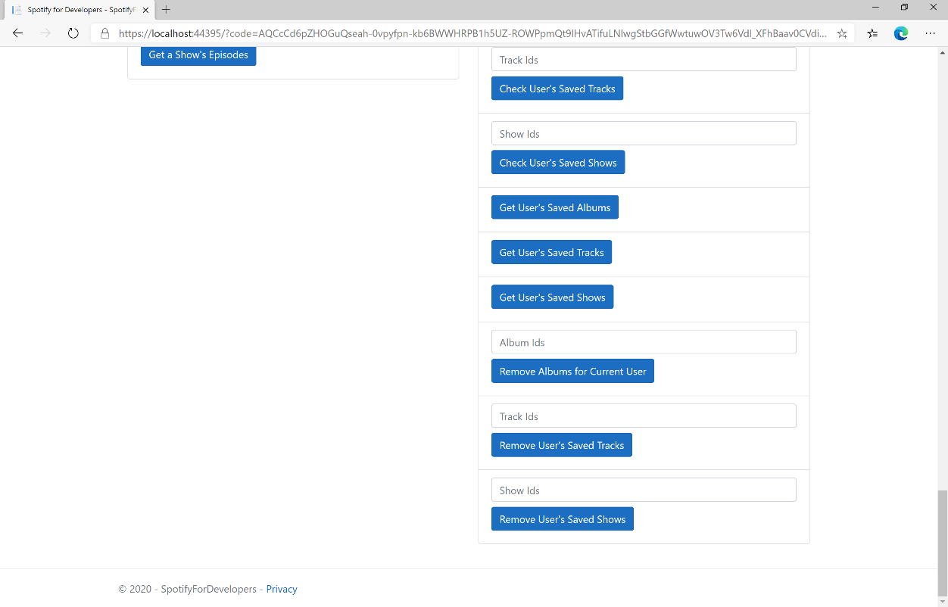

### Step 10

You can get a **Show Id** from **Search For An Item** using **Shows** or copy the same **Show Ids** used in **Save Shows for User** in **Show Ids** above **Remove User's Saved Shows** and then select **Remove User's Saved Shows** and scroll down to view **Results** like the following:

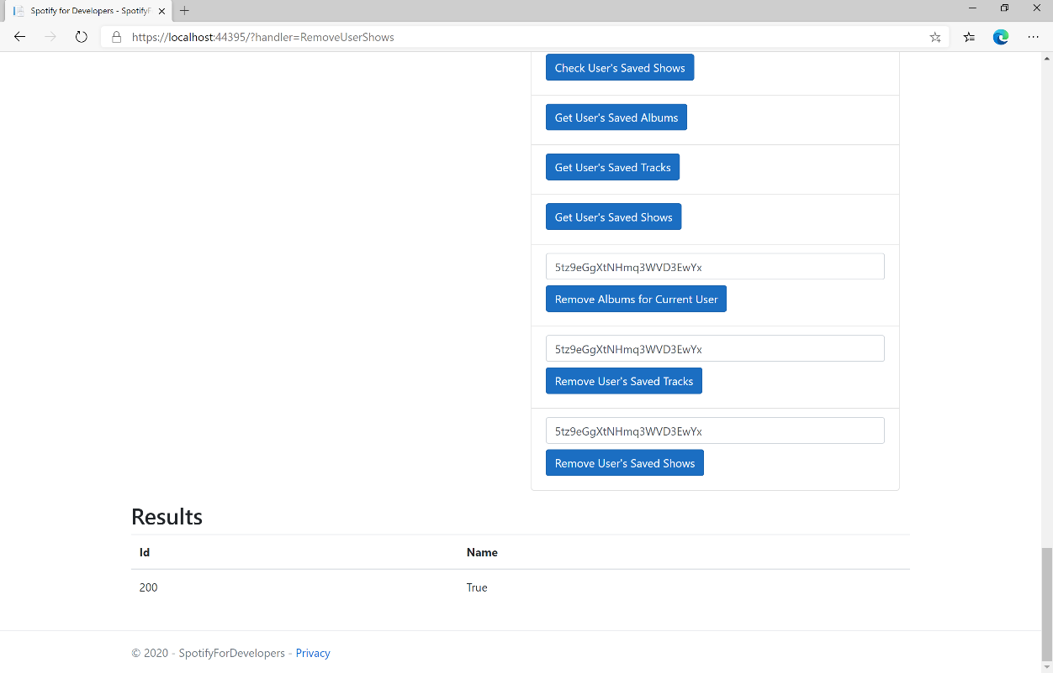

### Step 11

|  |  |
| --- | --- |
|  | You can stop the **web application** in **Visual Studio 2019** by selecting the **Stop debugging** button |

### Step 12

|  |  |
| --- | --- |
|  | You can exit **Visual Studio 2019** by selecting the **Close** button in the top right of the **application** as that completes thispart of the workshop |

# Player

## Add an Item to the User's Playback Queue

Add an item to the end of the user’s current playback queue.

|  |  |
| --- | --- |
| POST https://api.spotify.com/v1/me/player/queue | |
| Header | |
| Authorization | User Token from Spotify Accounts service with **user-modify-playback-state** scope |
| Query Parameter | |
| uri | Uri of the item to add to the queue. Must be a track or an episode uri |
| device_id | Device Id to target, if not supplied the user’s current active device is the target |

|  |  |
| --- | --- |
| Header | Response |
| Success | |
| Http Status 204  No Content |  |
| Error | |
| HTTP Status 404  Not Found | NO_ACTIVE_DEVICE - Device was not found |
| HTTP Status 403  Forbidden | PREMIUM_REQUIRED - Returned when account non-premium |
| Error Code | Error Object |

### Step 1

|  |  |
| --- | --- |
|  | In **Windows 10** choose **Start**, and then from the **Start Menu** find and select **Visual Studio 2019** |
|  | Once done, from the **Get started** screen for **Visual Studio 2019** select **Open a project or solution** |
|  | Then locate and select **SpotifyForDevelopers.sln** and select **Open** if you don’t have this file already then please follow the previous parts of the workshop including **Getting Started**, **Authorisation Guide**, **Search & Browse**, **Playlists & Artists**, **Albums & Tracks**, **Episodes & Shows**, **Follow**, **Playlists** and **Library** |

### Step 2

|  |  |
| --- | --- |
|  | Once opened, in the **Solution Explorer** open the **Pages** section, then open the **Index.cshtml** section and select **Index.cshtml.cs** |

### Step 3

|  |  |
| --- | --- |
|  | Then from the **Menu** choose **View** and then **Open** |

### Step 4

In the **Code View** for **Index.cshtml.cs** below the **method** for public async Task<IActionResult> OnPostRemoveUserShowsAsync(...) { ... } enter the following **method**:

|  |
| --- |
| public async Task<IActionResult> OnPostUserPlaybackAddToQueueAsync(string value, string option)  {  LoadToken();  var uri = $"spotify:{option.ToLower()}:{value}";  var result = await Api.UserPlaybackAddToQueueAsync(uri);  if (result != null)  {  Results = new List<Result>() { new Result()  {  Id = result.Code.ToString(),  Name = result.Success.ToString()  }};  }  return Page();  } |

The **method** for OnPostUserPlaybackAddToQueueAsync **adds** the **track** or **episode** to the **playback queue** with Value of the **Item Id** of the **Track Id** or **Episode Id** and the Option of **Track** or **Episode** and populate the **property** for Results of the **success** of the operation accordingly.

### Step 5

|  |  |
| --- | --- |
|  | In the **Solution Explorer** in the **Pages** section select **Index.cshtml** |

### Step 6

|  |  |
| --- | --- |
|  | Then from the **Menu** choose **View** and then **Open** |

### Step 7

Once in the **Code View** for **Index.cshtml** above <!-- Spotify Web API User Authorisation --> enter the following:

|  |
| --- |
| <ul class="list-group mb-2">  <li class="list-group-item list-group-item-primary">  <h5 class="list-group-item-heading">Player</h5>  </li>  <li class="list-group-item">  <form **asp-page-handler**="UserPlaybackAddToQueue" method="post">  <select **asp-for**="Option" class="form-control mb-2">  <option>Track</option>  <option>Episode</option>  </select>  <input **asp-for**="Value" placeholder="Item Id" class="form-control mb-2" />  <button class="btn btn-primary mb-2">  Add an Item to the User's Playback Queue  </button>  </form>  </li>  <!-- Player -->  </ul> |

This form will **post** to the **method** for UserPlaybackAddToQueue with the Value of the **Item Id** and the Option of **Track** or **Episode** and will output to the **Results**.

### Step 8

|  |  |
| --- | --- |
|  | Finally, in **Visual Studio 2019** select **IIS Application** to run the **Web Application** |

### Step 9

Once the **Web Application** is running and you select **Authorisation Code Flow Login** or **Implicit Grant Flow Login** and scroll down you should see something like the following:

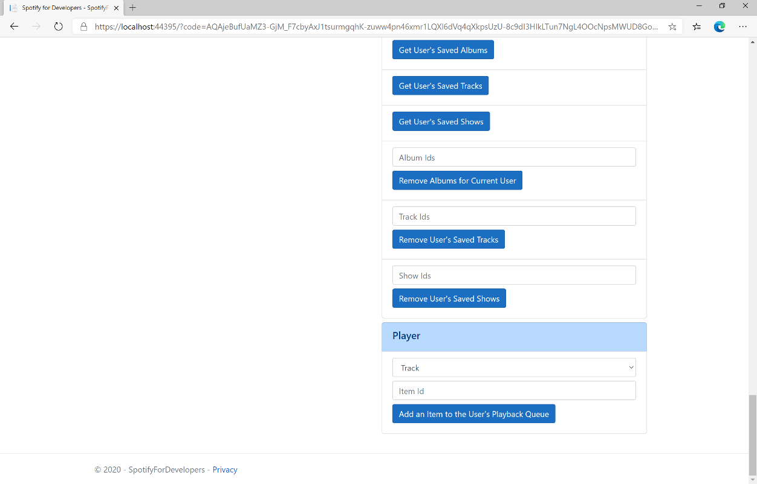

### Step 10

Make sure **Spotify** is running then you can get a **Track Id** from **Search For An Item** using **Tracks** or an **Episode Id** using **Episodes** and enter this in **Item Id** above **Add an Item to the User's Playback Queue** and then select **Add an Item to the User's Playback Queue** and also scroll down to view **Results** like the following:

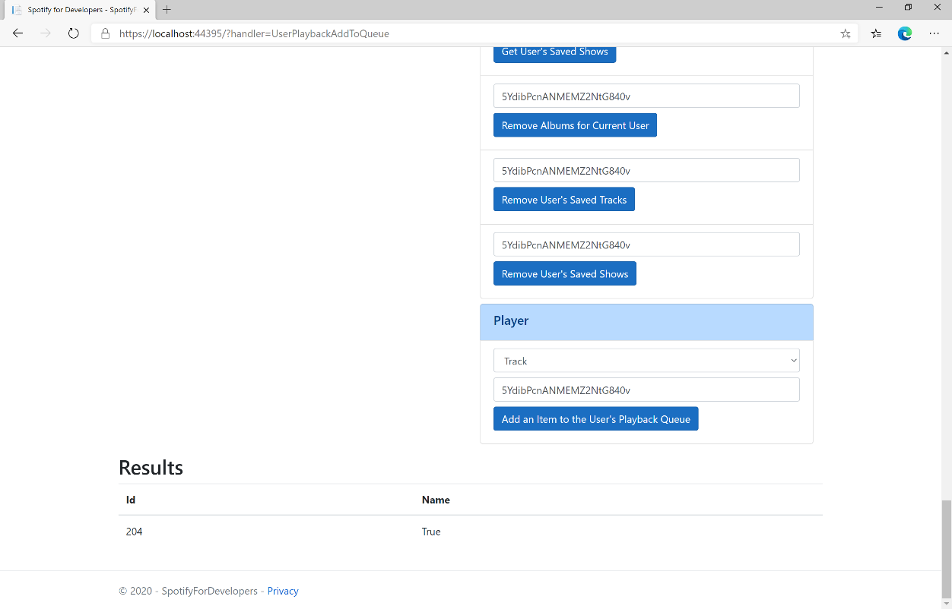

### Step 11

|  |  |
| --- | --- |
|  | You can stop the **web application** in **Visual Studio 2019** by selecting the **Stop debugging** button |

### Step 12

|  |  |
| --- | --- |
|  | You can choose to exit **Visual Studio 2019** by selecting the **Close** button in the top right of the **application** as that completes thispart of the workshop |

## Start/Resume a User's Playback

Start a new context or resume current playback on the user’s active device.

|  |  |
| --- | --- |
| PUT https://api.spotify.com/v1/me/player/play | |
| Header | |
| Authorization | User Token from Spotify Accounts service with **user-modify-playback-state** scope |
| Query Parameter | |
| device_id | Device Id to target, if not supplied the user’s current active device is the target |
| Body Parameter | |
| context_uri | Spotify URI of the context to play. Valid contexts are albums, artists, playlists |
| uris | Spotify track URIs to play |
| offset | Indicates from where in the context playback should start. Only available when context_uri corresponds to an album or playlist object, or when the uris parameter is used. |
| position_ms | Indicates from what position to start playback |

|  |  |
| --- | --- |
| Header | Response |
| Success | |
| Http Status 204  No Content |  |
| Error | |
| HTTP Status 404  Not Found | NO_ACTIVE_DEVICE - Device was not found |
| HTTP Status 403  Forbidden | PREMIUM_REQUIRED - Returned when account non-premium |
| Error Code | Error Object |

### Step 1

|  |  |
| --- | --- |
|  | If you chose to close **Visual Studio 2019** previously, in **Windows 10** choose **Start**, and then from the **Start Menu** find and select **Visual Studio 2019** |
|  | Once done, from the **Get started** screen for **Visual Studio 2019** select **Open a project or solution** |
|  | Then locate and select **SpotifyForDevelopers.sln** and select **Open** if you don’t have this file already then please follow the previous parts of the workshop including **Getting Started**, **Authorisation Guide**, **Search & Browse**, **Playlists & Artists**, **Albums & Tracks**, **Episodes & Shows**, **Follow**, **Playlists**, **Library** and **Player** |

### Step 2

|  |  |
| --- | --- |
|  | Once opened, in the **Solution Explorer** open the **Pages** section, then open the **Index.cshtml** section and select **Index.cshtml.cs** |

### Step 3

|  |  |
| --- | --- |
|  | Then from the **Menu** choose **View** and then **Open** |

### Step 4

In the **Code View** for **Index.cshtml.cs** below the **method** for public async Task<IActionResult> OnPostUserPlaybackAddToQueueAsync(...) { ... } enter the following **method**:

|  |
| --- |
| public async Task<IActionResult> OnPostUserPlaybackStartResumeAsync(string value, string option)  {  var isTrack = option.Equals("Track");  var uri = $"spotify:{option.ToLower()}:{value}";  var uris = new List<string> { uri };  var result = await Api.UserPlaybackStartResumeAsync(  contextUri: isTrack ? null : uri,  uris: isTrack ? uris : null,  offsetPosition: 0, position: 0);  if (result != null)  {  Results = new List<Result>() { new Result()  {  Id = result.Code.ToString(),  Name = result.Success.ToString()  }};  }  return Page();  } |

The **method** for OnPostUserPlaybackStartResumeAsync will **start** the **playback** with the Value of the **Item Id** of the Option of an **Album**, **Track**, **Artist** or **Playlist** and populate the **property** for Results of the **success** of the operation accordingly.

### Step 5

|  |  |
| --- | --- |
|  | In the **Solution Explorer** in the **Pages** section select **Index.cshtml** |

### Step 6

|  |  |
| --- | --- |
|  | Then from the **Menu** choose **View** and then **Open** |

### Step 7

Once in the **Code View** for **Index.cshtml** above <!-- Player --> enter the following:

|  |
| --- |
| <li class="list-group-item">  <form **asp-page-handler**="UserPlaybackStartResume" method="post">  <select **asp-for**="Option" class="form-control mb-2">  <option>Album</option>  <option>Track</option>  <option>Artist</option>  <option>Playlist</option>  </select>  <input **asp-for**="Value" placeholder="Item Id" class="form-control mb-2" />  <button class="btn btn-primary mb-2">  Start/Resume a User's Playback  </button>  </form>  </li> |

This form will **post** to the **method** for UserPlaybackStartResume with the Value of the **Item Id** and the Option of **Album**, **Track**, **Artist** and **Playlist** will output to the **Results**.

### Step 8

|  |  |
| --- | --- |
|  | Finally, in **Visual Studio 2019** select **IIS Application** to run the **Web Application** |

### Step 9

Once the **Web Application** is running and you select **Authorisation Code Flow Login** or **Implicit Grant Flow Login** and scroll down you should see something like the following:

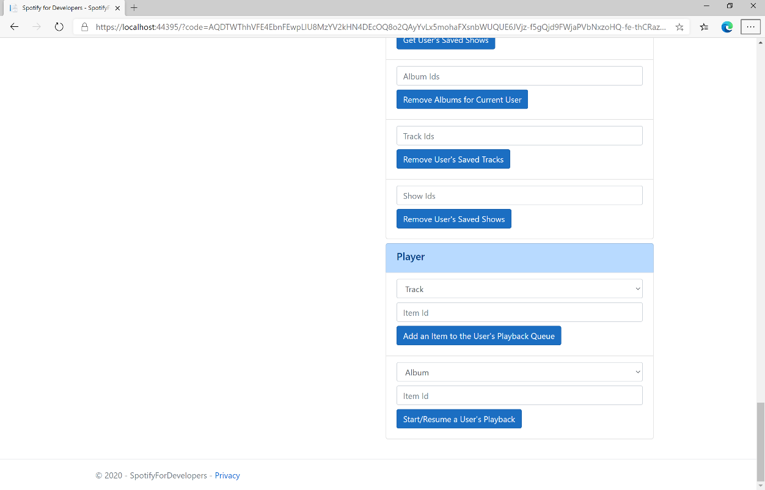

### Step 10

Make sure **Spotify** is running then get an **Album Id** from **Search For An Item** using **Albums** or an **Track Id** using **Tracks**, or an **Artist Id** using **Artists**, or a **Playlist Id** using **Playlists** and enter this in **Item Id** above **Start/Resume a User's Playback** and then select **Start/Resume a User's Playback** and scroll down to view **Results** like the following:

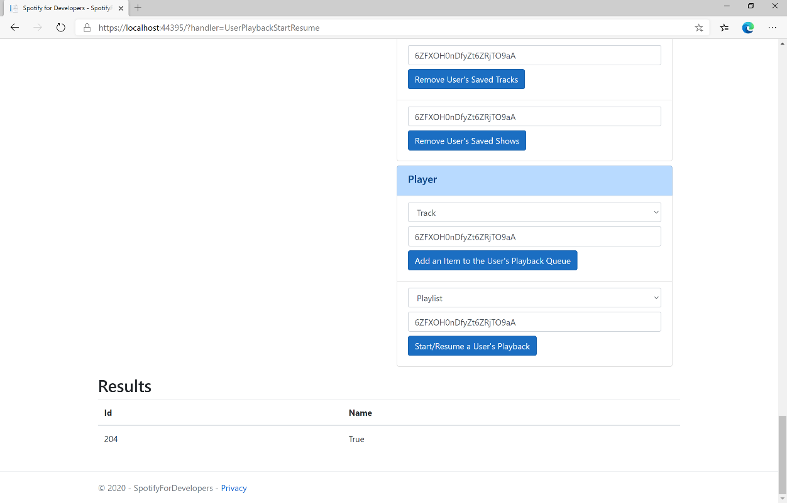

### Step 11

|  |  |
| --- | --- |
|  | You can stop the **web application** in **Visual Studio 2019** by selecting the **Stop debugging** button |

### Step 12

|  |  |
| --- | --- |
|  | You can choose to exit **Visual Studio 2019** by selecting the **Close** button in the top right of the **application** as that completes thispart of the workshop |

## Pause a User's Playback

Pause playback on the user’s account.

|  |  |
| --- | --- |
| PUT https://api.spotify.com/v1/me/player/pause | |
| Header | |
| Authorization | User Token from Spotify Accounts service with **user-modify-playback-state** scope |
| Query Parameter | |
| device_id | Device Id to target, if not supplied the user’s current active device is the target |

|  |  |
| --- | --- |
| Header | Response |
| Success | |
| Http Status 204  No Content |  |
| Error | |
| HTTP Status 404  Not Found | NO_ACTIVE_DEVICE - Device was not found |
| HTTP Status 403  Forbidden | PREMIUM_REQUIRED - Returned when account non-premium |
| Error Code | Error Object |

### Step 1

|  |  |
| --- | --- |
|  | If you chose to close **Visual Studio 2019** previously, in **Windows 10** choose **Start**, and then from the **Start Menu** find and select **Visual Studio 2019** |
|  | Once done, from the **Get started** screen for **Visual Studio 2019** select **Open a project or solution** |
|  | Then locate and select **SpotifyForDevelopers.sln** and select **Open** if you don’t have this file already then please follow the previous parts of the workshop including **Getting Started**, **Authorisation Guide**, **Search & Browse**, **Playlists & Artists**, **Albums & Tracks**, **Episodes & Shows**, **Follow**, **Playlists**, **Library** and **Player** |

### Step 2

|  |  |
| --- | --- |
|  | Once opened, in the **Solution Explorer** open the **Pages** section, then open the **Index.cshtml** section and select **Index.cshtml.cs** |

### Step 3

|  |  |
| --- | --- |
|  | Then from the **Menu** choose **View** and then **Open** |

### Step 4

In the **Code View** for **Index.cshtml.cs** below the **method** for public async Task<IActionResult> OnPostUserPlaybackStartResumeAsync(...) { ... } enter the following **method**:

|  |
| --- |
| public async Task<IActionResult> OnPostUserPlaybackPauseAsync()  {  LoadToken();  var result = await Api.UserPlaybackPauseAsync();  if (result != null)  {  Results = new List<Result>() { new Result()  {  Id = result.Code.ToString(),  Name = result.Success.ToString()  }};  }  return Page();  } |

The **method** for OnPostUserPlaybackPauseAsync will **pause** any **playback** and populate the **property** for Results of the **success** of the operation accordingly.

### Step 5

|  |  |
| --- | --- |
|  | In the **Solution Explorer** in the **Pages** section select **Index.cshtml** |

### Step 6

|  |  |
| --- | --- |
|  | Then from the **Menu** choose **View** and then **Open** |

### Step 7

Once in the **Code View** for **Index.cshtml** above <!-- Player --> enter the following:

|  |
| --- |
| <li class="list-group-item">  <form **asp-page-handler**="UserPlaybackPause" method="post">  <button class="btn btn-primary mb-2">  Pause a User's Playback  </button>  </form>  </li> |

This form will **post** to the **method** for UserPlaybackPause and will output to the **Results**.

### Step 8

|  |  |
| --- | --- |
|  | Finally, in **Visual Studio 2019** select **IIS Application** to run the **Web Application** |

### Step 9

Once the **Web Application** is running and you select **Authorisation Code Flow Login** or **Implicit Grant Flow Login** and scroll down you should see something like the following:

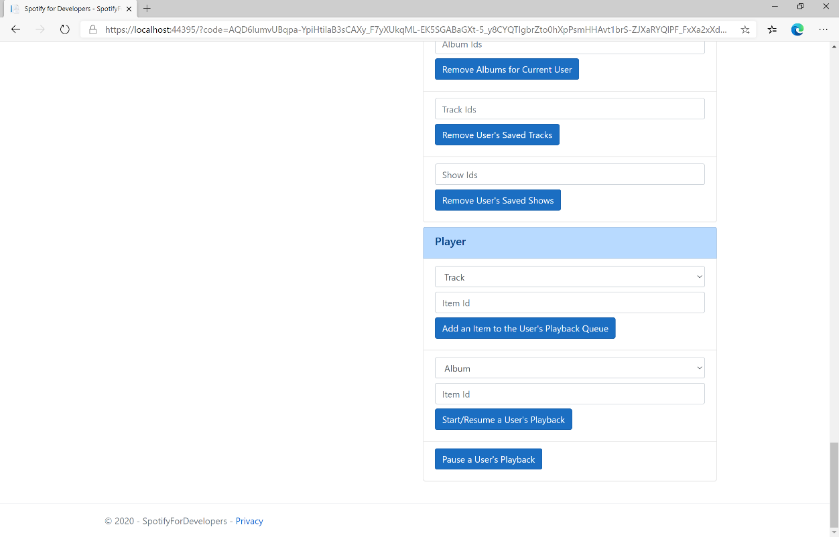

### Step 10

Make sure **Spotify** is running then you can select **Pause a User's Playback** and then scroll down to view **Results** like the following:

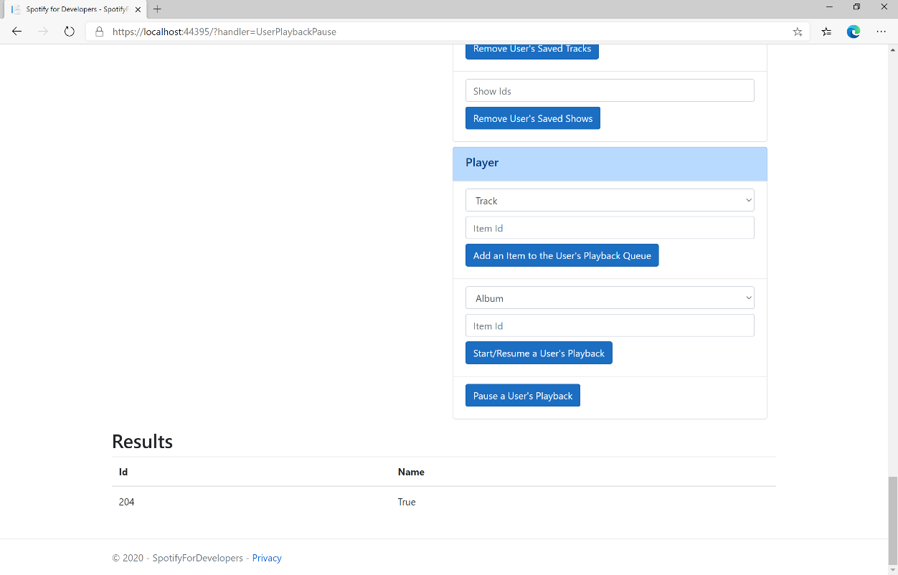

### Step 11

|  |  |
| --- | --- |
|  | You can stop the **web application** in **Visual Studio 2019** by selecting the **Stop debugging** button |

### Step 12

|  |  |
| --- | --- |
|  | You can choose to exit **Visual Studio 2019** by selecting the **Close** button in the top right of the **application** as that completes thispart of the workshop |

## Skip User’s Playback to Next Track

Skips to next track in the user’s queue.

|  |  |
| --- | --- |
| POST https://api.spotify.com/v1/me/player/next | |
| Header | |
| Authorization | User Token from Spotify Accounts service with **user-modify-playback-state** scope |
| Query Parameter | |
| device_id | Device Id to target, if not supplied the user’s current active device is the target |

|  |  |
| --- | --- |
| Header | Response |
| Success | |
| HTTP Status 204  No Content |  |
| Error | |
| HTTP Status 404  Not Found | NO_ACTIVE_DEVICE - Device was not found |
| HTTP Status 403  Forbidden | PREMIUM_REQUIRED - Returned when account non-premium |
| Error Code | Error Object |

### Step 1

|  |  |
| --- | --- |
|  | If you chose to close **Visual Studio 2019** previously, in **Windows 10** choose **Start**, and then from the **Start Menu** find and select **Visual Studio 2019** |
|  | Once done, from the **Get started** screen for **Visual Studio 2019** select **Open a project or solution** |
|  | Then locate and select **SpotifyForDevelopers.sln** and select **Open** if you don’t have this file already then please follow the previous parts of the workshop including **Getting Started**, **Authorisation Guide**, **Search & Browse**, **Playlists & Artists**, **Albums & Tracks**, **Episodes & Shows**, **Follow**, **Playlists**, **Library** and **Player** |

### Step 2

|  |  |
| --- | --- |
|  | Once opened, in the **Solution Explorer** open the **Pages** section, then open the **Index.cshtml** section and select **Index.cshtml.cs** |

### Step 3

|  |  |
| --- | --- |
|  | Then from the **Menu** choose **View** and then **Open** |

### Step 4

In the **Code View** for **Index.cshtml.cs** below the **method** for public async Task<IActionResult> OnPostUserPlaybackPauseAsync() { ... } enter the following **method**:

|  |
| --- |
| public async Task<IActionResult> OnPostUserPlaybackNextTrackAsync()  {  LoadToken();  var result = await Api.UserPlaybackNextTrackAsync();  if (result != null)  {  Results = new List<Result>() { new Result()  {  Id = result.Code.ToString(),  Name = result.Success.ToString()  }};  }  return Page();  } |

The **method** for OnPostUserPlaybackNextTrackAsync will **skip** to the **next track** in **playback** and populate the **property** for Results of the **success** of the operation accordingly.

### Step 5

|  |  |
| --- | --- |
|  | In the **Solution Explorer** in the **Pages** section select **Index.cshtml** |

### Step 6

|  |  |
| --- | --- |
|  | Then from the **Menu** choose **View** and then **Open** |

### Step 7

Once in the **Code View** for **Index.cshtml** above <!-- Player --> enter the following:

|  |
| --- |
| <li class="list-group-item">  <form **asp-page-handler**="UserPlaybackNextTrack" method="post">  <button class="btn btn-primary mb-2">  Skip User’s Playback to Next Track  </button>  </form>  </li> |

This form will **post** to the **method** for UserPlaybackNextTrack and will output to the **Results**.

### Step 8

|  |  |
| --- | --- |
|  | Finally, in **Visual Studio 2019** select **IIS Application** to run the **Web Application** |

### Step 9

Once the **Web Application** is running and you select **Authorisation Code Flow Login** or **Implicit Grant Flow Login** and scroll down you should see something like the following:

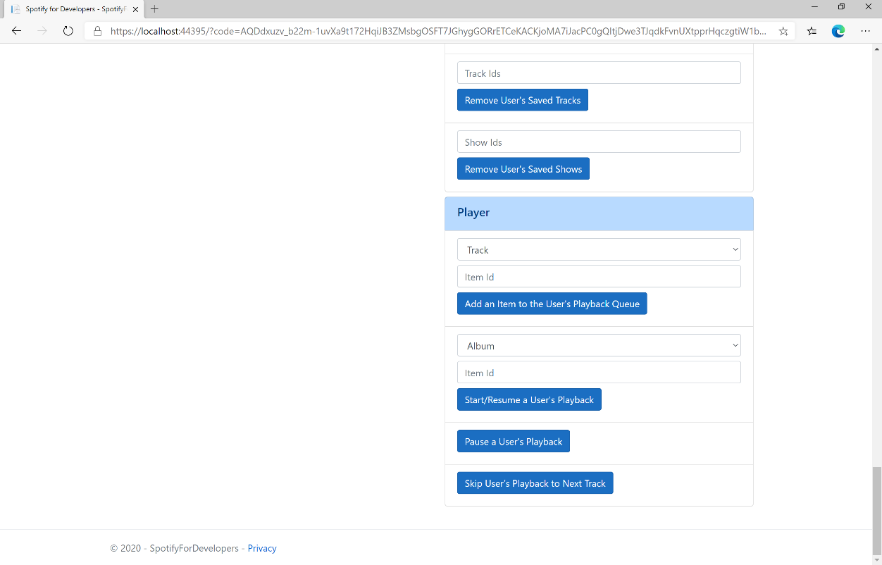

### Step 10

Make sure **Spotify** is running then you can select **Skip User’s Playback to Next Track** and then scroll down to view **Results** like the following:

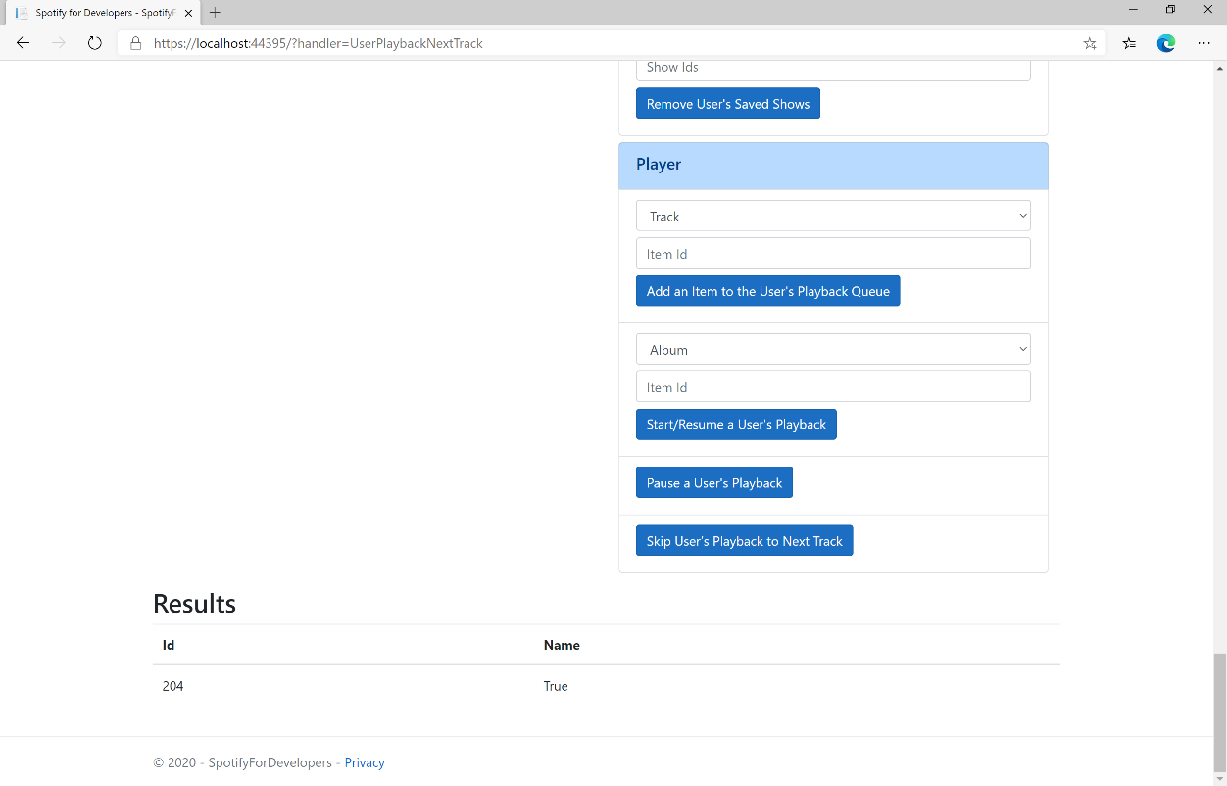

### Step 11

|  |  |
| --- | --- |
|  | You can stop the **web application** in **Visual Studio 2019** by selecting the **Stop debugging** button |

### Step 12

|  |  |
| --- | --- |
|  | You can choose to exit **Visual Studio 2019** by selecting the **Close** button in the top right of the **application** as that completes thispart of the workshop |

## Skip User’s Playback to Previous Track

Skips to previous track in the user’s queue.

|  |  |
| --- | --- |
| POST https://api.spotify.com/v1/me/player/previous | |
| Header | |
| Authorization | User Token from Spotify Accounts service with **user-modify-playback-state** scope |
| Query Parameter | |
| device_id | Device Id to target, if not supplied the user’s current active device is the target |

|  |  |
| --- | --- |
| Header | Response |
| Success | |
| HTTP Status 204  No Content |  |
| Error | |
| HTTP Status 404  Not Found | NO_ACTIVE_DEVICE - Device was not found |
| HTTP Status 403  Forbidden | PREMIUM_REQUIRED - Returned when account non-premium |
| Error Code | Error Object |

### Step 1

|  |  |
| --- | --- |
|  | If you chose to close **Visual Studio 2019** previously, in **Windows 10** choose **Start**, and then from the **Start Menu** find and select **Visual Studio 2019** |
|  | Once done, from the **Get started** screen for **Visual Studio 2019** select **Open a project or solution** |
|  | Then locate and select **SpotifyForDevelopers.sln** and select **Open** if you don’t have this file already then please follow the previous parts of the workshop including **Getting Started**, **Authorisation Guide**, **Search & Browse**, **Playlists & Artists**, **Albums & Tracks**, **Episodes & Shows**, **Follow**, **Playlists**, **Library** and **Player** |

### Step 2

|  |  |
| --- | --- |
|  | Once opened, in the **Solution Explorer** open the **Pages** section, then open the **Index.cshtml** section and select **Index.cshtml.cs** |

### Step 3

|  |  |
| --- | --- |
|  | Then from the **Menu** choose **View** and then **Open** |

### Step 4

In the **Code View** for **Index.cshtml.cs** below the **method** for public async Task<IActionResult> OnPostUserPlaybackNextTrackAsync() { ... } enter the following **method**:

|  |
| --- |
| public async Task<IActionResult> OnPostUserPlaybackPreviousTrackAsync()  {  LoadToken();  var result = await Api.UserPlaybackPreviousTrackAsync();  if (result != null)  {  Results = new List<Result>() { new Result()  {  Id = result.Code.ToString(),  Name = result.Success.ToString()  }};  }  return Page();  } |

The **method** for OnPostUserPlaybackPreviousTrackAsync will **skip** to the **previous track** in **playback** and populate the **property** for Results of the **success** of the operation accordingly.

### Step 5

|  |  |
| --- | --- |
|  | In the **Solution Explorer** in the **Pages** section select **Index.cshtml** |

### Step 6

|  |  |
| --- | --- |
|  | Then from the **Menu** choose **View** and then **Open** |

### Step 7

Once in the **Code View** for **Index.cshtml** above <!-- Player --> enter the following:

|  |
| --- |
| <li class="list-group-item">  <form **asp-page-handler**="UserPlaybackNextTrack" method="post">  <button class="btn btn-primary mb-2">  Skip User’s Playback to Previous Track  </button>  </form>  </li> |

This form will **post** to the **method** for UserPlaybackNextTrack and will output to the **Results**.

### Step 8

|  |  |
| --- | --- |
|  | Finally, in **Visual Studio 2019** select **IIS Application** to run the **Web Application** |

### Step 9

Once the **Web Application** is running and you select **Authorisation Code Flow Login** or **Implicit Grant Flow Login** and scroll down you should see something like the following:

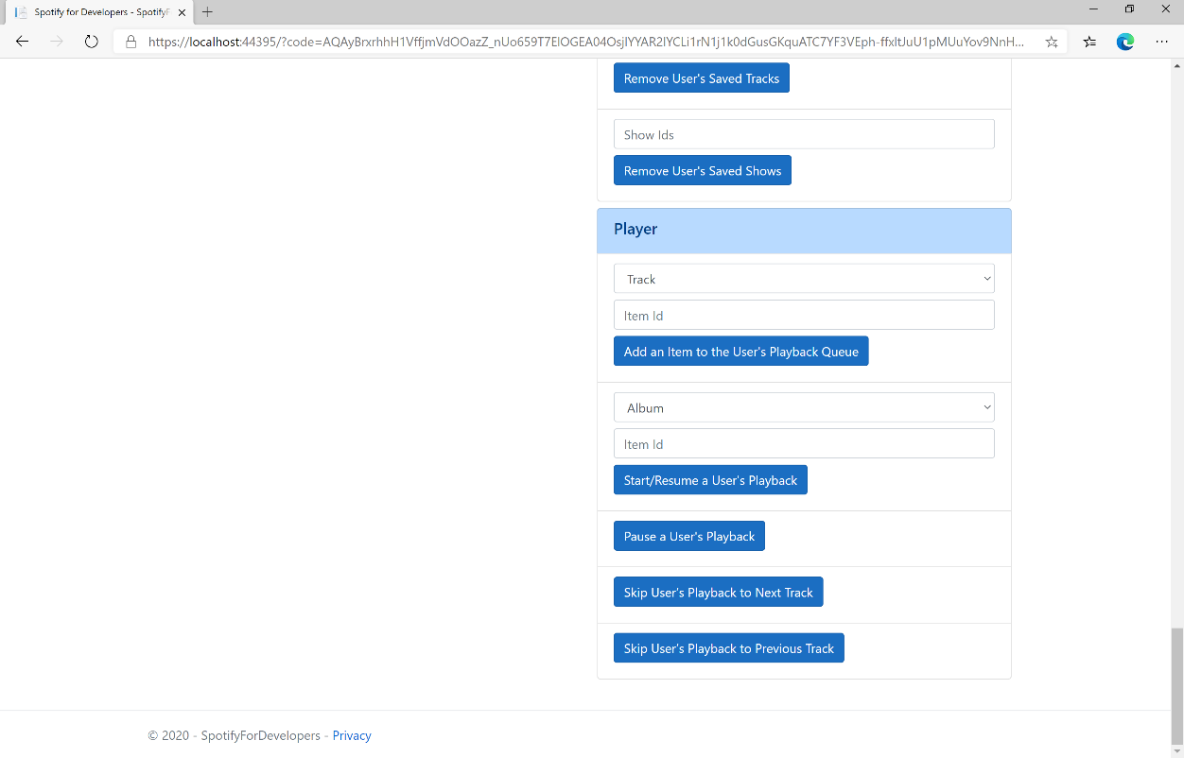

### Step 10

Make sure **Spotify** is running then you can select **Skip User’s Playback to Previous Track** and then scroll down to view **Results** like the following:

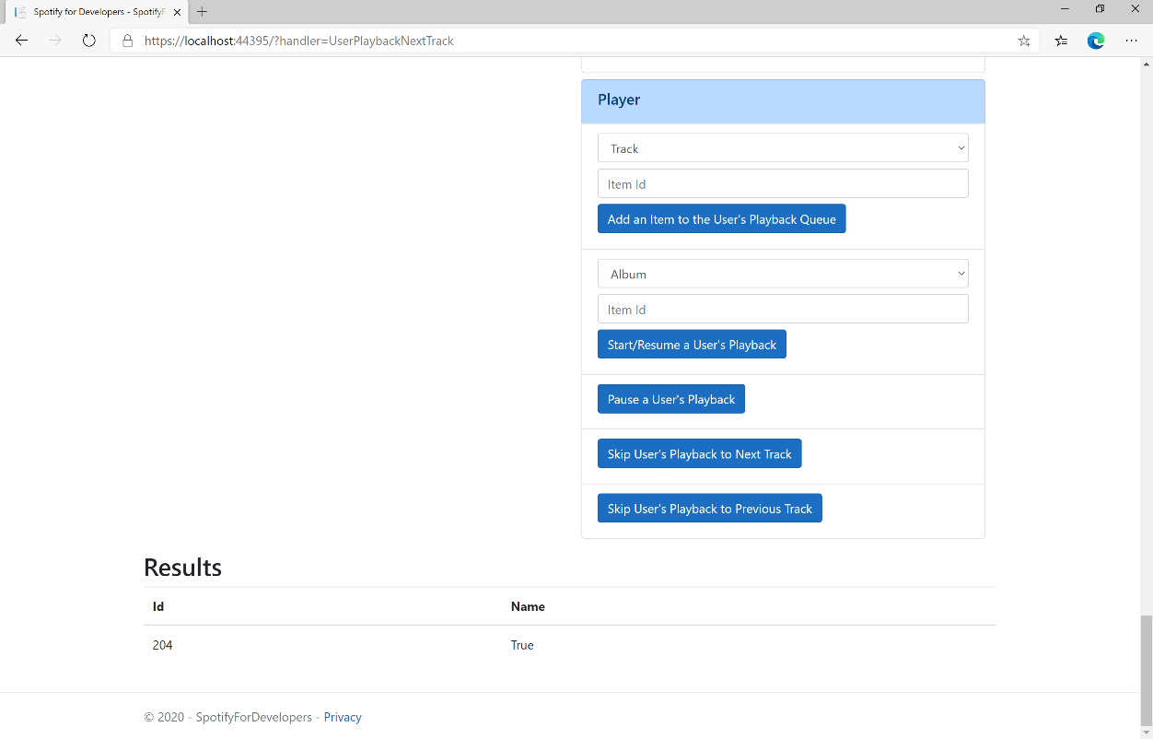

### Step 11

|  |  |
| --- | --- |
|  | You can stop the **web application** in **Visual Studio 2019** by selecting the **Stop debugging** button |

### Step 12

|  |  |
| --- | --- |
|  | You can choose to exit **Visual Studio 2019** by selecting the **Close** button in the top right of the **application** as that completes thispart of the workshop |

## Seek to Position in Currently Playing Track

Seeks to the given position in the user’s currently playing track.

|  |  |
| --- | --- |
| PUT https://api.spotify.com/v1/me/player/seek | |
| Header | |
| Authorization | User Token from Spotify Accounts service with **user-modify-playback-state** scope |
| Query Parameter | |
| position_ms | Position in milliseconds to seek to, must be a positive number |
| device_id | Device Id to target, if not supplied the user’s current active device is the target |

|  |  |
| --- | --- |
| Header | Response |
| Success | |
| HTTP Status 204  No Content |  |
| Error | |
| HTTP Status 404  Not Found | NO_ACTIVE_DEVICE - Device was not found |
| HTTP Status 403  Forbidden | PREMIUM_REQUIRED - Returned when account non-premium |
| Error Code | Error Object |

### Step 1

|  |  |
| --- | --- |
|  | If you chose to close **Visual Studio 2019** previously, in **Windows 10** choose **Start**, and then from the **Start Menu** find and select **Visual Studio 2019** |
|  | Once done, from the **Get started** screen for **Visual Studio 2019** select **Open a project or solution** |
|  | Then locate and select **SpotifyForDevelopers.sln** and select **Open** if you don’t have this file already then please follow the previous parts of the workshop including **Getting Started**, **Authorisation Guide**, **Search & Browse**, **Playlists & Artists**, **Albums & Tracks**, **Episodes & Shows**, **Follow**, **Playlists**, **Library** and **Player** |

### Step 2

|  |  |
| --- | --- |
|  | Once opened, in the **Solution Explorer** open the **Pages** section, then open the **Index.cshtml** section and select **Index.cshtml.cs** |

### Step 3

|  |  |
| --- | --- |
|  | Then from the **Menu** choose **View** and then **Open** |

### Step 4

In the **Code View** for **Index.cshtml.cs** below the **method** for public async Task<IActionResult> OnPostUserPlaybackPreviousTrackAsync() { ... } enter the following **method**:

|  |
| --- |
| public async Task<IActionResult> OnPostUserPlaybackSeekTrackAsync(string option)  {  LoadToken();  var position = (int)TimeSpan.FromSeconds(int.Parse(option)).TotalMilliseconds;  var result = await Api.UserPlaybackSeekTrackAsync(position);  if (result != null)  {  Results = new List<Result>() { new Result()  {  Id = result.Code.ToString(),  Name = result.Success.ToString()  }};  }  return Page();  } |

The **method** for OnPostUserPlaybackSeekTrackAsync is used to **seek** to the **position** of a currently playing **track** with the Option of the **Position Seconds** of the **track** and populate the **property** for Results of the **success** of the operation accordingly.

### Step 5

|  |  |
| --- | --- |
|  | In the **Solution Explorer** in the **Pages** section select **Index.cshtml** |

### Step 6

|  |  |
| --- | --- |
|  | Then from the **Menu** choose **View** and then **Open** |

### Step 7

Once in the **Code View** for **Index.cshtml** above <!-- Player --> enter the following:

|  |
| --- |
| <li class="list-group-item">  <form **asp-page-handler**="UserPlaybackSeekTrack" method="post">  <input **asp-for**="Option" placeholder="Position Seconds" class="form-control mb-2" />  <button class="btn btn-primary mb-2">  Seek to Position in Currently Playing Track  </button>  </form>  </li> |

This form will **post** to the **method** for UserPlaybackSeekTrack with the Option of **Position Seconds** and will output to the **Results**.

### Step 8

|  |  |
| --- | --- |
|  | Finally, in **Visual Studio 2019** select **IIS Application** to run the **Web Application** |

### Step 9

Once the **Web Application** is running and you select **Authorisation Code Flow Login** or **Implicit Grant Flow Login** and scroll down you should see something like the following:

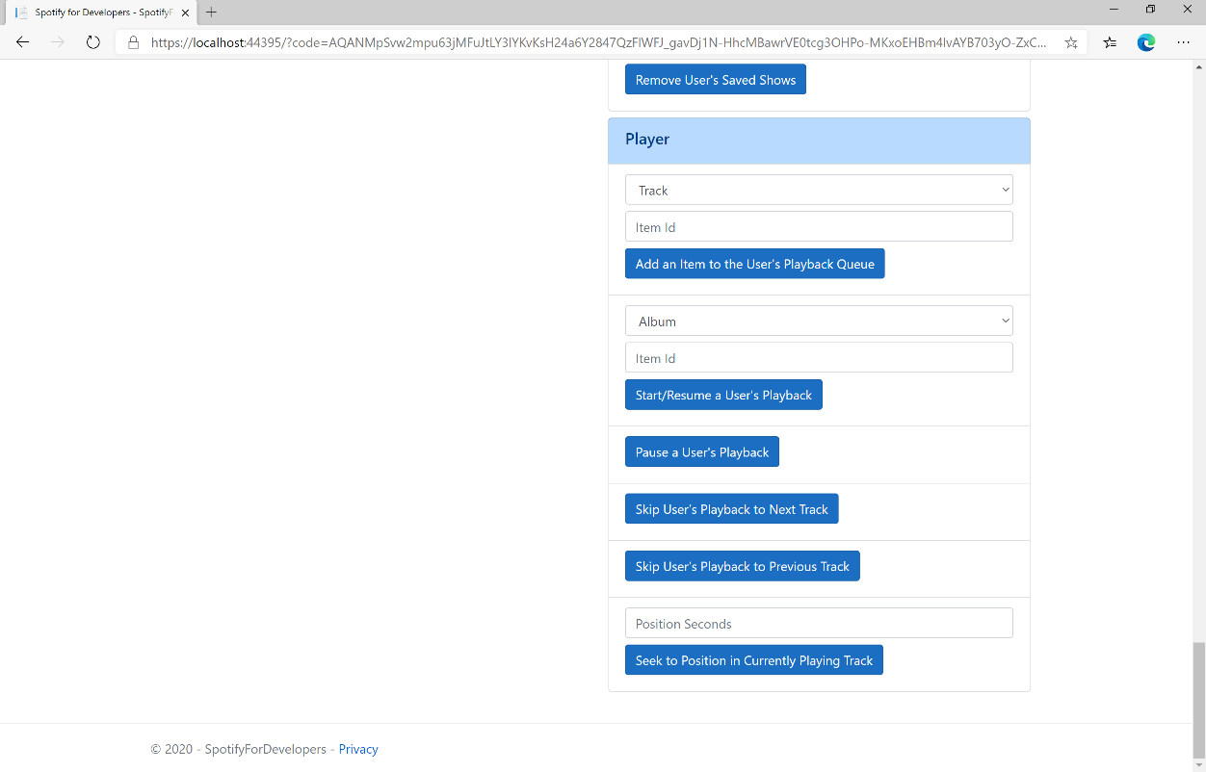

### Step 10

Make sure **Spotify** is running then you can then enter **Position Seconds** where you'd like **playback** to **seek** to above **Seek to Position in Currently Playing Track** and then select **Seek to Position in Currently Playing Track** and scroll down to view **Results** like the following:

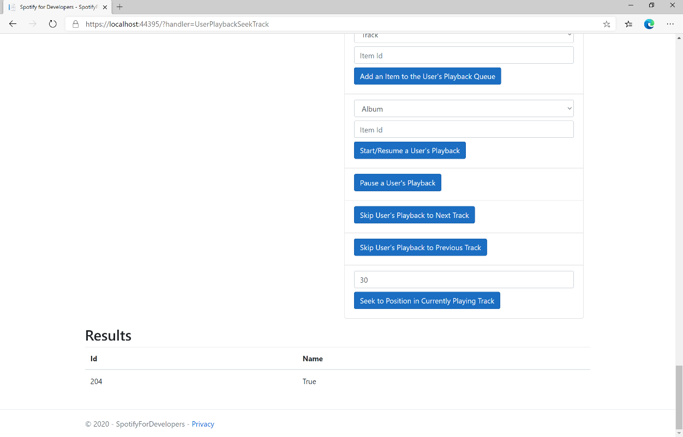

### Step 11

|  |  |
| --- | --- |
|  | You can stop the **web application** in **Visual Studio 2019** by selecting the **Stop debugging** button |

### Step 12

|  |  |
| --- | --- |
|  | You can choose to exit **Visual Studio 2019** by selecting the **Close** button in the top right of the **application** as that completes thispart of the workshop |

## Set Volume for User's Playback

Set the volume for the user’s current playback device.

|  |  |
| --- | --- |
| PUT https://api.spotify.com/v1/me/player/volume | |
| Header | |
| Authorization | User Token from Spotify Accounts service with **user-modify-playback-state** scope |
| Query Parameter | |
| volume_percent | Volume to set - must be a value from 0 to 100 |
| device_id | Device Id to target, if not supplied the user’s current active device is the target |

|  |  |
| --- | --- |
| Header | Response |
| Success | |
| HTTP Status 204  No Content |  |
| Error | |
| HTTP Status 404  Not Found | NO_ACTIVE_DEVICE - Device was not found |
| HTTP Status 403  Forbidden | PREMIUM_REQUIRED - Returned when account non-premium |
| Error Code | Error Object |

### Step 1

|  |  |
| --- | --- |
|  | If you chose to close **Visual Studio 2019** previously, in **Windows 10** choose **Start**, and then from the **Start Menu** find and select **Visual Studio 2019** |
|  | Once done, from the **Get started** screen for **Visual Studio 2019** select **Open a project or solution** |
|  | Then locate and select **SpotifyForDevelopers.sln** and select **Open** if you don’t have this file already then please follow the previous parts of the workshop including **Getting Started**, **Authorisation Guide**, **Search & Browse**, **Playlists & Artists**, **Albums & Tracks**, **Episodes & Shows**, **Follow**, **Playlists**, **Library** and **Player** |

### Step 2

|  |  |
| --- | --- |
|  | Once opened, in the **Solution Explorer** open the **Pages** section, then open the **Index.cshtml** section and select **Index.cshtml.cs** |

### Step 3

|  |  |
| --- | --- |
|  | Then from the **Menu** choose **View** and then **Open** |

### Step 4

In the **Code View** for **Index.cshtml.cs** below the **method** for public async Task<IActionResult> OnPostUserPlaybackSeekTrackAsync(...) { ... } enter the following **method**:

|  |
| --- |
| public async Task<IActionResult> OnPostUserPlaybackSetVolumeAsync(string option)  {  LoadToken();  var percent = int.Parse(option);  var result = await Api.UserPlaybackSetVolumeAsync(percent);  if (result != null)  {  Results = new List<Result>() { new Result()  {  Id = result.Code.ToString(),  Name = result.Success.ToString()  }};  }  return Page();  } |

The **method** for OnPostUserPlaybackSetVolumeAsync is used set the **volume** of **playback** with the Option using a **Range** which by default is **0** to **100** and populate the **property** for Results of the **success** of the operation accordingly.

### Step 5

|  |  |
| --- | --- |
|  | In the **Solution Explorer** in the **Pages** section select **Index.cshtml** |

### Step 6

|  |  |
| --- | --- |
|  | Then from the **Menu** choose **View** and then **Open** |

### Step 7

Once in the **Code View** for **Index.cshtml** above <!-- Player --> enter the following:

|  |
| --- |
| <li class="list-group-item">  <form **asp-page-handler**="UserPlaybackSetVolume" method="post">  <input **type**="range" **asp-for**="Option" class="form-control-range mb-2" />  <button class="btn btn-primary mb-2">  Set Volume for User's Playback  </button>  </form>  </li> |

This form will **post** to the **method** for UserPlaybackSetVolume with the Option of the **Range** selected and will output to the **Results**.

### Step 8

|  |  |
| --- | --- |
|  | Finally, in **Visual Studio 2019** select **IIS Application** to run the **Web Application** |

### Step 9

Once the **Web Application** is running and you select **Authorisation Code Flow Login** or **Implicit Grant Flow Login** and scroll down you should see something like the following:

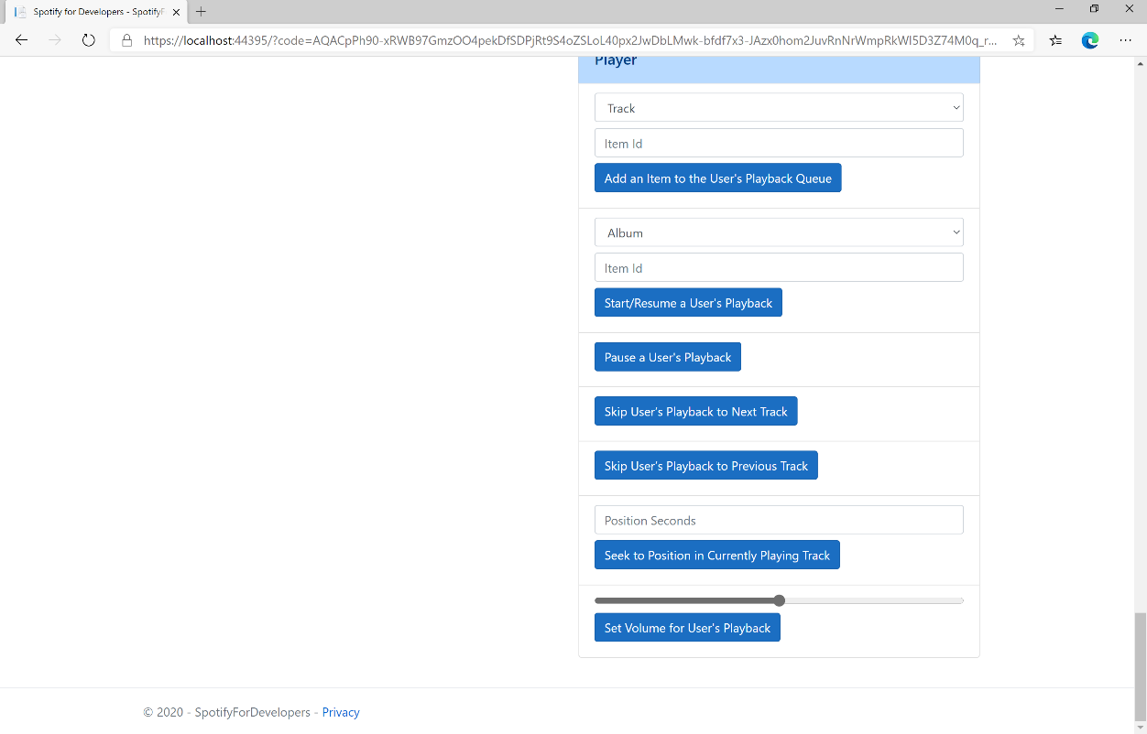

### Step 10

Make sure **Spotify** is running then you can then use the **Range** to set the **volume** above **Set Volume for User's Playback** and then select **Set Volume for User's Playback** and scroll down to view **Results** like the following:

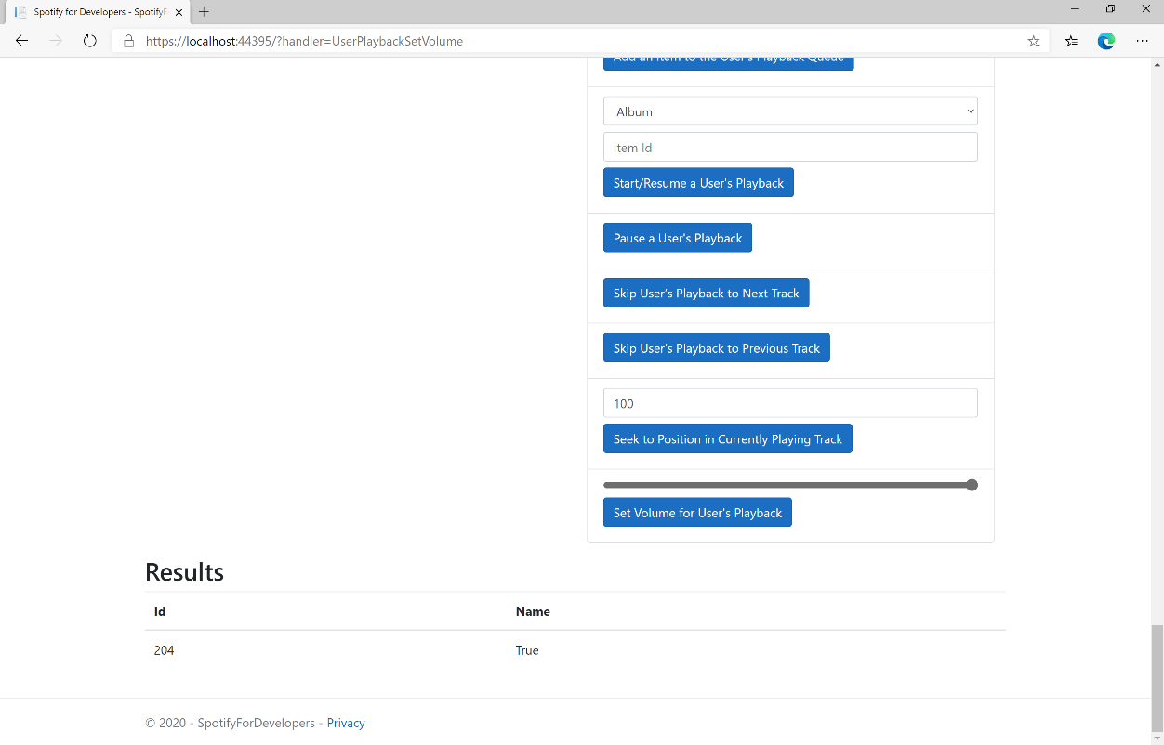

### Step 11

|  |  |
| --- | --- |
|  | You can stop the **web application** in **Visual Studio 2019** by selecting the **Stop debugging** button |

### Step 12

|  |  |
| --- | --- |
|  | You can choose to exit **Visual Studio 2019** by selecting the **Close** button in the top right of the **application** as that completes thispart of the workshop |

## Toggle Shuffle for User’s Playback

Toggle shuffle on or off for user’s playback.

|  |  |
| --- | --- |
| PUT https://api.spotify.com/v1/me/player/shuffle | |
| Header | |
| Authorization | User Token from Spotify Accounts service with **user-modify-playback-state** scope |
| Query Parameter | |
| state | If true, shuffle user’s playback, if false do not shuffle user’s playback |
| device_id | Device Id to target, if not supplied the user’s current active device is the target |

|  |  |
| --- | --- |
| Header | Response |
| Success | |
| HTTP Status 204  No Content |  |
| Error | |
| HTTP Status 404  Not Found | NO_ACTIVE_DEVICE - Device was not found |
| HTTP Status 403  Forbidden | PREMIUM_REQUIRED - Returned when account non-premium |
| Error Code | Error Object |

### Step 1

|  |  |
| --- | --- |
|  | If you chose to close **Visual Studio 2019** previously, in **Windows 10** choose **Start**, and then from the **Start Menu** find and select **Visual Studio 2019** |
|  | Once done, from the **Get started** screen for **Visual Studio 2019** select **Open a project or solution** |
|  | Then locate and select **SpotifyForDevelopers.sln** and select **Open** if you don’t have this file already then please follow the previous parts of the workshop including **Getting Started**, **Authorisation Guide**, **Search & Browse**, **Playlists & Artists**, **Albums & Tracks**, **Episodes & Shows**, **Follow**, **Playlists**, **Library** and **Player** |

### Step 2

|  |  |
| --- | --- |
|  | Once opened, in the **Solution Explorer** open the **Pages** section, then open the **Index.cshtml** section and select **Index.cshtml.cs** |

### Step 3

|  |  |
| --- | --- |
|  | Then from the **Menu** choose **View** and then **Open** |

### Step 4

In the **Code View** for **Index.cshtml.cs** below the **method** for public async Task<IActionResult> OnPostUserPlaybackSetVolumeAsync(...) { ... } enter the following **method**:

|  |
| --- |
| public async Task<IActionResult> OnPostUserPlaybackToggleShuffleAsync(bool flag)  {  LoadToken();  var result = await Api.UserPlaybackToggleShuffleAsync(flag);  if (result != null)  {  Results = new List<Result>() { new Result()  {  Id = result.Code.ToString(),  Name = result.Success.ToString()  }};  }  return Page();  } |

The **method** for OnPostUserPlaybackToggleShuffleAsync is used set the **shuffle** mode of the **playback** with the Flag of **true** or **false** and populate the **property** for Results of the **success** of the operation accordingly.

### Step 5

|  |  |
| --- | --- |
|  | In the **Solution Explorer** in the **Pages** section select **Index.cshtml** |

### Step 6

|  |  |
| --- | --- |
|  | Then from the **Menu** choose **View** and then **Open** |

### Step 7

Once in the **Code View** for **Index.cshtml** above <!-- Player --> enter the following:

|  |
| --- |
| <li class="list-group-item">  <form **asp-page-handler**="UserPlaybackToggleShuffle" method="post">  <input **type**="checkbox" **asp-for**="Flag" class="form-control mb-2" />  <button class="btn btn-primary mb-2">  Toggle Shuffle for User’s Playback  </button>  </form>  </li> |

This form will **post** to the **method** for UserPlaybackToggleShuffle with the Flag of the **Checkbox** and will output to the **Results**.

### Step 8

|  |  |
| --- | --- |
|  | Finally, in **Visual Studio 2019** select **IIS Application** to run the **Web Application** |

### Step 9

Once the **Web Application** is running and you select **Authorisation Code Flow Login** or **Implicit Grant Flow Login** and scroll down you should see something like the following:

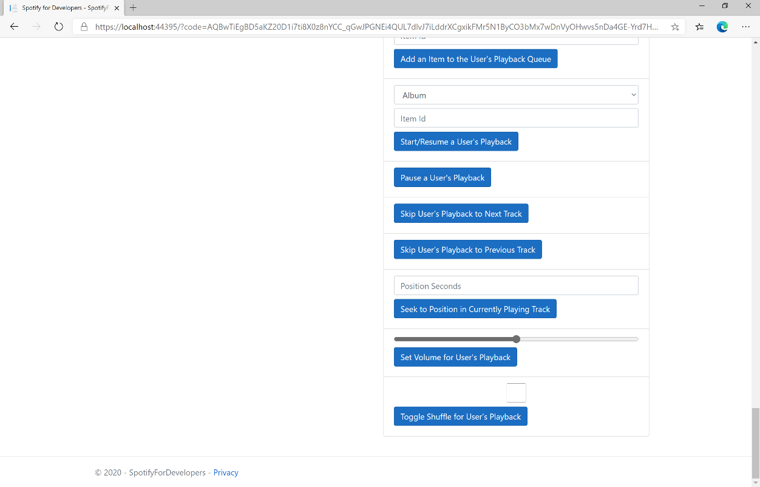

### Step 10

Make sure **Spotify** is running then you can then **tick** the **Checkbox** above **Toggle Shuffle for User’s Playback** to enable **shuffle** and **untick** the **Checkbox** to disable **shuffle** and select **Toggle Shuffle for User’s Playback** and scroll down to view **Results** like the following:

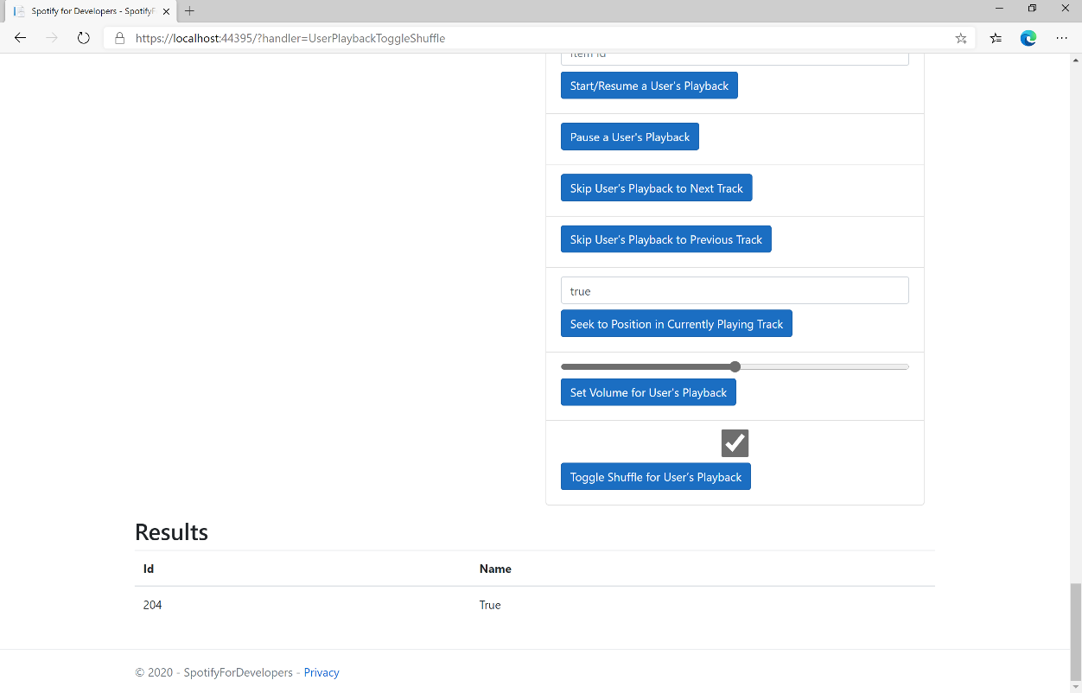

### Step 11

|  |  |
| --- | --- |
|  | You can stop the **web application** in **Visual Studio 2019** by selecting the **Stop debugging** button |

### Step 12

|  |  |
| --- | --- |
|  | You can choose to exit **Visual Studio 2019** by selecting the **Close** button in the top right of the **application** as that completes thispart of the workshop |

## Set Repeat Mode on User’s Playback

Set the repeat mode for the user’s playback. Options are repeat-track, repeat-context, and off.

|  |  |
| --- | --- |
| PUT https://api.spotify.com/v1/me/player/repeat | |
| Header | |
| Authorization | User Token from Spotify Accounts service with **user-modify-playback-state** scope |
| Query Parameter | |
| state | track will repeat current track, context will repeat current context and off will turn repeat off. |
| device_id | Device Id to target, if not supplied the user’s current active device is the target |

|  |  |
| --- | --- |
| Header | Response |
| Success | |
| HTTP Status 204  No Content |  |
| Error | |
| HTTP Status 404  Not Found | NO_ACTIVE_DEVICE - Device was not found |
| HTTP Status 403  Forbidden | PREMIUM_REQUIRED - Returned when account non-premium |
| Error Code | Error Object |

### Step 1

|  |  |
| --- | --- |
|  | If you chose to close **Visual Studio 2019** previously, in **Windows 10** choose **Start**, and then from the **Start Menu** find and select **Visual Studio 2019** |
|  | Once done, from the **Get started** screen for **Visual Studio 2019** select **Open a project or solution** |
|  | Then locate and select **SpotifyForDevelopers.sln** and select **Open** if you don’t have this file already then please follow the previous parts of the workshop including **Getting Started**, **Authorisation Guide**, **Search & Browse**, **Playlists & Artists**, **Albums & Tracks**, **Episodes & Shows**, **Follow**, **Playlists**, **Library** and **Player** |

### Step 2

|  |  |
| --- | --- |
|  | Once opened, in the **Solution Explorer** open the **Pages** section, then open the **Index.cshtml** section and select **Index.cshtml.cs** |

### Step 3

|  |  |
| --- | --- |
|  | Then from the **Menu** choose **View** and then **Open** |

### Step 4

In the **Code View** for **Index.cshtml.cs** below the **method** for public async Task<IActionResult> OnPostUserPlaybackToggleShuffleAsync(...) { ... } enter the following **method**:

|  |
| --- |
| public async Task<IActionResult> OnPostUserPlaybackSetRepeatModeAsync(bool flag)  {  var state = flag ? RepeatState.Track : RepeatState.Off;  var result = await Api.UserPlaybackSetRepeatModeAsync(state);  if (result != null)  {  Results = new List<Result>() { new Result()  {  Id = result.Code.ToString(),  Name = result.Success.ToString()  }};  }  return Page();  } |

The **method** for OnPostUserPlaybackSetRepeatModeAsync is used set the **repeat** mode of the **playback** with the Flag of **true** or **false** and populate the **property** for Results of the **success** of the operation accordingly.

### Step 5

|  |  |
| --- | --- |
|  | In the **Solution Explorer** in the **Pages** section select **Index.cshtml** |

### Step 6

|  |  |
| --- | --- |
|  | Then from the **Menu** choose **View** and then **Open** |

### Step 7

Once in the **Code View** for **Index.cshtml** above <!-- Player --> enter the following:

|  |
| --- |
| <li class="list-group-item">  <form **asp-page-handler**="UserPlaybackSetRepeatMode" method="post">  <input **type**="checkbox" **asp-for**="Flag" class="form-control mb-2" />  <button class="btn btn-primary mb-2">  Set Repeat Mode on User’s Playback  </button>  </form>  </li> |

This form will **post** to the **method** for UserPlaybackSetRepeatMode with the Flag of the **Checkbox** and will output to the **Results**.

### Step 8

|  |  |
| --- | --- |
|  | Finally, in **Visual Studio 2019** select **IIS Application** to run the **Web Application** |

### Step 9

Once the **Web Application** is running and you select **Authorisation Code Flow Login** or **Implicit Grant Flow Login** and scroll down you should see something like the following:

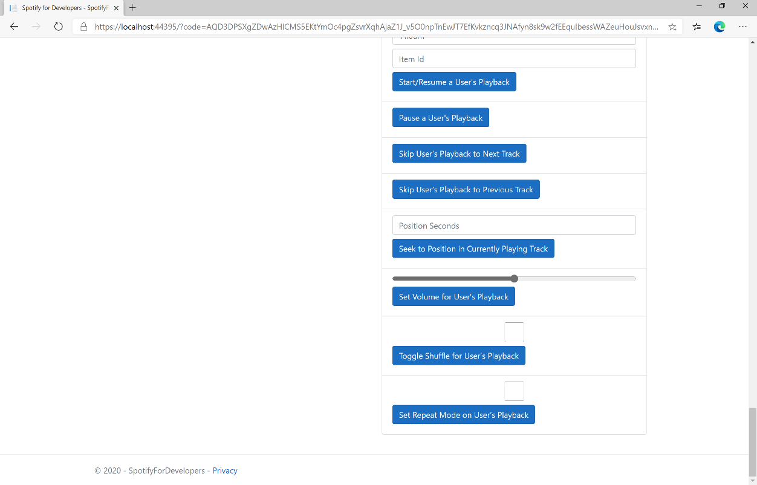

### Step 10

Make sure **Spotify** is running then you can then **tick** the **Checkbox** above **Set Repeat Mode on User’s Playback** to enable **repeat** and **untick** the **Checkbox** to disable **repeat** and select **Set Repeat Mode on User’s Playback** and scroll down to view **Results** like the following:

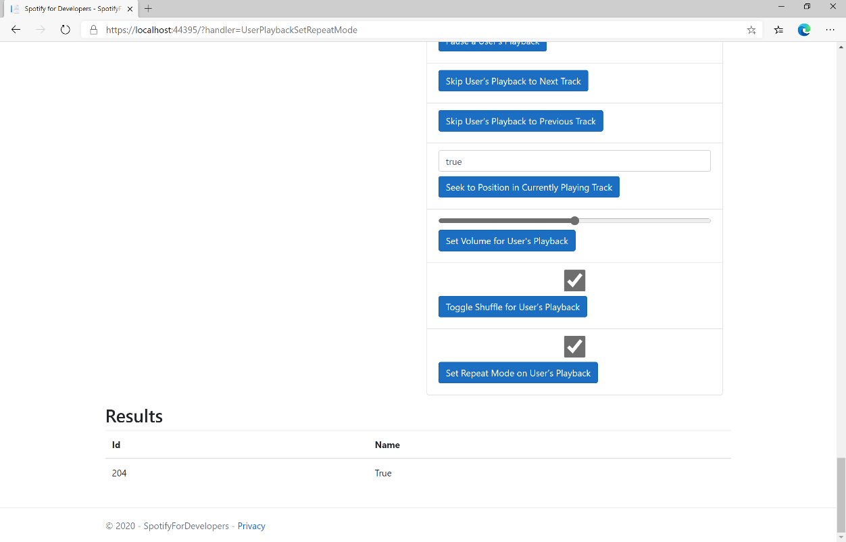

### Step 11

|  |  |
| --- | --- |
|  | You can stop the **web application** in **Visual Studio 2019** by selecting the **Stop debugging** button |

### Step 12

|  |  |
| --- | --- |
|  | You can choose to exit **Visual Studio 2019** by selecting the **Close** button in the top right of the **application** as that completes thispart of the workshop |

## Get Information about the User's Current Playback

Get information about the user’s current playback state, including track, track progress, and active device.

|  |  |
| --- | --- |
| GET https://api.spotify.com/v1/me/player | |
| Header | |
| Authorization | User Token from Spotify Accounts service with **user-read-playback-state** scope |
| Query Parameter | |
| market | ISO 3166-1 alpha-2 country code. Provide to apply Track Relinking |
| additional_types | Comma-separated list of item types that your client supports besides the default track type. Valid types are track and episode. An unsupported type in the response is expected to be represented as null value in the item field |

|  |  |
| --- | --- |
| Header | Response |
| Success | |
| HTTP Status 200 OK | Currently Playing Object |
| Error | |
| Error Code | Error Object |

### Step 1

|  |  |
| --- | --- |
|  | If you chose to close **Visual Studio 2019** previously, in **Windows 10** choose **Start**, and then from the **Start Menu** find and select **Visual Studio 2019** |
|  | Once done, from the **Get started** screen for **Visual Studio 2019** select **Open a project or solution** |
|  | Then locate and select **SpotifyForDevelopers.sln** and select **Open** if you don’t have this file already then please follow the previous parts of the workshop including **Getting Started**, **Authorisation Guide**, **Search & Browse**, **Playlists & Artists**, **Albums & Tracks**, **Episodes & Shows**, **Follow**, **Playlists**, **Library** and **Player** |

### Step 2

|  |  |
| --- | --- |
|  | Once opened, in the **Solution Explorer** open the **Pages** section, then open the **Index.cshtml** section and select **Index.cshtml.cs** |

### Step 3

|  |  |
| --- | --- |
|  | Then from the **Menu** choose **View** and then **Open** |

### Step 4

In the **Code View** for **Index.cshtml.cs** below the **method** for public async Task<IActionResult> OnPostUserPlaybackSetRepeatModeAsync(...) { ... } enter the following **method**:

|  |
| --- |
| public async Task<IActionResult> OnPostGetUserPlaybackCurrentAsync()  {  LoadToken();  var result = await Api.GetUserPlaybackCurrentAsync(country,  new List<string> { "track", "episode" });  if (result != null)  {  if(result.Track != null)  {  Results = new List<Result> { new Result()  {  Id = result?.Track?.Id,  Name = result?.Track?.Name,  Image = result?.Track.Album?.Images?.FirstOrDefault()?.Url,  Inner = new Result()  {  Id = result?.Track?.Artists?.FirstOrDefault()?.Id,  Name = result?.Track?.Artists?.FirstOrDefault()?.Name  }  }};  }  if (result.Episode != null)  {  Results = new List<Result> { new Result()  {  Id = result?.Episode?.Id,  Name = result?.Episode?.Name,  Image = result?.Episode?.Images?.FirstOrDefault()?.Url,  Inner = new Result()  {  Id = result?.Episode?.Show?.Id,  Name = result?.Episode?.Show?.Name  }  }};  }  }  return Page();  } |

The **method** for OnPostGetUserPlaybackCurrentAsync is used get **information** the currently playing **track** or **episode** and populate the **property** for Results accordingly.

### Step 5

|  |  |
| --- | --- |
|  | In the **Solution Explorer** in the **Pages** section select **Index.cshtml** |

### Step 6

|  |  |
| --- | --- |
|  | Then from the **Menu** choose **View** and then **Open** |

### Step 7

Once in the **Code View** for **Index.cshtml** above <!-- Player --> enter the following:

|  |
| --- |
| <li class="list-group-item">  <form **asp-page-handler**="GetUserPlaybackCurrent" method="post">  <button class="btn btn-primary mb-2">  Get Information about the User's Current Playback  </button>  </form>  </li> |

This form will **post** to the **method** for GetUserPlaybackCurrent and will output to the **Results**.

### Step 8

|  |  |
| --- | --- |
|  | Finally, in **Visual Studio 2019** select **IIS Application** to run the **Web Application** |

### Step 9

Once the **Web Application** is running and you select **Authorisation Code Flow Login** or **Implicit Grant Flow Login** and scroll down you should see something like the following:

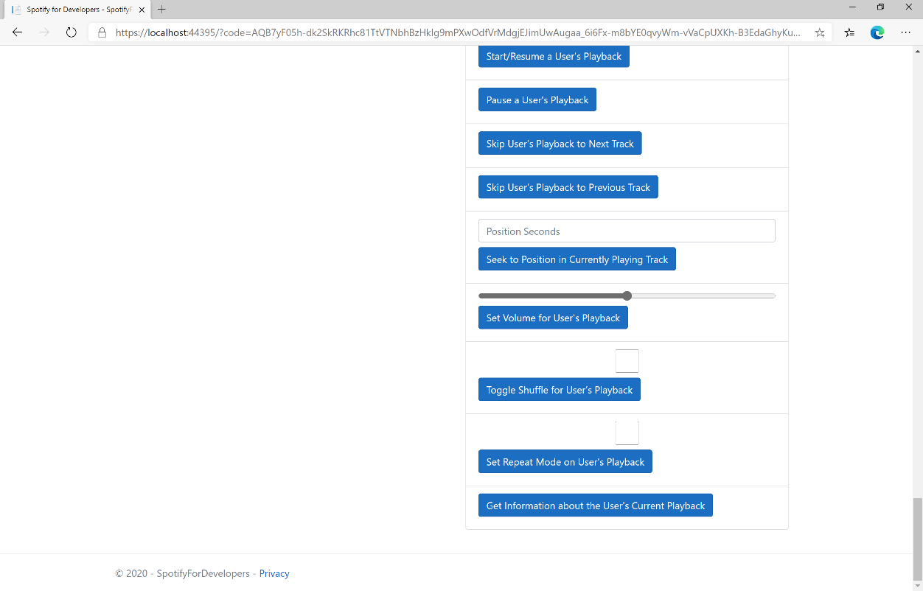

### Step 10

Make sure **Spotify** is running then you can then use **Start/Resume a User's Playback** with a **Track Id** or **Episode Id** from **Search For An Item** with option of **Track** or **Episode** then select **Get Information about the User's Current Playback** and scroll down to view **Results** like the following:

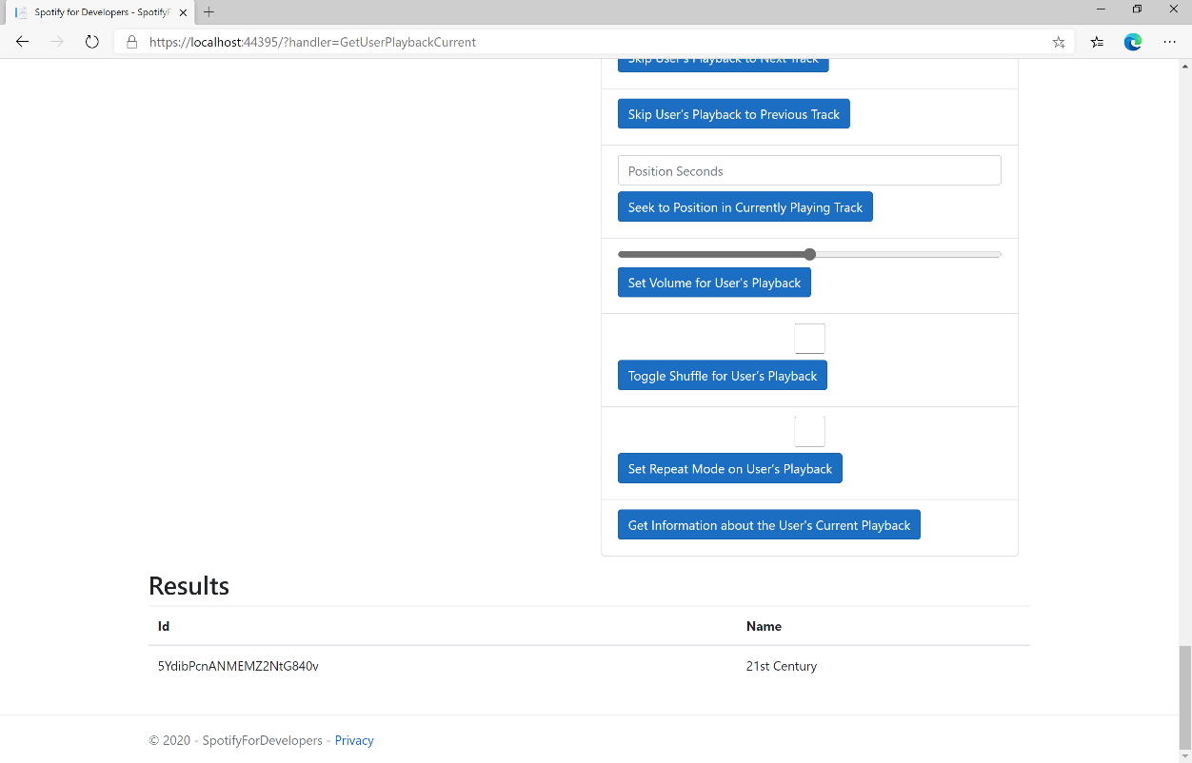

### Step 11

|  |  |
| --- | --- |
|  | You can stop the **web application** in **Visual Studio 2019** by selecting the **Stop debugging** button |

### Step 12

|  |  |
| --- | --- |
|  | You can choose to exit **Visual Studio 2019** by selecting the **Close** button in the top right of the **application** as that completes thispart of the workshop |

## Get the User's Currently Playing Track

Get the object currently being played on the user’s Spotify account.

|  |  |
| --- | --- |
| GET https://api.spotify.com/v1/me/player/currently-playing | |
| Header | |
| Authorization | User Token from Spotify Accounts service with **user-read-currently-playing** and/or  **user-read-playback-state** scope |
| Query Parameter | |
| market | ISO 3166-1 alpha-2 country code. Provide to apply Track Relinking |
| additional_types | Comma-separated list of item types that your client supports besides the default track type. Valid types are track and episode. An unsupported type in the response is expected to be represented as null value in the item field |

|  |  |
| --- | --- |
| Header | Response |
| Success | |
| HTTP Status 200 OK | Currently Playing Track or Episode and Context |
| HTTP Status 204  No Content | No Payload if nothing playing or if private session an empty payload |
| Error | |
| Error Code | Error Object |

### Step 1

|  |  |
| --- | --- |
|  | If you chose to close **Visual Studio 2019** previously, in **Windows 10** choose **Start**, and then from the **Start Menu** find and select **Visual Studio 2019** |
|  | Once done, from the **Get started** screen for **Visual Studio 2019** select **Open a project or solution** |
|  | Then locate and select **SpotifyForDevelopers.sln** and select **Open** if you don’t have this file already then please follow the previous parts of the workshop including **Getting Started**, **Authorisation Guide**, **Search & Browse**, **Playlists & Artists**, **Albums & Tracks**, **Episodes & Shows**, **Follow**, **Playlists**, **Library** and **Player** |

### Step 2

|  |  |
| --- | --- |
|  | Once opened, in the **Solution Explorer** open the **Pages** section, then open the **Index.cshtml** section and select **Index.cshtml.cs** |

### Step 3

|  |  |
| --- | --- |
|  | Then from the **Menu** choose **View** and then **Open** |

### Step 4

In the **Code View** for **Index.cshtml.cs** below the **method** for public async Task<IActionResult> OnPostGetUserPlaybackCurrentAsync() { ... } enter the following **method**:

|  |
| --- |
| public async Task<IActionResult> OnPostGetUserPlaybackCurrentTrackAsync()  {  LoadToken();  var result = await Api.GetUserPlaybackCurrentTrackAsync(country,  new List<string> { "track", "episode" });  if (result != null)  {  if (result.Track != null)  {  Results = new List<Result> { new Result()  {  Id = result?.Track?.Id,  Name = result?.Track?.Name,  Image = result?.Track.Album?.Images?.FirstOrDefault()?.Url,  Inner = new Result()  {  Id = result?.Track?.Artists?.FirstOrDefault()?.Id,  Name = result?.Track?.Artists?.FirstOrDefault()?.Name  }  }};  }  if (result.Episode != null)  {  Results = new List<Result> { new Result()  {  Id = result?.Episode?.Id,  Name = result?.Episode?.Name,  Image = result?.Episode?.Images?.FirstOrDefault()?.Url,  Inner = new Result()  {  Id = result?.Episode?.Show?.Id,  Name = result?.Episode?.Show?.Name  }  }};  }  }  return Page();  } |

The **method** for OnPostGetUserPlaybackCurrentTrackAsync is used get **information** the currently playing **track** or **episode** and populate the **property** for Results accordingly.

### Step 5

|  |  |
| --- | --- |
|  | In the **Solution Explorer** in the **Pages** section select **Index.cshtml** |

### Step 6

|  |  |
| --- | --- |
|  | Then from the **Menu** choose **View** and then **Open** |

### Step 7

Once in the **Code View** for **Index.cshtml** above <!-- Player --> enter the following:

|  |
| --- |
| <li class="list-group-item">  <form **asp-page-handler**="GetUserPlaybackCurrentTrack" method="post">  <button class="btn btn-primary mb-2">  Get the User's Currently Playing Track  </button>  </form>  </li> |

This form will **post** to the **method** for GetUserPlaybackCurrentTrack and will output to the **Results**.

### Step 8

|  |  |
| --- | --- |
|  | Finally, in **Visual Studio 2019** select **IIS Application** to run the **Web Application** |

### Step 9

Once the **Web Application** is running and you select **Authorisation Code Flow Login** or **Implicit Grant Flow Login** and scroll down you should see something like the following:

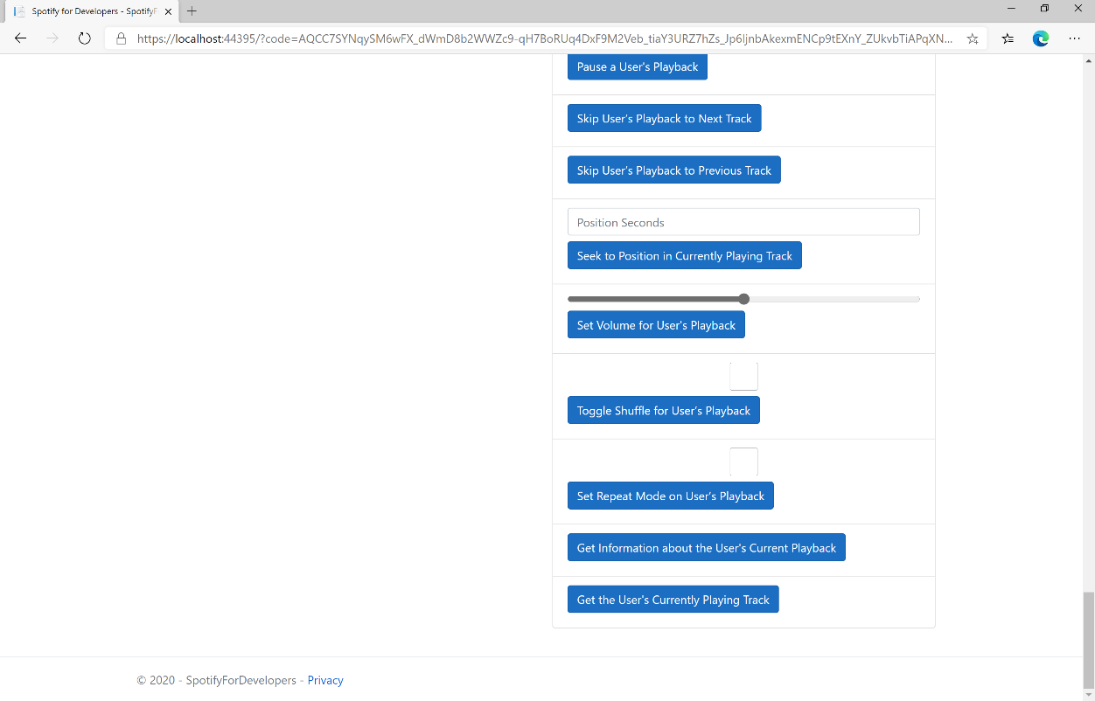

### Step 10

Make sure **Spotify** is running then you can then use **Start/Resume a User's Playback** with a **Track Id** or **Episode Id** from **Search For An Item** with option of **Track** or **Episode** then select **Get the User's Currently Playing Track** and scroll down to view **Results** like the following:

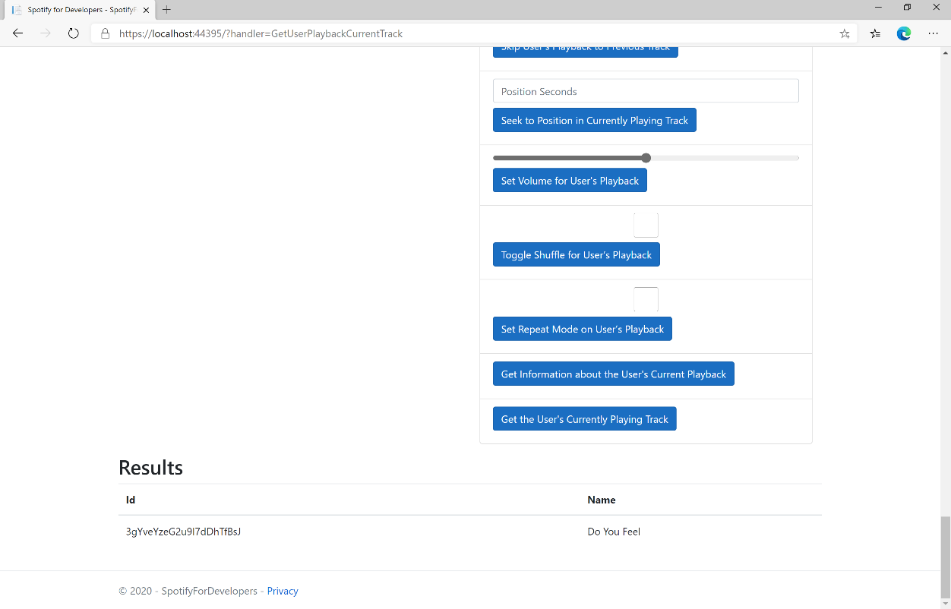

### Step 11

|  |  |
| --- | --- |
|  | You can stop the **web application** in **Visual Studio 2019** by selecting the **Stop debugging** button |

### Step 12

|  |  |
| --- | --- |
|  | You can choose to exit **Visual Studio 2019** by selecting the **Close** button in the top right of the **application** as that completes thispart of the workshop |

## Get Current User's Recently Played Tracks

Get tracks from the current user’s recently played tracks.

|  |  |
| --- | --- |
| GET https://api.spotify.com/v1/me/player/recently-played | |
| Header | |
| Authorization | User Token from Spotify Accounts service with **user-read-recently-played** scope |
| Query Parameter | |
| limit | Maximum number of items to return. Default: 20. Minimum: 1. Maximum: 50. |
| after | Unix timestamp in milliseconds. Returns all items after but not including this cursor position. If after is specified, before must not be specified. |
| before | Unix timestamp in milliseconds. Returns all items before but not including this cursor position. If before is specified, after must not be specified. |

|  |  |
| --- | --- |
| Header | Response |
| Success | |
| HTTP Status 200 OK | Array of Play History Objects wrapped in a Cursor Paging Object |
| HTTP Status 204  No Content | If private session an empty payload |
| Error | |
| Error Code | Error Object |

### Step 1

|  |  |
| --- | --- |
|  | If you chose to close **Visual Studio 2019** previously, in **Windows 10** choose **Start**, and then from the **Start Menu** find and select **Visual Studio 2019** |
|  | Once done, from the **Get started** screen for **Visual Studio 2019** select **Open a project or solution** |
|  | Then locate and select **SpotifyForDevelopers.sln** and select **Open** if you don’t have this file already then please follow the previous parts of the workshop including **Getting Started**, **Authorisation Guide**, **Search & Browse**, **Playlists & Artists**, **Albums & Tracks**, **Episodes & Shows**, **Follow**, **Playlists**, **Library** and **Player** |

### Step 2

|  |  |
| --- | --- |
|  | Once opened, in the **Solution Explorer** open the **Pages** section, then open the **Index.cshtml** section and select **Index.cshtml.cs** |

### Step 3

|  |  |
| --- | --- |
|  | Then from the **Menu** choose **View** and then **Open** |

### Step 4

In the **Code View** for **Index.cshtml.cs** below the **method** for public async Task<IActionResult> OnPostGetUserPlaybackCurrentTrackAsync() { ... } enter the following **method**:

|  |
| --- |
| public async Task<IActionResult> OnPostGetUserRecentlyPlayedTracksAsync()  {  LoadToken();  var results = await Api.GetUserRecentlyPlayedTracksAsync();  if (results?.Items != null)  {  Results = results.Items.Select(result => new Result()  {  Id = result.Track.Id,  Name = result.Track.Name,  Image = result?.Track.Album?.Images?.FirstOrDefault()?.Url,  Inner = new Result()  {  Id = result?.Track?.Artists?.FirstOrDefault()?.Id,  Name = result?.Track?.Artists?.FirstOrDefault()?.Name  }  });  }  return Page();  } |

The **method** for OnPostGetUserRecentlyPlayedTracksAsync is used to get the **tracks** that have been played **recently** and populate the **property** for Results accordingly.

### Step 5

|  |  |
| --- | --- |
|  | In the **Solution Explorer** in the **Pages** section select **Index.cshtml** |

### Step 6

|  |  |
| --- | --- |
|  | Then from the **Menu** choose **View** and then **Open** |

### Step 7

Once in the **Code View** for **Index.cshtml** above <!-- Player --> enter the following:

|  |
| --- |
| <li class="list-group-item">  <form **asp-page-handler**="GetUserRecentlyPlayedTracks" method="post">  <button class="btn btn-primary mb-2">  Get User's Recently Played Tracks  </button>  </form>  </li> |

This form will **post** to the **method** for GetUserRecentlyPlayedTracks and will output to the **Results**.

### Step 8

|  |  |
| --- | --- |
|  | Finally, in **Visual Studio 2019** select **IIS Application** to run the **Web Application** |

### Step 9

Once the **Web Application** is running and you select **Authorisation Code Flow Login** or **Implicit Grant Flow Login** and scroll down you should see something like the following:

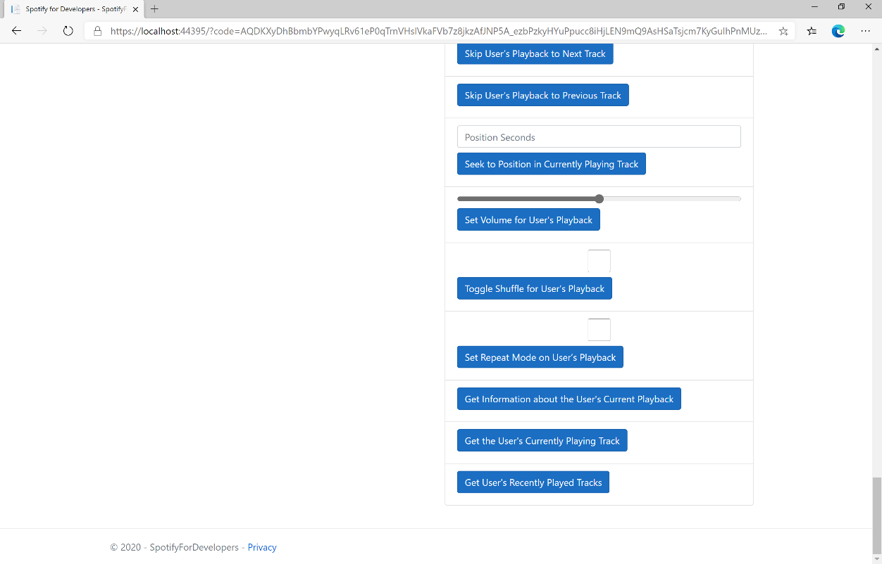

### Step 10

You can select **Get User's Recently Played Tracks** and scroll down to view **Results** like the following:

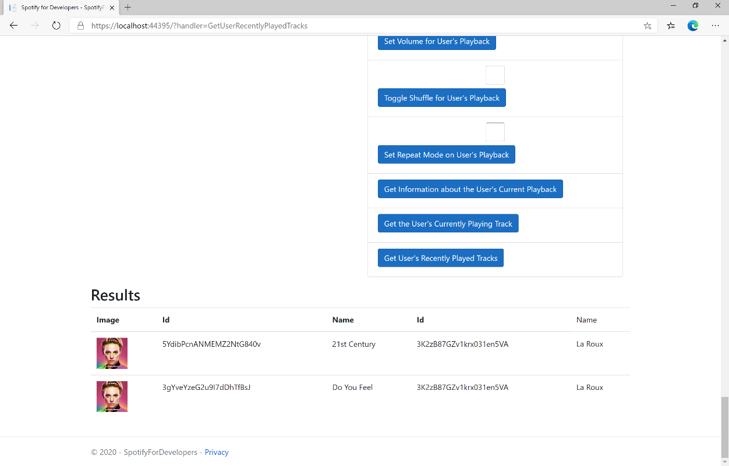

### Step 11

|  |  |
| --- | --- |
|  | You can stop the **web application** in **Visual Studio 2019** by selecting the **Stop debugging** button |

### Step 12

|  |  |
| --- | --- |
|  | You can choose to exit **Visual Studio 2019** by selecting the **Close** button in the top right of the **application** as that completes thispart of the workshop |

## Get a User's Available Devices

Get information about a user’s available devices.

|  |  |
| --- | --- |
| GET https://api.spotify.com/v1/me/player/devices | |
| Header | |
| Authorization | User Token from Spotify Accounts service with **user-read-playback-state** scope |

|  |  |
| --- | --- |
| Header | Response |
| Success | |
| HTTP Status 200 OK | Array of Device Objects or Empty if none |
| Error | |
| Error Code | Error Object |

### Step 1

|  |  |
| --- | --- |
|  | If you chose to close **Visual Studio 2019** previously, in **Windows 10** choose **Start**, and then from the **Start Menu** find and select **Visual Studio 2019** |
|  | Once done, from the **Get started** screen for **Visual Studio 2019** select **Open a project or solution** |
|  | Then locate and select **SpotifyForDevelopers.sln** and select **Open** if you don’t have this file already then please follow the previous parts of the workshop including **Getting Started**, **Authorisation Guide**, **Search & Browse**, **Playlists & Artists**, **Albums & Tracks**, **Episodes & Shows**, **Follow**, **Playlists**, **Library** and **Player** |

### Step 2

|  |  |
| --- | --- |
|  | Once opened, in the **Solution Explorer** open the **Pages** section, then open the **Index.cshtml** section and select **Index.cshtml.cs** |

### Step 3

|  |  |
| --- | --- |
|  | Then from the **Menu** choose **View** and then **Open** |

### Step 4

In the **Code View** for **Index.cshtml.cs** below the **method** for public async Task<IActionResult> OnPostGetUserRecentlyPlayedTracksAsync() { ... } enter the following **method**:

|  |
| --- |
| public async Task<IActionResult> OnPostGetUserPlaybackDevicesAsync()  {  LoadToken();  var results = await Api.GetUserPlaybackDevicesAsync();  if (results?.Items != null)  {  Results = results.Items.Select(result => new Result()  {  Id = result.Id,  Name = result.Name,  });  }  return Page();  } |

The **method** for OnPostGetUserPlaybackDevicesAsync is used to get the **devices** that are **available** for a **user** and populate the **property** for Results accordingly.

### Step 5

|  |  |
| --- | --- |
|  | In the **Solution Explorer** in the **Pages** section select **Index.cshtml** |

### Step 6

|  |  |
| --- | --- |
|  | Then from the **Menu** choose **View** and then **Open** |

### Step 7

Once in the **Code View** for **Index.cshtml** above <!-- Player --> enter the following:

|  |
| --- |
| <li class="list-group-item">  <form **asp-page-handler**="GetUserPlaybackDevices" method="post">  <button class="btn btn-primary mb-2">  Get a User's Available Devices  </button>  </form>  </li> |

This form will **post** to the **method** for GetUserPlaybackDevices and will output to the **Results**.

### Step 8

|  |  |
| --- | --- |
|  | Finally, in **Visual Studio 2019** select **IIS Application** to run the **Web Application** |

### Step 9

Once the **Web Application** is running and you select **Authorisation Code Flow Login** or **Implicit Grant Flow Login** and scroll down you should see something like the following:

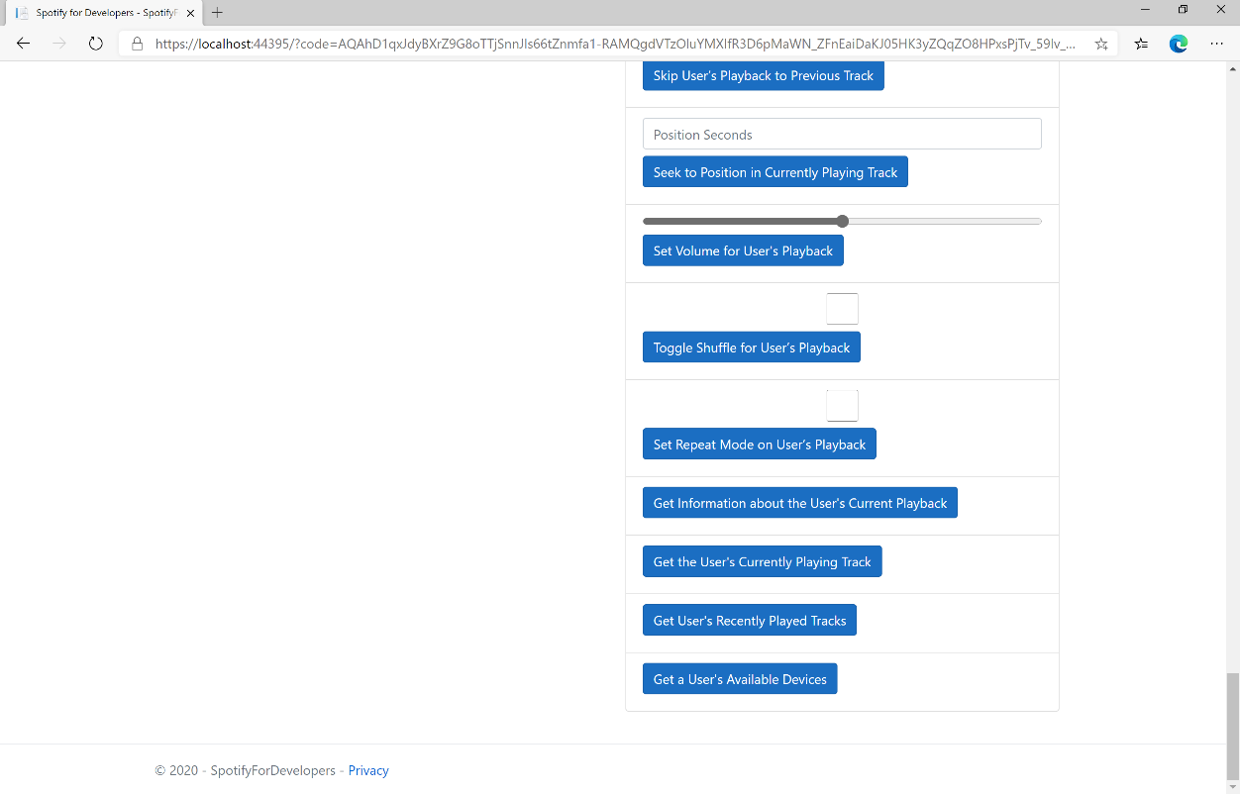

### Step 10

You can select **Get a User's Available Devices** and scroll down to view **Results** like the following:

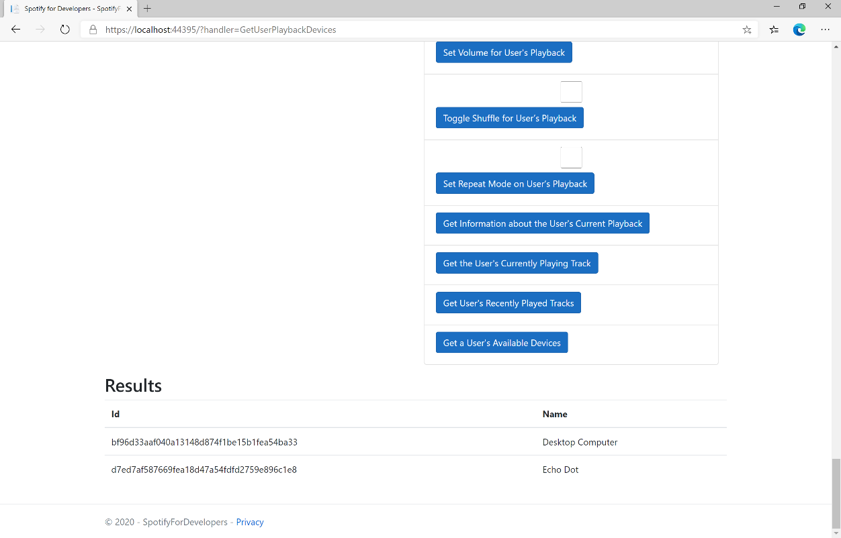

### Step 11

|  |  |
| --- | --- |
|  | You can stop the **web application** in **Visual Studio 2019** by selecting the **Stop debugging** button |

### Step 12

|  |  |
| --- | --- |
|  | You can choose to exit **Visual Studio 2019** by selecting the **Close** button in the top right of the **application** as that completes thispart of the workshop |

## Transfer a User's Playback

Transfer playback to a new device and determine if it should start playing.

|  |  |
| --- | --- |
| PUT https://api.spotify.com/v1/me/player | |
| Header | |
| Authorization | User Token from Spotify Accounts service with **user-modify-playback-state** scope |
| Body Parameter | |
| device_ids | Device Id on which playback should be started/transferred, only one Device Id is supported |
| play | If true, ensure playback happens on new device. If false, or not provided keep the current playback state. |

|  |  |
| --- | --- |
| Header | Response |
| Success | |
| HTTP Status 204  No Content |  |
| Error | |
| Error Code | Error Object |

### Step 1

|  |  |
| --- | --- |
|  | If you chose to close **Visual Studio 2019** previously, in **Windows 10** choose **Start**, and then from the **Start Menu** find and select **Visual Studio 2019** |
|  | Once done, from the **Get started** screen for **Visual Studio 2019** select **Open a project or solution** |
|  | Then locate and select **SpotifyForDevelopers.sln** and select **Open** if you don’t have this file already then please follow the previous parts of the workshop including **Getting Started**, **Authorisation Guide**, **Search & Browse**, **Playlists & Artists**, **Albums & Tracks**, **Episodes & Shows**, **Follow**, **Playlists**, **Library** and **Player** |

### Step 2

|  |  |
| --- | --- |
|  | Once opened, in the **Solution Explorer** open the **Pages** section, then open the **Index.cshtml** section and select **Index.cshtml.cs** |

### Step 3

|  |  |
| --- | --- |
|  | Then from the **Menu** choose **View** and then **Open** |

### Step 4

In the **Code View** for **Index.cshtml.cs** below the **method** for public async Task<IActionResult> OnPostGetUserPlaybackDevicesAsync() { ... } enter the following **method**:

|  |
| --- |
| public async Task<IActionResult> OnPostUserPlaybackTransferAsync(string value)  {  LoadToken();  var deviceIds = new List<string> { value };  var result = await Api.UserPlaybackTransferAsync(deviceIds, true);  if (result != null)  {  Results = new List<Result>() { new Result()  {  Id = result.Code.ToString(),  Name = result.Success.ToString()  }};  }  return Page();  } |

The **method** for OnPostUserPlaybackTransferAsync is used to set the **device** to use for **playback** with the Value of the **Device Id** and populate the **property** for Results of the **success** of the operation accordingly.

### Step 5

|  |  |
| --- | --- |
|  | In the **Solution Explorer** in the **Pages** section select **Index.cshtml** |

### Step 6

|  |  |
| --- | --- |
|  | Then from the **Menu** choose **View** and then **Open** |

### Step 7

Once in the **Code View** for **Index.cshtml** above <!-- Player --> enter the following:

|  |
| --- |
| <li class="list-group-item">  <form **asp-page-handler**="UserPlaybackTransfer" method="post">  <input **asp-for**="Value" placeholder="Device Id" class="form-control mb-2" />  <button class="btn btn-primary mb-2">  Transfer a User's Playback  </button>  </form>  </li> |

This form will **post** to the **method** for UserPlaybackTransfer with the Value of **Device Id** and will output to the **Results**.

### Step 8

|  |  |
| --- | --- |
|  | Finally, in **Visual Studio 2019** select **IIS Application** to run the **Web Application** |

### Step 9

Once the **Web Application** is running and you select **Authorisation Code Flow Login** or **Implicit Grant Flow Login** and scroll down you should see something like the following:

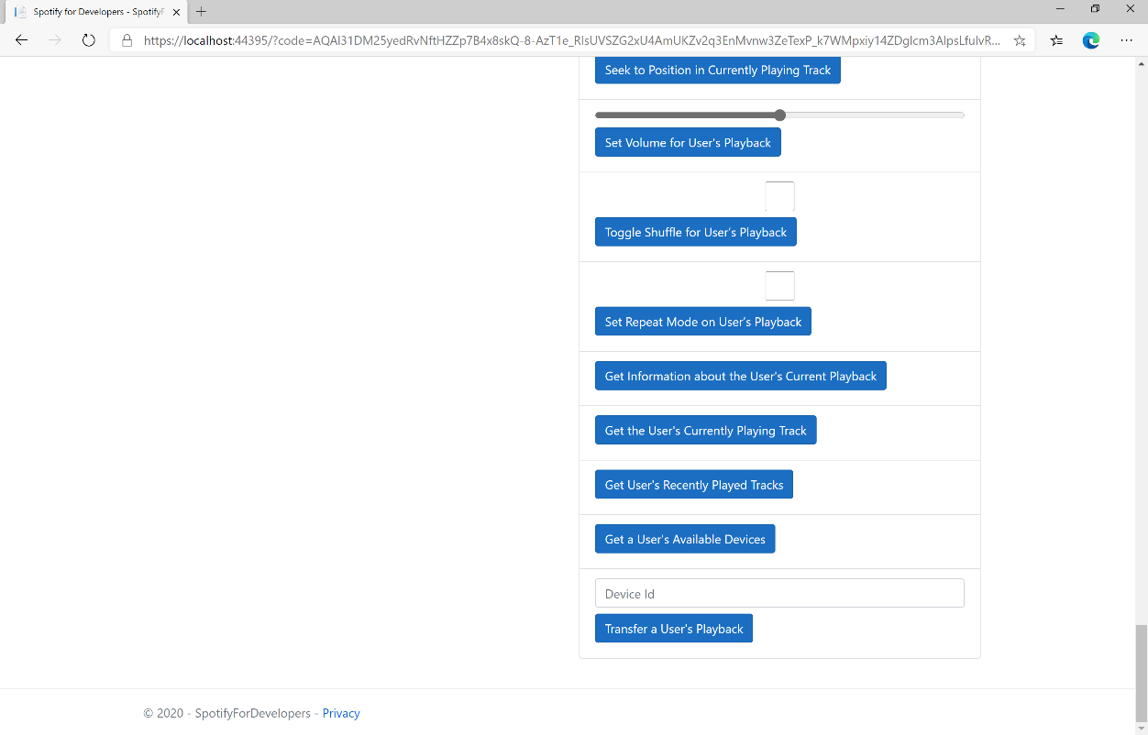

### Step 10

Make sure **Spotify** is running then you can then enter a **Device Id** from **Get a User's Available Devices** and enter this in **Device Id** above **Transfer a User's Playback** and then select **Transfer a User's Playback** and scroll down to view **Results** like the following:

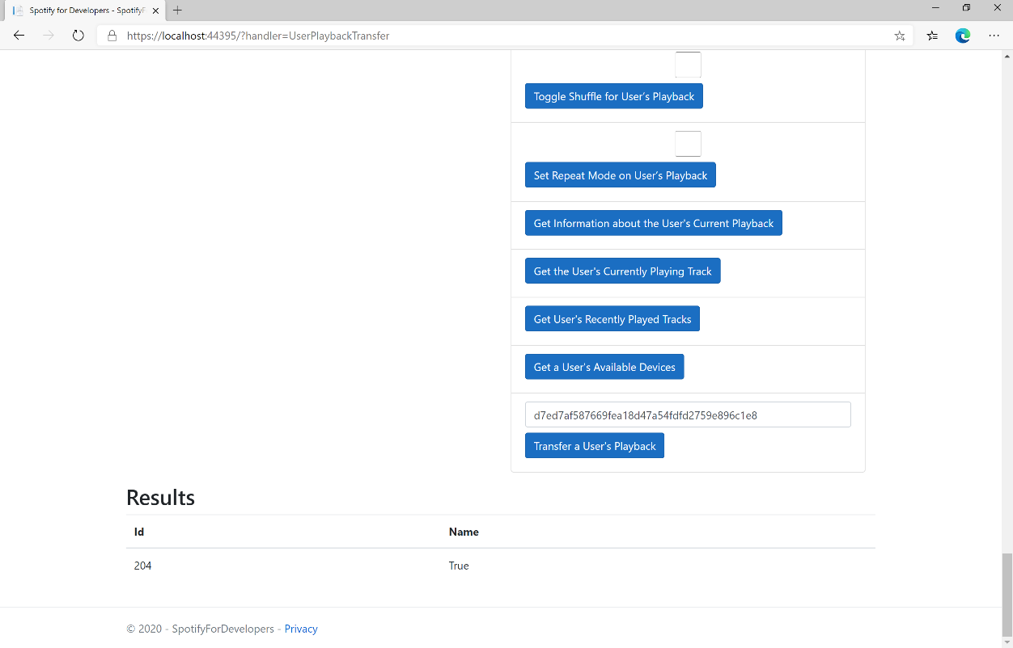

### Step 11

|  |  |
| --- | --- |
|  | You can stop the **web application** in **Visual Studio 2019** by selecting the **Stop debugging** button |

### Step 12

|  |  |
| --- | --- |
|  | You can exit **Visual Studio 2019** by selecting the **Close** button in the top right of the **application** as that completes thispart of the workshop |

# Personalisation & User Profile

## Get a User's Top Artists and Tracks

Get the current user’s top artists based on calculated affinity.

|  |  |
| --- | --- |
| GET https://api.spotify.com/v1/me/top/ | |
| Header | |
| Authorization | User Token from Spotify Accounts service with **user-top-read** scope |
| Path Parameter | |
| type | The type of entity to return. Valid values: artists or tracks |
| Query Parameter | |
| limit | Number of entities to return. Default: 20. Minimum: 1. Maximum: 50 |
| offset | Index of the first entity to return. Default: 0 |
| time_range | Over what time frame the affinities are computed. long_term - calculated from several years of data and including all new data as it becomes available, medium_term - approximately last 6 months and short_term - approximately last 4 weeks. Default: medium_term |

|  |  |
| --- | --- |
| Header | Response |
| Success | |
| HTTP Status 200 OK | List of Artists or Tracks wrapped in a Paging Object |
| Error | |
| Error Code | Error Object |

### Step 1

|  |  |
| --- | --- |
|  | In **Windows 10** choose **Start**, and then from the **Start Menu** find and select **Visual Studio 2019** |
|  | Once done, from the **Get started** screen for **Visual Studio 2019** select **Open a project or solution** |
|  | Then locate and select **SpotifyForDevelopers.sln** and select **Open** if you don’t have this file already then please follow the previous parts of the workshop including **Getting Started**, **Authorisation Guide**, **Search & Browse**, **Playlists & Artists**, **Albums & Tracks**, **Episodes & Shows**, **Follow**, **Playlists**, **Library** and **Player** |

### Step 2

|  |  |
| --- | --- |
|  | Once opened, in the **Solution Explorer** open the **Pages** section, then open the **Index.cshtml** section and select **Index.cshtml.cs** |

### Step 3

|  |  |
| --- | --- |
|  | Then from the **Menu** choose **View** and then **Open** |

### Step 4

In the **Code View** for **Index.cshtml.cs** below the **method** for public async Task<IActionResult> OnPostUserPlaybackTransferAsync() { ... } enter the following **method**:

|  |
| --- |
| public async Task<IActionResult> OnPostGetUserTopArtistsAndTracksAsync(string option)  {  LoadToken();  if(option.Equals("Artists"))  {  var results = await Api.GetUserTopArtistsAsync();  if (results?.Items != null)  {  Results = results.Items.Select(result => new Result()  {  Id = result.Id,  Name = result.Name,  Image = result?.Images?.FirstOrDefault()?.Url  });  }  }  else  {  var results = await Api.GetUserTopTracksAsync();  if (results?.Items != null)  {  Results = results.Items.Select(result => new Result()  {  Id = result.Id,  Name = result.Name,  Image = result?.Album?.Images?.FirstOrDefault()?.Url,  Inner = new Result()  {  Id = result?.Album?.Artists?.FirstOrDefault()?.Id,  Name = result?.Album?.Artists?.FirstOrDefault()?.Name  }  });  }  }  return Page();  } |

The **method** for OnPostGetUserTopArtistsAndTracksAsync is used to get the **top** played **artists** or **tracks** using the Option of the **Artists** and **Tracks** and populate the **property** for Results accordingly.

### Step 5

|  |  |
| --- | --- |
|  | In the **Solution Explorer** in the **Pages** section select **Index.cshtml** |

### Step 6

|  |  |
| --- | --- |
|  | Then from the **Menu** choose **View** and then **Open** |

### Step 7

Once in the **Code View** for **Index.cshtml** above <!-- Spotify Web API User Authorisation --> enter the following:

|  |
| --- |
| <ul class="list-group mb-2">  <li class="list-group-item list-group-item-primary">  <h5 class="list-group-item-heading">Personalisation</h5>  </li>  <li class="list-group-item">  <form **asp-page-handler**="GetUserTopArtistsAndTracks" method="post">  <select **asp-for**="Option" class="form-control mb-2">  <option>Artists</option>  <option>Tracks</option>  </select>  <button class="btn btn-primary mb-2">  Get a User's Top Artists and Tracks  </button>  </form>  </li>  </ul> |

This form will **post** to the **method** for GetUserTopArtistsAndTracks with the Option of **Artists** and **Tracks** and will output to the **Results**.

### Step 8

|  |  |
| --- | --- |
|  | Finally, in **Visual Studio 2019** select **IIS Application** to run the **Web Application** |

### Step 9

Once the **Web Application** is running and you select **Authorisation Code Flow Login** or **Implicit Grant Flow Login** and scroll down you should see something like the following:

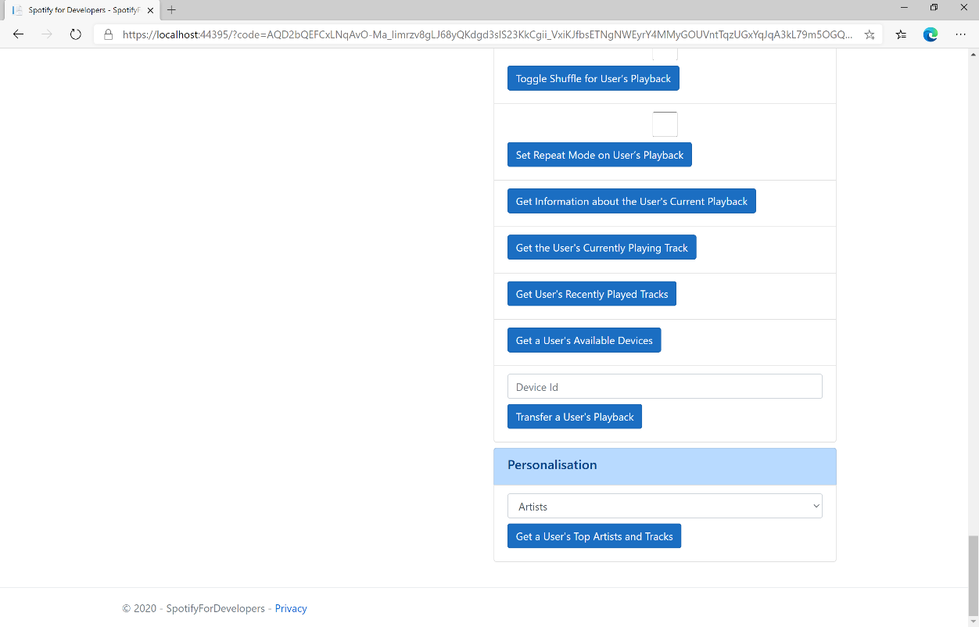

### Step 10

You can then select either **Artists** or **Tracks** above **Get a User's Top Artists and Tracks** and then select **Get a User's Top Artists and Tracks** and scroll down to view **Results** like the following:

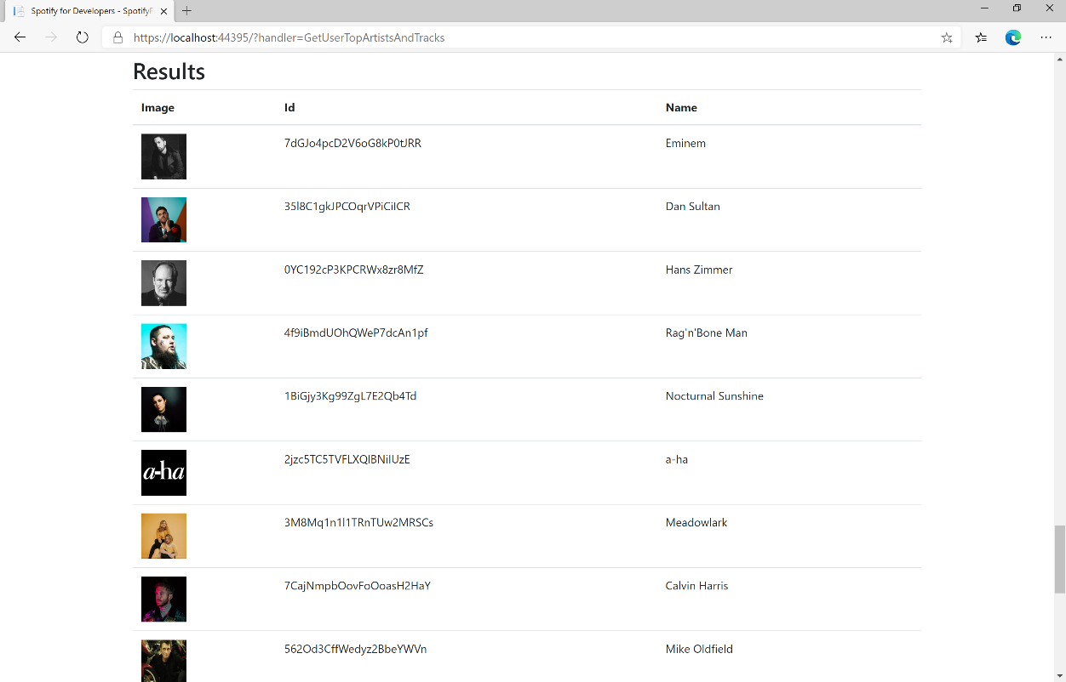

### Step 11

|  |  |
| --- | --- |
|  | You can stop the **web application** in **Visual Studio 2019** by selecting the **Stop debugging** button |

### Step 12

|  |  |
| --- | --- |
|  | You can choose to exit **Visual Studio 2019** by selecting the **Close** button in the top right of the **application** as that completes thispart of the workshop |

## Get a User's Profile

Get public profile information about a Spotify user.

|  |  |
| --- | --- |
| GET https://api.spotify.com/v1/users/{user_id} | |
| Header | |
| Authorization | User Token from Spotify Accounts service |
| Path Parameter | |
| user_id | The user’s Spotify User Id |

|  |  |
| --- | --- |
| Header | Response |
| Success | |
| HTTP Status 200 OK | List of Tracks wrapped in a Paging Object |
| Error | |
| HTTP Status 404  Not Found | User does not exist |
| Error Code | Error Object |

### Step 1

|  |  |
| --- | --- |
|  | If you chose to close **Visual Studio 2019** previously, in **Windows 10** choose **Start**, and then from the **Start Menu** find and select **Visual Studio 2019** |
|  | Once done, from the **Get started** screen for **Visual Studio 2019** select **Open a project or solution** |
|  | Then locate and select **SpotifyForDevelopers.sln** and select **Open** if you don’t have this file already then please follow the previous parts of the workshop including **Getting Started**, **Authorisation Guide**, **Search & Browse**, **Playlists & Artists**, **Albums & Tracks**, **Episodes & Shows**, **Follow**, **Playlists**, **Library**, **Player** and **Personalisation & User Profile** |

### Step 2

|  |  |
| --- | --- |
|  | Once opened, in the **Solution Explorer** open the **Pages** section, then open the **Index.cshtml** section and select **Index.cshtml.cs** |

### Step 3

|  |  |
| --- | --- |
|  | Then from the **Menu** choose **View** and then **Open** |

### Step 4

In the **Code View** for **Index.cshtml.cs** below the **method** for public async Task<IActionResult> OnPostGetUserTopArtistsAndTracksAsync(...) { ... } enter the following **method**:

|  |
| --- |
| public async Task<IActionResult> OnPostGetUserProfileAsync(string value)  {  LoadToken();  var result = await Api.GetUserProfileAsync(value);  if (result != null)  {  Results = new List<Result> { new Result()  {  Id = result.Id,  Name = result.DisplayName,  Image = result?.Images?.FirstOrDefault()?.Url  }};  }  return Page();  } |

The **method** for OnPostGetUserProfileAsync is used to get the **profile** of a **user** using the Value of the **User Id** and populate the **property** for Results accordingly.

### Step 5

|  |  |
| --- | --- |
|  | In the **Solution Explorer** in the **Pages** section select **Index.cshtml** |

### Step 6

|  |  |
| --- | --- |
|  | Then from the **Menu** choose **View** and then **Open** |

### Step 7

Once in the **Code View** for **Index.cshtml** above <!-- Spotify Web API User Authorisation --> enter the following:

|  |
| --- |
| <ul class="list-group mb-2">  <li class="list-group-item list-group-item-primary">  <h5 class="list-group-item-heading">User Profile</h5>  </li>  <li class="list-group-item">  <form **asp-page-handler**="GetUserProfile" method="post">  <input **asp-for**="Value" placeholder="User Id" class="form-control mb-2" />  <button class="btn btn-primary mb-2">  Get a User's Profile  </button>  </form>  </li>  <!-- User Profile -->  </ul> |

This form will **post** to the **method** for GetUserProfile with the Value of **User Id** and will output to the **Results**.

### Step 8

|  |  |
| --- | --- |
|  | Finally, in **Visual Studio 2019** select **IIS Application** to run the **Web Application** |

### Step 9

Once the **Web Application** is running and you select **Authorisation Code Flow Login** or **Implicit Grant Flow Login** and scroll down you should see something like the following:

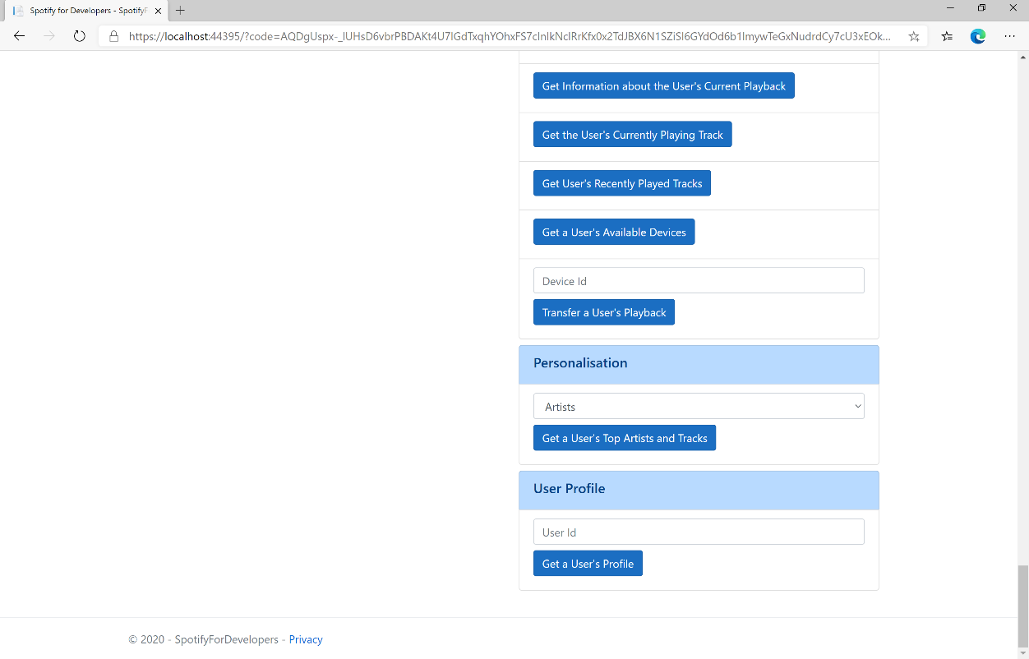

### Step 10

You can then enter above **Get a User's Profile** your **User Id**, to get this in **Spotify** select your **Username** then **...** and **Copy Spotify URI** your **User Id** will be after **spotify:user:** and then select **Get a User's Profile** and scroll down to view **Results** like the following:

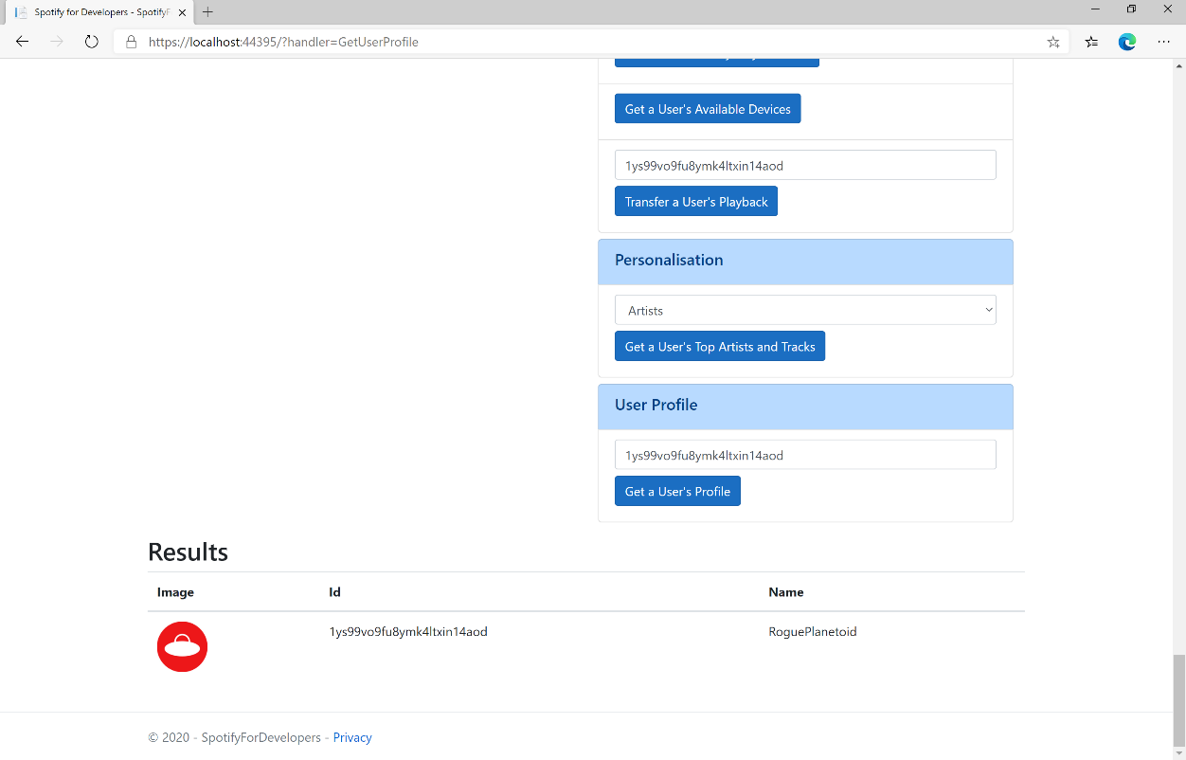

### Step 11

|  |  |
| --- | --- |
|  | You can stop the **web application** in **Visual Studio 2019** by selecting the **Stop debugging** button |

### Step 12

|  |  |
| --- | --- |
|  | You can choose to exit **Visual Studio 2019** by selecting the **Close** button in the top right of the **application** as that completes thispart of the workshop |

## Get Current User's Profile

Get detailed profile information about the current user including the current user’s username.

|  |  |
| --- | --- |
| GET https://api.spotify.com/v1/me | |
| Header | |
| Authorization | User Token from Spotify Accounts service. Reading the user’s email address requires the **user-read-email** scope or reading country and product subscription level requires the **user-read-private scope** |

|  |  |
| --- | --- |
| Header | Response |
| Success | |
| HTTP Status 200 OK | List of Tracks wrapped in a Paging Object |
| Error | |
| HTTP Status 403  Forbidden | When requesting fields that you don’t have the user’s authorisation to access |
| Error Code | Error Object |

### Step 1

|  |  |
| --- | --- |
|  | If you chose to close **Visual Studio 2019** previously, in **Windows 10** choose **Start**, and then from the **Start Menu** find and select **Visual Studio 2019** |
|  | Once done, from the **Get started** screen for **Visual Studio 2019** select **Open a project or solution** |
|  | Then locate and select **SpotifyForDevelopers.sln** and select **Open** if you don’t have this file already then please follow the previous parts of the workshop including **Getting Started**, **Authorisation Guide**, **Search & Browse**, **Playlists & Artists**, **Albums & Tracks**, **Episodes & Shows**, **Follow**, **Playlists**, **Library**, **Player** and **Personalisation & User Profile** |

### Step 2

|  |  |
| --- | --- |
|  | Once opened, in the **Solution Explorer** open the **Pages** section, then open the **Index.cshtml** section and select **Index.cshtml.cs** |

### Step 3

|  |  |
| --- | --- |
|  | Then from the **Menu** choose **View** and then **Open** |

### Step 4

In the **Code View** for **Index.cshtml.cs** below the **method** for public async Task<IActionResult> OnPostGetUserProfileAsync(...) { ... } enter the following **method**:

|  |
| --- |
| public async Task<IActionResult> OnPostGetCurrentUserProfileAsync()  {  LoadToken();  var result = await Api.GetUserProfileAsync();  if (result != null)  {  Results = new List<Result> { new Result()  {  Id = result.Id,  Name = result.DisplayName,  Image = result?.Images?.FirstOrDefault()?.Url  }};  }  return Page();  } |

The **method** for OnPostGetCurrentUserProfileAsync is used to get the **profile** of the **current user** and populate the **property** for Results accordingly.

### Step 5

|  |  |
| --- | --- |
|  | In the **Solution Explorer** in the **Pages** section select **Index.cshtml** |

### Step 6

|  |  |
| --- | --- |
|  | Then from the **Menu** choose **View** and then **Open** |

### Step 7

Once in the **Code View** for **Index.cshtml** above <!-- User Profile --> enter the following:

|  |
| --- |
| <li class="list-group-item">  <form **asp-page-handler**="GetCurrentUserProfile" method="post">  <button class="btn btn-primary mb-2">  Get Current User's Profile  </button>  </form>  </li> |

This form will **post** to the **method** for GetCurrentUserProfile and will output to the **Results**.

### Step 8

|  |  |
| --- | --- |
|  | Finally, in **Visual Studio 2019** select **IIS Application** to run the **Web Application** |

### Step 9

Once the **Web Application** is running and you select **Authorisation Code Flow Login** or **Implicit Grant Flow Login** and scroll down you should see something like the following:

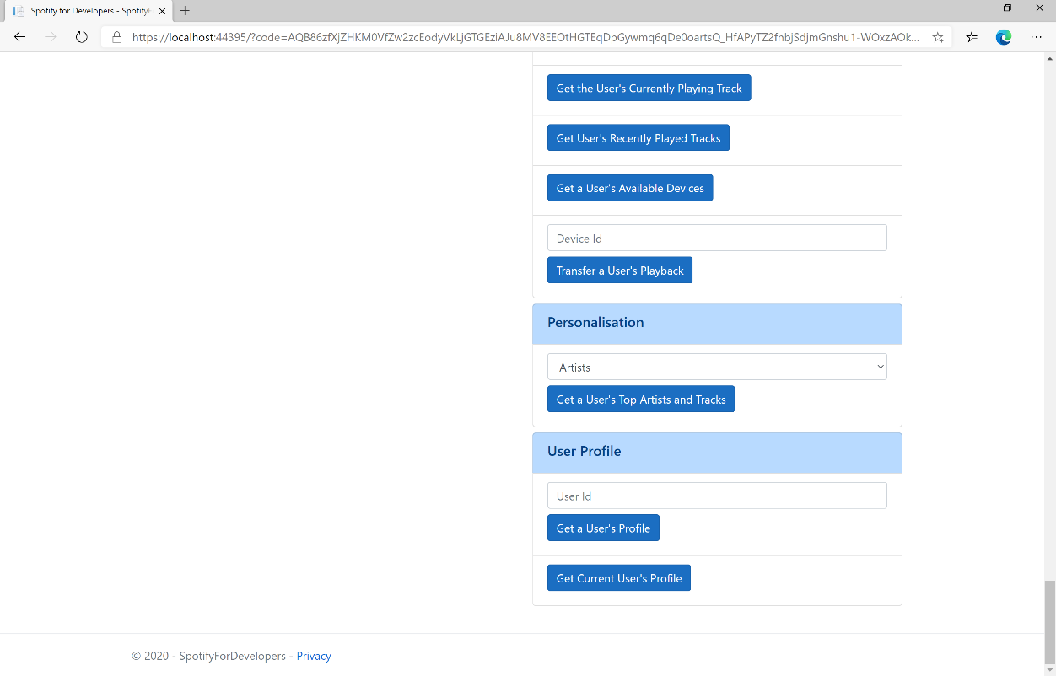

### Step 10

You can then select **Get Current User's Profile** and scroll down to view **Results** like the following:

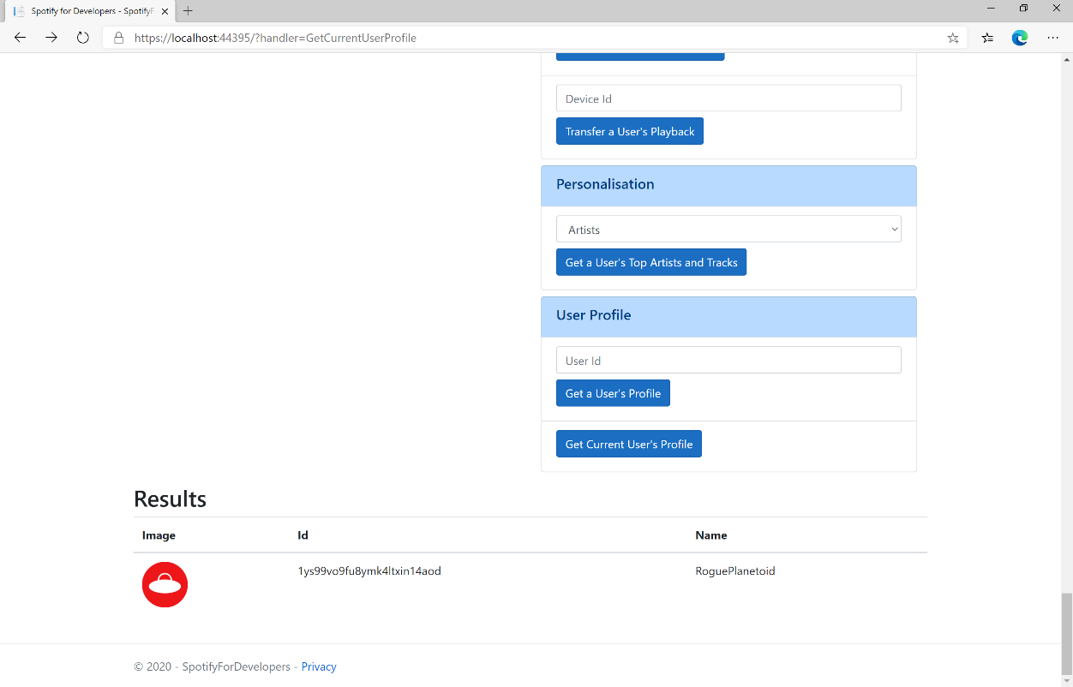

### Step 11

|  |  |
| --- | --- |
|  | You can stop the **web application** in **Visual Studio 2019** by selecting the **Stop debugging** button |

### Step 12

|  |  |
| --- | --- |
|  | You can exit **Visual Studio 2019** by selecting the **Close** button in the top right of the **application** as that completes thisworkshop |

# Requests & Responses

Spotify API allows applications to retrieve Spotify content such as album data, playlists and more in UTF-8 format with endpoints using standard HTTPS requests based on simple REST principles using the appropriate HTTP verbs for each action and return JSON formatted metadata about artists, albums and tracks. It also provides access to user related data, like playlists and music the user saves in their library.

## Request Verbs

|  |  |
| --- | --- |
| Request Method | Description |
| GET | Retrieves Resources |
| POST | Creates Resources |
| PUT | Changes and/or replaces Resources or Collections |
| DELETE | Deletes Resources |

## Response Codes

|  |  |
| --- | --- |
| Response Codes | Description |
| 200 | **OK** - Request has succeeded. The client can read the result of the request in the body and the headers of the response. |
| 201 | **Created** - Request has been fulfilled and resulted in a new resource being created. |
| 202 | **Accepted** - Request has been accepted for processing, but processing has not been completed. |
| 204 | **No Content** - Request has succeeded but returns no message body. |
| 304 | **Not Modified** - If response has not changed means a cached version is still good |
| 400 | **Bad Request** - Request could not be understood by the server due to malformed syntax. The message body will contain more information. |
| 401 | **Unauthorized** - Request requires user authentication or, if the request included authorisation credentials, authorisation has been refused for those credentials. |
| 403 | **Forbidden** - The server understood the request but is refusing to fulfil it. |
| 404 | **Not Found** - The requested resource could not be found. This error can be due to a temporary or permanent condition. |
| 429 | **Too Many Requests** - Rate Limiting has been applied. |
| 500 | **Internal Server Error** - Should never receive this error as Spotify should catch them |
| 502 | **Bad Gateway** - Server was acting as a gateway or proxy and received an invalid response from upstream server. |
| 503 | **Service Unavailable** - Server is currently unable to handle request due to a temporary condition which will be alleviated after some delay. You can choose to resend the request again. |